**PROJECT REPORT**

ON

**“Real Time Analysis of a Battery in context with MPPT Charge Controller”**

*Submitted in partial fulfilment for the award of degree of*

BACHELOR OF TECHNOLOGY

IN

ELECTRICAL ENGINEERING

Department of Electrical Engineering

of Assam Engineering College under Assam Science and Technology University

Session: 2022



**Submitted by:**

KANGKANA DAS (17/150) 180610003042

APARNA KALITA (18/165) 180610003019

SNIGDHA RANI DOWERAH (18/174) 180610003081

PRAGYALINA BORA (18/346) 180612603033

*Under the guidance of*

Dr.Barnali Goswami

Associate Professor

Department of Electrical & Instrumentation Engineering

Assam Engineering College

**Department of Electrical & Instrumentation Engineering Assam Engineering College, Jalukbari, Guwahati-781013**

# ABSTRACT

This work is concentrated on determining and evaluating the performance of the lead acid battery energy storage system in context with MPPT. At the beginning the design and simulation of a simple but effective charge controller with maximum power point tracker for photovoltaic systems was done. As the system employs the maximum power point tracker (MPPT), it consists of various MPPT algorithms and control methods which are opted for this project. MPPT design and hardware implementation is done for LCD interfacing. The results validate that MPPT can significantly increase the efficiency and the performance of PV.

After that the evaluation of the performance of solar battery energy storage systems having prominent significance and contribution with respect to adapting and utilising the indispensable solar power (PV) technology is done. The battery performance evaluation was done by analysing the long day performance data of the battery on a daily basis and comparing them for better understanding of the condition of the battery. The battery backup unit performance evaluation was done by analysing the long day performance, in terms of storage and charging time.

# Certificate from the Supervisor

This is to certify that the project entitled “**Real Time Analysis of a Battery in context with MPPT Charge Controller**” has been carried out and presented by

|  |  |  |
| --- | --- | --- |
| **KANGKANA DAS** | **(17/150)** | **180610003042** |
| **APARNA KALITA** | **(18/165)** | **180610003019** |
| **SNIGDHA RANI DOWERAH** | **(18/174)** | **180610003081** |
| **PRAGYALINA BORA** | **(18/346)** | **180612603033** |

students of B.E. 8th Semester in Electrical Engineering, Assam Engineering College, under my supervision and guidance in a manner satisfactory to warrant its acceptance as a prerequisite for the award of the degree of Bachelor of Technology in Electrical Engineering of Assam Science and Technology University. Further, the report has not been submitted/reproduced in any form for the award of any other degree.

Date: Dr. Barnali Goswami

Associate Professor

Place: Department of Electrical and Instrumentation Engineering

Assam Engineering College, Guwahati- 781013

# Certificate from the Head of the Department

This is to certify that the project entitled “**Real Time Analysis of a Battery in context with MPPT Charge Controller**” has been submitted by the following B.E. 8th Semester students

**KANGKANA DAS (17/150) 180610003042**

**APARNA KALITA (18/165) 180610003019**

**SNIGDHA RANI DOWERAH (18/174) 180510003081**

**PRAGYALINA BORA (18/346) 180612603033**

in partial fulfilment of the requirements for the award of the degree of Bachelor of Technology in Electrical Engineering of Assam Science and Technology University.

Date: Dr.Damodar Agarwal

Place: Guwahati Head of The Department Assam Department of Electrical and Instrumentation Engineering

Assam Engineering College, Guwahati- 781013

# ACKNOWLEDGEMENT

At the very outset, we would like to express our thanks and gratitude to our guide Dr. Barnali Goswami, Associate Professor, Department of Electrical & Instrumentation Engineering, for her invaluable guidance, direction and intense supervision at every step of progress of this project work. It has been a privilege and honor to have her guidance.

We would like to convey our indebtedness to Dr. Damodar Agarwal Sir, HOD, Department of Electrical & Instrumentation Engineering, for allowing us to undertake the project. We express our pleasure in submitting this project working “**Real Time Analysis of a Battery in context with MPPT Charge Controller**”in partial fulfillment of the requirement for awarding of the Bachelor of Engineering Degree under Assam Science and Technology University(ASTU)

KANGKANA DAS(17/150)

180610003042

APARNA KALITA(18/165)

180610003019

SNIGDHA RANI DOWERAH(18/174)

180610003081

PRAGYALINA BORA(18/346)

180612603033

**CONTENTS**

Table of Contents

*ABSTRACT i*

*Certificate from the Supervisor ii*

*Certificate from the Head of the Department iii*

*ACKNOWLEDGEMENT iv*

*LIST OF TABLES ix*

CHAPTER 1: INTRODUCTION 1

1.1 INTRODUCTION TO SOLAR ENERGY 1

1.2 USE OF DC-DC CONVERTER AND MPPT (Maximum Power Point Tracking) IN SOLAR 1

1.3 APPLICATION OF SOLAR ENERGY IN LEAD ACID BATTERY 2

1.5 REAL TIME ANALYSIS 3

CHAPTER 2: SYSTEM DESCRIPTION 4

2.1 SYSTEM DESCRIPTION- I 4

2.1.1 BLOCK DIAGRAM 4

2.1.2 THEORY 4

2.1 I-V CHARACTERISTICS: 7

2.2 P-V CHARACTERISTICS: 8

2.3 EFFECT OF IRRADIANCE ANDTEMPERATURE 8

2.3.1Effect of irradiance: 8

2.3.2 Effect of temperature 9

2.2 SYSTEM DESCRIPTION- II 18

2.2.1 MAIN CIRCUIT DIAGRAM 18

2.2.2 BASIC COMPONENTS USED: 18

2.2.3 BASIC WORKING: 18

CHAPTER 3: TECHNOLOGIES USED 20

3.1 MATLAB INTRODUCTION 20

3.2 SIMULINK INTRODUCTION: 20

3.3 PROTEUS: 21

3.4 ARDUINO IDE: 22

3.5 VISUAL BASIC: 22

3.5.1 History of Visual Basic: 23

3.5.2 Visual Basic features and characteristics: 23

3.5.3 How Visual Basic is used: 24

3.5.4 Benefits of Visual Basic: 24

3.6 PULSE WIDTH MODULATION: 24

3.7 SERIAL COMMUNICATION: 26

3.7.1 Types of serial communication: 26

3.7.2 UART 27

3.8 DATABASE MANAGEMENT SYSTEM (DBMS): 28

3.9 WAMP SERVER 29

3.10 MySQL 29

3.11 PHP + MySQL Database System 30

3.12 HTML: 30

3.13 GRAPHICAL USER INTERGERENCE (GUI): 31

CHAPTER 4: IMPLEMENTATION 32

4.1 SOFTWARE IMPLEMENTATION: 32

4.1.1 MATLAB SIMULATION OF PV ARRAY 32

4.1.2 OUTPUT OF PV ARRAY: 34

4.1.3 MATLAB SIMULATION OF DC-DC BOOST CONVERTER 34

4.1.4 OUTPUT OF DC-DC BOOST CONVERER: 35

4.1.5 MPPT SIMULATION OF MPPT: 36

4.1.6 OUTPUT OF MPPT: 36

4.1.7 MATLAB SIMULATION OF BATTERY CHARGING FROM SOLAR WITH MPPT: 36

4.1.8 DATA CAPTURE THROUGH SERIAL PORT: 37

4.1.9 DATA CAPTURE IN MySQL: 37

4.1.10 DESIGNING OF TABLE: 37

4.1.11 DESIGNING OF DATABASE: 38

4.1.12 GRAPHICAL REPRESENTATION: 38

4.1.13 PERFORMANCE ANALYSIS 38

4.1.14 WEBPAGE: 39

4.2 HARDWARE IMPLEMENTATION: 39

4.2.1 COMPONENTS USED FOR THE HARDWARE IMPLEMENTATION: 39

4.2.2 MICROCONTROLLER AND VOLTAGE REGULATOR: 46

4.2.3 ANALOG TO DIGITAL CONVERSION (ADC): 47

CHAPTER 5: CONCLUSION 49

FUTURE SCOPE: 49

REFERENCE 50

**LIST OF FIGURES**

|  |  |  |
| --- | --- | --- |
| CHAPTER | NAME | PAGE NO |
| CHAPTER 2 | 2.1 Block Diagram of Real Time Analysis of a Battery in context with MPPT Charge Controller | 4 |
| 2.2 p-n junction of solar cell | 5 |
| 2.3 PV cell, PV module and PV array | 5 |
| 2.4 PV cell with equivalent circuit | 6 |
| 2.5 (a) Short circuit current  2.5 (b) Open circuit voltage | 6 |
| 2.6 I-V Characteristics of a PV cell | 7 |
| 2.7 I-V Characteristics curve for different resistive loads | 7 |
| 2.8 P-V Characteristics of a PV cell | 8 |
| 2.9 I-V curve with different irradiance | 8 |
| 2.10 P-V curve with different irradiance | 9 |
| 2.11 I-V curve with different temperature | 9 |
| 2.12 P-V curve with different irradiance | 10 |
| 2.13 Lead-Acid Battery | 11 |
| 2.14 MPPT implementation | 14 |
| 2.15 Output power using P&O algorithm | 16 |
| 2.16 P&O algorithm flowchart | 16 |
| 2.17 Main circuit diagram | 18 |
| CHAPTER 3 | 3.1 25% duty cycle | 25 |
| 3.2 50% duty cycle | 25 |
| 3.3 75% duty cycle | 25 |
| 3.4 Transmission of 8-bit Data | 26 |
| 3.5 Data transmission in UART | 27 |
| CHAPTER 4 | 4.1 Simulation for saturation current | 32 |
| 4.2 Simulation for reverse saturation current | 32 |
| 4.3 Simulation for shunt current | 32 |
| 4.4 Simulation for photo current | 33 |
| 4.5 Simulation for current | 33 |
| 4.6 PV array simulation at Standard Test Conditions (STC) | 33 |
| 4.7 I-V curve of photovoltaic cell | 34 |
| 4.8 P-V curve of photovoltaic cell | 34 |
| 4.9 Simulation Of DC-DC Boost Converter | 34 |
| 4.10 Simulation of DC-DC Boost Converter connected with PV array | 35 |
| 4.11 The simulated graph for DC-DC boost converter, where the voltage boosts up to 300V | 35 |
| 4.12 The simulated for DC-DC boost converter connected with PV array, where the voltage boosts up and fluctuates from 499V-500.4V | 35 |
| 4.13 Simulation of MPPT | 36 |
| 4.14 Output of MPPT simulation | 36 |
| 4.15 Simulation of Battery charging from solar with MPPT | 36 |
| 4.16 Data Capture through serial port | 37 |
| 4.17 Data Capture in MySQL | 37 |
| 4.18 Designing of table | 37 |
| 4.19 Designing of database | 38 |
| 4.20 Graphical Representation | 38 |
| 4.21 Performance Analysis | 38 |
| 4.22 Webpage Representation | 39 |
| 4.23 Voltage Regulator (LM7805) | 40 |
| 4.24 Current Sensor (ACS712) | 41 |
| 4.25 Arduino Nano | 41 |
| 4.26 Arduino Nano pinout | 42 |
| 4.27 16x2 LCD | 43 |
| 4.28 p-n-p power MOSFET | 44 |
| 4.29 Diodes | 45 |
| 4.30 Capacitors | 45 |
|  | 4.31 Induction coil | 45 |
| 4.32 Heat sink | 46 |
| 4.33 Voltage Regulator (LM7805) connected to the ATMEGA328 RESET (pin 1) | 47 |
| 4.34 Voltage sensing circuit diagram | 47 |
| 4.35 Current sensing circuit diagram | 48 |
| 4.36 LCD interfacing circuit diagram | 48 |
| 4.37 Main Hardware | 48 |

# LIST OF TABLES

|  |  |  |
| --- | --- | --- |
| CHAPTER | NAME | PAGE NO |
| 2 | 2.1P&O methods efficiency | 17 |

# CHAPTER 1: INTRODUCTION

## 1.1 INTRODUCTION TO SOLAR ENERGY

Solar energy is one of the most important renewable energy sources that has been gaining increased attention in recent years. Solar energy is plentiful; it has the greatest availability compared to other energy sources. The amount of energy supplied to the earth in one day by the sun is sufficient to power the total energy needs of the earth for one year. Solar energy is clean and free of emissions, since it does not produce pollutants or by-products harmful to nature. The conversion of solar energy into electrical energy has many applications.

Solar to electrical energy conversion can be done in two ways: solar thermal and solar photovoltaic. Solar thermal is similar to conventional AC electricity generation by steam turbine. Solar photovoltaic use cells made of silicon or certain types of semiconductor materials which convert the light energy absorbed from incident sunshine into DC electricity. To make up for intermittency and night time storage of the generated electricity into battery is needed.

In this report, the application of solar energy using the photovoltaic solar panel’s operation is presented. PV generation systems generally use a microcontroller-based charge controller connected to a battery and the load.

## 1.2 USE OF DC-DC CONVERTER AND MPPT (Maximum Power Point Tracking) IN SOLAR

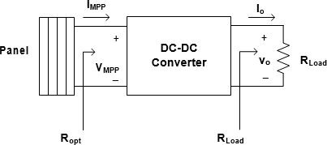If the connection is made between PV array and the load directly with no intermediate then the consequences can be discussed. When the PV array which is directly connected to the load, the two resistances Roptimum or Rpv-internal and RL represent the PV array internal resistance and load resistance respectively. As per the Maximum Power Transfer Theorem, whenever source resistance matches with load resistance, maximum power will get transferred. Now, the problem may arise, where the Roptimum or Rpv-internal of the PV array varies following the temperature and irradiances, Roptimum or Rpv-internal resistances are found to be different. So, the goal is to match the internal resistance or Roptimum or Rpv-internal of the PV array with load resistance RL. So, DC-DC converter carries out these intermediate operations.

Next, the foremost way to increase the efficiency of a solar panel is to use a Maximum Power point Tracker (MPPT), a power electronic device that significantly increases the system efficiency. Maximum Power Point Tracking is electronic tracking - usually digital. The charge controller looks at the output of the panels and compares it to the battery voltage. It then figures out what is the best power that the panel can put out to charge the battery. It takes this and converts it to best voltage to get maximum AMPS into the battery. MPPT operate at very high audio frequencies usually in the 20 to 80 kHz range.

## 1.3 APPLICATION OF SOLAR ENERGY IN LEAD ACID BATTERY

The demand for electric power for industrial purposes is growing rapidly. Many transportation vehicles and uninterruptible power supply (UPS) systems that are used in heavy industries require electric power for their smooth operation. These vehicles and UPS systems are equipped with lead–acid batteries as an alternate source of electric power. In addition, fuel saving strategies that actively utilize the power from these batteries are being considered. Therefore, a reliable battery system is indispensable for effective operation in industry. However, it is to be noted that these batteries are considerably costlier and excessive use could result in their malfunction. Also, the damaged lead–acid batteries can have a negative impact on the environment during the recycling process. It is therefore very important to continuously monitor the development and management of these batteries to preclude undue damage and prolong the life time of the battery.

**1.3.1** WORKING PRINCIPLE OF LEAD ACID BATTERY:

As sulphuric acid is used as an electrolyte in the battery, when it gets dissolved, the molecules in it are dispersed as SO4– (negative ions) and 2H+ (positive ions) and these will have free movement. When these electrodes are dipped in the solutions and provide a DC supply, then the positive ions will have a movement and move towards the direction of the negative edge of the battery. In the same way, the negative ions will have a movement and move towards the direction of the positive edge of the battery.

Every hydrogen and sulphate ions collect one and two-electron and negative ions from the cathode and anode and they have a reaction with water. This forms hydrogen and sulphuric acid. Whereas the developed from the above reactions react with lead oxide and forms lead peroxide. This means at the time of the charging process; the lead cathode element stays as lead itself whereas the lead anode is formed as lead peroxide.

**1.4** ABOUT BATTERY HEALTH MONITORING

Battery Health Monitoring System (BHMS) is used to monitor vital parameters of battery like battery bank voltage, individual cell voltage, cell temperature, ambient temperature, Ah in and Ah out and alert the user if any cell is weak or over charged thus preventive measures can be taken to save individual cells or batteries before it gets damaged. Solar batteries are units that silently charge up during sunny spells, and when the solar panels stop generating electricity, the batteries can discharge energy. Solar battery storage allows you to continue to use the energy that was generated and saved during the sunny period to power your appliances.

Solar battery storage can help to take up the excess power created by panels so that this energy doesn’t go to waste; the battery can then supply the houses with power at night or during cloudy days. For an average building using solar energy, it is unlikely that it will use all of the energy created by solar panels throughout the day. For this instance, battery storage is a way to harness the excess power and use it later to reduce the reliance on retail electricity.

## 1.5 REAL TIME ANALYSIS

Real-time monitoring system for multiple lead–acid batteries based on IoT, suitable for the industrial environment, is proposed and evaluated. The proposed monitoring system procedures and stores the important parameters of the battery in real time. A data acquisition system based on dedicated software and hardware is developed. Inter-integrated circuit, analog to digital converter (ADC), serial communication, TCP/UDP, and universal asynchronous receiver/transmitter (UART) are the protocols used for communication in the proposed system. The main objective of this scheme is to provide credible and valuable lead–acid battery data. From the utility point of view, the proposed system is designed to prevent battery damage caused by overuse, regardless of the low battery capacity; the cost can be further minimized and maintenance of the battery is relatively easier in the proposed system. Further, the data from multiple batteries are also displayed on an android device and are stored in a MySQL server database. A real prototype to devise an end product for the proposed system is developed. In summary, the main contribution can be outlined as follows:

* The real-time monitoring of multiple lead–acid batteries is proposed and evaluated through dedicated software and hardware.
* Further, an android program to display data from the connected battery client is developed and this data is stored in a MySQL server database for mobile and robust monitoring.
* Finally, a real prototype to devise an end product for our proposed system is developed. 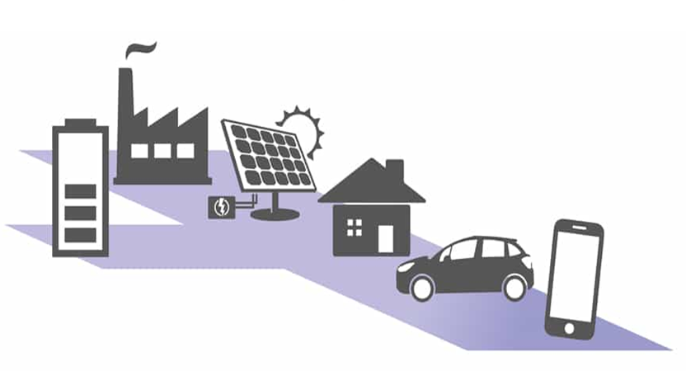

# CHAPTER 2: SYSTEM DESCRIPTION

## 2.1 SYSTEM DESCRIPTION- I

### 2.1.1 BLOCK DIAGRAM

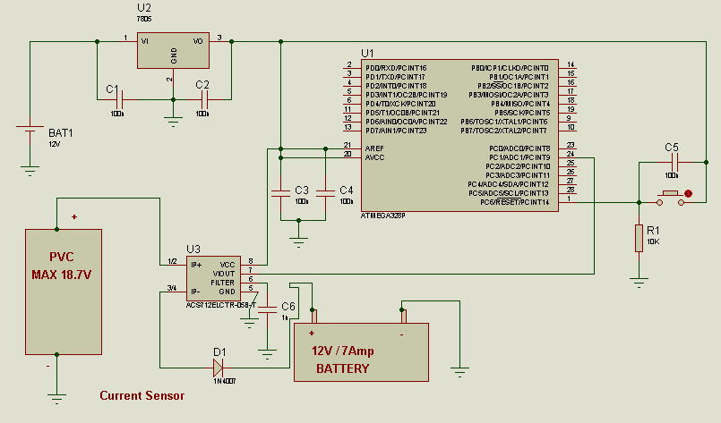

Figure No 2.1: Block Diagram of “Real Time Analysis of a Battery in context with MPPT Charge Controller”

The block diagram of the system is shown in Figure No 2.1 which consists of following major components:

1. Solar panel
2. Battery
3. Maximum Power Point Tracker (MPPT)

A brief theoretical description of each of the system components is given below:

### 2.1.2 THEORY

#### 2.1.2.1 SOLAR PANEL

##### (A) INTRODUCTION TO SOLAR CELL:

Photovoltaic or solar cells, at the present time, furnish one of the most-important long- duration power supplies. This cell is considered a major candidate for obtaining energy from the sun, since it can convert sunlight directly to electricity with high conversion efficiency. It can provide nearly permanent power at low operating cost, and is virtually free of pollution. Since a typical photovoltaic cell produces less than 3 watts at approximately 0.5-volt dc, cells must be connected in series-parallel configurations to produce enough power for high-power applications. Cells are configured into module and modules are connected as arrays. Modules may have peak output powers ranging from a few watts, depending upon the intended application, to more than 300 watts. Typical array output power is in the 100-watt-kilowatt range, although megawatt arrays do exist. Photovoltaic cells, like batteries, generate direct current (DC), which is generally used for small loads (electronic equipment). When DC from photovoltaic cells is used for commercial applications or sold to electric utilities using the electric grid, it must be converted to alternating current (AC) using grid inverters, solid-state 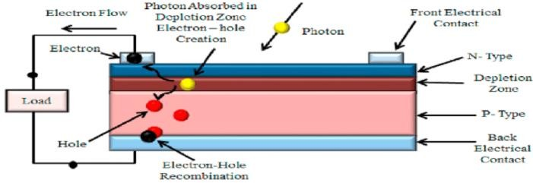devices that convert DC power to AC.

Figure No 2.2: p-n junction of solar cell

##### (B) PHOTOVOLTAIC MODULES AND ARRAYS:

A PV or solar cell is the basic building block of a PV (or solar electric) system. An individual PV cell is usually quite small, typically producing about 1 or 2W of power. To boost the power output of PV cells, they have to be connected together to form larger units called modules. The modules, in turn, can be connected to form larger units called arrays, which can be interconnected to produce more power. By connecting the cells or modules in series, the output voltage can be increased. On the other hand, the output current can reach higher values by connecting the cells or modules in parallel.

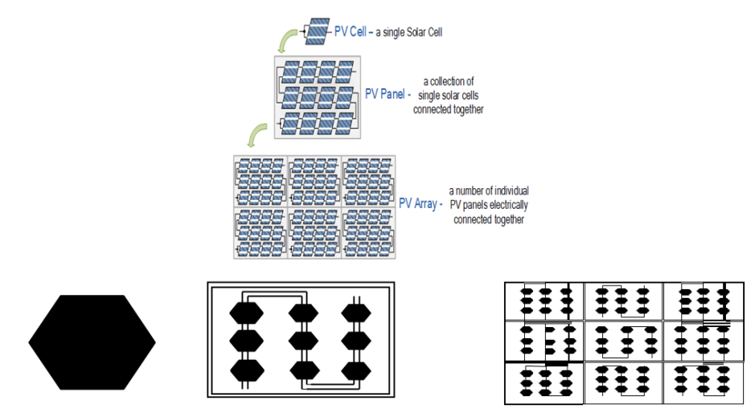

Figure No 2.3: PVcell, PV model, andPV array

PV devices can be made from various types of semiconductor materials, deposited or arranged in various structures. The three main types of materials used for solar cells are silicon, polycrystalline thin films, and single crystalline thin film.

Solar energy systems are typically classified into two systems: Passive and Active system. Passive systems do not involve panel system or other moving mechanisms to produce energy. Active systems typically involve electrical and mechanical components to capture sunlight and process it into usable forms such as heating, lighting and electricity.

##### (C) PHOTOVOLTAIC CELL MODEL:

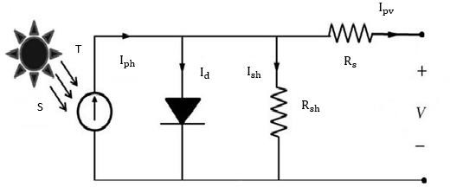The use of equivalent electric circuits (Figure: 2.3) makes it possible to model characteristics of a PV cell. The PV model consists of a current source, a diode and a series resistance. The effect of parallel resistance, represents the leakage resistance of the cell is very small in a single module, thus the model does not include it. The current source represents the current generated by photons, and its output is constant under constant temperature and constant incident radiation of light.

Figure No 2.4: PV cell with equivalent circuit

Current-voltage (I-V) curves are obtained by exposing the cell to a constant level of light, while maintaining a constant cell temperature, varying the resistance of the load, and measuring the produced current. I-V curve typically passes through two points:

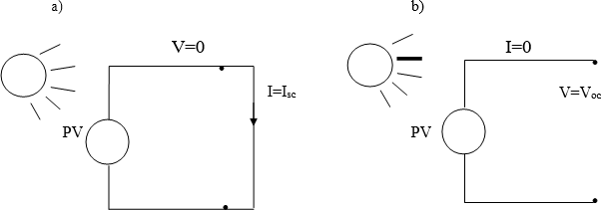Short-circuit current (Isc) is the current produced when the positive and negative terminals of the cell are short-circuited, and the voltage between the terminals is zero, which corresponds to zero load resistance. Figure: 2.5(a). Open-circuit voltage (Voc) is the voltage across the positive and negative terminals under open- circuit conditions, when the current is zero, which corresponds to infinite load resistance. Figure: 2.5(b)

Figure No 2.5(a): short circuit current & 2.5(b): open circuit voltage

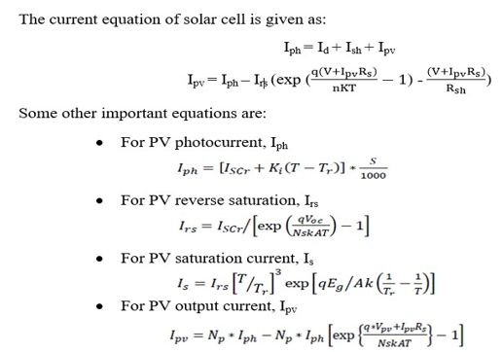

## 2.1 I-V CHARACTERISTICS:

I-V characteristic of a PV panel simulated is shown below in Figure: 2.5. For any given set of operational conditions, cells have a single operating point where the values of the current (I) and Voltage (V) of the cell result in a maximum power output.

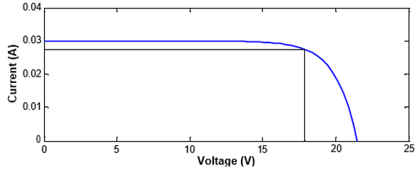

Figure No 2.6: IV characteristics of a PV cell

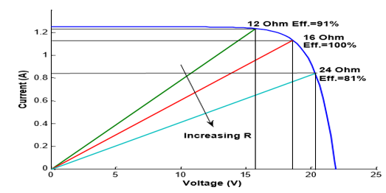

Figure No 2.7: PV characteristics curve for different resistive load

## 2.2 P-V CHARACTERISTICS:

P-VcharacteristicofaPVpanelsimulatedisshownbelowinFigure:2.7.ThepowerPisgiven by P=VI. A plot of panel output power vs. panel voltage is shown in figure: 2.7 which have a peak point indicated by MPP which falls off on both sides. This is known as the maximum power point (MPP) and corresponds to the "knee" of the curve, at which the module operates with the maximum efficiency and produces the maximum outputpower.

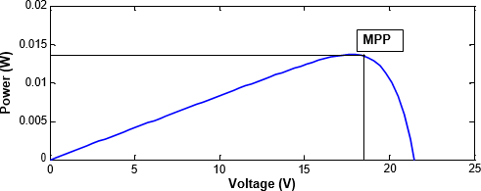

Figure No 2.8: PV characteristics of a PV cell

## 2.3 **EFFECT OF IRRADIANCE ANDTEMPERATURE**

There are two key parameters frequently used to characterize a PV cell. Shorting together the terminals of the cell, the photon generated current will follow out of the cell as a short-circuit current (Isc). When there is no connection to the PV cell (open-circuit), the photon generated current is shunted internally by the intrinsic p-n junction diode. This gives the open circuit voltage (Voc). The PV module or cell manufacturers usually provide the values of these parameters in their datasheet.

### 2.3.1 Effect of irradiance:

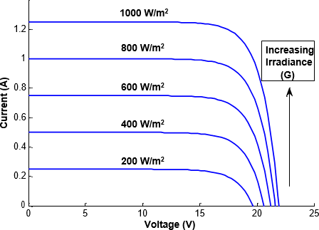

Figure No 2.9: IV curve with different irradiance

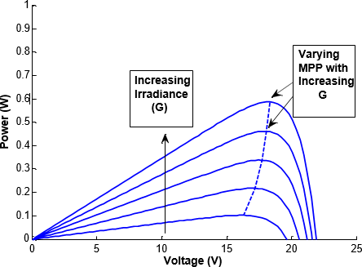

Figure No 2.10: PV curve with different irradiance

For the same irradiance and *p-n* junction temperature conditions, the short circuit current Iscit is the greatest value of the current generated by the cell. The short circuit current Iscis given by:



For the same irradiance and *p-n* junction temperature conditions, the open circuit voltage Vocis the greatest value of the voltage at the cell terminals. The open circuit voltage Vocis given by:



This is how the curve is obtained in Figure2.8.The PVcell output is both limited by the cell current and the cell voltage, and it can only produce a power with any combinations of current and voltage on the I-V curve. As in Figure: 2.9 the P-V curve shifts with different irradiance so the MPP also shifts. Now, as the I-V curve of a PV cell changes with different irradiance so it reveals that the amount of power produced by the PV module varies greatly depending on its irradiance. It is important to operate the system at the MPP of PV module in order to exploit the maximum power from themodule.

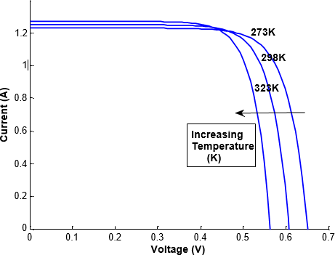2.3.2 Effect of temperature**:**

Figure No 2.11: IV curve with different temperature

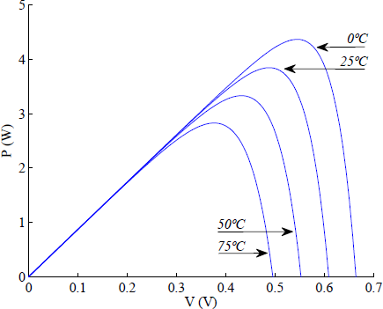

Figure No 2.12: PV curve with different irradiance

Like all other semiconductor devices, solar cells are sensitive to temperature. Increases in temperature reduce the bandgap of a semiconductor, thereby affecting most of the semiconductor material parameters. The decrease in the band gap of a semiconductor with increasing temperature can be viewed as increasing the energy of the electrons in the material. Lower energy is therefore needed to break the bond. In the bond model of a semiconductor bandgap, a reduction in the bond energy also reduces the bandgap. Therefore, increasing the temperature reduces the bandgap.

In a solar cell, the parameter most affected by an increase in temperature is the open-circuit voltage. With the increase of temperature, the I-V characteristics of a PV cell shifts toward lefts and so the MPP decreases with increase in temperature.

Because of the photovoltaic nature of solar panels, their current-voltage, or IV, curves depend on temperature and irradiance levels. Therefore, the operating current and voltage which maximize power output will change with environmental conditions. Hence, Figure 2.11 and figure 2.12 shows the required results.

Therefore, the MPP needs to be located by a tracking algorithm, which is the heart of MPPT controller. MPPT algorithm tells controller how to move the operating voltage. Then, it is a MPPT controller’s task to bring the voltage to a desired level and maintain it. To obtain a stable voltage from an input supply (PV cells) that is higher and lower than the output, a high efficiency and minimum ripple DC-DC converter required in the system.

#### 2.1.2.2BATTERY

In stand-alone photovoltaic system, the electrical energy produced by the PV array cannot always be used when it is produced because the demand for energy does not always coincide with its production. Electrical storage batteries are commonly used in PV system. The primary functions of a storage battery in a PV system are:

* Energy Storage Capacity and Autonomy: to store electrical energy when it is produced by the PV array and to supply energy to electrical loads as needed or on demand.
* Voltage and Current Stabilization: to supply power to electrical loads at stable voltages and currents, by suppressing or smoothing out transients that may occur in PV system.
* Supply Surge Currents: to supply surge or high peak operating currents to electrical loads or appliances.

Here, in this project Lead –Acid Batteries are used.

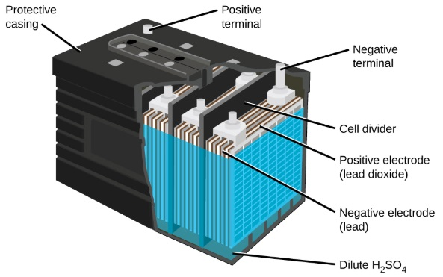

Figure No 2.13: Lead Acid Battery

The Lead-acid battery is one of the oldest types of rechargeable batteries. These batteries were invented in the year 1859 by the French physicist Gaston Plante.

Despite having a small energy-to-volume ratio and a very low energy-to-weight ratio, its ability to supply high surge contents reveals that the cells have a relatively large power-to-weight ratio. Lead-acid batteries can be classified as secondary batteries. The chemical reactions that occur in secondary cells are reversible. The reactants that generate an electric current in these batteries (via chemical reactions) can be regenerated by passing current through the battery (recharging). The chemical process of extracting current from a secondary battery (forward reaction) is called discharging. The method of regenerating active material is called charging.

**(A) WORKING OF LEAD ACID BATTERY:**The storage battery or secondary battery is such a battery where electrical energy can be stored as chemical energy and this chemical energy is then converted to electrical energy as and when required. The conversion of electrical energy into chemical energy by applying an external electrical source is known as charging of batteries. Whereas conversion of chemical energy into electrical energy for supplying the external load is known as discharging of secondary batteries.

During charging of the battery, current is passed through it which causes some chemical changes inside the battery. These chemical changes absorb energy during their formation.

When the battery is connected to the external load, the chemical changes take place in reverse direction, during which the absorbed energy is released as electrical energy and supplied to the load. Now the principle working of lead acid batteries is studies and for that first about the lead acid batteries are discussed which is very commonly used as storage batteries or secondary batteries.

**(B) MATERIALS USED FOR LEAD ACID BATTERY CELLS:** The main active materials required to construct a lead acid battery are:

* Lead peroxide (PbO2): The positive plate is made of lead peroxide. This is a dark brown, hard and brittle substance.
* Sponge lead (Pb): The negative plate is made of pure lead in soft sponge condition.
* Dilute sulfuric acid (H2SO4): Dilute sulfuric acid used for lead acid battery has a ratio of water : acid = 3:1

The lead acid storage battery is formed by dipping lead peroxide plate and sponge lead plate in dilute sulfuric acid. A load is connected externally between these plates. In diluted sulfuric acid the molecules of the acid split into positive hydrogen ions (H+) and negative sulphate ions (SO4 − −). The hydrogen ions when they reach the PbO2 plate, they receive electrons from it and become hydrogen atoms which again attack PbO2 and form PbO and H2O (water). This PbO reacts with H2SO4 and forms PbSO4 and H2O (water).

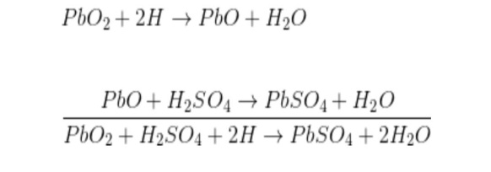

SO4 − − ions are moving freely in the solution so some of them will reach to pure Pb plate where they give their extra electrons and become radical SO4. As the radical SO4 cannot exist alone it will attack Pb and will form PbSO4.

As H+ ions take electrons from PbO2 plate and SO4 − − ions give electrons to Pb plate, there would be an inequality of electrons between these two plates. Hence there would be a flow of current through the external load between these plates for balancing this inequality of electrons. This process is called discharging of lead acid batteries.

The lead sulphate (PbSO4) is whitish in colour. During discharging,

* Both of the plates are covered with PbSO4.
* Specific gravity of sulfuric acid solution falls due to formation of water during reaction at PbO2 plate.
* As a result, the rate of reaction falls which implies the potential difference between the plates decreases during the discharging process.

Now the load is disconnected and PbSO4 covered with PbO2 plate with positive terminal of an external DC source and PbO2 covered with Pb plate with negative terminal of that DC source is connected. During discharging, the density of sulfuric acid falls but there still sulfuric acid exists in the solution. This sulfuric acid also remains as H+ and SO4− − ions in the solution. Hydrogen ions (cation) being positively charged, move to the electrode (cathode) connected with the negative terminal of the DC source. Here each H+ ion takes one electron from that and becomes a hydrogen atom. These hydrogen atoms then attack PbSO4 and form lead and sulfuric acid.

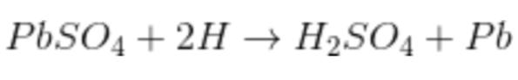

SO4− − ions (anions) move towards the electrode (anode) connected with the positive terminal of the DC source where they will give up their extra electrons and become radical SO4. This radical SO4 cannot exist alone hence reacts with PbSO4 of anode and forms lead peroxide (PbO2) and sulfuric acid (H2SO4).

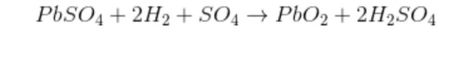

Hence by charging the lead acid storage battery cell,

* Lead sulphate anode gets converted into lead peroxide.
* Lead sulphate of cathode is converted to pure lead.
* Terminal; potential of the cell increases.
* Specific gravity of sulfuric acid increases

**(C)CHARGE CONTROLLER:**

A charge controller or charge regulator limits the rate at which electric current is added to or drawn from electric batteries. It prevents overcharging and may prevent against overvoltage, which can reduce battery performance or lifespan, and may pose a safety risk. It may also prevent completely draining ("deep discharging") a battery, or perform controlled discharges, depending on the battery technology, to protect battery life. In simple words, Solar Charge controller is a device, which controls the battery charging from solar cell and also controls the battery drain by load. The simple Solar Charge controller checks the battery whether it requires charging and if yes it checks the availability of solar power and starts charging the battery. Whenever controller found that the battery has reached the full charging voltage levels, it then stops the charging from solar cell. On the other hand, when it found no solar power available then it assumes that it is night time and switch on the load. It keeps on the load until the battery reached to its minimum voltage levels to prevent the battery dip-discharge. Simultaneously Charge controller also gives the indications like battery dip- discharge, load on, charging on etc.

In this project, microcontroller-based charge controller is used. Microcontroller is a kind of miniature computer containing a processor core, memory, and programmable input/output peripherals. The Functions of a microcontroller in charge controller are:

* Measures Solar Cell Voltage.
* Measures Battery Voltage.
* Decides when to start battery charging.
* Decides when to stop battery charging.
* Decides when to switch on the load.
* Decides when to switch odd the load.

Most importantly in this project, microcontroller also tracks the MPP of the output power.

#### 2.1.2.3 Maximum Power Point Tracker (MPPT)

In a (Power-Voltage or current-voltage) curve of a solar panel, there is an optimum operating point such that the PV delivers the maximum possible power to the load. This unique point is the maximum power point (MPP) of solar panel. Because of the photovoltaic nature of solar panels, their current-voltage, or IV, curves depend on temperature and irradiance levels. Therefore, the operating current and voltage which maximize power output will change with environmental conditions. As the optimum point changes with the natural conditions so it is very important to track the maximum power point (MPP) for a successful PV system. So in PV systems a maximum power point tracker (MPPT) is very much needed. In most PV systems a control algorithm, namely maximum power point tracking algorithm is utilized to have the full advantage of the PV systems.

##### (A) PV PANEL WITH MPPT IMPLEMENTATION

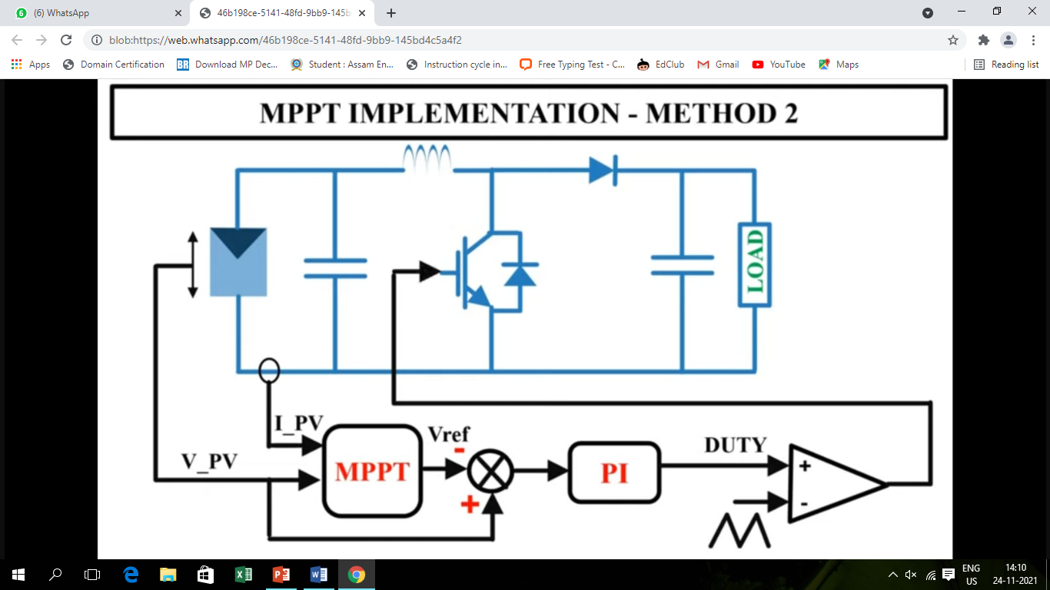

Figure No 2.14: MPPT Implementation

The power generation of the PV Panel is tracked by P&O MPPT technique using DC-DC Boost converter. Both the voltage and current of the PV panel is sensed and the signals are sent to the MPPT algorithm, in which it will generate the required duty ratio according to power and voltage variations. The variation of the voltage i.e. previous and present values of voltage is computed Vold - Vnew. In other words, the voltage reference is compared to the PV voltage to find the error and this particular error is then fed to the PI controller. The output of the controller will give the required duty cycle for the PWM generation and finally, the value is then compared with the carrier signal and given to the gate terminal of the IGBT. This will provide us better MPPT tracking performance since it has a close look mechanism. Also, the power difference is computed by Pold - Pnew.

##### (B)MAXIMUM POWER POINT TRACKING (MPPT):

MPPT stands for maximum power point tracking which is used to extract maximum solar energy. That is, the I-V curve of a solar panel shows a nonlinear distribution of power as it forms different knee points and distribution for different sunlight conditions. So, the basic goal of MPPT is to track the maximum power point or knee point in changing sun conditions.

The load with resistance R=V/I, which is equal to the reciprocal of this value and draws the maximum power from the device is sometimes called the characteristic resistance of the cell. This is a dynamic quantity which changes depending on the level of illumination, as well as other factors such as temperature and the age of the cell. If the resistance is lower or higher than this value, the power drawn will be less than the maximum available, and thus the cell will not be used as efficiently as it could be. Maximum power point trackers utilize different types of control circuit or logic to search for this point and thus to allow the converter circuit to extract the maximum power available from a cell. MPPT thus tracks the voltage and current in order to draw maximum available power from the solar panel so that it can be used further. There are mainly two types of solar charge controllers:

* One is MPPT and
* The other one is the PWM charge controller.

**(**C ) METHODS OF MPPT ALGORITHMS:

Maximum Power Point Tracking (MPPT) is used to obtain the maximum power from these systems. In these applications, the load can demand more power than the PV system can deliver. There are many different approaches to maximizing the power from a PV system, this range from using simple voltage relationships to more complexes multiple sample based analysis. There are some conventional methods for MPPT. Seven of them are listed here. These methods include:

* Constant Voltage method
* Open Circuit Voltage method
* Short Circuit Current method
* Perturb and Observe method
* Incremental Conductance method
* Temperature method
* Temperature Parametric method

For this project Perturb and Observe (P&O) Method is used.

##### (D) PERTURB AND OBSERVE (P&O) METHOD:

In the Perturb and Observe method, the power is measured by change in the voltage by a diminutive amount from the array by the controller. If in case, the power increases, adjustments are tried to be done in that particular direction until the power ceases to increase. This is known as the Perturb and Observe method. This method can result in an increase in the oscillations of power output, but still it is the most commonly used method. Since this method depends upon the rise in the power curve against voltage below its maximum power point and the fall which is above that particular point, this is referred to as the Hill Climbing Method. This algorithm of Perturb and Observe (P&O) increases or decreases the output terminal voltage of the Photovoltaic Cell periodically and then it simultaneously compares the power obtained in the current cycle with the power obtained in the previous cycle. If the power is comparatively more than the previous value, then it indicates that it has moved the operating point closer to the maximum power point (MPP). Thus, further voltage perturbations if in the same direction, should move the operating point, even closer to the MPP. If the power decreases, the operating point moves away from the Maximum Power Point (MPP), and the direction of the perturbation has to be changed and reversed to move back towards the MPP.

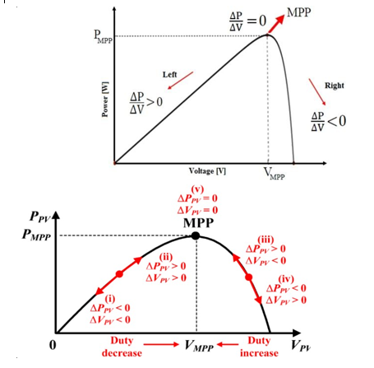

Figure No 2.15: Graph of output power using P&O algorithm

The flowchart of this algorithm is given by:

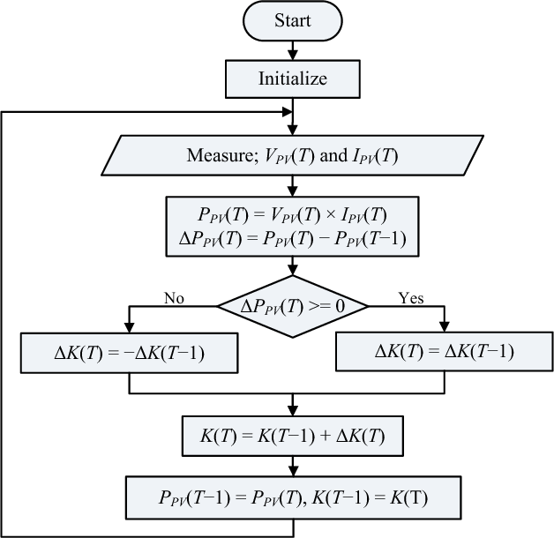

Figure No 2.16: P&O algorithm flow chat

Here the chart of P&O method’s efficiency during several conditions

Table No 2.1: P&O method’s efficiency

|  |  |  |
| --- | --- | --- |
| **SKY CONDITIONS** | **DAYS OF DATA** | **MPPT** |
| Clear | 20 | 98.7 |
| Partially cloudy | 14 | 96.5 |
| Cloudy | 09 | 98.1 |
| Overall | 43 | 97.8 |
| TOTAL |  | 99.3 |

##### (E ) CONTROL TECHNIQUE:

As explained in the previous section, the MPPT algorithm tells a MPPT controller how to move the operating voltage. Then, it is a MPPT controller’s task to bring the voltage to a desired level and maintain it. There are several methods often used for MPPT.

* PI control: MPPT takes measurement of PV voltage and current, and then tracking algorithm calculates the reference voltage (Vref) where the PV operating voltage should move next. The task of MPPT algorithm is to set Vref only, and it is repeated periodically with a slower rate (typically 1~10) samples per second).
* Direct control: This control method is simpler and uses only one control loop, and it performs the adjustment of duty cycle within the MPP tracking algorithm. The way how to adjust the duty cycle is totally based on the theory of load matching.
* Output sensing control: The system usually requires another set of sensors for the output to detect the over voltage and over-current condition of load. This output sensing method measures the power change of PV at the output side of converter and uses the duty cycle as a control variable. This control method employs the P&O algorithm to locate the MPP.

To obtain a stable voltage from an input supply (PV cells) that is higher and lower than the output, a high efficiency and minimum ripple DC-DC converter required in the system for residential power production. The MPPT algorithm drives the converter so that it can draw the maximum power always.

## 2.2SYSTEM DESCRIPTION- II

### 2.2.1 MAIN CIRCUIT DIAGRAM

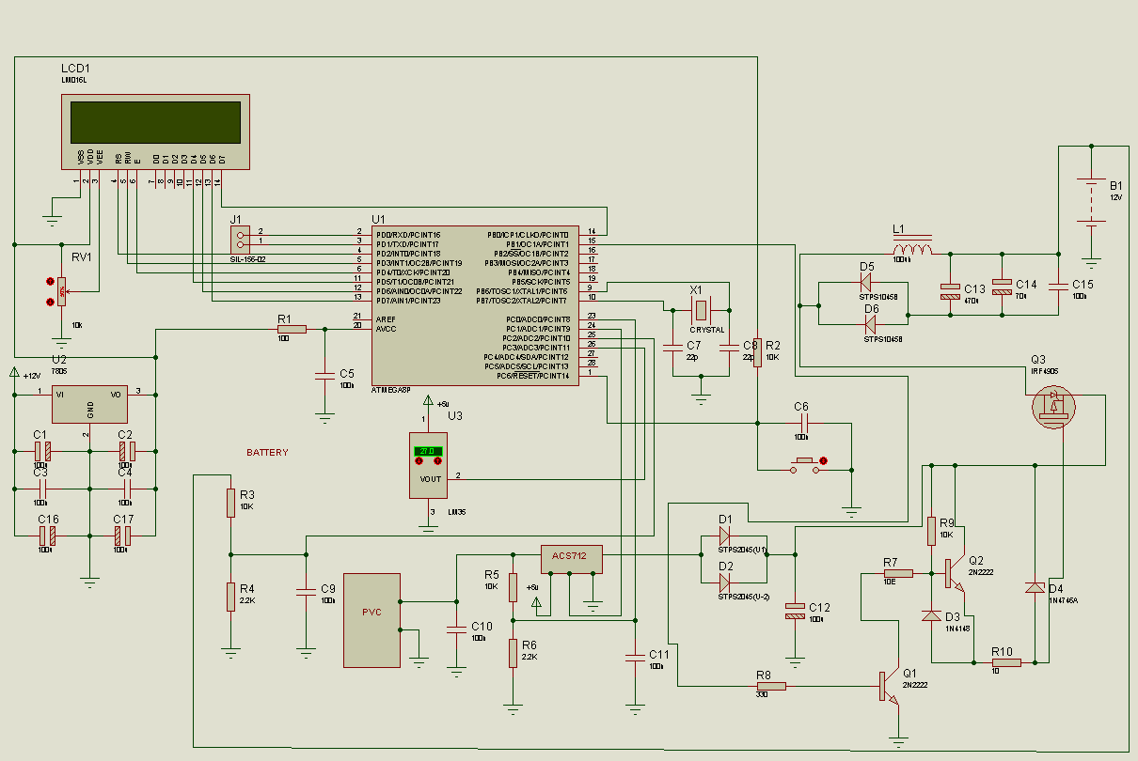

Figure No 2.17: Main circuit diagram

### 2.2.2 BASIC COMPONENTS USED:

Some basic components used other than solar panel and battery, are briefly mentioned and discussed below:

* Voltage Regulator (LM7805)
* Current Sensor (ACS712)
* Arduino Nano
* 16x2 LCD
* P-n-p Power MOSFET
* Diodes
* Capacitors
* Induction Coil

### 2.2.3 BASIC WORKING:

The microcontroller is solely responsible for calculating the voltage level of the solar plate from Vout. That means the Vout using ADC has to be calculated or measured and then the Vout is mapped to Vin. This is how Vin is calculated. Then 7085 is responsible for providing regulated +5V and this is used only for the power supply, nothing else. This has 3 terminals, 1-input, 2-ground, 3-output. Pin no 1 can be supplied from 5V to 18V. All commons are single ground. The output of pin no 3 is regulated output. With respect to the input voltage at pin no 1, the output voltage at pin no 3 is always 5V theoretically. But practically, it could be 4.9V to 5.1V which is enough to run the circuit without any failure.

Then a current sensor is used, which is responsible for calculating the flow of current from the solar plate. But when a current sensor is used, it returns a voltage to the ADC. Now there are three variants, 5amp, 20amp and 30amp. For 5amp, the sensitivity ratio or factor is 185. But here 20amp is used so the sensitivity factor is 100. Header is used to provide power supply to any external circuit The two diodes inbuilt in a single chip. The main objective is to provide more current to pass through those diodes. The Power MOSFET (PNP MOSFET) which is responsible for charging the battery by allowing the current to flow through the battery. But when the MOSFET is used, it has to be triggered. And to trigger this MOSFET a 2N2222 switching transistor of type npn is used. And the second transistor is actually triggered by the first transistor. Next, an inductance coil is used to stop the reversal flow of current. If this coil is not used, the circuit will work properly but will be more prone to damage

# CHAPTER 3: TECHNOLOGIES USED

3.1 MATLAB INTRODUCTION**:**

MATLAB is a high-performance language for technical computing. It integrates computation, visualization, and programming in an easy-to-use environment where problems and solutions are expressed in familiar mathematical notation. Typical uses include:

* Math and computation
* Algorithm development
* Modelling, simulation, and prototyping
* Data analysis, exploration, and visualization
* Scientific and engineering graphics
* Application development, including Graphical User Interface building

MATLAB is an interactive system whose basic data element is an array that does not require dimensioning. This allows us to solve many technical computing problems, especially those with matrix and vector formulations, in a fraction of the time it would take to write a program in a scalar non-interactive language such as C or FORTRAN. The name MATLAB stands for matrix laboratory. MATLAB was originally written to provide easy access to matrix software developed by the LINPACK and EISPACK projects, which together represent the state-of-the-art in software for matrix computation.

MATLAB has evolved over a period of years with input from many users. In university environments, it is the standard instructional tool for introductory and advanced courses in mathematics, engineering, and science. In industry, MATLAB is the tool of choice for high- productivity research, development, and analysis. It features a family of application-specific solutions called toolboxes. Very important to most users of MATLAB, toolboxes allow us to *learn* and *apply* specialized technology. Toolboxes are comprehensive collections of MATLAB functions (M-files) that extend the MATLAB environment to solve particular classes of problems. Areas in which toolboxes are available include signal processing, control systems, neural networks, fuzzy logic, wavelets, simulation, and many others.

## 3.2 SIMULINK INTRODUCTION:

Simulink, an add-on product to MATLAB, provides an interactive, graphical environment for modelling, simulating, and analysing of dynamic systems. It enables rapid construction of virtual prototypes to explore design concepts at any level of detail with minimal effort. For modelling, Simulink provides a graphical user interface (GUI) for building models as block diagrams. It includes a comprehensive library of predefined blocks to be used to construct graphical models of systems using drag-and-drop mouse operations. The user is able to produce an “up-and-running” model that would otherwise require hours to build in the laboratory environment. It supports linear and nonlinear systems, modelled in continuous-time, sampled time, or hybrid of the two. Since students learn efficiently with frequent feedback, the interactive nature of Simulink encourages you to try things out, you can change parameters “on the fly” and immediately see what happens, for “what if” exploration. Lastly, and not the least, Simulink is integrated with MATLAB and data can be easily shared between the program.

## 3.3 PROTEUS:

The Proteus Design Suite is a proprietary software tool suite used primarily for electronic design automation. The software is used mainly by electronic design engineers and technicians to create schematics and electronic prints for manufacturing printed circuit boards.

The first version of what is now the Proteus Design Suite was called PC-B and was written by the company chairman, John Jameson, for DOS in 1988. Schematic Capture support followed in 1990, with a port to the Windows environment shortly thereafter. Mixed mode SPICE Simulation was first integrated into Proteus in 1996 and microcontroller simulation then arrived in Proteus in 1998. Shape based autorouting was added in 2002 and 2006 saw another major product update with 3D Board Visualisation. More recently, a dedicated IDE for simulation was added in 2011 and MCAD import/export was included in 2015. Support for high speed design was added in 2017. [1] Feature led product releases are typically biannual, while maintenance-based service packs are released as it is required.

The Proteus Design Suite is a Windows application for schematic capture, simulation, and PCB (Printed Circuit Board) layout design. It can be purchased in many configurations, depending on the size of designs being produced and the requirements for microcontroller simulation. All PCB Design products include an autorouter and basic mixed mode SPICE simulation capabilities.

* Schematic Capture: Schematic capture in the Proteus Design Suite is used for both the simulation of designs and as the design phase of a PCB layout project. It is therefore a core component and is included with all product configurations.
* Microcontroller Simulation: The micro-controller simulation in Proteus works by applying either a hex file or a debug file to the microcontroller part on the schematic. It is then co-simulated along with any analog and digital electronics connected to it. This enables its use in a broad spectrum of project prototyping in areas such as motor control, temperature control and user interface design. It also finds use in the general hobbyist community and, since no hardware is required, is convenient to use as a training or teaching tool. Support is available for co-simulation of:
  + Microchip Technologies PIC10, PIC12, PIC16, PIC18, PIC24, dsPIC33 microcontrollers
  + Atmel AVR (and Arduino), 8051 and ARM Cortex-M3 microcontrollers
  + NXP 8051, ARM7, ARM Cortex-M0 and ARM Cortex-M3 microcontrollers
  + Texas Instruments MSP430, PICCOLO DSP and ARM Cortex-M3 microcontrollers
  + Parallax Basic Stamp, Freescale HC11, 8086 microcontrollers
* PCB Design: The PCB Layout module is automatically given connectivity information in the form of a netlist from the schematic capture module. It applies this information, together with the user specified design rules and various design automation tools, to assist with error free board design. PCB's of up to 16 copper layers can be produced with design size limited by product configuration.
* 3D Verification: The 3D Viewer module allows the board under development to be viewed in 3D together with a semi-transparent height plane that represents the boards enclosure. STEP output can then be used to transfer to mechanical CAD software such as Solid works or Autodesk for accurate mounting and positioning of the board.

## 3.4 ARDUINO IDE:

The ARDUINO IDE is a part ARDUINO Project started by MASIMO BANZI, ARDUINO is not only a hardware, or software, ARDUINO is an integrated system that include Hardware, IDE, Project as well as a community. The ARDUINO make it easier for the new comer and the hobbyist who is having limited knowledge of technical background. Because of ARDUINO people from different field of Engineering are successfully designing and implementing the power of electronics and embedded system. With the improvement of ARDUINO IDE and different hardware platform it become popular among the IT and CS students. Before ARDUINO Embedded system was a complicated system for both CS and Electronics students. Where Electronics student do not have proper programming knowledge, the CS/IT student was not having proper knowledge of Electronics circuit and sensors. The ARDUINO minimize the gap between these two distinct faculties.

The Arduino Integrated Development Environment is a cross-platform IDE designed for Arduino microcontrollers. The IDE uses a combination of the C standard library and C++. It is used to write and upload programs to Arduino compatible boards, but also, with the help of third-party cores, other vendor development boards.

The source code for the IDE is released under the GNU General Public License, version 2. The Arduino IDE supports the languages C and C++ using special rules of code structuring. The Arduino IDE supplies a software library from the Wiring project, which provides many common input and output procedures. User-written code only requires two basic functions, for starting the sketch and the main program loop, that are compiled and linked with a program stub main() into an executable cyclic executive program with the GNU toolchain, also included with the IDE distribution. The Arduino IDE employs the program avrdude to convert the executable code into a text file in hexadecimal encoding that is loaded into the Arduino board by a loader program in the board's firmware. By default, avrdude is used as the uploading tool to flash the user code onto official Arduino boards.

Arduino IDE is a derivative of the Processing IDE, however as of version 2.0, the Processing IDE will be replaced with the Visual Studio Code-based Eclipse Theia IDE framework.

With the rising popularity of Arduino as a software platform, other vendors started to implement custom open-source compilers and tools (cores) that can build and upload sketches to other microcontrollers that are not supported by Arduino's official line of microcontrollers.

In October 2019, the Arduino organization began providing early access to a new Arduino Pro IDE with debugging and other advanced features.

## 3.5 VISUAL BASIC:

Visual Basic (VB) is an event-driven programming language and environment from Microsoft that provides a graphical user interface (GUI) which allows programmers to modify code by simply dragging and dropping objects and defining their behavior and appearance. VB is derived from the BASIC programming language and is considered to be event-driven and object-oriented. VB is intended to be easy to learn and fast to write code with; as a result, it is sometimes called a rapid application development (RAD) system and is used to prototype an application that will later be written in a more difficult but efficient language.

The last version of VB, Visual Basic 6, was released in 1998, but has since been replaced by VB .NET, Visual Basic for applications (VBA) and Visual Stuido .NET. VBA and Visual Studio are the two frameworks most commonly used today.

### 3.5.1. History of Visual Basic:

Visual Basic was first introduced in 1991; it is considered the third generation of event-driven programming languages. Various Windows programs were developed throughout the 1990s using VB.

VB continued to evolve throughout the 1990s until Visual Basic 6 was released in 1998, which was replaced by VB .NET. However, Visual Basic for Applications, which is most commonly used today to automate Microsoft Office tasks, is highly compatible with the classic VB 6.

### 3.5.2 Visual Basic features and characteristics:

VB is a GUI-based development tool that offers a faster RAD than most other programming languages. VB also features syntax that is more straightforward than other languages, a visual environment that is easy to understand and high database connectivity.

Visual Basic was designed to be a complete programming language that contained ordinary features, such as string processing and computation. The visual environment is characterized by a drag-and-drop feature which allows programmers to build a user interface that is easy to use, even for developers with minimum experience.

While these features of VB are advantageous, there are others that can have a negative effect. The VB programming environment requires a large amount of memory, both for the initial installation and to run efficiently afterwards. The graphical features of the programming tool take up a large amount of space and require a significant amount of memory.

Furthermore, Visual Basic is not useful when developing programs that require a lot of processing time, like games, and the use of VB is restricted to Microsoft operating systems (OS).

Finally, with C languages, programmers can feasibly locate and use the defined values for variable data in a computer program at declaration time. This initialization practice is something that isn't easily done with VB.

### 3.5.3 How Visual Basic is used:

The structure of VB is designed to allow programmers to use the environment to write executable files (exe files). Also, using VB, developers can create programs that can be utilized as a front end to databases. VB tools can help programmers develop applications or complete software while still allowing them to modify and revise their work accordingly.

The most popular type of Visual Basic in use today is VBA. VBA is a version of Visual Basic that can be used to program Microsoft Office apps, such as Excel and PowerPoint. However, it can only be used to modify existing apps; VBA cannot be used to create new apps.

Typical users engage VBA to make repeated, everyday tasks less monotonous through the use of macros. Macros automate almost any activity -- such as performing word and data processing or generating custom charts and tables. For example, a typical user might write a macro that allows them to create and fill a spreadsheet with a single click. Computer professionals use VBA and macros in more complicated ways. Programmers will often write macros that can replicate large portions of code or define specific languages.

Businesses and organizations can use VBA to customize Excel for their unique purposes, such as pulling certain statistics or information from a spreadsheet. Businesses and organizations can also use VBA externally, or in non-Microsoft applications, by applying a technology called a component object model (COM) interface that enables commands to communicate across computer boundaries. This allows VBA to be used on an enterprise-specific application.

### 3.5.4 Benefits of Visual Basic:

The BASIC programming language, which VB is derived from, is simple and easy to work with, especially when writing exe files.

However, VB becomes extremely beneficial when used with Microsoft's COM interface. The COM components can be written in various languages and then integrated using VB. Additionally, VB provides not only a programming language, but an integrated development environment (IDE) that has been written and optimized to best support RAD. This allows programmers to easily build GUIs and connect them to functions within the application.

Furthermore, the Visual Basic IDE provides views of the management of the program structure that are easy to understand.

Overall, VB enables the rapid development of Windows based applications while also assisting in the access of databases by using ActiveX data objects (ADO) while allowing programmers to use ActiveX control and various objects.

## 3.6 PULSE WIDTH MODULATION:

A Pulse Width Modulation (PWM) Signal is a method for generating an analog signal using a digital source. A PWM signal consists of two main components that define its behaviour: a duty cycle and a frequency. The duty cycle describes the amount of time the signal is in a high (on) state as a percentage of the total time it takes to complete one cycle. The frequency determines how fast the PWM completes a cycle (i.e., 1000 Hz would be 1000 cycles per second), and therefore how fast it switches between high and low states. By cycling a digital signal off and on at a fast enough rate, and with a certain duty cycle, the output will appear to behave like a constant voltage analog signal when providing power to devices.

Below are some graphs demonstrating PWM signals with different duty cycles:

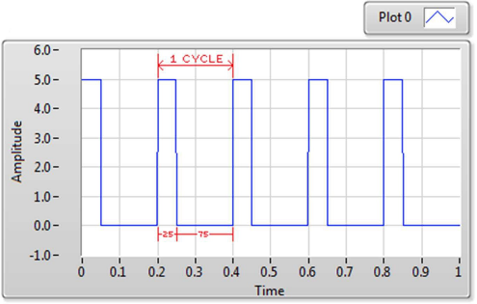

Figure No 3.1: 25% duty cycle

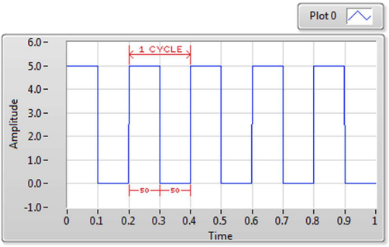

Figure No 3.2: 50% duty cycle

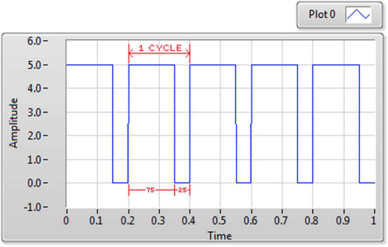

Figure No 3.3: 75% duty cycle

The rate (or frequency) at which the power supply must switch can vary greatly depending on load and application. For example, switching has to be done several times a minute in an electric stove; 120 Hz in a lamp dimmer; between a few kilohertz (kHz) and tens of kHz for a motor drive; and well into the tens or hundreds of kHz in audio amplifiers and computer power supplies. The main advantage of PWM is that power loss in the switching devices is very low. When a switch is off there is practically no current, and when it is on and power is being transferred to the load, there is almost no voltage drop across the switch. Power loss, being the product of voltage and current, is thus in both cases close to zero. PWM also works well with digital controls, which, because of their on/off nature, can easily set the needed duty cycle.

PWM has also been used in certain communication systems where its duty cycle has been used to convey information over a communications channel.

## 3.7 SERIAL COMMUNICATION:

Data transmission refers to the process of transferring data between two or more digital devices. Data is transmitted from one device to another in analog or digital format. Basically, data transmission enables devices or components within devices to speak to each other.

Data is transferred in the form of bits between two or more digital devices. There are two methods used to transmit data between digital devices: serial transmission and parallel transmission. Serial data transmission sends data bits one after another over a single channel. Parallel data transmission sends multiple data bits at the same time over multiple channels.

### 3.7.1 Types of serial communication:

When data is sent or received using serial data transmission, the data bits are organized in a specific order, since they can only be sent one after another. The order of the data bits is important as it dictates how the transmission is organized when it is received. It is viewed as a reliable data transmission method because a data bit is only sent if the previous data bit has already been received.

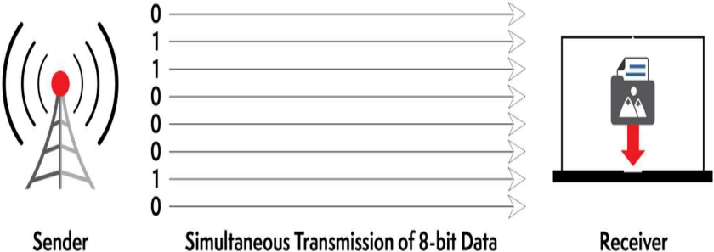

Figure No 3.4: Transmission of 8-bit Data

**Asynchronous Serial Transmission:**

Data bits can be sent at any point in time. Stop bits and start bits are used between data bytes to synchronize the transmitter and receiver and to ensure that the data is transmitted correctly.

The time between sending and receiving data bits is not constant, so gaps are used to provide time between transmissions.

The advantage of using this method is that no clock synchronisation is required between the transmitter and receiver devices. It is also a more cost-effective method. A disadvantage is that data transmission can be slower, but this is not always the case.

**Synchronous Serial Transmission:**

Data bits are transmitted as a continuous stream in time with a master clock. The data transmitter and receiver both operate using a synchronized clock frequency; therefore, start bits, stop bits, and gaps are not used. This means that data moves faster and timing errors are less frequent because the transmitter and receiver time is synced. However, data accuracy is highly dependent on timing being synced correctly between devices. In comparison with asynchronous serial transmission, this method is usually more expensive.

### 3.7.2 UART

UART takes bytes of data and transmits the individual bits in a sequential fashion. At the destination, a second UART re-assembles the bits into complete bytes. Each UART contains a shift register, which is the fundamental method of conversion between serial and parallel forms. Serial transmission of digital information (bits) through a single wire or other medium is less costly than parallel transmission through multiple wires.

The UART usually does not directly generate or receive the external signals used between different items of equipment. Separate interface devices are used to convert the logic level signals of the UART to and from the external signalling levels, which may be standardized voltage levels, current levels, or other signals.

Communication may be simplex (in one direction only, with no provision for the receiving device to send information back to the transmitting device), full duplex (both devices send and receive at the same time) or half duplex (devices take turns transmitting and receiving).

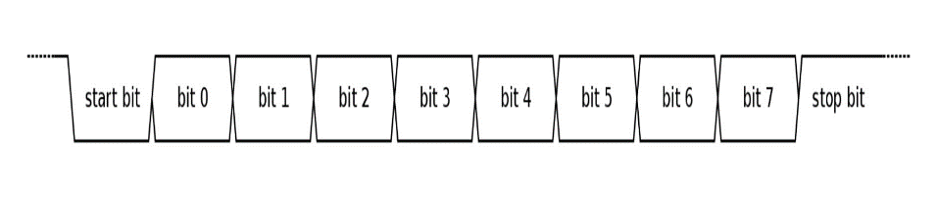

Figure No 3.5: Data Transmission in UART

A UART usually contains the following components:

* a clock generator, usually a multiple of the bit rate to allow sampling in the middle of a bit period
* input and output shift registers
* transmit/receive control
* read/write control logic
* transmit/receive buffers (optional)
* system data bus buffer (optional)
* First-in, first-out (FIFO) buffer memory (optional)
* Signals needed by a third-party DMA controller (optional)
* Integrated bus mastering DMA controller (optional)

**Receiver:**

All operations of the UART hardware are controlled by an internal clock signal which runs at a multiple of the data rate, typically 8 or 16 times the bit rate. The receiver tests the state of the incoming signal on each clock pulse, looking for the beginning of the start bit. If the apparent start bit lasts at least one-half of the bit time, it is valid and signals the start of a new character. If not, it is considered a spurious pulse and is ignored. After waiting a further bit time, the state of the line is again sampled and the resulting level clocked into a shift register. After the required number of bit periods for the character length (5 to 8 bits, typically) have elapsed, the contents of the shift register are made available (in parallel fashion) to the receiving system. The UART will set a flag indicating new data is available, and may also generate a processor interrupt to request that the host processor transfers the received data.

**Transmitter:**

Transmission operation is simpler as the timing does not have to be determined from the line state, nor is it bound to any fixed timing intervals. As soon as the sending system deposits a character in the shift register (after completion of the previous character), the UART generates a start bit, shifts the required number of data bits out to the line, generates and sends the parity bit (if used), and sends the stop bits. Since full-duplex operation requires characters to be sent and received at the same time, UARTs use two different shift registers for transmitted and received characters. High performance UARTs could contain a transmit FIFO (first in first out) buffer to allow a CPU or DMA controller to deposit multiple characters in a burst into the FIFO rather than have to deposit one character at a time into the FIFO. Since transmission of a single or multiple characters may take a long time relative to CPU speeds, a UART maintains a flag showing busy status so that the host system knows if there is at least one character in the transmit buffer or shift register; "ready for next character(s)" may also be signalled with an interrupt.

## 3.8 DATABASE MANAGEMENT SYSTEM (DBMS):

Database is a collection of related data and data is a collection of facts and figures that can be processed to produce information. Mostly data represents recordable facts. Data aids in producing information, which is based on facts. A database management system stores data in such a way that it becomes easier to retrieve, manipulate, and produce information.

Traditionally, data was organized in file formats. DBMS was a new concept then, and all the research was done to make it overcome the deficiencies in traditional style of data management.

A modern DBMS has the following characteristics:

* Real-world entity: A modern DBMS is more realistic and uses real-world entities to design its architecture. It uses the behaviour and attributes too.
* Relation-based tables: DBMS allows entities and relations among them to form tables. A user can understand the architecture of a database just by looking at the table names.
* Isolation of data and application: A database system is entirely different from its data. A database is an active entity, whereas data is said to be passive, on which the database works and organises. DBMS also stores metadata, which is data about data, to ease its own process.
* Less redundancy: DBMS follows the rules of normalisation, which splits a relation when any of its attributes is having redundancy in values. Normalisation is a mathematically rich and scientific process that reduces data redundancy.
* Consistency: Consistency is a state where every relation in a database remains consistent. There exist methods and techniques, which can detect attempts to leave the database in an inconsistent state. A DBMS can provide greater consistency as compared to earlier forms of data storing applications like file-processing systems.
* Query Language: DBMS is equipped with query language, which makes it more efficient to retrieve and manipulate data.

Some DBMS examples include MySQL, Microsoft Access, SQL Server, FileMaker, Oracle, RDBMS, dBase, Clipper, and FoxPro.

## 3.9 WAMP SERVER

WampServer is a Web development platform on Windows that allows you to create dynamic Web applications with Apache2, PHP, and MySQL. WampServer automatically installs everything you need to intuitively developed Web applications. You will be able to tune your server without even touching its setting files. Best of all, WampServer is available for free (under GPML license) in both 32- and 64-bit versions. Wampserver is not compatible with Windows XP, SP3, or Windows Server 2003.

Features

* Manage your Apache and MySQL services
* Switch online/offline (give access to everyone or only localhost)
* Install and switch Apache, MySQL and PHP releases
* Manage servers settings
* Access logs
* Access settings files
* Create alias

## 3.10 MySQL

MySQL is an open-source relational database management system. Its name is a combination of MY,the name of co-founder Michael Widenius's daughter, and "SQL", the abbreviation for Structured Query Language. The MySQL development project has made its source code available under the terms of the GNU General Public License, as well as under a variety of proprietary agreements. MySQL was owned and sponsored by a single for-profit firm, the Swedish company MySQL AB, now owned by Oracle Corporation. For proprietary use, several paid editions are available, and offer additional functionality.

MySQL is a central component of the LAMP open-source web application software stack (and other "AMP" stacks). LAMP is an acronym for "Linux,Apache, MySQL, Perl/PHP/Python". Applications that use the MySQL database include: TYPO3, MODx, Joomla, WordPress, Simple Machines Forum,phpBB,MyBB, and Drupal. MySQL is also used in many high-profile, large-scale websites, including Google(though not for searches), Facebook Twitter Flickr and YouTube.

MySQL is written in C and C++ Its SQL parser is written in yace, but it uses a home-brewed lexical analyzer MySQL works en many system platforms, including AIX, BSDi, FreeBSD, HP-UX, eComStation i5 OS, IRIX, Limax, macOS, Microsoft Windows, NetBSD, Novell NetWare, OpenBSD, OpenSolaris, OS/2 Warp, QNX, Oracle Solaris, Symbian, SunOS, SCO OpenServer, SCO UnixWare. Sanos and Tru64 A port of MySQL to OpenVMS also exists

The MySQL server software itself and the chent libraries use dual licensing distribution. They are offered under GPL version 2. beginning from 28 June 2000 (which in 2009 has been extended with aFLOSS License Exception) or to use a proprietary license

Support can be obtained from the official manual. Free support additionally is available in different IRC channels and forums. Oracle offers paid support via its MySQL Enterprise products. They differ in the scope of services and in price. Additionally, a number of third-party organizations exist to provide support and services, including MariaDB and Percona

MySQL has received positive reviews, and reviewers noticed it "performs extremely well in the average case" and that the "developer interfaces are there, and the documentation (not to mention feedback in the real world via Web sites and the like) is very, very good". It has also been tested to be a "fast, stable and true multi-user, multi-threaded sql database server"

## 3.11 PHP + MySQL Database System

PHP is a general-purpose scripting language that is especially suited to server-side web development, in which case PHP generally runs on a web server. Any PHPcode in a requested file is executed by the PHP runtime, usually to create dynamic web page content or dynamic images used on websites or elsewhere.

PHP (recursive acronym for PHP: Hypertext Pre-processor) is a widely-used open-source general-purpose scripting language that is especially suited for web development and can be embedded into HTML. It was originally created by RasmusLerdorf in 1994, the PHP reference implementation is now produced by The PHP Group

## 3.12 HTML:

Hypertext Mark-up Language (HTML) is the standard mark-up language for creating web pages and web applications. With Cascading Style Sheets (CSS) and JavaScript, it forms a triad of cornerstone technologies for the World Wide Web.

Web browsers receive HTML documents from a web server or from local storage and render the documents into multimedia web pages. HTML describes the structure of a web page semantically and originally included cues for the appearance of the document.

HTML elements are the building blocks of HTML pages. With HTML constructs, images and other objects such as interactive forms may be embedded into the rendered page. HTML provides a means to create structured documents by denoting structural semantics for text such as headings, paragraphs, lists, links, quotes and other items. HTML elements are delineated by tags, written using angle brackets. Tags such as <img /> and <input /> directly introduce content into the page. Other tags such as <p> surround and provide information about document text and may include other tags as sub-elements. Browsers do not display the HTML tags, but use them to interpret the content of the page. HTML can embed programs written in a scripting language such as JavaScript, which affects the behaviour and content of web pages. Inclusion of CSS defines the look and layout of content. The World Wide Web Consortium (W3C), maintainer of both the HTML and the CSS standards, has encouraged the use of CSS over explicit presentational HTML since 1997.

## 3.13 GRAPHICAL USER INTERGERENCE (GUI):

A graphical user interface (GUI) is an interface through which a user interacts with electronic devices such as computers, hand-held devices and other appliances. This interface uses icons, menus and other visual indicator (graphics) representations to display information and related user controls, unlike text-based interfaces, where data and commands are in text. GUI representations are manipulated by a pointing device such as a mouse, trackball, stylus, or a finger on a touch screen.

The need for GUI became apparent because the first human/computer text interface was through keyboard text creation by what is called a prompt (or DOS prompt). Commands were typed on a keyboard at the DOS prompt to initiate responses from a computer. The use of these commands and the need for exact spelling created a cumbersome and inefficient interface.

**Benefits of a graphical user interface:**

The major benefit of a GUI is that systems using one are accessible to people of all levels of knowledge, from an absolute beginner to an advanced developer or other tech-savvy individuals. They make it simple for anyone to open menus, move files, launch programs or search the internet without having to tell the computer via the command line to carry out a function.

GUIs also provide instant feedback. Clicking an icon will open it up, for example, and this can be seen in real-time. Using a command line interface, you won’t know whether it’s a valid entry until you hit return; if it’s not valid, nothing will happen.

**Disadvantages of using a graphical user interface:**

Because the elements are graphics rather than text, GUIs can use a lot more processing power compared to a standard text-based UI.

Additionally, advanced users can find GUIs frustrating, because often a chain of actions will have to happen (such as opening up a menu, navigating to the file you want to open, clicking it) before the process is complete. With a text or command-line UI, one single line can be inputted and it will be actioned.

# CHAPTER 4: IMPLEMENTATION

## 4.1 SOFTWARE IMPLEMENTATION:

* + 1. MATLAB SIMULATION OF PV ARRAY**:**

###### SIMULATION FOR SATURATION CURRENT (IO):

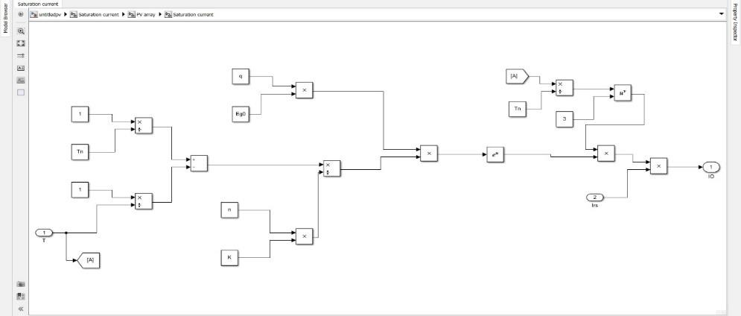

Figure No 4.1: simulation for saturation current

###### (B) SIMULATION FOR REVERSE SATURATION CURRENT (Irs):

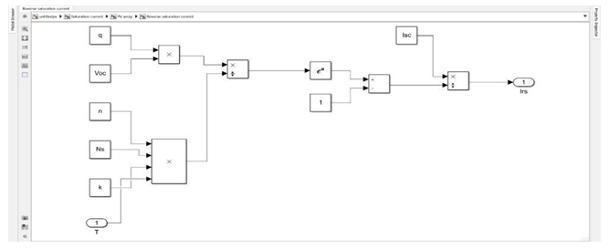

Figure No 4.2: Simulation for reverse saturation current

###### (C) SIMULATION FOR SHUNT CURRENT (Ish):

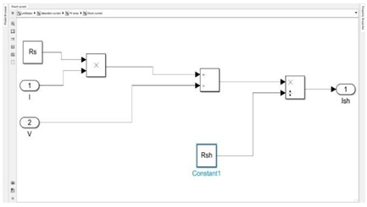

Figure No 4.3: Simulation for shunt current

###### (D) SIMULATION FOR PHOTOCURRENT (Iph):

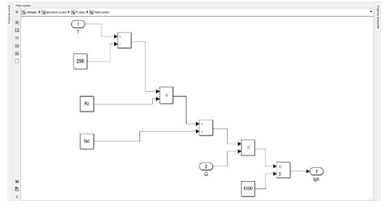

Figure No 4.4: Simulation for photo current

###### (E) SIMULATION FOR CURRENT (I)

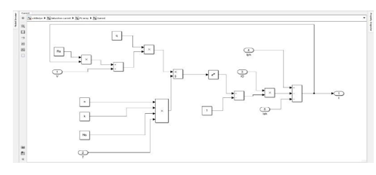

Figure No 4.5: Simulation for current

###### (F) PV ARRAY SIMULATION:

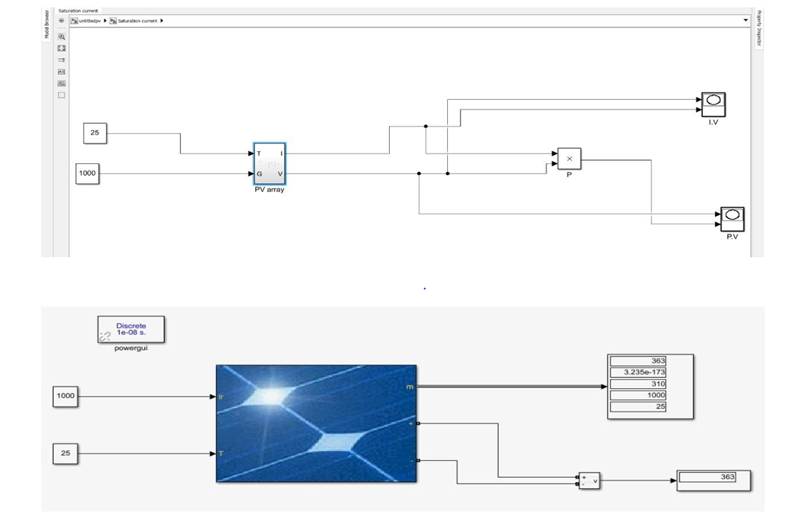

Figure No 4.6: PV array simulation with standard test condition

### 4.1.2 OUTPUT OF PV ARRAY:

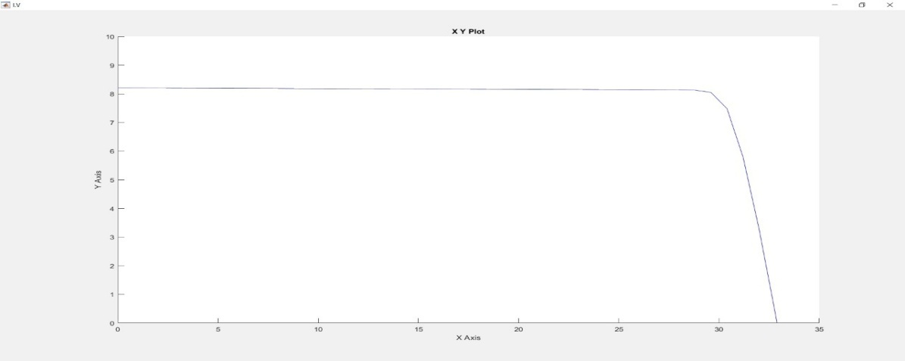

Figure No 4.7: PV curve with photovoltaic cell

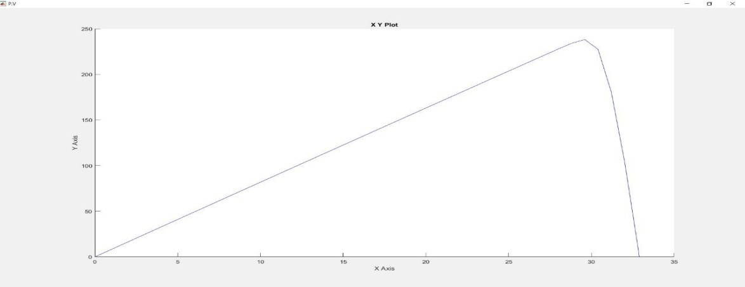

Figure No 4.8: PV curve of photovoltaic cell

* + 1. MATLAB SIMULATION OF DC-DC BOOST CONVERTER**:**

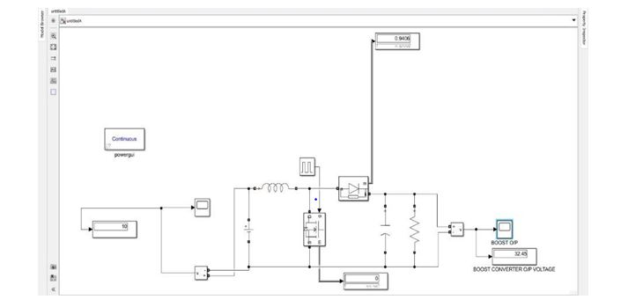

Figure No 4.9: Simulation of dc dc boost converter

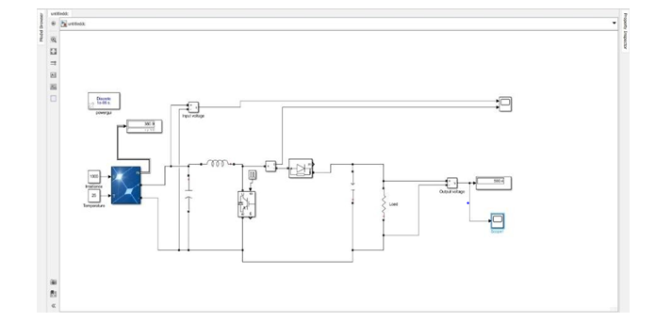

Figure No 4.10: Simulation of dc dc boost converter connected with pv array

### 4.1.4 OUTPUT OF DC-DC BOOST CONVERER:

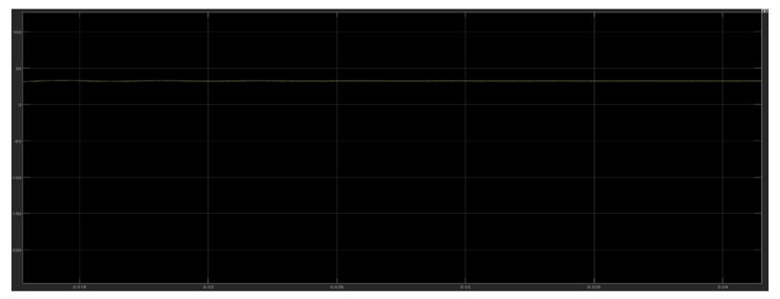

Figure No 4.11: the simulated graph for dc dc boost converter where the voltage boost after 300 volt

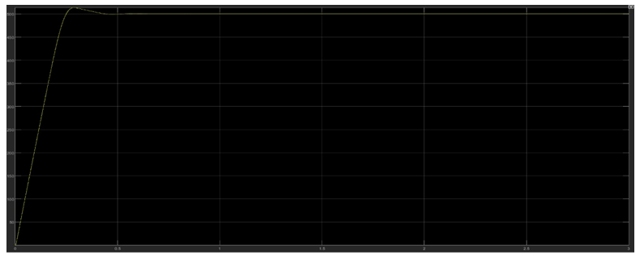

Figure No 4.12: The simulated graph for dc dc boost converter connected with pv array where the voltage boosts upand fluctuate from 499volt to 500.4 volt

### 4.1.5 MPPT SIMULATION OF MPPT:

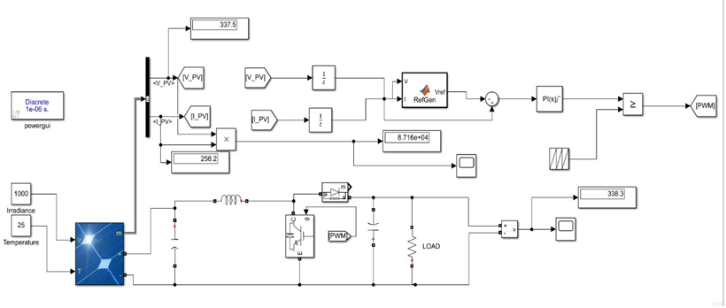

Figure No 4.13: Simulation of MPPT

### 4.1.6 OUTPUT OF MPPT:

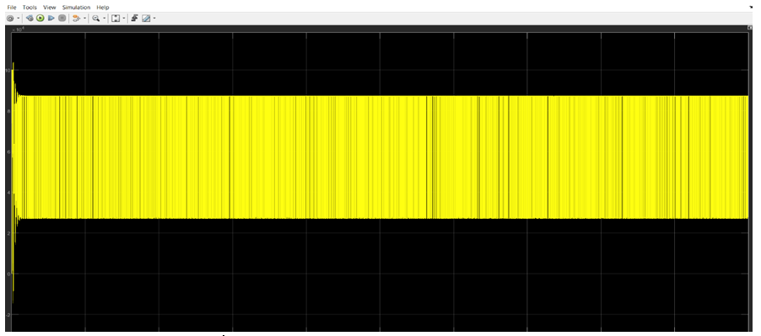

Figure No 4.14: Output of MPPT simulation

### 4.1.7 MATLAB SIMULATION OF BATTERY CHARGING FROM SOLAR WITH MPPT:

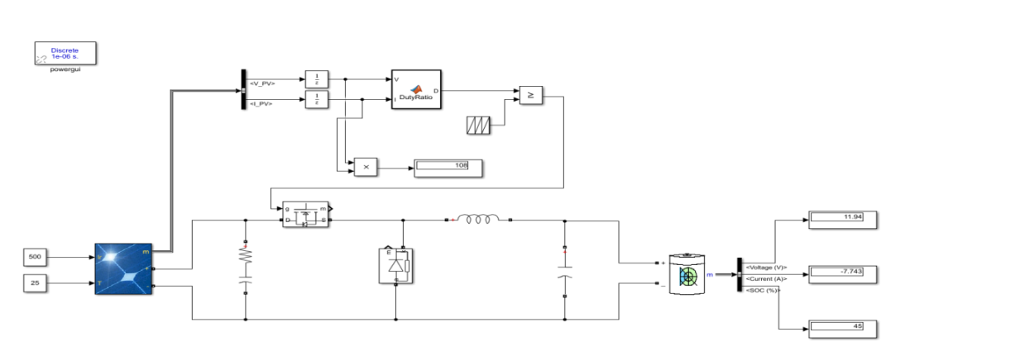

Figure No 4.15: Simulation of battery charging from solar with MPPT

### 4.1.8 DATA CAPTURE THROUGH SERIAL PORT:

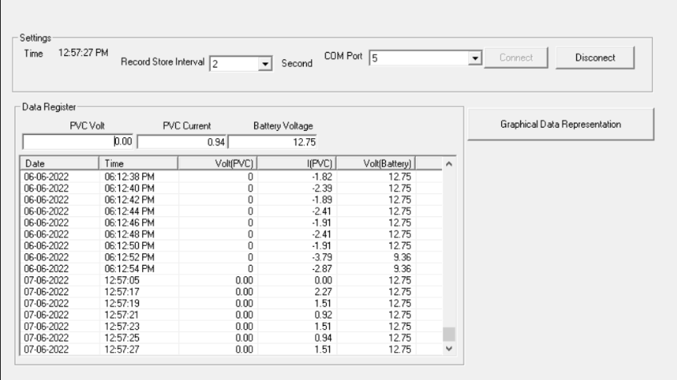

Figure No 4.16: Data capture through serial port

### 4.1.9DATA CAPTURE IN MySQL:

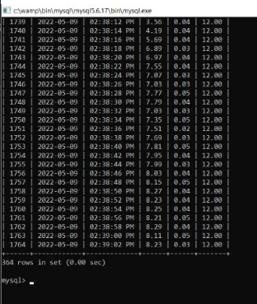

Figure No 4.17: Data capture in MySQL

### 4.1.10 DESIGNING OF TABLE:

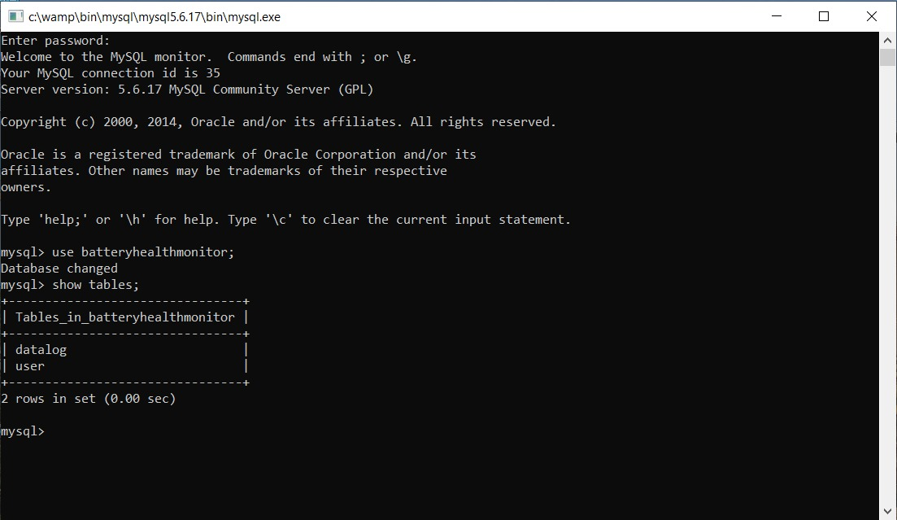

Figure No 4.18: Designing of table

### **4.1.11 DESIGNING OF DATABASE**:

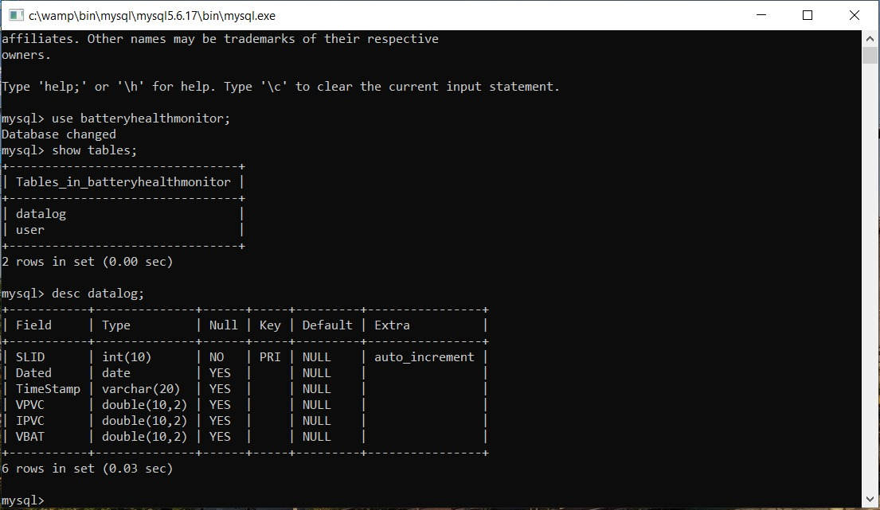

Figure No 4.19: designing of database

### 4.1.12GRAPHICAL REPRESENTATION:

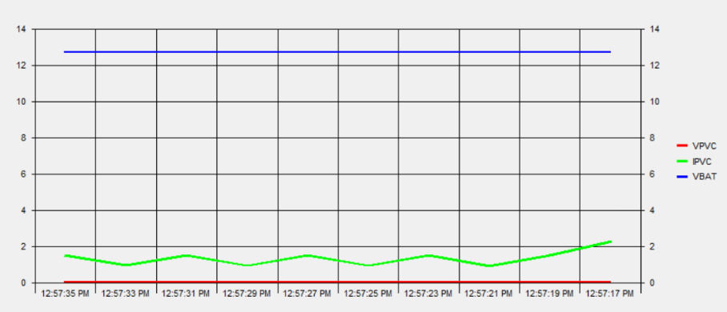

Figure No 4.20: Graphical representation

### PERFORMANCE ANALYSIS:

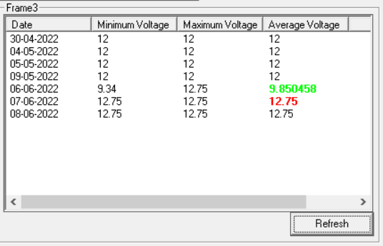

Figure No 4.21: Performance analysis

### **4.1.14 WEBPAGE**:

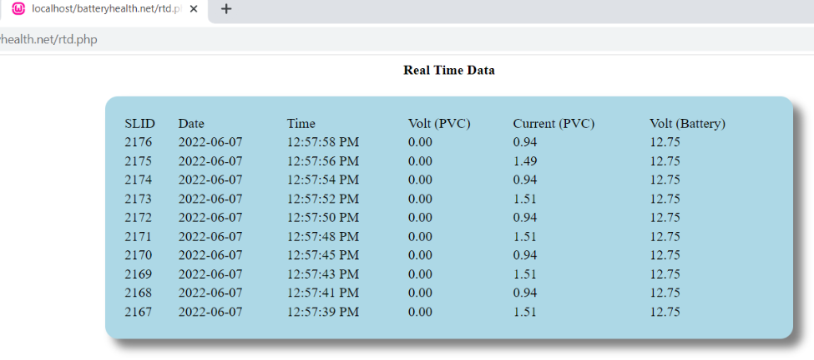

Figure No 4.22: Webpage

## 4.2 HARDWARE IMPLEMENTATION:

In this project, the Maximum Power Point Tracker (MPPT) is implemented by using a microcontroller that is programmed to execute the desired algorithm. The program will control the charge controller of the PV array by sensing the panel voltage (V) and current (I) and the battery voltage of to determine the single operating point where the values of current (I) and voltage (V) result in a maximum power output. This is the Maximum Power Point (MPP). The goal of the MPPT is to match the impedance of the battery to the optimal impedance of the panel. After taking the measurements of voltage and current, and decides the tracking algorithm (Perturb and Observe) which is the heart of the MPPT controller. The algorithm that is used is written using C# programming language on an interface known as Micro C. The program built generates a “. hex” file which is burned onto the microcontroller by means of a lockburner.

### 4.2.1 COMPONENTS USED FOR THE HARDWARE IMPLEMENTATION:

Some basic components used in the hardware implementation other than solar panel and battery, are briefly mentioned and discussed below:

* Voltage Regulator (LM7805)
* Current Sensor (ACS712)
* Arduino Nano
* 16x2 LCD
* P-n-p Power MOSFET
* Diodes
* Capacitors
* Induction Coil

#### 4.2.1.1 VOLTAGE REGULATOR (LM7805)

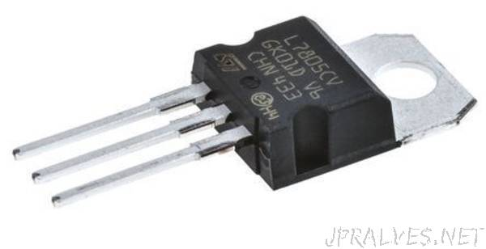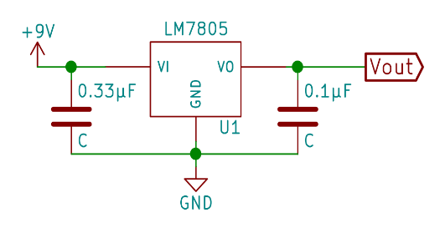

Figure No 4.23: Voltage regulator

The 7805 Voltage Regulator IC is a commonly used voltage regulator that finds its application in most of the electronics projects. It provides a constant +5V output voltage for a variable input voltage supply. The voltage regulator IC 7805 is actually a member of the 78xx series of voltage regulator ICs. It is a fixed linear voltage regulator. The xx present in 78xx represents the value of the fixed output voltage that the particular IC provides. For 7805 IC, it is +5V DC regulated power supply. This regulator IC also adds a provision for a heat sink. The input voltage to this voltage regulator can be up to 35V, and this IC can give a constant 5V for any value of input less than or equal to 35V which is the threshold limit.

The use of pins are listed below:

* PIN 1-INPUT: The function of this pin is to give the input voltage
* PIN 2-GROUND: We connect the ground to this pin. For output and input, this pin is equally neutral (0V).
* PIN 3-OUTPUT: This pin is used to take the regulated output.

In the IC 7805 voltage regulator, lots of energy is exhausted in the form of heat. The difference in the value of input voltage and output voltage comes as heat. So, if the difference between input voltage and the output voltage is high, there will be more heat generation. Without a heat sink, this too much heat will cause malfunction. 7805 Regulator Features are:

* + 5V Positive Voltage Regulator.
  + Minimum Input Voltage is 7V.
  + Maximum Input Voltage is 25V.
  + Operating current (IQ) is 5mA.
  + Internal Thermal Overload and Short Circuit current limiting protection is available.
  + Junction Temperature maximum 125 degree Celsius.
  + Available in TO-220 and KTE packages.

#### 4.2.1.2 CURRENT SENSOR (ACS712)

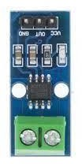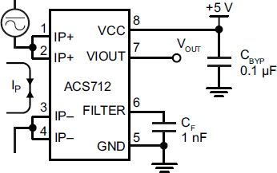

Figure No 4.24: Current sensor

The ACS712 provides economical and precise solutions for AC or DC current sensing in industrial, commercial, and communications systems. The device package allows for easy implementation by the customer. Typical applications include motor control, load detection and management, switch mode power supplies, and overcurrent fault protection. The device is not intended for automotive applications. The device consists of a precise, low-offset, linear Hall circuit with a copper conduction path located near the surface of the die. Applied current flowing through this copper conduction path generates a magnetic field which the Hall IC converts into a proportional voltage. Device accuracy is optimized through the close proximity of the magnetic signal to the Hall transducer. A precise, proportional voltage is provided by the low-offset, chopper-stabilized BiCMOS Hall IC, which is programmed for accuracy afterpackaging. The features and benefits are:

* Low-noise analog signalpath
* Device bandwidth is set via the new FILTERpin
* 5 μs output rise time in response to step inputcurrent
* 80 kHzbandwidth
* Total output error 1.5% at TA =25°C
* Small footprint, low-profile SOIC8package
* 1.2 mΩ internal conductorresistance
* 2.1 kVRMS minimum isolation voltage from pins 1-4 to pins5-8
* 5.0 V, single supplyoperation
* 66 to 185 mV/A outputsensitivity
* Output voltage proportional to AC or DCcurrents
* Factory-trimmed foraccuracy
* Extremely stable output offsetvoltage

#### 4.2.1.3 ARDUINO NANO

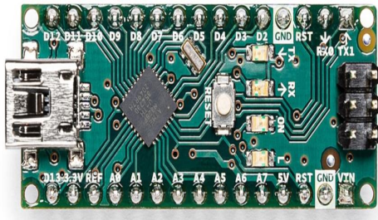

Figure No 4.25: ARDUINO NANO

Arduino Nano is one type of microcontroller board, and it is designed by Arduino.cc. It can be built with a microcontroller like Atmega328. This microcontroller is also used in Arduino UNO. It is a small size board and also flexible with a wide variety of applications. This board has many functions and features like an Arduino Duemilanove board. However, this Nano board is different in packaging. It doesn’t have any DC jack so that the power supply can be given using a small USB port otherwise straightly connected to the pins like VCC & GND. This board can be supplied with 6 to 20 volts using a mini USB port on the board. Arduino Nano Features: The features of an Arduino Nano mainly include the following:

* ATmega328P Microcontroller is from 8-bit AVR family
* Operating voltage is 5V
* Input voltage (Vin) is 7V to 12V
* Input/output Pins are 22
* Analog input pins are 6 from A0 to A5
* Digital pins are 14
* Power consumption is 19 mA
* I/O pins DC Current is 40 mA
* Flash memory is 32 KB
* SRAM is 2 KB
* EEPROM is 1 KB
* CLK speed is 16 MHz
* Weight-7g
* Size of the printed circuit board is 18 X 45mm
* Supports three communications like SPI, IIC, & USART

The Arduino Nano Pinout:

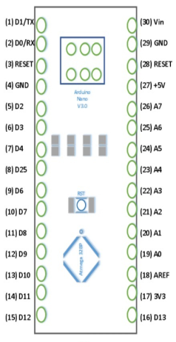

Figure No4.26: Arduino Nano Pinout

Arduino nano pin configuration is shown below and each pin functionality is discussed below:

* Power Pin (Vin, 3.3V, 5V, GND): These pins are power pins
  + Vin is the input voltage of the board, and it is used when an external power source is used from 7V to 12V.
  + 5V is the regulated power supply voltage of the nano board and it is used to give the supply to the board as well as components.
  + 3.3V is the minimum voltage which is generated from the voltage regulator on the board.
* GND is the ground pin of the board
* RST Pin( Reset): This pin is used to reset the microcontroller
* Analog Pins (A0-A7): These pins are used to calculate the analog voltage of the board within the range of 0V to 5V
* I/O Pins (Digital Pins from D0 – D13): These pins are used as an i/p otherwise o/p pins. 0V & 5V
* Serial Pins (Tx, Rx): These pins are used to transmit & receive TTL serial data.
* External Interrupts (2, 3): These pins are used to activate an interrupt.
* PWM (3, 5, 6, 9, 11): These pins are used to provide 8-bit of PWM output.
* SPI (10, 11, 12, & 13): These pins are used for supporting SPI communication.
* Inbuilt LED (13): This pin is used to activate the LED
* IIC (A4, A5): These pins are used for supporting TWI communication.
* AREF: This pin is used to give reference voltage to the input voltage

#### 4.2.1.4 16x2 LCD

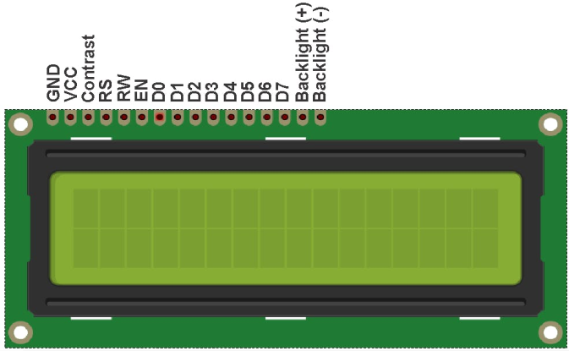

Figure No4.27: 16 x 2 LCD

LCDs (Liquid Crystal Displays) are used in embedded system applications for displaying various parameters and status of the system. LCD 16x2 is a 16-pin device that has 2 rows that can accommodate 16 characters each. LCD 16x2 can be used in 4-bit mode or 8-bit mode. It is also possible to create custom characters. It has 8 data lines and 3 control lines that can be used for control purposes. The use of pins of LCD 16x2 are listed below:

* + GND(VSS): The ground of the power supply is connected to this pin.
  + VCC: This pin is connected to 5v
  + Contrast (VEE): This pin is used to adjust the contrast of the Display.
  + RS: RS pin means Register select pin. It selects the command register when the pin is LOW. And selects a data register when this pin is HIGH.
  + RW: It represents the Read Write pin. When this pin is LOW, the MCU writes to register. And when the pin is HIGH, MCU reads from the register.
  + EN (E): EN pin means the Enable pin. Send data to data pins when a HIGH to LOW pulse is given.
  + D0-D7 (DB0-DB7): These are 8 data pins used to interface the LCD with the Arduino.
  + Backlight (+): This is the anode pin of the backlight of the display
  + Backlight (-): This is the cathode pin of the backlight of the display

#### 4.2.1.5 P-n-p POWER MOSFET

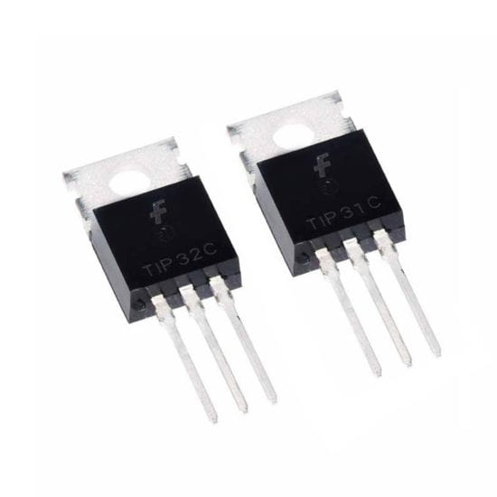

Figure No 4.28: p-n-p power MOSFET

A P-Channel MOSFET is a type of MOSFET in which the channel of the MOSFET is composed of a majority of holes as current carriers. When the MOSFET is activated and is on, the majority of the current flowing are holes moving through the channels. This is in contrast to the other type of MOSFET, which are N-Channel MOSFETs, in which the majority of current carriers are electrons. A P-Channel MOSFET is made up of a P channel, which is a channel composed of a majority of hole current carriers. The gate terminals are made up of N-type material.

Depending on the voltage quantity and type (negative or positive) determines how the transistor operates and whether it turns on or off.

* + - * 1. HOW TO TURN ON THE MOSFET: With a sufficient positive voltage to the source and load, and sufficient negative voltage applied to the gate, the P-Channel Enhancement-type MOSFET is fully functional and is in the active 'ON' mode of operation.
        2. HOW TO TURN OFF THE MOSFET: Either by cutting off the bias positive voltage that powers the source or by turning off the negative voltage going to the gate of the transistor we can switch off the MOSFET.

#### 4.2.1.6 DIODES

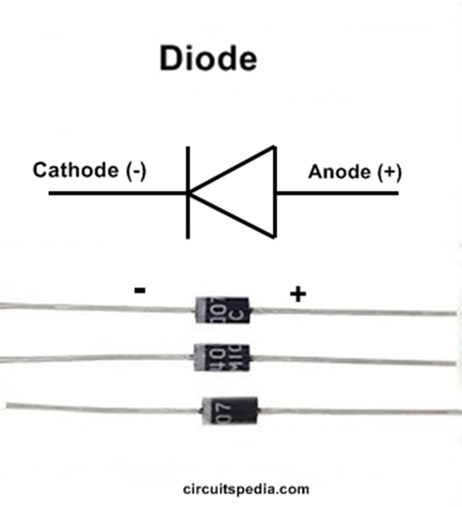

Figure No 4.29: Diodes

It allows high current to pass through it during charging of the battery and resist backward flow of current from battery to solar cell.

#### 4.2.1.7 CAPACITORS

The primary purpose of capacitors is to store electrostatic energy in an electric field and where possible, to supply this energy to the circuit. To prevent a dangerous failure of the circuit, they allow the AC to move but block the flow of DC.

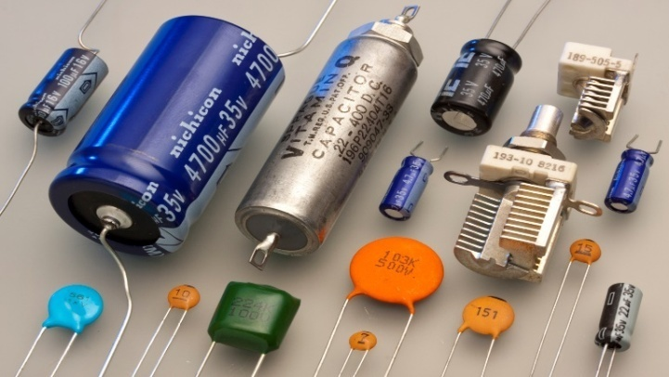

Figure No 4.30: Capacitors

#### 4.2.1.8 INDUCTION COIL

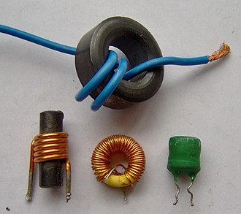

Figure No 4.31: Inductors

Induction coil is used to protect the circuit from damage due to flow of reverse current. Coils are also used to:

* + - Block the flow of the alternating current in the circuit, short-circuit the direct current (voltage),
    - measure time on the basis of decline of the current flow,
    - build an oscillatory circuit,
    - build filters for particular frequencies,
    - couple the amplifier stages,
    - decrease or increase the voltage

#### 4.2.1.9 HEAT SINK

A heat sink is an electronic device made of good thermal conducting material and usually attached to an electronic device to dissipate the unwanted heat. It is used to cool the circuit components by dissipating the excess heat to prevent overheating, premature failure, and improve the reliability and performance of the components.

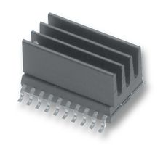

Figure No 4.32: Heat sink

### 4.2.2 MICROCONTROLLER AND VOLTAGE REGULATOR:

The microcontroller that will be used in this system is PIC16F876A. It is a 28 pin IC. It has a memory of 368 bytes and external programmable memory (EEPROM) of 256 bytes. The microcontroller senses both the panel and battery voltages and takes decisions to activate different components of the circuits such as, transistors, relays and LED indicators. It is powered up by the lead-acid battery connected to it through a voltage regulator (LM7805) which converts the 12V into 5V and is connected to a RESET(pin1). The microcontroller is also powered by a 5V supply at pin 20 and ground at pin 8 and19.

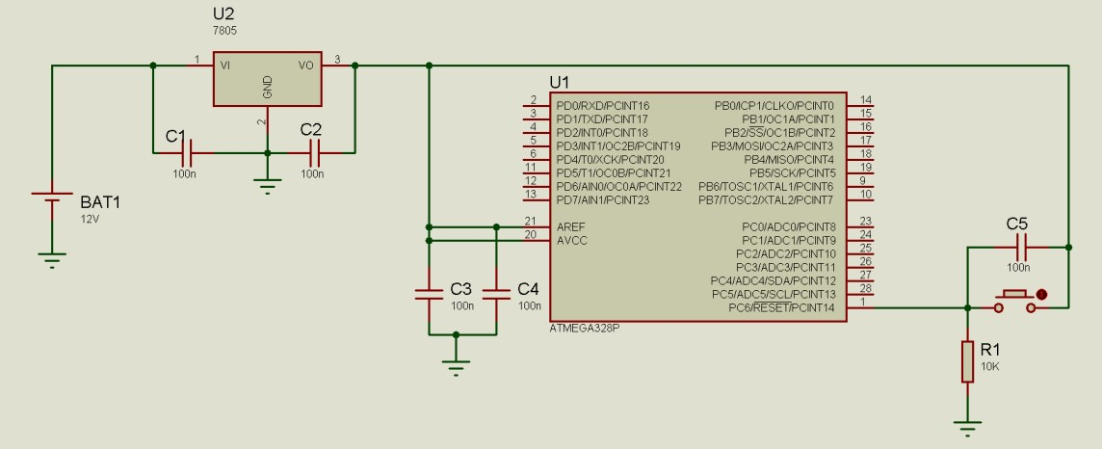

Figure No 4.33: Voltage regulator ( LM7805) connected to the ATMEGA328 RESET (PIN1)

### 4.2.3 ANALOG TO DIGITAL CONVERSION (ADC):

#### 4.2.3.1 VOLTAGE SENSING:

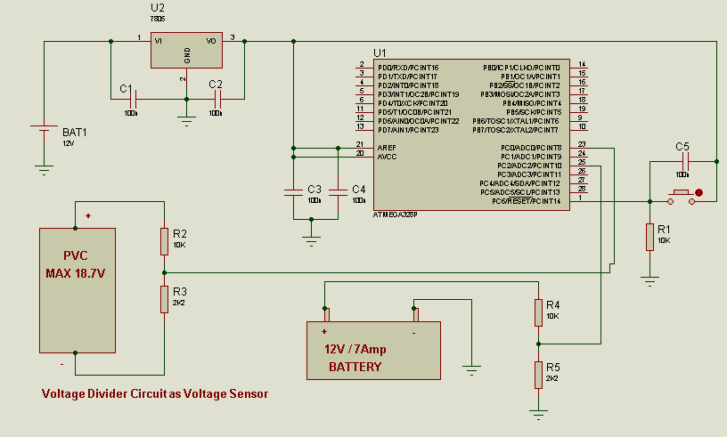The ATMEGA328 microcontroller consists of in built 8 Channels Analog- to- Digital (ADC) converters. It has 10 BIT ADC. These enable the conversion of the analog inputs into quantized values. The voltage inputs from the panel and the battery must be “stepped down” by using voltage divider formula. Then ode voltages between the two resistors connected to the panel is fed to one ADC pin (A0). Similarly, then ode voltages from the resistors connected to the battery are connected to A1. The maximum voltage it can handle is 5V. Therefore, the voltage divider circuit (Voltage Sensor) must be designed such a way that, at any condition Vout will not cross 5V.The ADC of the microcontroller divides these analog inputs into 1024 (210 = 1024) quantized levels. These values are 0 (for 0V input) and 1023 (for 5V input). In this way, voltage sensing of the panel and battery is achieved.

Figure No 4.34: Voltage sensing circuit diagram

#### 4.2.3.2CURRENT SENSING:

To read the current supplied by the PV module, a shunt resistor is placed in series with an ADC input. This value is amplified and connected to the ADC port. The shunt resistor gives a voltage that is proportional to the current, e.g.: if 1A gives 5mV, 10A gives 50mV. This voltage output is then connected to another ADC port.

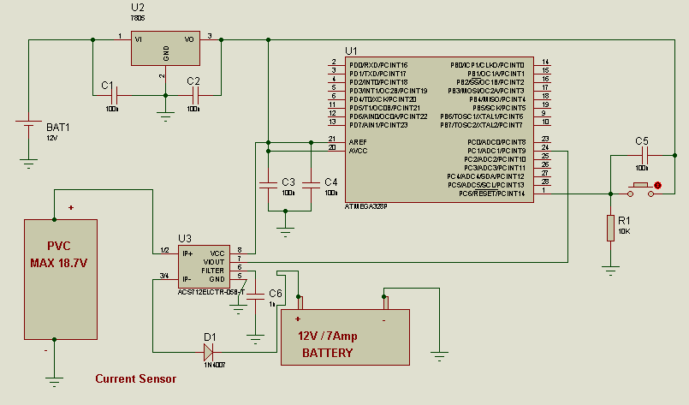

Figure No 4.35: Current sensing circuit diagram

#### 4.2.3.3 LCD **INTERFACING**:

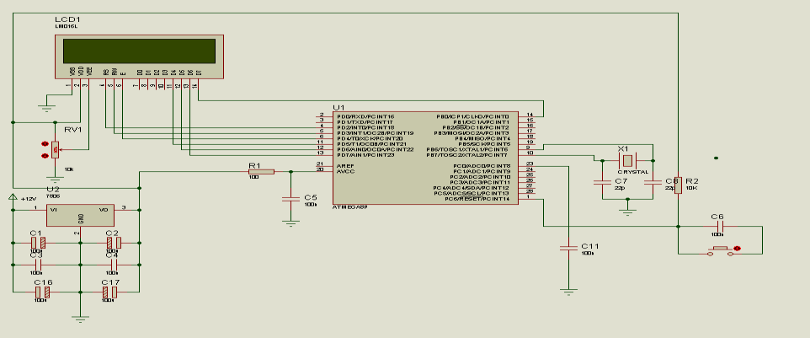

Figure No 4.36: LCD interfacing circuit diagram

#### 4.2.3.4 HARDWARE:

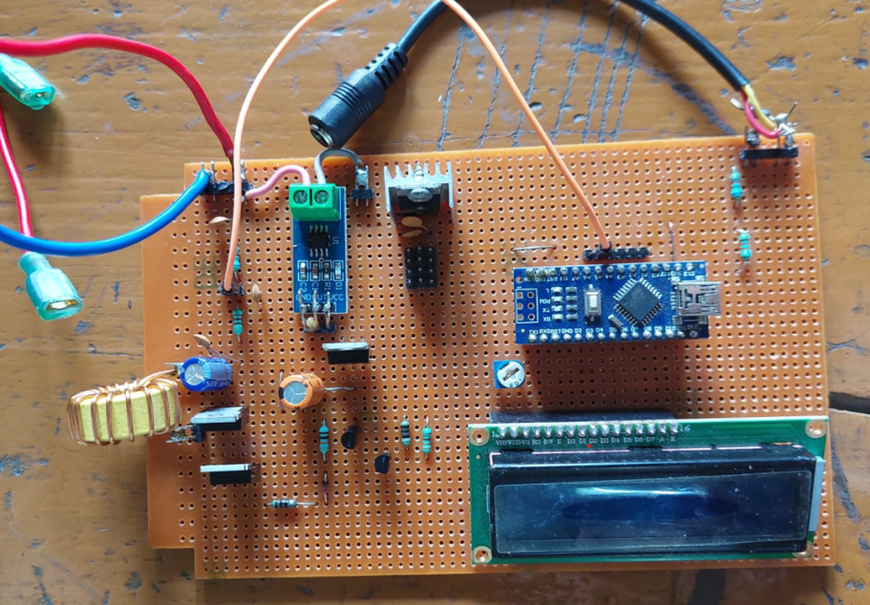

Figure no 4.37: Main hardware circuit

# CHAPTER 5: CONCLUSION

The project works for MPPT based charger designing which was conceived in terms of providing an effective charging solution for compact battery packs with the help of solar power. The MPPT circuit is successfully with the help of a programmable device (ATmega 328P). After designing and implementation an analytical system for performance monitoring is realised which is equally important for a battery charging unit. Keeping these things in mind, the project work has been extended with battery performance analysis in terms of storage and charging time. During this project work different hurdles and challenges were faced due to lack of practical exposure and experience with software. During this project work, many new concepts and software tools which will definitely be helpful in future to work with new projects and provide a better exposure in the field of real time analysis.

# FUTURE SCOPE:

The state of health (SOH) of battery prediction plays significant roles in battery management and the determination of the durability of the battery in service. Currently the traditional method of MPPT charging technique along with data collection for serial communication is used and the data is represented in graphical format. The project can be upgraded by implementing IOT features and collecting data over Wi-Fi, Bluetooth or ZigBee as well as the LoRa protocol. It will enhance the data collection and store data from different or multiple charging units into a centralised location which will help to compare the performance of multiple batteries. The additional features can be added with battery life and service time prediction with the help of AI.

# REFERENCE

1. <https://www.saftbatteries.com/products-solutions/products/intelli-connect-nickel-battery-monitoring-solution?gclid=CjwKCAjwquWVBhBrEiwAt1KmwiEJ8YpWwg7QeH-1cOpP3_AgnLNar3xk5OKnxv1oG_W1G1w8Va3CNBoCE-kQAvD_BwE>
2. <https://www.researchgate.net/publication/318034281_Design_and_Development_of_a_Real-Time_Monitoring_System_for_Multiple_Lead-Acid_Batteries_Based_on_Internet_of_Things>
3. <https://www.arduino.cc/en/software>
4. <https://docs.arduino.cc/software/ide-v1/tutorials/arduino-ide-v1-basics>
5. <https://en.m.wikipedia.org/wiki/Solar_panel>
6. <https://www.cleanenergyreviews.info/blog/mppt-solar-charge-controllers>
7. <https://en.m.wikipedia.org/wiki/Visual_Basic>
8. Photovoltaic System Engineering {2nd Edition] by Roger A. Messenger and Jerry Ventre
9. http://courseware.ee.calpoly.edu/~jharris/research/super_project/ao_thesis.pdf
10. [http://www.archives-ijaet.org/media/15I5-IJAET0511537-COMPARISON- OF- MAXIMUM-POWER-Copyright-IJAET.pdf](http://www.archives-ijaet.org/media/15I5-IJAET0511537-COMPARISON-%20OF-%20MAXIMUM-POWER-Copyright-IJAET.pdf)
11. Wikipedia.
12. Batteries and Charge Control in Stand-Alone Photovoltaic Systems Fundamentals and Application-Prepared by:James P. Dunlop, P.E.Florida Solar Energy Center1679 Clearlake RoadCocoa, FL 32922-5703