A DISSERTATION ON

**ENERGY AUDIT OF COMMERCIAL BUILDINGS**

*Submitted in partial fulfilment of the requirement for the award of the Degree of*

**MASTER OF TECHNOLOGY** in **ELECTRICAL ENGINEERING**

(With specialization in **Power System Engineering**)

under

**ASSAM SCIENCE AND TECHNOLOGY UNIVERSITY**

**SESSION: 2022-2024**

Submitted by:

**PRAN KRISHNA NATH**

**ASTU Roll No**.: 220620064012



*Under the guidance of*

**DR. BIMAL CH. DEKA**

**Professor**

**Department of Electrical Engineering**

**ASSAM ENGINEERING COLLEGE**

JALUKBARI, GUWAHATI-13, ASSAM

**CERTIFICATE OF APPROVAL FROM THE SUPERVISOR**

This is to certify that the work presented in this report entitled “**ENERGY AUDIT OF COMMERCIAL BUILDINGS**” is carried out by

**Pran Krishna Nath**

ASTU Roll No.: 220620064012

Session: 2022-2024

a student of M. Tech 4th semester, Department of Electrical Engineering, Assam Engineering College, under my guidance and submitted in a manner satisfactory to warrant its acceptance as a prerequisite for the award of the Degree of M. Tech in Electrical Engineering with specialization in Power System Engineering under Assam Science and Technology University.

Further, the report has not been submitted/ reproduced in any form for the award of any other degree/diploma.

Date: (Dr. Bimal Ch. Deka)

Place: Guwahati Professor

Electrical Engineering

Assam Engineering College

**CERTIFICATE OF APPROVAL FROM THE HEAD OF DEPARTMENT**

This is to certify that the following student of M. Tech 4th semester of Electrical Engineering Department, Assam Engineering College, has submitted his project report on “**ENERGY AUDIT OF COMMERCIAL BUILDINGS**” in partial fulfilment of the requirement for the award of the degree of Master of Technology in Electrical Engineering with specialization in Power System Engineering under Assam Science and Technology University.

Name: **PRAN KRISHNA NATH**

ASTU Roll NO: 220620064012

ASTU Registration No: 322109519

Date: (DR. RUNUMI SARMA)

Place: Guwahati (Professor & HOD)

Department of Electrical Engineering

Assam Engineering College

**CANDIDATE’S DECLARATION**

I do hereby declare that the project entitled “**ENERGY AUDIT OF COMMERCIAL BUILDINGS**” carried out by me under the guidance of Dr. Bimal Ch. Deka, Professor, Electrical Engineering Department, Assam Engineering College for the award of the degree of Master of Technology under Assam Science and Technology University has not been submitted/ reproduced in any form for the award of any other degree/diploma.

DATE PRAN KRISHNA NATH

PLACE ASTU ROLL NO – 220620064012

SESSION 2022-2024

**ACKNOWLEDGMENTS**

I take this opportunity to express my sincere gratitude and heartiest thanks to my supervisor Dr. Bimal Ch. Deka, Department of Electrical Engineering, Assam Engineering College, for his valuable guidance, cooperation and helpful suggestions throughout the course of my project. His keen interest in this topic has been constant source of encouragement for me.

I would like to express my heartiest thanks to Dr. Runumi Sarma, HOD, EE Department for valuable advice and help during the entire course of our project.

I am indebted to all the faculties of department of Electrical Engineering for the deep insights and discernment given through the various courses they had taught. I also owe to my family and all friends who have supported me during the course of my study.

PRAN KRISHNA NATH

**ABSTRACT**

Energy audit is very essential in the present-day world because of growing demand of energy which is occurring due to rise in population and peoples opting for high standard of living. With the help of energy audits, it is become easier to detect and identify intentional and unintentional wastage of electrical energy. The energy audit is basically conducted to identify the energy consumption pattern of commercial buildings on the basis of actual survey and detailed analysis during the period of audit. The audit is conducted to search for opportunities to improve energy efficiency and .to reduce energy consumption or energy waste. It is also conducted to find out the scope for energy savings and to check low energy efficient appliances, devices etc. and recommend for replacement by calculating the payback period.

In this project work energy audit has been carried out in 3 different hotels or commercial buildings that are situated in different locations of the city of Guwahati. The relevant data have been collected from three reputed hotels of Guwahati and analysis have been done to find out the energy consumption or energy losses.

The report accounts for energy consumption patterns of different areas like restaurant, royal kitchen, reception, hotel kitchen, gym room, large numbers of hotel rooms, guest pantry in each floor etc. All the area are surveyed and inspected before collection of data. The collected data have been used in cost saving calculation in order to provide more efficient energy savings ways to reduce wastage of energy and to conserve energy.

**CONTENT-1**

|  |  |  |
| --- | --- | --- |
| **CHAPTER NO** | **TOPIC** | **PAGE NO** |
| 0 | ABSTRACT | vi |
| 1 | INTRODUCTION  General introduction to energy  audit  Need for energy audit  Types of energy audit | 1  1  2  2-3 |
| 2 | LITERATURE REVIEW | 4-5 |
| 3 | ENERGY AUDIT METHODOLOGY  To collect relevant data and documents  To conduct a pre-audit assessment  To perform a walk-through analysis  To analyze energy usage  To develop a plan  To implement changes and monitor progress  Review and revise  Identification of scope for savings  Division of loads  Proposal for solar PV  Payback period | 6  6  6  6  6  7  6  6  7  7  7  8 |
| 4 | ELECTRICAL LOADS | 9 |
|  | Ginger Hotel, Six Mile, Guwahati | 9-12 |
|  | Kiranshree Grand, near Guwahati Airport | 12-15 |
|  | Hotel Gateway Grandeur, Christian Basti | 15-17 |
| 5 | PROPOSED SOLAR PV SYSTEM | 18 |
|  | Solar PV system for Ginger Hotel | 18-24 |
|  | Solar PV system for Kiranshree Grand | 24-26 |
|  | Solar PV system for Hotel Gateway | 26-28 |
| 6 | PAYBACK PERIOD CALCULATION | 29 |
|  | Ginger Hotel | 29-30 |
|  | Kiranshree Grand Hotel | 30 |
|  | Hotel Gateway grandeur | 30-31 |
| 7 | COMPARITIVE ANALYSIS | 32 |
|  | Energy saved by three hotels after addition of solar PV | 32 |
| 8 | CONCLUSION | 33 |
| 9 | REFERENCES | 35 |

|  |  |  |
| --- | --- | --- |
| **FIGURE.NO** | **LIST OF FIGURES** | **PAGE NO** |
| Figure 4.1.3 | Power consumption of electrical loads of ginger hotel | 11 |
| Figure 4.1.4 | Energy consumption of some components of ginger hotel | 12 |
| Figure 4.2.3 | Power consumption of electrical loads of Kiranshree Grand hotel | 14 |
| Figure 4.2.4 | Energy consumption of some components of kiranshree grand hotel | 15 |
| Figure 4.3.3 | Power consumption of electrical loads of hotel gateway grandeur | 16 |
| Figure 4.3.4 | Energy consumption of some components of hotel gateway grandeur | 17 |
| Figure 5.1.2 | Mono PERC solar panel | 20 |
| Figure 5.1.3 | 3KVA inverter | 21 |
| Figure 5.1.4 | UPS of rating 1KVA | 24 |
| Figure 7.1 | Energy saved by three hotels | 32 |

|  |  |  |
| --- | --- | --- |
| **Table no** | **List of Tables** | **Page no** |
| Table 4.1.1 | Connected Electrical loads | 9 |
| Table 4.1.2 | Major loads of Ginger Hotel | 10 |
| Table 4.2.1 | Connected electrical loads | 12-13 |
| Table 4.2.2 | Major loads of Kiranshree Grand Hotel | 13-14 |
| Table 4.3.1 | Connected Electrical loads | 15-16 |
| Table 4.3.2 | Major loads of Hotel Gateway Grandeur | 16 |
| Table 5.1.1 | Loads taken for solar PV | 18 |
| Table 5.2.1 | Loads taken for solar PV | 24-25 |
| Table 5.3.1 | Loads taken for solar PV | 27 |

**CHAPTER 1**

**INTRODUCTION**

* 1. **GENERAL INTRODUCTION TO ENERGY AUDIT**

Energy audit is a process in which survey and analysis of flow of electricity in a building are to be done to detect the energy consumption or waste of energy and to identify the alternative ways or devices to achieve efficient energy savings. Electricity is the most flexible form of energy which is required for all types of activity; due to which a rapid growth in electric power demand is happening from various categories of consumers. Electric power is considered to be the engine of economic growth, especially in developing country like India with the progress of agriculture, industrial and commercial sectors largely depending on it. It is also a basic necessity for the domestic sector. Since much of the electrical power generated from fossil fuels which is a very precious commodity. So, it become essential to used electricity in an efficient manner. In the latest decades of twentieth century, India has been facing acute crisis with the power generation not keeping up with the demand.

Energy audit is the key to a symmetric approach for decision making in the area of energy management which is a strategy of adjusting and optimising energy using systems and procedures in order to reduce energy requirement per unit output while reducing the total cost of producing these outputs. The energy audit is basically done to seek opportunities to save energy by identifying the areas where scope for savings exists. It is a systematic approach for identifying energy wastes in a facility and determining how these wastes can be eliminated most optimally.

As per the Energy Conservation Act, 2001, Energy Audit is defined as the verification, monitoring and analysis of use of energy including submission of technical report containing recommendations for improving energy efficiency with cost benefit analysis and an action plan to reduce energy consumption.

In this paper, a commercial energy audit report is prepared to understand energy usage patterns in three commercial buildings present in the location of Guwahati to reduce an organization's carbon footprint, ensure compliance, reduce energy wastage, achieve efficient energy savings and promote an overall healthy environment.

* 1. **NEED FOR ENERGY AUDIT**

In any commercial sector, the three operating costs are energy, labour and materials out of which energy has the highest potential for cost reduction. The energy audit helps us to understand more about the ways in which energy is flows or used in the commercial building and also help us to identify the areas where energy waste is occurs and where the scope of improvement lies or possible. Such kind of audit program will review the variation in energy cost, availability reliability of energy supply, take decision on appropriate energy conservation technique and retrofit for energy conservation. In general, energy audit is the transformation of conservation ideas into realities by evolving technically feasible solutions with economic and other considerations within a specified time period.

* 1. **TYPES OF ENERGY AUDIT**

The types of energy audit to be performed depends upon the type of the commercial building, the depth to which the final audit is needed and the potential and magnitude for cost reduction desired. There are mainly two types of energy audit. These are:

* + 1. **Primary or preliminary energy audit**

The preliminary energy audit also known as simple audit, screening audit or walk through audit. It is a relatively quick exercise and uses existing or easily available data. It basically includes minimal interviews with site operating personnel, a brief review on facility utility bills or some other operational data and a walk through of the facility to become familiar with the operation of the building and identify the area where energy waste is happening. The scope for preliminary energy is to ---

* Establish energy consumption in the organisation.
* Obtained relative data such as production for relating with energy consumption.
* Estimate the scope of energy savings
* Identify the most likely and easiest areas for attention. For example, unnecessary lighting, higher temperature setting, leakage etc.
* Identify immediate improvement or savings.
* Set up and reference or base line for energy consumption.
* Identify the areas for detailed study or measurement.

The preliminary energy audit focuses on the major energy suppliers and demand usually accounting for approximately 70% of total energy. This audit is performed in a very short duration i.e. in 5-12 days. During this period, the auditor relies on his experience along with all the relevant written and oral visual information that helps to get a quick identification of the plant energy situation. It focuses on the diagnosis of obvious sources of energy wastages.

* + 1. **Detailed Energy audit**

The detailed energy audit is also known as mini audit, site energy audit or complete site energy audit that expand on preliminary audit by collecting more detailed information about facility operation and identify a more detailed evaluation of energy conservation measures. The utility bills are collected for a 12-36 months duration that helps the auditor to evaluate the facility’s energy/demand rate pattern, and energy usage profiles. Sometimes, specific energy consuming metering systems are used to performed supplement utility data.

The detailed energy audit helps to get a quantitative estimate of costs and savings. It also includes engineering recommendations and well-defined project based on priorities. At about 97% of total energy is accounted for detailed energy audit period. It basically conducted after preliminary audit. Some sophisticated instrument like flow meter, flue gas analyser and scanner are also used to evaluate energy efficiency.

Detailed energy audit is carried out in 3 phases such as

* Pre-audit phase
* Audit phase
* Post-audit phase

**CHAPTER 2**

**LITERATURE REVIEW**

The review of literature has been carried out and summarised a few important and relevant literature in the following sections.

Magdum PS et.al (2018) performed energy audit of a commercial building and an educational building. In the commercial building connected loads are tube lights, fan, motor, spot light, ceiling fan, wipro light fixture, cash counting machine, cctv camera, inverter, battery CFL bulb which accounts for total load of 8.37KW. Recommended changes are only given for luminaries. LED tubes, LED bulb, LED spotlights are recommended changes for existing florescent tube, CFL bulb and halogen spot light.

In the educational building existing system of energy usage goes up to 47.11 kw and recommended system brings down to 29.55kw.

Innowell (2020) conducted energy audit of Mangalore Institute of Technology and Engineering which have a plot area of 74 acres and built up area of 774834 Sq.ft . Electricity consumption in the year 2018 is 1357345 kwh and in the year 2019 is 1330360kwh from utility grid. For energy conservation Innowell recommended replacement of old fans with BLDC fans with a implementation cost of Rs 160000 and payback period of 1.5years, installations of more solar panels with a cost of Rs 85000 and payback period of .5years, installations of occupancy sensors with a cost Rs 200000, replacement of 36w light with 18w or 20w fixtures with a cost of Rs 10551 and .1 years, installations of solar panels to street lights inside the campus with a cost of Rs 20899 and payback period of .8 years.

Sharma (2017) in his paper Energy Audit of a Commercial Building made recommendation of replacement of 60watt fans with good quality 50watt havells /khaitan fans, replacement of tube lights with led. The building was divided into workshop building, west wing and central wing. Investment cost in workshop building is Rs 371109 with a payback period of 14weeks, investment cost of west wing is Rs 329565 with a payback period of 12 weeks, investment cost of central wing is Rs 473932 with a payback period of 14 weeks.

Sharma P et.al (2018) Carbon emission exists in any building directly or indirectly, so to reduce this emission, energy audit is done to see if any green energy measures can be added.

Malkovska M et.al (2019) The energy performance of buildings should be calculated on the basis of a methodology that can be differentiated at national and regional level. This includes, in addition to thermal characteristics, other factors that play an increasingly important role such as heating and air conditioning, use of energy from renewable sources, passive heating and cooling elements, shading, indoor air quality, adequate natural light and design on the building. The methodology for calculating energy performance should be based not only on data for the heating season, but should cover the annual energy performance of buildings.

**CHAPTER 3**

**ENERGY AUDIT METHODOLOGY**

In this work, energy audit has been carried out in three Hotels situated in Guwahati, Assam. It is essential to collect relevant data from the organisation before audit has been done. The chronology of activities of energy audit are described in the following sections:

**3.1** **To collect relevant data and documents**

* To collect energy bills of last 1-3 years, property-related documents, manuals of equipment, maintenance history, occupancy data, and utility consumption rate information.

**3.2** **To Conduct a pre-audit assessment**

* Current energy use, Occupancy patterns, Maintenance records, Building’s operating schedules, Occupant interviews and surveys, Equipment-wise energy consumption.
* This assessment sets the groundwork for the audit by compiling all the essential information in a single place.

**3.3** **To Perform a walk-through analysis**

* A walk-through analysis is a visual inspection of facility's internal and external systems. This typically includes lighting, HVAC systems, insulation, windows, doors, and other energy systems. The goal is to prepare a preliminary understanding of the scope for improvement and opportunities to optimize usage.

**3.4** **To Analyze energy usage**

* While a walk-through analysis offers a surface-level understanding of the building’s energy usage patterns, a software base data analytics dig deeper to provide more actionable insights.

**3.5** **To Develop a plan**

* Create a well-detailed plan including the recommended measures, implementation process, costs, and timelines. Compile all findings and recommendations in a detailed and actionable document.

**3.6** **To Implement changes and monitor progress**

* Implement all the measures outlined in the report. Plan how to track and measure the efficiency of strategies and review progress at least once every six months.

**3.7** **Review and revise**

* Review the new progress report and compare whether the building’s energy consumption has become more efficient and cost-effective. Identify gaps, if any, and take corrective measures to improve energy efficiency further.

**3.8 Identification of scope for savings**

* To find out the scope for saving is the key factor of energy audit. An auditor must try to find out the scope for savings. While visiting the three hotels the area where energy can be saved is found out and the saving is proposed to be done by addition of solar energy which is also an approach for green energy addition and reduction of carbon emission.

**3.9 Division of loads**

* It is observed that all types of electrical load do not remain energised all time. So, the loads which remain energised all the time i.e. 24hours is categorised as constant loads and the others as variable loads.

**3.10 Proposal for solar PV system**

* After doing the division of loads it is found that the constant load remains on for almost 24 hours. Solar energy addition is done to supply power to the constant loads so as to reduce some energy consumption from utility grid.

**3.11 Payback period**

* Payback period is defined as the number of years required to recover the original cash investment. In other words, it is the period of time at the end of which a machine, facility, or other investment has produced sufficient net revenue to recover its investment costs.

**CHAPTER 4**

**ELECTRICAL LOADS**

Three different hotels have been chosen for the energy audit. Data of connected electrical loads of three different hotels have been shown separately.

**4.1 Ginger Hotel, Six Mile, Guwahati**

The ginger hotel Guwahati is one of the best budget hotels in the city and offers 70 smartly furnished rooms in addition to a host of modern facilities.

**Table 4.1.1 Connected Electrical loads**

|  |  |  |  |  |
| --- | --- | --- | --- | --- |
| SL NO | Name of electrical component | Ratings | Nos | Total power in watt |
| 1 | LED light | 15W Each | 544 | 8160 |
| 2 | LED light | 9W Each | 30 | 270 |
| 3 | LED light | 12W Each | 20 | 240 |
| 4 | Ceiling fan | 52W Each | 70 | 3640 |
| 5 | LED TV | 110W Each | 70 | 7700 |
| 6 | Mini Fridge | 90W Each | 70 | 6300 |
| 7 | Electric Kettle | 500W Each | 70 | 35000 |
| 8 | Water Dispenser | 500W Each | 2 | 1000 |
| 9 | Diffuser | 30W Each | 3 | 90 |
| 10 | Wall fan | 55W Each | 3 | 165 |
| 11 | Street light (LED) | 45W Each | 10 | 450 |
| 12 | Smoke Detector | 12V DC | 70 |  |
| 13 | Treadmill | 4097W | 1 | 4097 |
|  |  |  | TOTAL | 67112 |

**Table 4.1.2 Major loads of Ginger Hotel**

|  |  |  |  |  |
| --- | --- | --- | --- | --- |
| SL NO | Name of electrical component | Rating | Nos | Total power in watt |
| 1 | Air condition | 2.5Ton Each | 70 | 175000 |
| 2 | Exhaust fan | 55W | 1 | 55 |
| 3 | Mass wet grinder | 375W | 1 | 375 |
| 4 | Refrigerator 2Door | 733W | 1 | 733 |
| 5 | Fridge 4door | 1400W | 2 | 2800 |
| 6 | Central AC | 375W each | 3 | 1125 |
| 7 | Pressurised water motor | 3Kw each | 3 | 9000 |
| 8 | Filter water pump | 7457W | 1 | 7457 |
| 9 | Water pump | 3738W | 1 | 3728 |
| 10 | Heat Pump | 170KW | 1 | 170000 |
| 11 | Lift | 7KW | 1 | 7000 |
|  |  |  | TOTAL | 377273 |

**4.1.3 POWER CONSUMPTION OF ELECTRICAL LOADS OF GINGER HOTEL**

Figure 4.1.3 Power consumption of electrical loads of Ginger Hotel

**4.1.4 ENERGY CONSUMPTION OF SOME COMPONENTS**

It is tried to observe the energy pattern of the electrical components of ginger hotel. Duration of use of some components were found and the energy consumption per day is shown below.

Figure 4.1.4 Energy consumption of some components of Ginger Hotel

Use hours of some of the electrical components are known and the energy consumption of those components are shown. It is seen that central AC runs, Fridge(4door), Refrigerator(i.e. Fridge 2door), diffuser and some LED light run for almost 24 hours and consumes an energy of 22500Wh, 67200Wh,17592Wh, 2160Wh and 2070Wh respectively. Exhaust fan runs almost for 18hours a day and consumes an energy of 825Wh. Street light runs for almost 10 to 12 hours and consumes an energy of 5400Wh.

**4.2 Kiranshree Grand Hotel, Near Guwahati Airport**

Kiranshree Grand is one of the best 5star hotel in Guwahati city. It has a total number of 122 rooms.

**Table 4.2.1 Connected electrical loads**

|  |  |  |  |  |
| --- | --- | --- | --- | --- |
| SL NO | Name of electrical component | Rating | Nos | Total power in watt |
| 1 | LED light | 7W Each | 2416 | 16912 |
| 2 | LED light | 3W Each | 926 | 2778 |
| 3 | LED light | 14W Each | 122 | 1708 |
| 4 | LED TV | 50W Each | 131 | 6550 |
| 5 | Mini Fridge | 90W Each | 122 | 10980 |
| 6 | Tea Kettle | 500W Each | 122 | 61000 |
| 7 | Hair dryer | 5W Each | 122 | 610 |
| 8 | DND | 10W Each | 122 | 1220 |
| 9 | Smoke Detector | 12V DC | 122 |  |
| 10 | Micro Oven | 2000W Each | 9 | 18000 |
| 11 | Flower Light | 20W Each | 50 | 1000 |
|  |  |  | TOTAL | 120758 |

**Table 4.2.2 Major loads of Kiranshree Grand Hotel**

|  |  |  |  |  |
| --- | --- | --- | --- | --- |
| SL NO | Name of Electrical component | Rating | NOS | Total power in watt |
| 1 | Air condition | 2Ton | 132 | 264000 |
| 2 | Air condition | 4Ton | 9 | 36000 |
| 3 | VRV AC | 8.5Ton | 4 | 34000 |
| 4 | VRV AC | 5.5Ton | 9 | 49500 |
| 5 | VRV AC | 11Ton | 4 | 44000 |
| 6 | Submersible Pump | 14914W Each | 3 | 44742 |
| 7 | Heat pump | 7000W | 1 | 7000 |
| 8 | Heat pump | 19800W | 2 | 39600 |
| 9 | Pressure Pump | 1491.4W | 3 | 4474.2 |
| 10 | Geyser | 3000W | 6 | 18000 |
| 11 | Washing machine 35kg | 2237.1W | 1 | 2237.1 |
| 12 | Washing Machine 18kg | 12750W | 1 | 12750 |
| 13 | Water pump | 5592.75W | 5 | 27963.75 |
| 14 | Exhaust Motor | 5593.75W | 2 | 11187.5 |
| 15 | Fridge 2 door | 700W | 1 | 700 |
| 16 | Deep fridge | 220W | 1 | 220 |
| 17 | Vertical fridge | 361W | 9 | 3249 |
| 18 | Ice cube machine | 300W | 1 | 300 |
| 19 | Battery bank | 20KVA | 1 |  |
| 20 | 12 V battery | 150AH | 30 |  |
| 21 | Street light (LED) | 250W | 50 | 12500 |
| 22 | Street light (LED) | 50W | 150 | 7500 |
| 23 | Street light (LED) | 30W | 30 | 900 |
| 24 | Street light (LED) | 200W | 100 | 20000 |
| 25 | Street light (LED) | 20W | 67 | 1340 |
| 26 | Street light (LED) | 100W | 60 | 600 |
|  |  |  | TOTAL | 642763.55 |

**4.2.3 POWER CONSUMPTION OF ELECTRICAL LOADS OF KIRANSHREE GRAND HOTEL**

Figure 4.2.3 Power consumption of electrical loads of Kiranshree Grand hotel

**4.2.4 ENERGY CONSUMPTION OF SOME COMPONENTS**

4.2.4 Energy consumption of some components of Kiranshree grand hotel

LED lights of reception area and corridors remains on for almost 24hours with other components like deep fridge, fridge and vertical fridge and consumes an energy of 104520Wh, 16800Wh,77976Wh respectively. Street light remains on for almost 10 to 12 hours a day and consumes an energy of 514080Wh. VRV AC remains on for almost 24hours and consumes energy of 204000Wh.

**4.3 Hotel Gateway Grandeur, Christian Basti, Guwahati**

Hotel Gateway Grandeur is situated in the heart of the Guwahati city in the town of Christian Basti. Is has a total number of 49 rooms.

**Table 4.3.1** **Connected Electrical loads**

|  |  |  |  |  |
| --- | --- | --- | --- | --- |
| SL NO | Name of electrical component | Rating | NOS | Total power in watt |
| 1 | LED Light | 3W Each | 283 | 849 |
| 2 | LED Light | 6W Each | 293 | 1758 |
| 3 | LED Light | 12W Each | 158 | 1896 |
| 4 | Strip light 3Meter | 25W Each | 100 | 2500 |
| 5 | LED TV | 39W Each | 52 | 2028 |
| 6 | Mini fridge | 48W Each | 49 | 2352 |
| 7 | Electric kettle | 900W Each | 49 | 44100 |
| 8 | Exhaust fan | 22W Each | 49 | 1078 |
| 9 | Smoke Detector | 12V DC | 69 |  |
| 10 | LED Tube light | 25W Each | 22 | 550 |
| 11 | Treadmill | 3352.5W Each | 2 | 6705 |
|  |  |  | TOTAL | 63816 |

**Table 4.3.2 Major loads of Hotel Gateway Grandeur**

|  |  |  |  |  |
| --- | --- | --- | --- | --- |
| SL NO | Name of Electrical component | Rating | Nos | Total power in watt |
| 1 | Air condition | 2 Ton | 70 | 140000 |
| 2 | Air condition | 1 Ton | 4 | 4000 |
| 3 | Air condition | 1.5Ton | 1 | 1500 |
| 4 | Hot water outlet pump | 3700W | 1 | 3700 |
| 5 | Water boiler | 22000W | 1 | 22000 |
| 6 | Washing machine | 2000W | 1 | 2000 |
| 7 | Washing machine | 2235W | 1 | 2235 |
| 8 | Fountain pump | 3725W | 1 | 3725 |
| 9 | Lift motor | 7500W | 2 | 15000 |
| 10 | Water pump | 7450W | 2 | 7450 |
| 11 | VRV AC | 8.5Ton | 1 | 8500 |
| 12 | Deep Fridge | 250W | 3 | 750 |
| 13 | Deep Fridge | 223W | 1 | 223 |
| 14 | Fridge 4Door | 680W | 1 | 680 |
| 15 | Exhaust system | 1000W | 8 | 8000 |
|  |  |  | Total | 219763 |

**4.3.3 POWER CONSUMPTION OF ELECTRICAL LOADS OF HOTEL GATEWAY**

Figure 4.3.3 Power consumption of electrical loads of hotel gateway grandeur

**4.3.4 ENERGY CONSUMPTION OF SOME COMPONENTS**

Figure 4.3.4 Energy consumption of some components of hotel gateway grandeur

Hotel Gateway Grandeur located in a congested area and hence there is no outer space outside the building and therefore has no street light. Corridor area lighting and reception area lighting remains on for almost 24 hours with other loads like deep fridge and fridge which consumes an energy of 21600Wh, 23352Wh and 16320Wh respectively. Exhaust system runs for 18 hours a day and consumes an energy of 144000Wh.

**CHAPTER 5**

**PROPOSED SOLAR PV SYSTEMS**

Scope for savings is found if solar energy is added in all three hotels for constant loads keeping in mind not to add much more load to solar so as to decrease the initial cost.

**5.1 Calculation of solar PV requirement for Ginger Hotel**

**Table 5.1.1 loads taken for solar PV**

|  |  |  |  |
| --- | --- | --- | --- |
| AREA | NO OF LED LIGHT | RATING | TOTAL POWER |
| RECEPTION | 5 | 9W EACH | 45W |
| CORRIDOR GROUND FLOOR | 5 | 15W EACH | 75W |
| CORRIDOR FIRST FLOOR | 38 | 15W EACH | 570W |
| CORRIDOR SECOND FLOOR | 38 | 15W EACH | 570W |
| CORRIDOR THIRD FLOOR | 24 | 15W EACH | 360W |
|  |  | TOTAL | 2070W |

Electrical load i.e LED lighting =2070W

Keeping provision for load addition we take =2200W

Total power required per day =2200W

Total energy required per day =2200×4hours

=8800WHour

$$\text{Power required from solar panel}\text{=}\frac{\text{Total energy required from solar PV(Wh)}}{\text{effective sunshine hour ×system efficiency}}$$

$\text{Power required from solar panel=}\frac{\text{8800}}{\text{6×0.73}}$

= 2009 W

$No of solar panel required=\frac{power required from solar panels}{output power of solar panel}$

$No of solar panel required=\frac{2009}{200}$

= 10

**MONO PERC (PASSIVATED EMITTER AND REAR CELL) SOLAR PANELS**

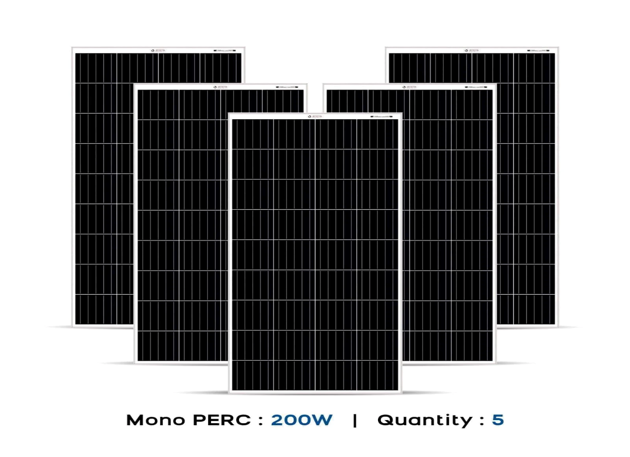

Figure 5.1.2 Mono PERC solar panel

**Inverter of rating 3KVA is sufficient for handling a load of 2.2KW**

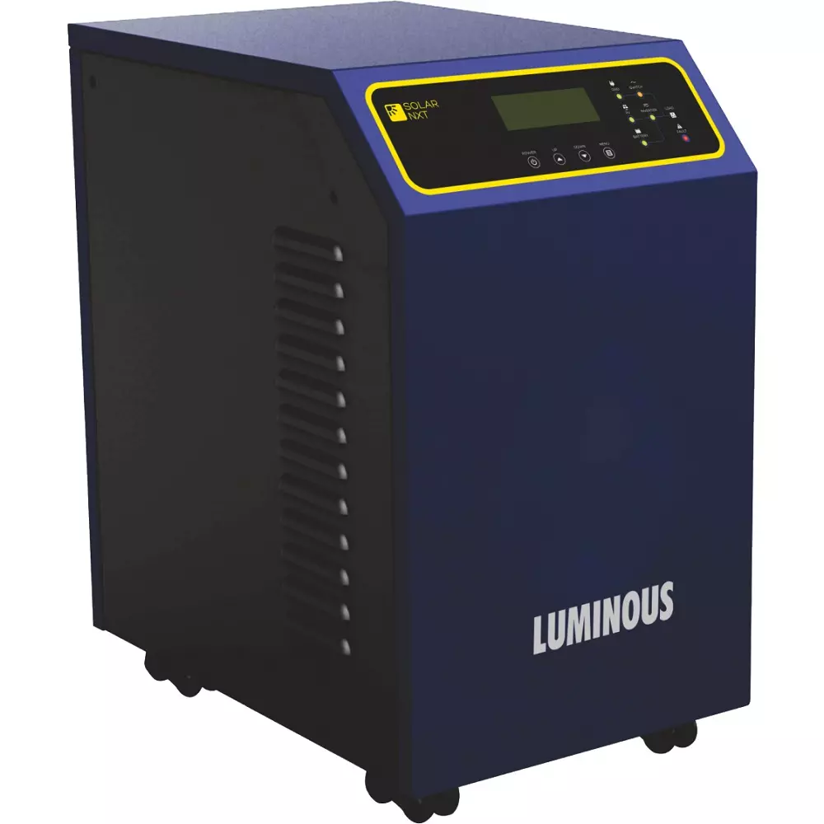

Figure 5.1.3 3KVA inverter

Cost of solar system for corridor and reception area lighting

Cost of 10 nos of Mono PERC panel= Rs. 85000

Cost of UPS of 2.5Kw = Rs. 45000

Installation cost with materials = Rs. 10000

Total cost = Rs. 140000

**CALCULATION OF SOLAR PV FOR STREET LIGHTING**

Electrical load i.e LED lighting = 450W

Keeping provision for load addition we take = 600W

Total power required per day = 600W

Total energy required per day =600×12hours

=7200WHour

$$\text{Power required from solar panel=}\frac{\text{Total energy required from solar PV(Wh)}}{\text{Effective sunshine hour × system efficiency}}$$

$\text{Power required from solar panel=}\frac{\text{7200}}{\text{6×0.73}}$

= 1643 W

$No of solar panel required=\frac{\text{power required from solar panel}}{\text{output power of solar panel}}$

$$\text{No of solar panel required =}\frac{\text{1643W}}{\text{200W}}$$

= 8

**BATTERY SELECTION FOR STREET LIGHTING**

Total power required per day = 600W

Total energy required per day= 7200Wh

$$\text{Required battery capacity=}\frac{\text{total backup energy required per day}}{\text{Battery voltage×depth of discharge×battery efficiency}}$$

$$=\frac{7200}{12×0.85×0.85}$$

= 830Ah

$$\text{Number of battery required=}\frac{\text{required battery capacity}\left(\text{Ah}\right)\text{×Back up day}}{\text{chosen battery(Ah)}}$$

$$\text{=}\frac{\text{830×1}}{\text{250}}$$

=3

**UPS of 1KVA is sufficient for 600W Street lighting**



Figure 5.1.4 UPS of rating 1KVA

**COST OF SOLAR PV FOR STREET LIGHTING**

Cost of 8 Nos of Mono PERC panel = Rs. 68000

Cost of UPS = Rs. 12000

Cost of 3 Nos lead acid 12v battery = Rs. 63000

Installation cost = Rs. 10000

Total = Rs. 153000

**5.2 Calculation of solar PV for Kiranshree Grand hotel**

**Table 5.2.1 Loads taken for solar PV**

|  |  |  |  |
| --- | --- | --- | --- |
| Area | No of LED light | Ratings | Total power |
| Reception Area | 200 | 7W | 1400W |
| Reception area | 100 | 3W | 300W |
| A block corridor 2nd floor | 50 | 7W | 350W |
| A block corridor 2nd floor | 25 | 3W | 75W |
| A block corridor 3rd floor | 75 | 7W | 525W |
| A block corridor 3rd floor | 50 | 3W | 150W |
| B block corridor 1st floor | 75 | 7W | 535W |
| B block corridor 1st floor | 60 | 3W | 180W |
| B block corridor 2nd floor | 100 | 7W | 700W |
| B block corridor 2nd floor | 50 | 3W | 150W |
|  |  | TOTAL | 4355W |

Calculation of solar system for reception and corridor area lighting

Electrical loads LED lighting = 4355W

Keeping provision for load addition = 5000W

Total power required per day = 5000W

Total energy required per day = 5000×4hours

=20000WHour

$$\text{P}\text{ower required from solar panel=}\frac{\text{Total energy required from solar PV(Wh)}}{\text{Effective sunshine hour×system efficiency}}$$

$$\text{Power required from solar panel=}\frac{\text{2000}}{\text{6×0.73}}$$

= 4566W

$$\text{No of solar panel required =}\frac{\text{Power required from solar panels}}{\text{Output power of solar panel}}$$

$$\text{No of solar }\text{panelrequired}\text{ =}\frac{\text{4566W}}{\text{400W}}$$

= 12

Inverter of rating 6KVA is sufficient to handling a load of 4.6KW

**Cost of solar system for kiranshree grand**

Cost of 10Nos Mono PERC 400W panel = Rs 80000

Cost of 3Nos Mono PERC 200W panel = Rs 25500

Cost of 6KVA inverter = Rs 120000

Installation cost with material = Rs 25000

Total cost = Rs 250000

**5.3 Calculation of solar PV for Hotel Gateway Grandeur**

**Table 5.3.1 Loads taken for solar PV**

|  |  |  |  |
| --- | --- | --- | --- |
| Area | No of led light | Ratings | Total power |
| Reception area | 68 | 3W Each | 204W |
| Reception area | 13 | 6W Each | 78W |
| Reception area | 13 | 12W Each | 156W |
| Corridor 2nd floor | 16 | 3W Each | 48W |
| Corridor 2nd floor | 6 | 6W Each | 36W |
| Corridor 2nd floor | 2 | 12W Each | 24W |
| Corridor 3rd floor | 16 | 3W Each | 48W |
| Corridor 3rd floor | 6 | 6W Each | 36W |
| Corridor 3rd floor | 2 | 12W Each | 24W |
| Corridor 4th floor | 12 | 3W Each | 36W |
| Corridor 4th floor | 2 | 6W Each | 12W |
| Corridor 4th floor | 1 | 12W Each | 12W |
| Corridor 4th floor | 3 | 25W Each | 75W |
| Corridor 5th floor | 22 | 3W Each | 66W |
| Corridor 6th floor | 15 | 3W Each | 45W |
|  |  | Total | 900W |

Electrical load i.e LED lighting = 900W

Keeping provision for load addition we take = 1200W

Total power required per day = 1200W

Total energy required per day =1200×4hours

=4800WHour

$$\text{Power required from solar panel=}\frac{\text{Total energy required from solar PV(Wh)}}{\text{Effective sunshine hour×system efficeincy}}$$

$$Power required from solar panel=\frac{4800}{6×0.73}$$

= 1095 W

$$\text{No of solar panel required =}\frac{\text{Power required from solar panels}}{\text{Output power of solar panel}}$$

$$=\frac{\text{1095W}}{\text{200W}}$$

= 6

Inverter of 1.5KVA will be handling a load of 1200W

**Cost of solar system for Hotel Gateway Grandeur**

Cost of 6Nos of Mono PERC panel = Rs.46000

Cost of inverter 1.5Kva = Rs 8200

Installation cost with material = Rs 8000

Total cost =Rs 62200

**CHAPTER 6**

**PAYBACK PERIOD CALCULATION**

Payback period is defined as the number of years required to recover the original cash investment. In other words, it is the period of time at the end of which a machine, facility, or other investment has produced sufficient net revenue to recover its investment costs.

**6.1 PAYBACK PERIOD FOR GINGER HOTEL**

**FOR RECEPTION AREA AND CORRIDORS LIGHTING**

Per day energy taken from solar = 8800Wh

=8.8Kwh

=9unit

Per day Cost of 9unit energy is = 9×7.9

= Rs 71.1

Monthly cost(30days) of 9unit energy = 71.1×30

= Rs. 2133

Cost of 9unit energy for 300days = Rs. 21330

$$\text{Payback period =}\frac{\text{140000}}{\text{21330}}$$

=6.5 years

**FOR STREET LIGHTING**

Per day energy taken from solar = 7200Wh

=7.2Kwh

=7.2unit

Per day Cost of 7.2 unit energy is = 7.2×7.9

= Rs 56.88

Monthly cost(30days) of 7.2unit energy = 56.88×30

=Rs 1706

Cost of 7.2unit energy for 300days = Rs 17064

$$\text{Payback period =}\frac{\text{153000}}{\text{17064}}$$

=8.9 years

=9years

**6.2 PAYBACK PERIOD FOR KIRANSHREE GRAND HOTEL**

Per day energy taken from solar = 20000Wh

=20Kwh

=20unit

Per day Cost of 20unit energy is = 20×7.9

= Rs 158

Monthly cost(30days) of 20unit energy = 158×30

= Rs. 4740

Cost of 20unit energy for 300days = Rs. 47400

$$\text{Payback period =}\frac{\text{250000}}{\text{47400}}$$

= 5.2 years

**6.3 PAYBACK PERIOD FOR HOTEL GATEWAY GRANDEUR**

Per day energy taken from solar = 4800Wh

=4.8Kwh

=5unit

Per day Cost of 5unit energy is = 5×7.9

= Rs 39.5

Monthly cost(30days) of 5unit energy = 39.5×30

= Rs. 1185

Cost of 5unit energy for 300days = Rs.39.5×300

=Rs 11850

$$Payback Period =\frac{62200}{11850}$$

= 5.2years

**CHAPTER 7**

**COMPARITIVE ANALYSIS**

|  |  |  |
| --- | --- | --- |
| Ginger hotel | Kiranshree Grand | Hotel Gateway Grandeur |
| Electrical Loads 67112W | Electrical loads 120758W | Electrical loads 63816W |
| Major loads 377273W | Major loads 642763.55W | Major loads 219763W |
| Solar system connected for a load of 2070W | Solar system connected for a load of 4355W | Solar system connected for a load of 900W |
| Yearly energy saved 4800KWh | Yearly energy saved 6000KWH | Yearly energy saved 1140KWH |
| Amount of rupees saved per year Rs.38394 | Amount of rupees saved per year Rs. 47400 | Amount of rupees saved per year Rs. 11850 |
| Payback period is 6.5years and 9years | Payback period is 5.2years | Payback period is 5.2 years |

**7.1 ENERGY SAVED BY THREE HOTELS AFTER SOLAR PV IS INTRODUCED**

Figure 7.1 Energy saved by three hotels

**CHAPTER 8**

**CONCLUSION**

Energy audit is a systematic approach for identifying energy wastes in a facility and determine how these wastes can be eliminated most optimally. For doing energy audit three hotels have been chosen. Those are Ginger hotel which is located at six mile Guwahati. The Kiranshree Grand hotel which is located near Guwahati airport and the Hotel Gateway Grandeur which is located at Christian Basti. All the information of electrical loads of these three hotels were collected. Interestingly some loads are found to be continuously energized for almost 24hours. Reception area and corridor lighting remains on for most of the time. So if these loads for some hours a day can be run by solar then it will save some amount of energy and also reduce some indirect carbon emission. Calculation done for solar installation. It comes Rs 140000 for ginger hotel with a payback period of 6.5years. For hotel Kiranshree Grand solar installation cost comes around Rs.250000 with a payback period of 5.2 years and for hotel Gateway Grandeur installation cost comes at Rs 62200 with a payback period of 5.2years. If solar installation is done for reception area and corridor area lighting which is a constant load i.e. remains energized for almost twenty four hours then Ginger hotel will be saving an energy of 4800Kwh per year ,Kiranshree Grand hotel will be saving an energy of 6000Kwh per year and Hotel Gateway Grandeur will be saving an energy of 1140Kwh. Since this much of energy will be introduced from non-conventional source i.e. solar so a total reduction of 11940Kwh from conventional source will happen which will help in indirect reduction of carbon emission.

**References**

[1.] Magdum, P.S., et.al, A case study: Energy audit at commercial and educational building, Research gate conference, pp 1360-1364, 2017

[2.] Innowell, Innowell Energy Audit MITE Mangalore, pp 4,11

[3.] Sharma, R., et.al, Energy Audit of Commercial Building, International Journal of Innovative Science and Research Technology, vol 2, pp. 635-638, 2017