

A PROJECT REPORT ON
SMART BATTERY CHARGE MONITORING WITH AUTO-DETECTION OF INDIVIDUAL BATTERY AND ACCOUNTABILITY

Submitted in partial fulfillment of the requirements for the Degree of Master of Technology in Electrical Engineering (Power System) Under ASSAM SCIENCE AND TECHNOLOGY UNIVERSITY


SESSION 2020-22

By
ANANYA DUTTA
Roll No: PG/EE/18
ASTU REG. NO.: of 2020-2022

Under the Guidance of
Dr. DEBA KUMAR MAHANTA
Associate Professor
Assam Engineering College
Electrical Engineering Department
Assam Engineering College

ASSAM ENGINEERING COLLEGE
JALUKBARI, GUWAHATI-781013

CANDIDATE DECLARATION

I hereby certify this project entitled “SMART BATTERY CHARGE MONITORING WITH AUTODETECTION OF INDIVIDUAL BATTERY AND ACCOUNTABILITY” is accorded for the award for the degree of “MASTER IN TECHNOLOGY” in ELECTRICAL ENGINEERING, with specialization in Power system engineering, submitted to the department of electrical engineering, Assam Engineering College, Guwahati in authentic record of my own work carried out under the supervision and guidance of Dr. Deba Kumar Mahanta, Associate Professor, Department of Electrical Engineering, Assam Engineering College, Guwahati.
The matter embodied in this project has not been submitted by me for the award of any other degree.

DATE: ANANYA DUTTA
PLACE: JALUKBARI Roll no: PG/EE -18

CERTIFICATE FOR APPROVAL

This is the certified that the work presented in the project report entitled “SMART BATTERY CHARGE MONITORING WITH AUTODETECTION OF INDIVIDUAL BATTERY AND ACCOUNTABILITY” Undertaken by Ananya Dutta (Roll no. PG /EE /18) a student of MTech 4th semester, Electrical engineering, Assam Engineering College, to the Assam Science and Technology University in partial fulfilment of the requirement for award of the degree of Master of Technology in Engineering with Specialization in Power System Engineering under my guidance and supervision.

DATE:
Place:
DR. DEBA KUMAR MAHANTA
(Associate Professor)
Department of Electrical Engineering
Guwahati-781013

CERTIFICATE FROM THE HEAD OF THE DEPARTMENT

This is to certify that the project “SMART BATTERY CHARGE MONITORING WITH AUTO-DETECTION OF INDIVIDUAL BATTERY AND ACCOUNTABILITY” has been carried out and presented by ANANYA DUTTA, Roll No: 200620032001 a student of M. Tech 4th semester, Department of Electrical Engineering, Assam Engineering College, in partial fulfillment of the requirements for the award of the degree of Master of Technology in Power System Engineering of Assam Science and Technical University.

Date:
Place
(DR. RUNUMI SHARMA)
Head of the Department
Department of Electrical Engineering
Assam Engineering College
Guwahati-781013
Guwahati-781013

ACKNOWLEDGEMENT

At the very onset I would like to express my deepest gratitude and sincere thanks to my respected guide Dr. Deba Kumar Mahanta, Associate Professor, Department of Electrical Engineering, Assam Engineering College for his valuable supervision, guidance and constructive suggestion in the course of my work.
I also express my sincere thanks and gratitude to the Head of the Department of Electrical Engineering, Assam Engineering College, for his kind co-operation while carrying out my work.
I extend my grateful thanks to all the faculty members and Staffs of the Department for lending their helping hand whenever I needed them.
I offer my heartiest thanks to my juniors and family members for their constant inspiration and encouragement.

ANANYA DUTTA
M.TECH 4th SEMESTER
Department of Electrical Engineering
Assam Engineering College
Jalukbari, Guwahati-13
Jalukbari, Guwahati-13

Jalukbari, Guwahati-13

ABSTRACT

This project work is emphasizing on the concept of smart charging based on IOT. By detecting a battery with RFID technology, the accountability of the battery history is analyzed. The project uses batteries as energy storage devices and analyses its capacity and efficiency during its charging operations. The information collected can be used for knowing the battery performance and comparison of the charging time and status with previous records stored. The auto detection mechanism provides two basic services, firstly it will automatically detect the battery and store data without any conflict, and secondly it will prevent from accidental exchange of batteries. The system presents an idea about the battery’s performances for the purpose of battery analysis.

However, despite having many benefits of EV charging knowledge in terms of industry and development of infrastructure is much needed to upgrade the technology and methods for implementing EVs. As Electrical Vehicle Charging Station is necessary for deploying the EV vehicles. Some of the topics that are limiting in the growth of EV’s are:

1) Charging time and techniques
2) Grid overloading
3) Load forecasting
4) Crowd management of EVs
5) Battery cost and degradation
6) Lack of charging infrastructure
7) Battery cost and degradation

LIST OF TABLES
TABLE NO. | DESCRIPTION | PAGE NO.

Table 1 | Energy Storage Devices used in EV’s | 12
Table 2 | Charging time and level of charging | 14
Table 3 | Data acquisition from BMS-IoT system | 46
Table 4 | Data acquisition from BMS-IoT system | 47

LIST OF FIGURES
FIGURE NO. | DESCRIPTION | PAGE NO.

Fig 1 | Microcontroller | 22
Fig 2 | RFID reader | 22
Fig 3 | Relay | 23
Fig 4 | LCD Screen | 23
Fig 5 | Web application | 24
Fig 5.1 | ESP32 | 25
Fig 5.2 | Buck Converter | 26
Fig 5.3 | LCD Display | 27
Fig 5.4 | Serial to Parallel Converter | 28
Fig 5.5 | 1N5408 Diode | 28
Fig 5.6 | Transistor | 29
Fig 5.7 | Voltage Regulator | 29
Fig 5.8 | Current Sensor | 30
Fig 5.9 | Buck Converter | 30
Fig 5.10 | Capacitor | 31
Fig 5.11 | Relay | 31
Fig 5.2 (a) | Hardware | 32
Fig 5.2 (b) | Working Model | 32
Fig 6.1 | Software application | 33
Fig 6.1.1.a, Fig 6.1.1.b, Fig 6.1.1.c, Fig 6.1.1.d | Charger Station | 34, 35
Fig 6.1.2.a, Fig 6.1.2.b, Fig 6.1.2.c | Charger Unit | 35, 36
Fig 6.1.3.a, Fig 6.1.3.b | Battery | 36, 37
Fig 6.1.4 | Battery Charging Time Analysis | 38
Fig 6.1.5 | Monitor | 39
Fig 6.1.6 | User Management | 40
Fig 6.2.1 | Charging Station Management System | 41
Fig 6.2.2 | Login Process | 42
Fig 9.1 | Block Diagram | 45
Fig 9.2 | Circuit Diagram | 46
Fig 10.1 | Battery charging performed for 4 hours | 49
Fig 10.2 | Comparison of data for multiple hours | 50
Fig. 10.3 | Battery discharging performed for 4 hours | 50
Fig. 10.4 | Comparison of data for multiple hours | 51

TABLE OF CONTENTS

Candidates Declaration……………………………………………………………… | ii
Certificate of approval………………………...……………………………………… | iii
Certificate from the Head of the Department……………………………………… | iv
Acknowledgment…………………………………………………………………... | v
Abstract…………………………………………………………………………….. | vi
List of Tables………………………………………………………………………… | vii
List of Figures………………………………………………………………………… | viii-x
CHAPTER 1  INTRODUCTION………………………………………………………………....... | 2
1.1 General Introduction about the Project…………………………………………… | 2
1.2 Objective…………………………………………………………………………. | 2
1.3 Advantage……………………………………………………………………….. | 3
1.4 Work done……………………………………………………………………… | 3
1.5 Applications……………………………………………………………………… | 4
1.6 Why EV charging is needed | 4
1.7 Government initiatives | 5
CHAPTER 2

OBJECTIVE OF STUDY……………………………………………………….…...

2.1 Literature Review………………………………………………………………… | 6-10
CHAPTER 3

Technical Background Study………………………………………………………..
3.1 Overview of batteries…………………………………………………………… | 11
3.2 Battery Charging………………………………………………………………… | 12
3.3 Types of charging stations………………………………………………………… | 12-14
3.4 Charging Techniques of Battery………………………………………………… | 14-15
3.5 Introduction to RFID……………………………………………………………… | 16
3.6 Database Management System…………………………………………………… | 17
3.7 State of Charge (SoC) and State of Health (SoH) of Li-Ion Battery……………… | 17
3.8 IoT (Internet of things) …………………………………………………………… | 18
CHAPTER 4

Software………………………………………………………………………………
4.1 Introduction……………………………………………………………………..... | 19
4.1 (1) PROTEUS 8 PROFESSIONAL………………………………………………. | 19
4.1 (2) ARDUINO IDE……………………………………………………………… | 19
4.1 (3) MySQL……………………………………………………………………… | 20
4.1 (4) HTML………………………………………………………………………… | 20
4.1 (5) PHP……………………………………………………………………………. | 21
4.1 (6) WAMP Server………………………………………………………………… | 21
4.2 Designing of web application…………………………………………………… | 21-24
CHAPTER 5

Hardware Requirements……………………………………………………………

5.1 Hardware and its components…………………………………………………… | 25
5.1(1) ESP32………………………………………………………………………… | 25
5.1(2) Buck Converter………………………………………………………………… | 26
5.1(3) 20 x 4 LCD…………………………………………………………………… | 27
5.1(4) PCF8574 - I2C To Parallel Converter………………………………………… | 27
5.1(5) 1N5408 Diode………………………………………………………………… | 28
5.1(6) Transistor...…………………………………………………………………… | 28
5.1(7) Voltage Regulator……………………………………………………………… | 29
5.1(8) Current Sensor ………………………………………………………………… | 29
5.1(9) Buck Converter.……………………………………………………………… | 30
5.1(10) Capacitor …………………………………………………………………… | 30
5.1(11) Relay………………………………………………………………………… | 31
5.2 Hardware at a glance……………………………………………………………… | 32
CHAPTER 6

Application…………………………………………………………………………...

6.2 Application Design……………………………………………………………… | 33-40
6.3 Charging Station Management System…………………………………………… | 41-42
CHAPTER 7  Working of the Project……………………………………………………………… | 43-44
CHAPTER 8 Methodology…………………………………………………………
8.1 Block Diagram…………………………………………………………………… | 45
8.2 Circuit Diagram………………………………………………………………….. | 46
8.3 Circuit Description………………………………………………………………. | 46-48
CHAPTER 9 Results and Discussion | 49-51
Conclusion………………………………………………………………………………... | 52
REFERENCES

CHAPTER 1

1.1 INTRODUCTION
The present invention provides for an intelligent battery monitoring system, that collects the battery status. Improper charging produces harmful effects on the performance and longevity of a battery. Typical battery charging system fails to maintain accountability of charging histories of individual battery. The present invention takes sources into account while charging including the initial state and periodical information of the battery. This system monitors the status of charging at real time environment. A well-designed battery charger unit can lead to reduce harm and increase in efficiency of the battery.
Continuous monitoring and optimization of charging processes leads to increase performance of the battery. The term IoT refers to interconnectivity of sensors and software on a network which helps to control the connected devices and their relevant data, to visualize over network or IoT platform.
Typical charging methods suffers from limitations such as real time monitoring of the charging process and lacking battery’s health protection. The available systems in the market are not capable of detecting each and every battery individually, and do not store the vital data that could be used for analysis. This method will change the conventional practice. The system will automatically create and maintain charging profile which will result in better tracking of the system.
Therefore, the battery management system is collaborated with IoT to give us a better performance and accountability in its operations.
1.2 OBJECTIVE
Today as the EV space is growing the need for EV charging station continues to grow. The Indian government is planning to bring changes in the transportation industry. To lower emissions and imports of petroleum products, electric vehicles can be used as the best solutions. To charge the EV batteries smart charging processes can be opted. Smart charging in which there is a data connection in between an electric vehicle, charging device and charging operator which enables real time monitoring of the charging processes. The primary objective of the project work is to charge batteries and collect information of the batteries. An intelligent smart charging system where the battery’s information is stored in cloud base system for it and can be retrieved or accessed from any part of the world. Since batteries are used as power tool to power electric vehicles or any devices powered by batteries. A system is must needed for detection of each and every battery’s individual life to store and evaluate the performance and working of the batteries.
Enabling EV’s will help in faster development of electric vehicles charging stations in India. Some of the objectives of EV charging stations are:
- To promote affordable tariff chargeable from EV owners and charging station operators/owners.
- To generate employment/income opportunities for small entrepreneurs.
- To proactively support creation of EV charging infrastructure in the initial phase and eventually create a market for EV industry.
- To encourage preparedness of electrical distribution system to adopt EV charging infrastructure.
  - ADVANTAGES
- Electric vehicles are future proof.
- Cheaper to run.
- Environment friendly and quiet.
- No fuel and emission free.
- Electric cars require lower maintenance.
- They are more energy efficient.
1.4 WORKDONE
We have designed a system that provides monitoring and analysis of battery charging processes for the reliability of EV users. To act as the main communicating tool in our project we have come up with an IoT based platform which is developed to access the charging details of the vehicle’s battery. Each and every battery will be identified by a unique RFID card which can be attached with the battery itself. Customers will have to use a RFID card to access their charging device. When they place the card near the RFID card reader, the charging station transmits data to the IoT platform. Based on IoT this smart charging device continuously sends data to the servers to give a real-time insight of the batteries condition to enhance the performance of batteries. Since batteries are integral component for EV’s this project is designed to be used by researchers, planners, companies involved in EV market and for customer experiences. The IoT is used to preserve the issues and information of every charging session of batteries to prevent breakdown and provide vehicle reliability to the users.

1.5 APPLICATIONS
The project aims to determine batteries which could be used in EV, E Scooter, E-Bike that implements rechargeable battery system. This work will help to understand the charging and discharging of batteries and identification of individual battery with automatic detection of voltage and current flow during battery charging. The AI based SOC and SOH can be implemented to enhance the performance of the proposed system.
1.6 WHY EV CHARGING IS NEEDED
Due to the growing concern of carbon dioxide emissions, greenhouse effects and rapid depletion of fossil fuels, the necessity to produce and adopt new eco-friendly sustainable alternatives to ICE vehicles are raising. For this reason, in the last decade EVs have become more widespread, principally because of their negligible flue gas emissions and lesser reliance on oil. However, a critical problem associated with EVs is that their high penetration causes significant issues on the power distribution grid such as: power quality deterioration, enhanced damaged of line, downturn of distribution transformers, increased distortion and higher fault current. One efficient approach to relieve the effect is to integrate local power generation such as renewable energy sources into the EV charging infrastructure.
For rapid promotion of EVs and for better storing of electrical energy, batteries are on the next. Batteries can be charged through conductive or inductive methods. Inductive charger are wireless charging systems (WCS). WCS can be stationary, which means that they can only be utilized when the car is parked or in stationary modes, such as in car parks, garages or at traffic signals or they can be dynamic.
Based on the power ratings EV battery chargers can be divided into level 1, level 2 and level 3. The selection of correct charging method is a feature that has to be considered during the charging procedure. The most popular charging strategies to recharge Li-ion batteries are constant-current/constant-voltage (CC/CV) and pulse current charging methods. However, these methods do not take into account the several internal process of the battery which influence its charging capability and aging. As a result, some promising charging strategies which are based on more complete models of lithium-ion batteries are now under research.
EV battery and power electronic devices costs are steadily falling. As the costs are falling, the trends of EV battery energy density, gross weight and semiconductor device performances are following exactly the opposite direction. In fact, with equal capacities, batteries are becoming ever smaller and lighter and the power electronic devices ever more performing. All this impacts the choice and the size of the charging systems. The sizing procedure of a suitable charging system is made even more difficult by the presence of many different technologies of the onboard and off-board chargers and also different cost, dimensions, weights, power rating and so on.
1.7 GOVERNMENT INITIATIVES
The Indian Government is concentrating towards environment friendly ecosystem and as per its mission to reduce carbon emission from the transport sector, deployment of EVs and installation of EV Charging Station has become their biggest concern. Government has reduced the tax on EV’s and provides subsidy for installing charging stations.

Fame India Scheme
FAME, or Faster Adoption and Manufacturing of (Hybrid and) Electric vehicles, is currently India’s flagship scheme for promoting electric mobility. Currently in its 2nd phase of implementation, FAME-II is being implemented by the Ministry of Heavy Industries for a period of five years commencing from 1st April,2019 with a total budgetary support of Rs. 10,000 crores. This phase mainly focuses on supporting electrification of public & shared transportation, and aims to support through demand incentive 7090 e-Buses, 5 lakh e-3 Wheelers, 55000 e-4 Wheeler Passenger Cars and 10 lakh e-2 Wheelers. In addition, creation of charging infrastructure is also supported under the Scheme. Currently, India leads the 2W and 3W market while being among the top five in terms of passenger autos and commercial vehicles (CV). Despite this the country’s share of EVs is negligible. Around 1,04806 EV’s have been registered in India since 2012.

CHAPTER 2
Literature Review

The project “smart battery charge monitoring with auto detection of individual battery and accountability” has been carried out in this work. Few references have been taken from various research papers, journals from various research workers to get an idea of the same. Few major works are briefly viewed in the section.

[1] Maltezo Melbern Rose C. et al., (2021) [1] has shown a BMS for lead acid battery in EVs for monitoring and measurement system for improving lead acid battery. Measurement of battery’s SOC and SOH is derived using its load voltage and temperature during experiments. The estimates from SOC, discharge rate and remaining useful life are derived from the yielded real time parameters using SD card. This study helps in identification and process of battery identification, monitoring and diagnosis through advancement in E-vehicles in the industrial era.

[2] Elie Ayoub et al., (2015) [2] discusses on various charging and discharging techniques of Li-ion batteries. The methods and their fundamental principles are implemented to identify the best methods to adopt in commercial markets. As Li-ion batteries are getting more interaction in their surroundings so for finding the optimal charging method will provide the best charging time and efficiency to not damage the battery. After discussing among the different methods, the Boost charging method is found to be most suitable that can recharge a battery without damaging to one third of its rated capacity.

[3] Jennifer S. Raj et al., (2021) [3] implements an SST family microcontroller and additional ESP8266 for Wi-Fi Communication. An 8-bit microcontroller collects the various data from different sensors, the data is processed by the microcontroller and the microcontroller is communicating with ESP8266 with serial communication. The web server is responsible to collect data and store in database management system. Also, to reduce complexity and enhance the performance we can replace SST microcontroller and ESP8266 with ESP32.

[4] L. Chitra et al., (2020) [4] have described a simple way of charging battery from 220V AC Mains. The simple system is efficient for charging the battery with AC Domestic lines. To use electric vehicle in rural or interior areas, we must have to have a mechanism to charge the vehicle's battery. This proposed system is verified with simulation and also the prototype is designed to charge an electric vehicle having a capacity of 48V 20Ah battery.

[5] Tianxiang Jiang et al., (2014) [5] develops a smart EV charge controller that can meets the user’s requirements by performance analysis and validation using simulation in MATLAB Simulink. With experimental tests it determines the optimal charging current based on battery’s SOH. The simulation of battery aging process is developed to investigate the performance of the effectiveness of the proposed “smart” charging system.

[6] Ebole Alpha F. et al., (2014) [6] monitors the vehicles health condition by notifying the users about various inner parameters of a vehicle such as heating rate, fuel level and status of the Carbon Monoxide of the vehicle. To measure the fuel level, a MQ7 based sensor is used in the engine to identify the status of CO. It will also sense faults in the vehicle as current health conditions to increase the performance and reliability of the vehicle.

[7] IIario Antonio Azzollini e al., (2018) [7] builds a model for electrochemical solid-state batteries. For design, evaluation, discharge process, battery thermal behavior and charge processes for lead acid energy storage batteries. They are formulated by an alternative third order model known as Ceraolo’s model and implements a methodology using particle swarm and non-linear programming optimization. These increases usability of SOC over a whole range of charge and discharge currents.

[8] Liang Rui Chen et al., (2009) [8] designs a duty-varied voltage pulse-charge strategy to improve the battery charge performance. By comparing the duty-varied voltage pulse charger with the standard constant-current and constant-voltage charge strategy, the charge speed of the proposed duty-varied voltage pulse charger is improved by about 14% and the charge efficiency is improved by 3.4% as compared to that of CC–CV. The DVVPCS can actually provide pulse with suitable duty to charge the battery.

[9] Zong-You Hou et al., (2017) [9] shows the parameters to evaluate BMS of EVs. In this paper the computation and monitoring of three indices namely, SOC, SOH and state of function for BMS. The BMS is designed to monitor battery conditions, including voltage, current, remaining range predictions and health conditions.

[10] Prakhar Prakash (2021) [10] uses an Android-based app to continuously monitor vehicle health conditions. An embedded system generates a vehicle health report which predicts future errors, interruptions and avoid accidents. The data needed to generate health report is taken from the in-built sensors of the vehicle. The Arduino and Internet of Things (IoT) gives motor warming and fuel pipe blockage which can be checked through Android application. These is made up of Arduino, a WI-FI module, a portable android-based device and a sensor module.

[11] Koko Friansa et al., (2016) [11] paper shows a battery monitoring system to monitor operation and performance of batteries based on IOT. The IOT uses data communication to retrieve parameters, such as voltage, current and temperature. A data acquisition algorithm is implemented in which all data is processed and converted to the structured query language and the data is stored in a cloud database. From analytical results, the average execution time for overall BMS-IOT based data acquisition to the cloud server is 19.54 +- 18.00 seconds, the average value of connection from and to LED is 1.04 +-0.66 seconds and the average value of connection to cloud database is 8.71+- 12.12 seconds.

[12] Ruben A Sousa et al., (2018) [12] shows the development of an IOT system for monitoring and controlling of electric vehicles. The smart battery’s real time charging current is measured using a wireless sensor network. An android app also communicates with the intra vehicular wireless sensor network, developed using Bluetooth low energy. A real time system was implemented to notify the users about certain events such as low battery and full battery charge conditions.

[13] Kasa Sudheer et al., (2020) [13] proposes a control algorithm for real time range estimation, indication of various parameters and generates alerts in the smart phone using IoT. This algorithm determines the amount of charge present in battery and how much distance can electric vehicle move with the remaining power available. Intelligent controller also improves battery performance and lifetime.

[14] Zeinab Moghaddam et al., (2017) [14] focusses on a smart charging strategy for a Plug-in electric vehicle (PEV) network that offers AC level 2 charging, DC fast charging and battery swapping facilities. To mitigate the challenges of longer waiting time and the potential overlap between the peak PEV and residential load periods, partial charging is introduced. In Ant Colony Optimization based solution, charging delay to 25% and cost up to 15%.

[15] Zengquan Yuan et al., (2012) [15] proposes a control charging management system for EVs charging station, comprises of charging controllers and a centralized management system. Charging Controller implemented via PWM signal control charging and charging time. EV Charging System obtains charging data and transmits control instructions via ZigBee and GPRS. This wireless communication network is low powered, highly reliable, dynamic and real time.

[16] Benzai Deng et al., (2011) [16] combines smart microgrid with distributed generation systems and big power grid supply systems. It is a three-level network structure about EV charging station. EV charging station technology promote smart grid planning and construction, with current energy utilization patterns of energy conservation and load shifting and improving energy efficiency by interaction with the grid. EV charging station is a challenge as the infrastructure for electric vehicle is essential to ensure flexibility.

[17] Prasetyo Aji et al., (2020) [17] developed a charging station management system using an application tool to monitor and control known as SONIK. This app has been connected in 3 cities which produces a report of charging from the filling stations. The level of charging has been shown by customer expectations and public transportation. The government should initiate to increase the number of EV charging stations.

[18] Seoung UK Jeon et al., (2021) [18] proposes a fast-charging strategy for EVs as the capacity of batteries decreases depending on the charging and discharging. It proposes an optimal charging strategy injecting constant power. This provides an optimal charging power reference to minimize costs, charging time, and energy loss based on billing system of EV charging. By using battery experimental results, an improved charging strategy considering the efficiency and size of energy capacity was proposed for EV users.

[19] Naoui Mohamed et al., (2022) [19] analyses some solutions for charging EV as it is considered one of the best methods to charge EVs. Advanced mathematical models are shown to present wireless charging. The present work defines the possible variables and parameters to build a mathematical model in both static and dynamic situations. This model calculates the quantity of power transferred from the transmitter to receiver. The obtained model estimates the potential stored energy and guesses the EV’s autonomy for different types of Wireless Power Transfer (WPT).

[20] Meng Di Yin et al., (2017) [20] did a case study for duty cycle charging algorithm. This work focusses on testing the performance of pulse-based charging methods for multiple batteries. The charging control program is developed in MATLAB. It is a control logic tool developed by MathWorks and the actual charging tests are done on the hardware circuit. Sum sung 18650 type Li-ion battery is used in the algorithm. A design flow of fast pulse charging algorithm and a hardware platform linked with MATLAB are introduced.

[21] llona Madalina Costea et al., (2018) [21] shows that the WPT is utilized to transfer power to batteries. Proposed wireless battery charging system and is verified experimentally according to constant-current constant-voltage charging profile. The proposed system is only made of AC-DC converter, power transmitter, and power receiver. The applied WPT system is a series-series WPT system, and is connected directly to the battery.

[22] Bita Arabsalmanabadi et al., (2018) [22] described a new hybrid charging algorithm for Li-ion battery for reducing the refilling time and improving the battery’s life cycle. The system connects constant current constant voltage with Pulse Charge technique for fast charging. The voltage and currents are restricted from overvoltage and over current of the battery. The battery is charged from 10 % SOC to 100% in a time of 600s, while the constraints are met to protect the battery.

[23] Hany A. Serhan et al., (2018) [23] investigates the circuit techniques and control methods for lead acid battery charging. Here MATLAB program is used to perform simulation to monitor the comparison on one cell of 50 AH lead-acid battery. Different charging techniques are studied to simulate the current and temperature during charging and discharging of lead acid battery. Reviews on the effect of the charging techniques are presented in this paper.

[24] Chien-Wu Lan et al., (2017) [24] proposes an intelligent battery-charging management system for quick charging of batteries. The system integrates battery monitoring and charging station. A dual charging method is used to control the charging voltage or current of charging stations. It depresses the temperature rise during charging to protect the batteries. The time of rapid charge can be reduced to about 1 hour, and the temperature rising can be depressed to 5 degrees. The system also provides with a graphic interface to select the charging method and monitor the state of batteries.

[25] Joao C. Ferreira et al., (2011) [25] an electric vehicle is designed. To allow information exchange for user mobility, a mobile application was created. This system uses vehicle-to grid technology, in order to connect EVs and also renewable energy sources to Smart Grids. A simulation tool helps in charging process to identify electrical distribution lines, and simulate operating conditions. Producers are benefitted from this data as they can check according to user needs through mobile apps. The artificial intelligent stores information that helps both the consumers and producers.

[26] Alireza Khaligh et al., (2011) [26] discusses the state of energy storage topologies for Hybrid electric vehicles and plug-in hybrid electric vehicle (PHEV). Batteries, the energy-storage devices charge during low power demands and discharge during high power demands. Increasing the electric range of vehicles increases the incremental cost of the energy storage system. In this case ultracapacitors with higher power densities are more appropriate for advanced hybrid vehicles. It composes of a hybrid storage system of batteries and fuel cells.

CHAPTER 3
TECHNICAL BACKGROUND STUDY

3.1 Overview of Batteries
A battery is a portable power supply that produces electrical energy whenever and wherever we need. Important aspect of a battery is to keep the battery's health condition in check to increase the batteries life in the long run. It depends on different factors like, how fast batteries charge, their temperature and their physical age. Examples include the lead-acid batteries used in vehicles and lithium-ion batteries.
Lithium-ion Battery:
A lithium-ion battery is a type of rechargeable battery. Lithium-ion batteries are commonly used for portable electronics and electric vehicles, and are growing in popularity for military and aerospace applications. In the batteries, lithium ions move from the negative electrode through an electrolyte to the positive electrode during discharge and back when charging. Li-ion batteries use an intercalated lithium compound as the material at the positive electrode and typically graphite at the negative electrode. The batteries have a high energy density, no memory effect and low self-discharge.
Lead-acid battery:
In lead-acid battery despite having a very low energy-to-weight ratio and a low-energy to-volume ratio, its ability to supply high surge currents means that the cells have a relatively large power-to-weight ratio. These features, along with their low cost, make them attractive for use in motor vehicles to provide the high current required by starter motors. As they are inexpensive compared to newer technologies, lead–acid batteries are widely used even when surge current is not important and other designs could provide higher energy densities.
Table 1. Energy Storage Devices used in EV’s

Specifications | Fuel Cells | Pb-Acid | Ni-Cd | Ni-MH | Li-Ion
Specific Energy | 4000 | 40 | 55 | 75 | 150
Specific Power | 80 | 250 | 150 | 600 | 1000
Power Density | 500 | 90 | 50 | 470 | 600
Lifetime | 6000 hours | 500 cycles | 2000 cycles | 1500 cycles | 1000 cycles
Cost (Rs/kWh) | 15 | 7,000 | 30,000 | 45,000 | 35,000
Charging Time | - | Hours | Hours | Hours | Tens of Minutes
Efficiency | 0.6-0.7 | 0.8-0.9 | 0.7-0.9 | 0.8 | > 0.9

3.2 BATTERY CHARGING
Batteries in electric vehicles (EVs), supply energy to power the vehicle's electric motor, which drives the wheels. Here's how the process works:
Battery packs: EVs are powered by a large battery pack composed of many individual cells. These cells are usually lithium-ion batteries, although other types are also used in some vehicles. The electricity stored in the battery pack is in the form of direct current (DC). This means that the flow of electric charge is in one direction only.
Inverter: Before the electricity can power the electric motor, it needs to be converted from DC to alternating current (AC), which is what most electric motors use. This conversion is done by inverter.
Electric motor: The AC electricity produced by the inverter is then supplied to the electric motor. The motor converts this electrical energy into mechanical energy, which drives the wheels of the vehicle.
Controller: The motor controller regulates the flow of electricity to the motor, controlling its speed and torque based on driver inputs like pressing the accelerator pedal and other factors such as the vehicle's speed and load.
The Li-ion battery as energy storage device has high energy and power density. The charging of battery has to be carried out very carefully. There are a number of ways to charge a vehicle, but regardless of the charging methods batteries always charge faster when they are empty and gets slower as they fill-up. Temperature is also a factor that affects how fast or quickly a car charges. The optimal techniques or types to charge an electric car’s battery is grouped into 3 levels. EV charging Stations is categorized into:
3.3 TYPES OF CHARGING STATIONS
1) Level 1 Electric Vehicles Charging
Level 1 charging is suited for small battery sizes and is the cheapest among all the available charging stations. Vehicles are charged at normal level or semi fast charging rate with 1 phase AC. It gets charged within 7 to 14 hours by this type of charging. Maximum power outlet is 1.9 kW. The residential charging of vehicles is done drawing less amount of current (12-16) A. The least expensive and slowest of all charging methods.
2) Level 2 Electric Vehicle Charging
The vehicle is directly connected to the electrical network via socket and a plug. Charging a vehicle while parking will reduce the pressure on public CS and on grid. Vehicles are kept parked for 5 hours in a day at workplaces, malls or libraries with a proper infrastructure for charging vehicles. Mainly such places can use level 2 charging via an AC power (20-60) A supply at semi fast charging rates with 240 V supply. It is the common home and public charging level. Level 2 charging is much quicker as it is done at higher voltage and at higher amperes.
3) Level 3 Electric Vehicle Charging
Level 3 chargers are also known as DC fast chargers. DC fast chargers are used in commercial applications. EV’s are charged via a dc supply at a fast-charging rate. L3 charges can charge EV in public and other areas. Level 3 charging provides fast charging to the vehicles than normal. With the help of various charging techniques and fast chargers 3 phase ac can be used.
Table 2. Charging time and level of charging
Charging time for 100 km of BEV range | Power supply | Power | Voltage | Max. current
6–8 hours | Single Phase | 3.3 kW | 230 V AC | 16 A
3–4 hours | Single Phase | 7.4 kW | 230 V AC | 32 A
2–3 hours | Three Phase | 11 kW | 400 V AC | 16 A
1–2 hours | Three Phase | 22 kW | 400 V AC | 32 A
20–30 minute | Three Phase | 43 kW | 400 V AC | 63 A
20–30 minutes | Direct Current | 50 kW | 400–500 V DC | 100–125 A
10 minutes | Direct Current | 120 kW | 300–500 V DC | 300–350 A

Charging stations are needed to provide convenient and accessible infrastructure for adoption of electric vehicles. As it provides a crucial role in accelerating to electric mobility. Some of the reasons as to why charging stations are needed:
1) Increasing the range of travel distance of the vehicle and the fear of running out of battery.
2) Travel Conveniences as the owners of the vehicle can be engaged in other activities (shopping, movies, gym) and the vehicle can be engaged in charging.
3) Fewer emissions than the gas-powered vehicles and reductions of carbon emissions contributing to environmental sustainability.
Few areas where Charging Stations are deployed to meet the growing demand for EVs are:
1) Residential Charging Station
Here vehicles are installed at homes to charge within 7 to 8 hours by L1 and L2 charging in residential charging stations. Accordingly charging of EVs at night hours is the best time to charge a vehicle and is effective. The residential charging of vehicles can be done by drawing less current.
2) Parking Charging Station
Charging a vehicle while parking will reduce the stress on the public charging station as well as on grid. Vehicles are parked around five hours in a day at work places, restaurants, shopping malls, library etc. With proper charging infrastructure parking lot can be converted into smart charging parking. Mainly in such place level 2 charging is used having both single phase and three phase slots.
3) Public Charging Station
The provision of public charging stations is located in public areas. These stations are provided with L2 or DC fast charging options to charge batteries. With the help of various charging topologies and fast charging infrastructure charging is carried out in public places.
4) Battery Swapping Station
In Battery Swapping Station vehicle’s discharged battery or battery pack can be immediately swapped by a fully charged battery reducing downtime involved in waiting for the battery to charge. The BSS takes care of the battery in safely removing and replacing EV batteries.

3.4 CHARGING TECHNIQUES OF BATTERY
Lithium-ion batteries are now days best known batteries in terms of energy density and longevity. The biggest challenge today is to charge these batteries efficiently and faster. Some of the charging techniques are:
A. Constant Current Charging
In constant current charging method battery is charged with uniformly constant current. The charging current remains constant throughout the process until a certain voltage is reached. To implement this method on the lithium-ion batteries high current is required which will charge the battery faster but the high temperature of the battery can damage the battery’s condition. In constant current charging, the charger provides a steady flow of current to the battery until its voltage reaches a predetermined level. This approach ensures that the battery receives a consistent current, to prevent overcharging and minimizes stress on the battery.
B. Constant Current Constant Voltage Charging
This method of charging is easy to implement, efficient and has its own advantages. In this CCCV technique there are four different modes to charge a battery
• Pre-Charge Mode: In this mode 10 % of battery is charged using full current to avoid overheating of cell. This mode is used to avoid overheating of the cells until it is able to accept full charge current.
• Constant Current Mode: In this mode of Charging if high charging current rates are implemented, cell voltage rises more rapidly and constant current stage become shorter.
• Constant Voltage Mode: In this type of charging the battery is charged at constant voltage of 4.2V until it reaches 100 % SOC. Here the battery may show full charge but still there is space left to charge, because of overheating and stress issues of constant current method the battery is charged with constant voltage.
• Charge Termination Mode: Termination of charge is carried out using minimum charge current method by monitoring charge current as it reaches 0.02-0.07C the charge is terminated.
Besides having advantages, this conventional charging of lithium-ion batteries takes longer time (at least more than 2 hours) to charge the completely.
C. Multistage Charging Scheme
In this method of charging the battery is charged at various current levels and each level has its own voltage limit. For fast charging, high current is required which increases the temperature of the battery. Also charging current decreases when the internal temperature of the battery is high. In this method the charging rate, SOC, charging current value and threshold voltage limits are decided to charge the battery efficiently without harming the life of the battery.

3.5 Introduction to RFID
Radio-frequency identification (RFID) is a technology that uses radio waves to transfer data from an electronic tag or label called RFID tag attached to an object. Through a reader it identifies and tracks objects. Some RFID tags can be read from several meters away and beyond the line of sight of the reader.
RFID can be used in many applications. For example, a tag can be fixed to any object and can be used to track assets, people etc. It can be affixed to cars, computer equipment’s, books, mobile phones. The Healthcare industry has used RFID to reduce counting, looking for things and auditing items. Many financial institutions use RFID to track key assets and automate compliance. Also, with recent advances in social media, RFID is being used to tie the physical world with the virtual world.
RFID Module
RFID Reader Module are also called as interrogators. They convert radio waves returned from the RFID tag into a form that can be passed on to controllers which can make use of it. RFID tags and readers have to be tuned to the same frequency in order to communicate. RFID systems use many different frequencies but the most common and widely used & supported by Reader is 13.56 MHz An RFID system consists of two separate components: a tag and a reader. Tags are analogous to barcode labels. The tag contains an antenna connected to a small microchip containing up to two kilobytes of data. The reader or scanner functions similarly to a barcode scanner however, while a barcode scanner uses a laser beam to scan the barcode. An RFID scanner uses electromagnetic waves. To transmit these waves the scanner uses an antenna that transmits signal, communicating with the tag’s antenna. The tags antenna receives data from the scanner and transmits that particular chip information to the scanner.
The data on the chip is usually stored in one of two types of memory. The most common is Read-Only Memory (ROM). Read-only memory cannot be altered once programmed onto the chip during the manufacturing process. The second type of memory is Read/Write Memory, though it is also programmed during the manufacturing process, it can later be altered by certain devices.

3.6 Database Management System
A database management system is employed to manage various aspects of battery operations. A battery management system can greatly enhance the efficiency reliability and longevity of a battery. Database is a collection of related data of facts and figures that can be processed to produce information. A database management system stores data in such a way that it becomes easier to retrieve, and produce information.
Generating Reports: A DBMS ensure that the necessary data is captured, stored, and made readily accessible for compliance reporting. It necessitates the collection and storage of data related to battery performance and environmental impact.
Detection of faults: By analyzing the data stored in the database, algorithms can be developed to detect potential faults in battery cells. These algorithms can trigger alerts for maintenance or replacement of batteries, reducing the risk of unexpected failures.
Monitoring: A DBMS can store data collected from battery sensors, such as temperature, voltage, and current. These data points can be continuously monitored to assess the monitoring performance and health of the batteries over time.

3.7 State of Charge and State of Health of Li-Ion Battery
SOC reflects the ability of a battery to deliver and receive energy and power. SOC is defined as the ratio of current capacity to its nominal capacity. It is the amount of charge that can be stored in the battery. SOC means remaining charge of the battery to total charge when the battery is fully charged.
During charges and discharges battery’s internal parameters like temperature, resistance vary with SOC, so these parameters are useful for SOC estimation.
SOC= 100% >Fully Charged
SOC= 0% >Fully discharged
SOH determines the remaining capacity of the battery. It is a figure of the present condition of the battery to its ideal condition. SOH can be defined as the ratio of current capacity and the rated capacity. If the battery capacity is 80% less than the initial value, that means SOH is less than 80%, time to change the battery.
The health of a battery decrements due to battery ageing and degradation. A modern DBMS is more realistic and uses real-world entities on which the database works and organizes. DBMS stores metadata, to ease its own process. A DBMS can provide greater consistency as compared to earlier forms of data storing applications like file-processing systems. BMS is equipped with structured query language, which makes it more efficient to retrieve and manipulate data.
3.8 IoT (Internet of things)
The Internet of Things (IoT) is a system of interrelated computing devices, mechanical and digital machines, objects or people that are provided with unique identifiers and the ability to transfer data over a network without requiring human-to-human or human-to-computer interaction. The IoT allows objects to be sensed or controlled remotely across existing network infrastructure, creating opportunities for more direct integration of the physical world into computer-based systems. Resulting in improved efficiency, accuracy and economic benefits to reduce human intervention. When IoT is augmented with sensors and actuators, the technology also encompasses technologies such as smart grids, smart homes and intelligent transportation. It is a great technology for EV automobiles and charging stations as most of its failures can be troubleshoot with remote operations. Hence, we can say that IoT is unquestionably the next big technology specifically in the automotive sector.

CHAPTER 4
SOFTWARE

4.1 INTRODUCTION
The project mainly deals with a solution to make charging stations for a hassle-free charging of Electric Vehicles. The device is a programmable device providing customers with a plugin battery charging. The prototype listed in this report is a portable charging station that can be presented at regular intervals on the road. This device can be placed at the streets, taking power from them and charging the vehicle plugged in. The full setup is made sure that there is no chance of battery being stolen. By this complete process, charging of the EVs is made easy, and secured and solely used to charge the respective EVs.
The components of software are:

4.1 (1) PROTEUS 8 PROFESSIONAL
The Proteus 8 professional is a software design tool used by engineers to draw and design schematics and electronic prints for circuit boards. It is used for circuit simulation as well as for PCB (Printed circuit Board) layout designs, where it converts the circuit diagram from the physical drawing to PCB structure. It is possible to develop and test designs before a physical prototype is constructed. It can also check and process the codes written for microcontrollers.

4.1 (2) ARDUINO IDE
The Arduino IDE (Integrated Development Environment) is a software platform used for programming Arduino microcontroller boards. Because of ARDUINO people from different field of Engineering are successfully designing and implementing power electronics and embedded systems.
The Arduino IDE supports special rules of code structure it includes a text editor for writing code, a compiler to convert the code into machine language, and then allows the code to be uploaded to the Arduino board. It is used to write and upload programs to Arduino.
The Arduino IDE supplies a software library which provides many common input and output procedures. The IDE includes a text editor to write Arduino code and other helpful features to aid in writing and editing code. The code is then compiled into machine code and the IDE handles this compilation and once the code is compiled, it is uploaded to Arduino board. The IDE communicates with the Arduino board via a USB connection, sending the compiled code and programming instructions to the microcontroller. The IDE includes a serial monitor tool that allows to communicate with Arduino board over a serial connection.
4.1(3) MySQL
MySQL is known for its use of extensive database management system. Its name is a combination of “MY” and “SQL” the abbreviation for Structured Query Language. MySQL is written in C and C++. It allows users to store, manage, and retrieve data in a structured manner. MySQL also provides features such as transactions, foreign key constraints which ensure data integrity and facilitate complex data operations. It can also handle large volumes of data and high traffic loads efficiently, making it a powerful and versatile database management system. It is suitable for a wide range of applications. MySQL also works on many system platforms, including AIX, BSDi, FreeBSD, HP-UX, IRIX, Linux, macOS, Microsoft Windows etc.

4.1(4) HTML
Hypertext Mark-up Language (HTML) is the standard mark-up language for creating web pages and web applications. HTML, along with Cascading Style Sheets (CSS) and JavaScript, forms the foundation of the World Wide Web. HTML provides the structure and content of web pages, CSS handles the presentation and styling, and JavaScript adds interactivity and dynamic behavior. Together, these three technologies enable the creation of rich and interactive web experiences, making them essential components of modern web development.Web browsers receive HTML documents from a web server or from local storage and render the documents into multimedia web pages. HTML provides a means to create structured documents for text such as headings, paragraphs, lists, links, quotes and other items. HTML can embed programs written in a scripting language such as JavaScript, which enables developers to enhance the behavior and interactivity of web pages. JavaScript can be used to perform various tasks such as validating forms, creating dynamic content, handling user interactions.

4.1(5) PHP
PHP stands for Hypertext Preprocessor. It is a popular scripting language designed for web development. It's widely used for creating dynamic web pages, handling form data, managing databases, and building web applications. Any PHP code in a requested file is executed by the PHP runtime, usually to create dynamic web page content or dynamic images used on websites or elsewhere. PHP is a widely-used open-source general-purpose scripting language that is especially suited for web development and can be embedded into HTML.

4.1(6) WAMP Server
Wamp Server is a Web development platform on Windows that allows us to create dynamic Web applications with Apache2, PHP and MySQL. Wamp Server automatically installs everything one needs to develop on Web applications. It provides components together making it easier for developers to set up local server, for testing and development of web applications.

Some features of Wamp server:

1) Manages Apache and MySQL services
2 Manage server settings
3) Access logs
4) Access settings files
The circuit is designed using “PROTEUS 8 PROFESSIONAL” software. The main components used were:
1) Microcontroller- The ESP32 is a very versatile chip with low power. It can be used as a general-purpose microcontroller and is connected to IoT through Wi-Fi and Bluetooth capabilities. It can be used to communicate with devices, sensors and servers over internet enabling it to collect data and interact with various IoT services.
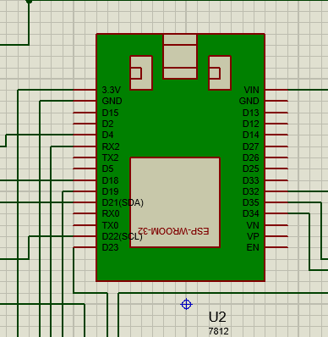
Fig 1
2) RFID reader- The RFID reader module is used to read the unique identification number from the RFID card. The purpose of RFID reader is to transmit and receive personal information onto various forms of storage and retrieve the data when needed. RFID readers can identify RFID tags through the use of radio signals. Through RFID tags an electronic identity is generated. The microcontroller will transmit the RFID data to an IoT gateway or directly to the cloud. Here, the data can be processed, analyzed, and stored for specific actions such as to grant access, track or monitor when connected it to the IOT server.
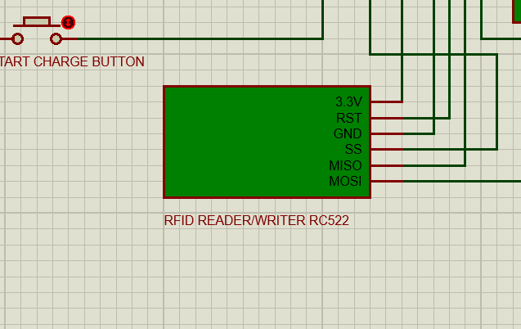
Fig 2
3) Relay- Relays can be used in the charging system of electric vehicles for safety and isolation. The relay we are using will connect the charging unit with the battery. The main function of a relay in the charging unit is to connect or isolate batteries from the charger to ensure safety. The relay contacts are normally closed but if high current flows to the battery the relay gets activated and contacts gets opened interrupting the current to cut off or de-activate it from the charger unit.
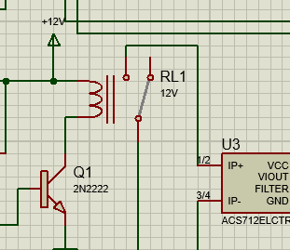
Fig 3
4) LCD Screen 20X4- In the LCD Screen the status of voltages and currents are shown in the display. And we can know whether the car battery is in charging or discharging mode.
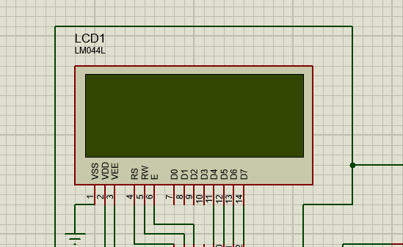
Fig 4
4.2 DESIGNING OF WEB APPLICATION

WAMP is a stack of software’s. It stands for Windows Apache MySQL and PHP. WAMP acts together and installs Apache, MySQL and PHP. It is used for operating websites and applications built on PHP files. PHP is the programming language for Web development that runs in Apache and communicates with MySQL database. To make Wamp work on website we need to have a hosting service and a domain.
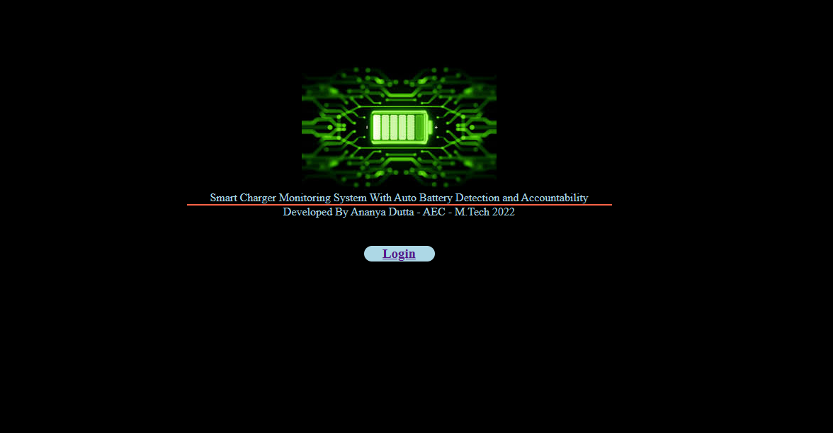

Fig 5
This is a log in file also known as welcome file built for a secure data handling, where user is required to key-in username and password.

CHAPTER 5

Hardware and its components
The software model is designed using PROTEUS 8 PROFESSIONAL. It is a software tool used for electronic designs. The hardware components used were:
5.1.1. ESP32
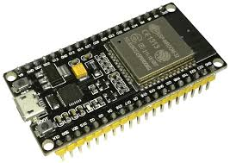
Fig 5.1

ESP32 is a highly-integrated solution for Wi-Fi-and-Bluetooth IoT applications, with around 20 external components, designed for low power applications, ESP32 integrates an antenna switch, RF balun, power amplifier, low-noise receive amplifier, filters and power management modules. It also has ultra-low-power 40 nm technology. It is designed to achieve the best power and RF performance, showing robustness, versatility and reliability in a wide variety of applications and power scenarios.
Features of the ESP32 include the following:
- Processors:
  - CPU: Xtensa dual-core (or single-core) 32-bit LX6 microprocessor, operating at 160 or 240 MHz and performing at up to 600 DMIPS
  - Ultra-low power (ULP) co-processor
- Memory: 320 KiB RAM, 448 KiB ROM
- Wireless connectivity:
  - Wi-Fi: 802.11 b/g/n
  - Bluetooth: v4.2 BR/EDR and BLE (shares the radio with Wi-Fi)
- Peripheral interfaces:
  - 34 × programmable GPIOs
  - 12-bit SAR ADC up to 18 channels
  - 2 × 8-bit DACs
  - 10 × touch sensors (capacitive sensing GPIOs)
  - 4 × SPI
  - 2 × I²S interfaces
  - 2 × I²C interfaces
  - 3 × UART

5.1.2. Buck Converter: Buck converter or step-down voltage regulator. It’s a type of DC-DC converter. It provides much greater power efficiency making task such as converting supply voltage to lower voltages. It's widely used in various electronic devices and power supplies where efficient voltage conversion is necessary. The output voltage can be adjusted by controlling the duty cycle. The buck converter is used to charge our battery. We are using a 300W buck converter.
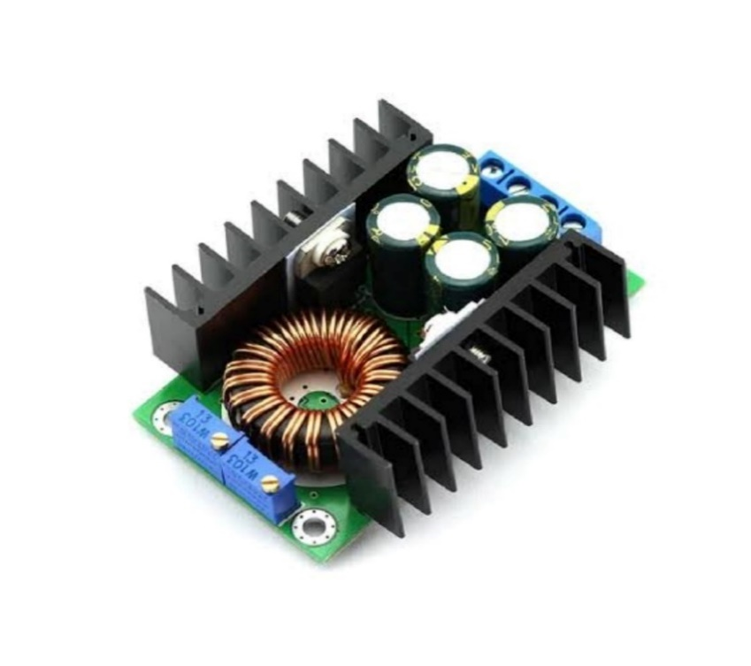
Fig 5.2
5.1.3. LCD Display: In a 20×4 LCD module, the status are displayed. Voltage and currents are shown in the display. And we can know whether the car is in charging or discharging mode.

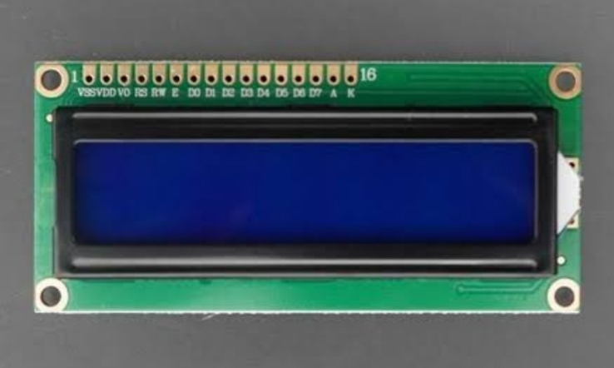
Fig 5.3 (i)

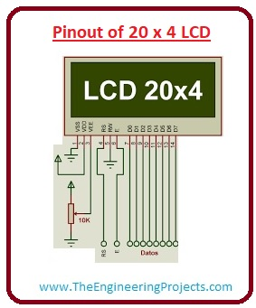
Fig 5.3 ii
5.1.4. Serial To Parallel Converter: This I2C Serial to Parallel Converter is a device or integrated circuit that translates data from a serial format, such as I2C (Inter-Integrated Circuit), into a parallel format. The converter contains logic circuitry that interprets the serial data received over the I2C bus and converts it into parallel format. They can be used to interface microcontrollers or other serial devices with parallel displays or where data needs to be translated between serial and parallel formats.
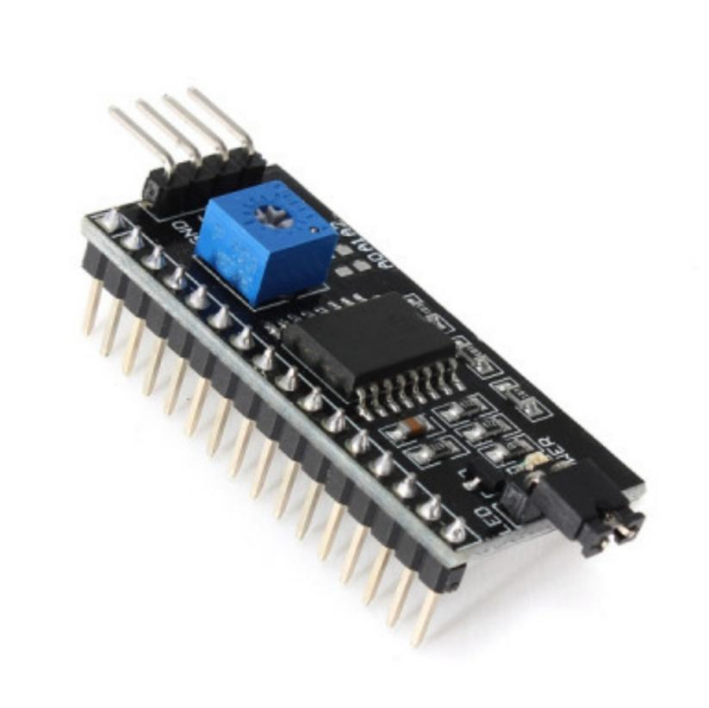
Fig 5.4
5.1.5 Diode: It is a two-terminal component in which current always flows from anode to cathode. This power diode has high current used for circuit protection and voltage rectification. This diode has a continuous reverse voltage rating of 1000V and is suitable for handling forward currents up to 3000mA/3A. The diode has a forward voltage drop of 1.2V.
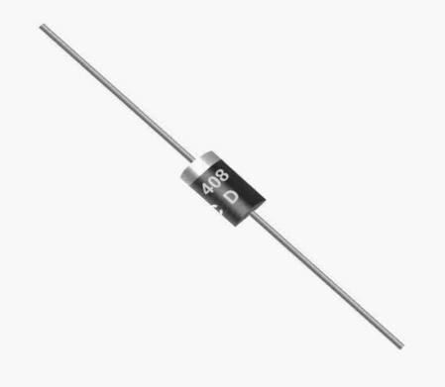
Fig 5.5
5.1.6 Transistor: It is NPN bipolar junction transistor used for low power amplifying or switching applications. The 2N2222 can be used for a variety of applications like switching and amplification of analog signals. The unique advantage of this transistor is that it has the capacity to handle high currents. NPN transistors are generally employed in very high frequency amplifiers. The 2N2222 transistor provides a constant DC collector current of 800mA, 225m storage time and 25ms rise time to operate on high transition frequency of 250 MHz
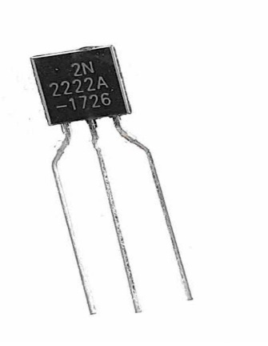
Fig 5.6
5.1.7 Voltage regulator: Voltage regulators play a crucial role in ensuring stable and reliable power supply in electronic circuits. They are commonly used in a wide range of applications, including power supplies for electronic devices, battery charging circuits etc. A voltage regulator is commonly used in power supplies where a stable voltage is required. They provide a stable output voltage regardless of changes in input voltage or load conditions. Here 7812 voltage regulator is used to step down the voltage from the buck converter to 12 volts.
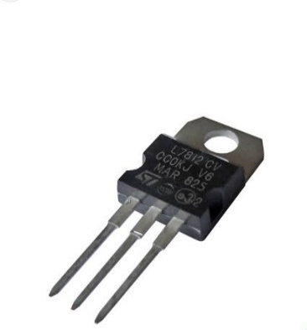
Fig 5.7
5.1.8 Current Sensor: The current sensor is used in various applications requiring current sensing, such as motor control, power management, battery chargers, and electronic loads. It provides a convenient and accurate means of monitoring current levels within a circuit. This is a current sensor that provides a solution for AC or DC current sensing. ACS712 current Sensor is the sensor that can be used to measure and calculate the amount of current applied. This current Sensor is a fully integrated, hall-effect based linear sensor. The ACS712 is a reliable and versatile current sensor suitable for a wide range of applications where precise current measurement is required.
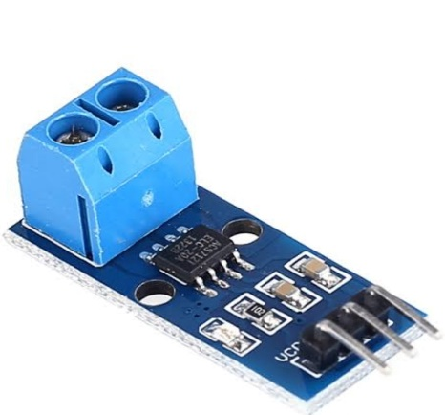
Fig 5.8
5.1.9 Buck Converter: It is a DC-DC converter which steps down the voltage. It provides greater efficiency that lowers voltages by dissipating power as heat. It can be used for converting a computer’s main supply voltage lower voltages needed by USB. Buck converters typically operate with a switching frequency range from 100kHz to a few MHz
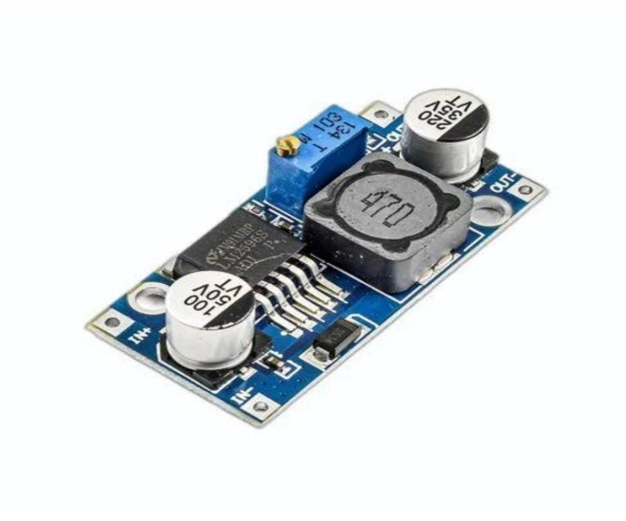
Fig 5.9
5.1.10 Capacitors: Capacitors are electronic components that store and release electrical energy in the form of an electric field. It consists of two passive terminal that stores electrical energy. Capacitors are used to store electrical energy in applications and this energy storing effect is known as capacitance. Capacitors are used in voltage regulation circuits to provide voltage suppression and voltage smoothing in applications such as voltage regulators. It helps suppress transient voltage spikes or fluctuations that may occur due to sudden changes in load current or other external factors.

Fig 5.10
5.1.11 Relay: Relays are electromechanical switches that are used to control high-power or high-voltage circuits with a low-power signal. They consist of a coil (electromagnet) and one or more sets of contacts. When the coil of the relay is energized, it generates a magnetic field that attracts an armature, causing the contacts to close or open, depending on the relay type. Relays provide electrical isolation between the control circuit (coil) and the controlled circuit (contacts). This isolation ensures that the high-power circuit does not affect the low-power control circuit and vice versa. It also provides safety to facilitate communication and coordination between the vehicle and the charging equipment. Here the relay is used as a medium between the buck converter and the battery.
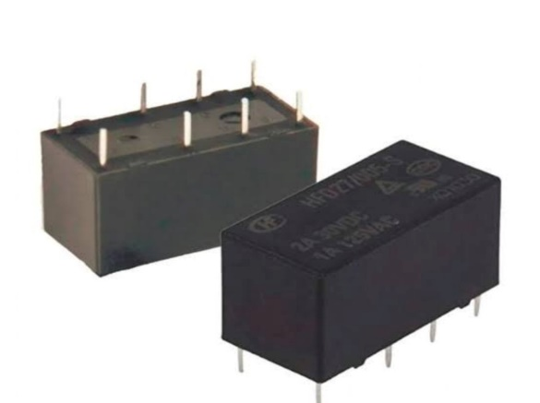
Fig 5.11
5.2 Hardware at a glance
With the combination of all the above-described components the prototype model has been fabricated. Below is a capture of labelled working hardware model.

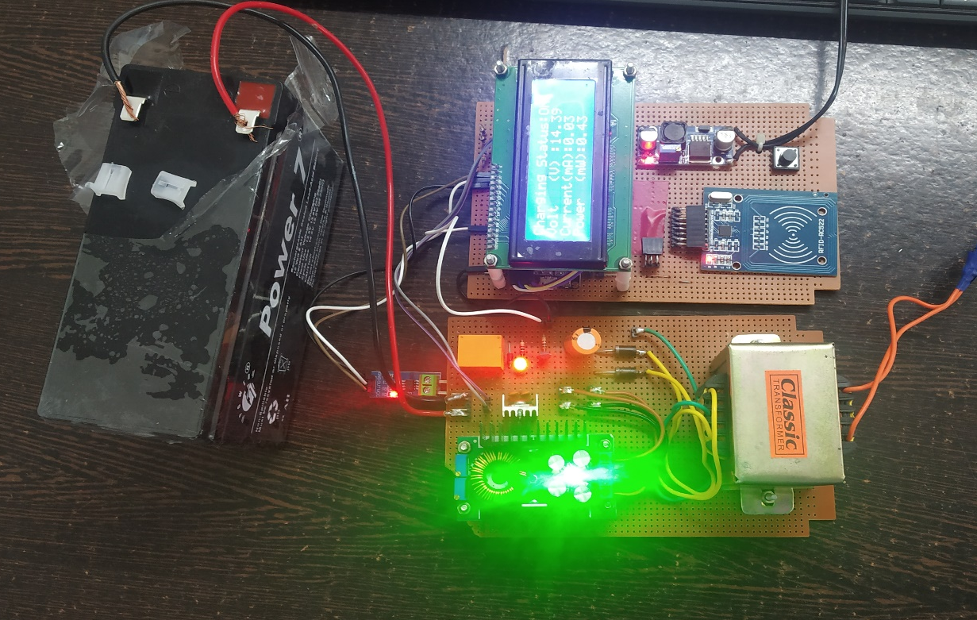
RFID Reader
LCD Display
Buck Converter
7812 Voltage Regulator
Current sensor
Capacitor
Diodes
Relay
Switch
Buck Converter
Battery
Volt regulator
Fig 5.2 (a) Hardware

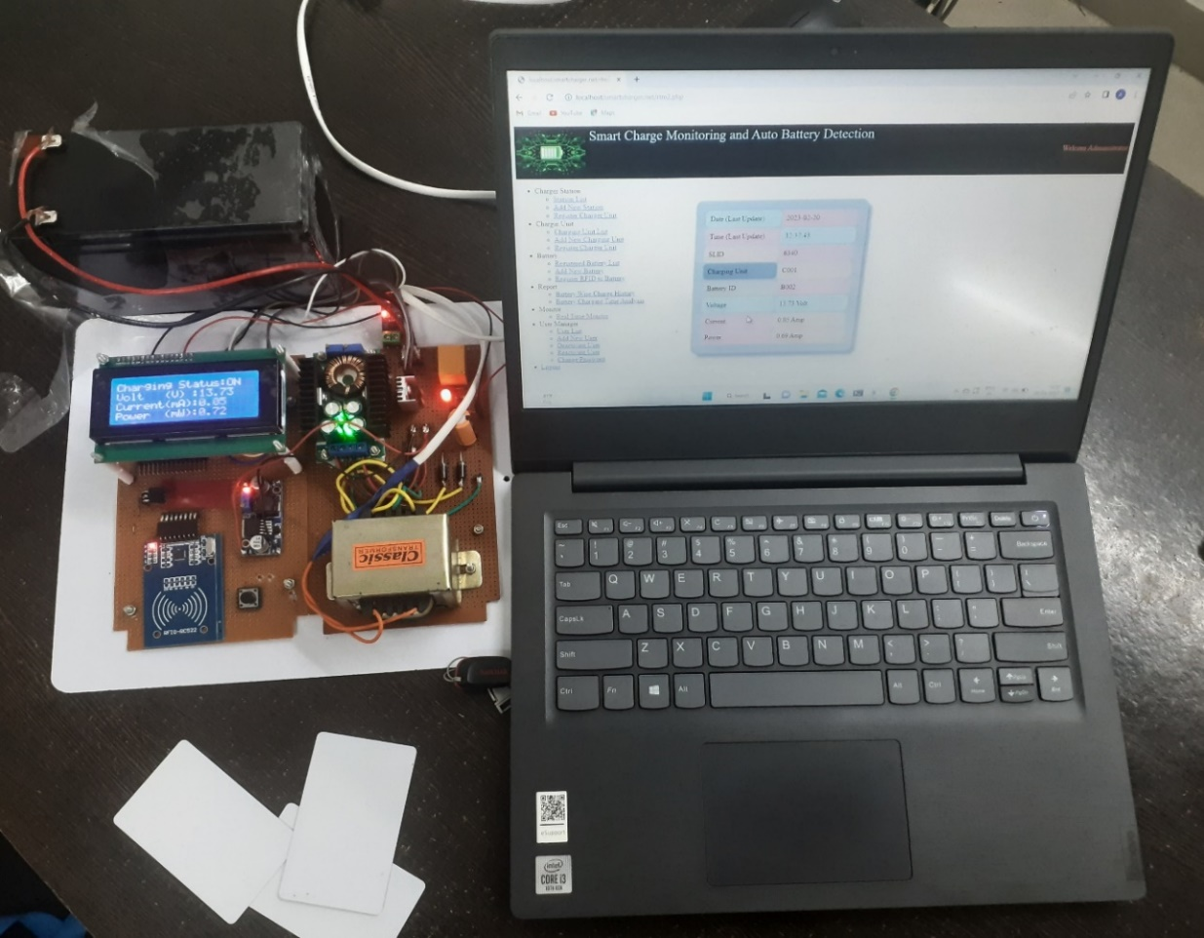
Fig 5.2 (b) Working Model

CHAPTER 6
APPLICATION
6.1 APPLICATION DESIGN
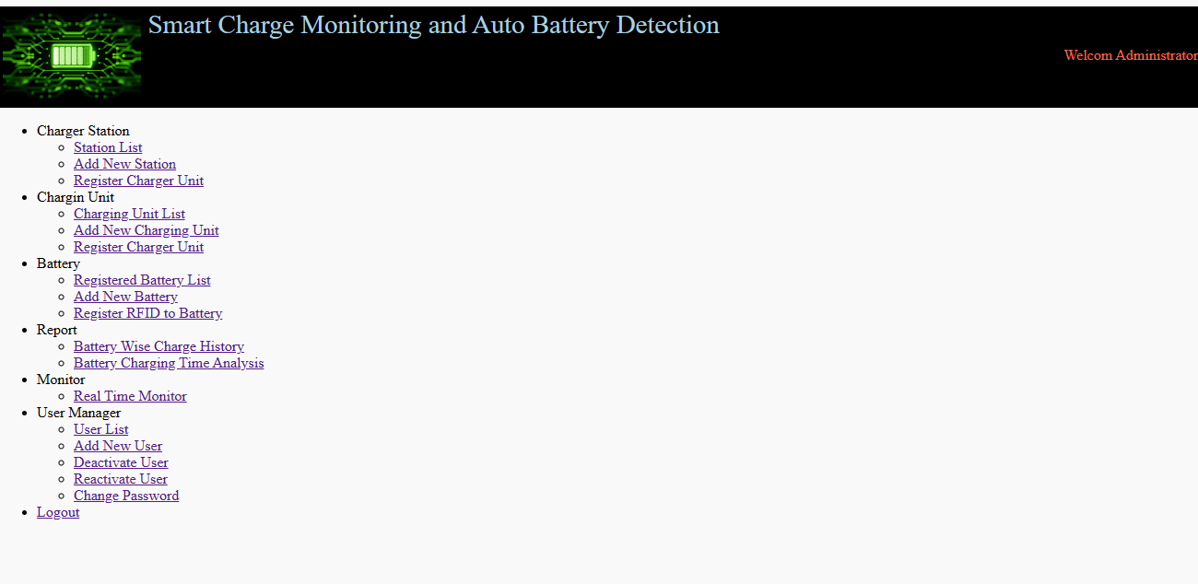
Fig 6.1 Software application
We have connected our computer with the web server application WAMP, installed in our local system. Several display buttons are provided to enter various other lists to receive more information. Information that are seen in menus are charging stations, customers, activities, data reports and administrators. Some of the features and modules that we have added are as follows:
6.1.1 Charger Station
6.1.2 Charger Unit
6.1.3 Battery
6.1.4 Report
6.1.5 Monitor
6.1.6 User Management

6.1.1 Charger Station
Station List
The Station list contains of a list of different charging stations from where battery charging can be done. The area and location of each charging station for EVs are mentioned in the list. Information related to new charging stations and addition of new CS can be done here.

Fig 6.1.1.a
Add new Station
As the growth of electric car owners are increasing on road with EV charging, it is clear that demand for more charging stations will increase in time, that requires more charging stations. Here in this prototype when new stations are to be installed, they can be added in this station list.
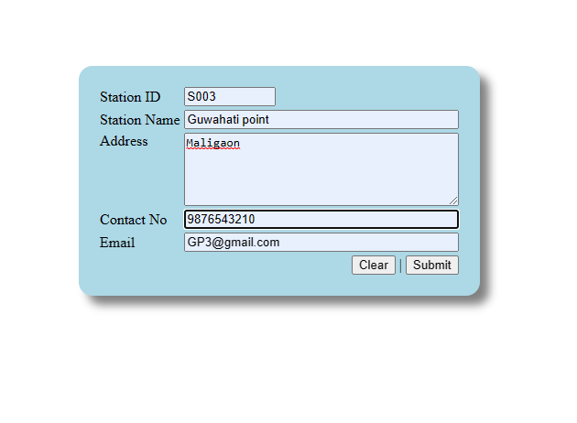
Fig 6.1.1.b
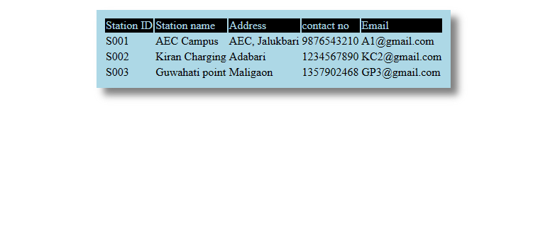
Fig 6.1.1.c
Register Charger Unit
Each station will have a registered charger ID so that it can detect the battery whenever it will be connected to the charging point.
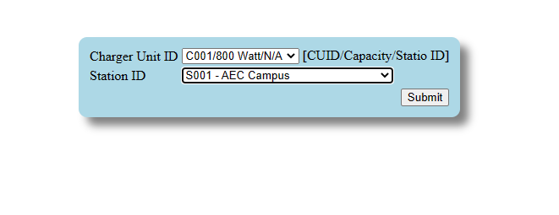
Fig 6.1.1.d
6.1.2 Charger Unit
Charging Unit List
Each station can have many charger points. The power output is pulled from the charger and is given to the vehicle’s battery. This unit list comprises of charger id alongside the station id. Charging is done depending on the rated capacity of the EV’s battery. Numerous EV products with variety in charger types, price and applications can be used. Here we have considered 800W charger in our project.

Add new Charging unit
New charging units can be added depending on the availabilities of EVs in the market. Stations where charger units are assigned, may also have wide range of powers to handle different ranges of powered vehicles.
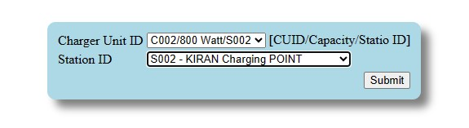
Fig 6.1.2.b

Register Charger Unit
To charge an electric powered car in charging station we have to select and register a charger from the station. For a charging station can have more than one charging slots. Therefore, the charger point has to be selected at first. This is done so that all information related to EVs can be stored on cloud and can have access to it.
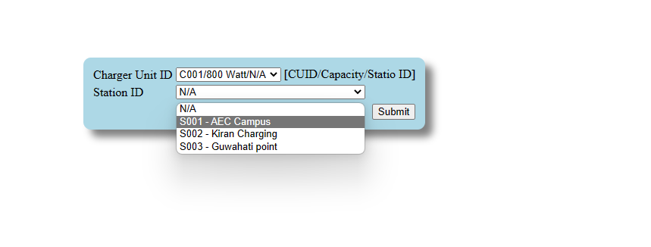
Fig 6.1.2.c
6.1.3 Battery
Registered Battery List
In the registered battery list the battery details and the owners are mentioned along with RFID tag. The details of vehicle will be stored in the system. And if the user is not registered the system will show invalid user and will not be able to charge the battery.
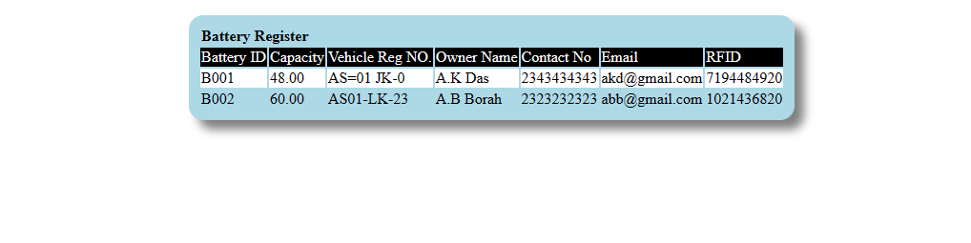
Fig 6.1.3.a
Add new Battery
When new batteries are registered RFID card reader will recognize the battery. Only once a user is identified, the system than start charging.
Register RFID to battery
Each battery will have a separate RFID tag. When a battery is registered with RFID the system will identify the battery. Along with charging it will also keep a record of its voltage, current and how frequently a vehicle is charging. The details will be displayed on an LCD. In this way the battery related issues like charging problems or careless handling of the batteries and accidental exchange of batteries will reduce and can be found out by looking at the history.
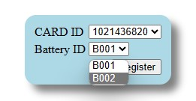
Fig 6.1.3.b
6.1.4 Report
Battery Wise Charge History
Charging of battery differs from vehicle to vehicle. It depends on many factors like the model of the car, capacity of battery, weather conditions and so on. Charging can be both AC and DC charging. We have considered here only one battery.
Battery Charging Time Analysis
Battery charging analysis provides a real time data of each battery unit. It gives a list of battery charging with Date, Time, Charger unit ID, Voltage, Current, Power.
Fig 6.1.4
6.1.5 Monitor
Real Time Monitor
The developed battery monitoring system is capable of monitoring multiple battery monitoring devices and the conditions of batteries. Figure 6.e shows the web-based user interface. Once the user has selected the registered battery with the charger unit the monitoring interface is displayed. The devices will show the information such as battery voltage, current, power reading and measured time. This information can be used for the user/admin to know about their battery condition especially during critical battery condition or degraded battery.
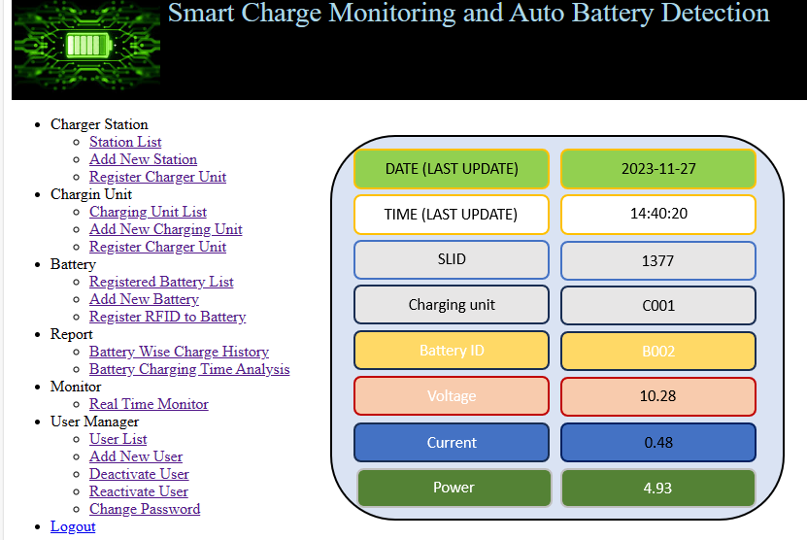
Fig 6.1.5
6.1.6 User Management
User List
The user list contains the user or customers that are related to the software. It is used by customers to access their individual battery operations by creating their passwords. In order to reduce the risk of unauthorized access of data, only the admin is able to configure customers battery information.
Add New User
This is used to add more users in the list by creating user details like user ID, username and password. To add, delete and modify or reactivate users from the list these features are used to help them administer their accounts. Only the admin can add or delete users.
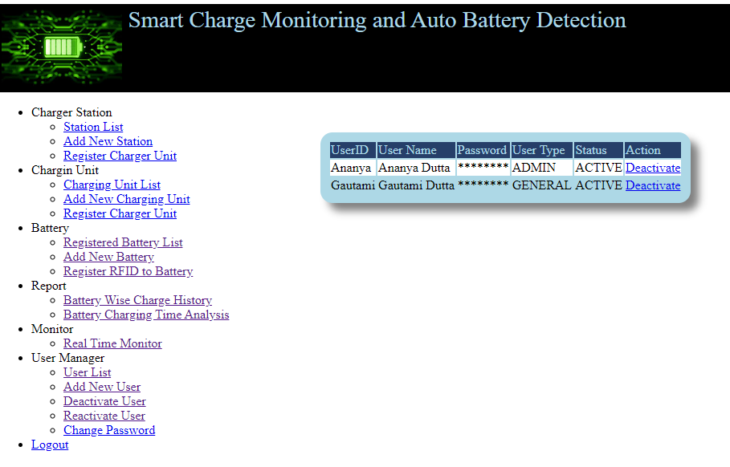
Fig 6.1.6

6.2 Charging Station Management System
RFID
USER ID, Password
Charging Station Monitoring System
USER
BATTERY
Battery Detect
Login Permission

BATTERY
RFID

Fig 6.2.1

6.2.2 Login Process

Login Process
USER
USER
USER ID, Password

ACKNOWLEDGEMENT
Permission
Battery Management Process
BATTERY
Details
Data Capture and Update process
Charger Status
Data Log
Report generate Process
USER
CUID BID
Report
USER ID, Password

BID Details

Fig 6.2.2

CHAPTER 7
Working of the project:
Working Principle of the project work “Smart battery charge monitoring and autodetection of individual battery and accountability” is based on blending of electronics embedded system and Web technology. The entire system is primarily divided into 3 segments:
1. The Hardware Section
2. The Firmware Section
3. Web Technology/Web Application
In this system we have used RFID technology to identify batteries. In our system every battery will be associated with an RFID card or RFID tag. When the battery attached with the card or the card itself placed near the RFID reader, the RFID reads the unique identification number from the card of a radio frequency. The received RFID number is transmitted to the web server using Wi-Fi communication. A program executing on the web server is responsible for receiving information to check in with the database for the existence of relevant records associated with the card. If it has corresponding records, such as battery ID, vehicle number, owner name, and contact information, it sends this information back to the battery charger unit. The program executing in the hardware section is responsible to display data on the LCD screen. The program executing in the hardware section is responsible for checking whether the charging button has been pressed or not. If charging button is pressed it activates a relay circuit based on 2N2222 NPN transistor. This transistor is responsible for completing the circuit of the relay coil. When the relay is switched on, the charging circuit connects with the battery and the voltage sensor and the current sensor is responsible for monitoring the current status of the battery. The system is designed in such a way that when it calculates charging voltage and the flow of current, it transmits this information along with the charging unit ID, voltage and current from the device as well as data and time from the computer system and store it in database management system as data log.
In hardware section we have used a constant current mechanism. At time of charging a battery generally 10-20% of the current is used to charge battery effectively. If the current flow is lowered than 10-20% the battery charging time will increase. If the current flow is increased the battery will charge faster but it will reduce the lifetime of the battery. For charging the battery we are also using maximum 14.5V to charge the target battery. When the charge is completed, it will stop flowing the current from charger unit to the battery. From the collected data we can generate/display the state of charging with the help of a graph.
A well-defined set of web pages serve the purpose of our project work starting from user authentication to real time monitor of the charging unit in which battery is connected to the charging unit at that time, charging voltage, charging current and power. The primary novelty of this project is to uniquely identify the battery so that the charging history of each and every battery can be easily retrieved.
For measuring current sensor, we are using ACS712 and for voltage sensor a voltage divider circuit is used. The internal 12-bit ADC of ESP32 is responsible for converting the analog data into digital form.

CHAPTER 9
METHODOLOGY
  - Block Diagram
LCD
Battery
Current Sensor
Voltage Sensor
ADC
MC
Load
Wi-Fi
PC

Fig 9.1

  - Circuit Diagram

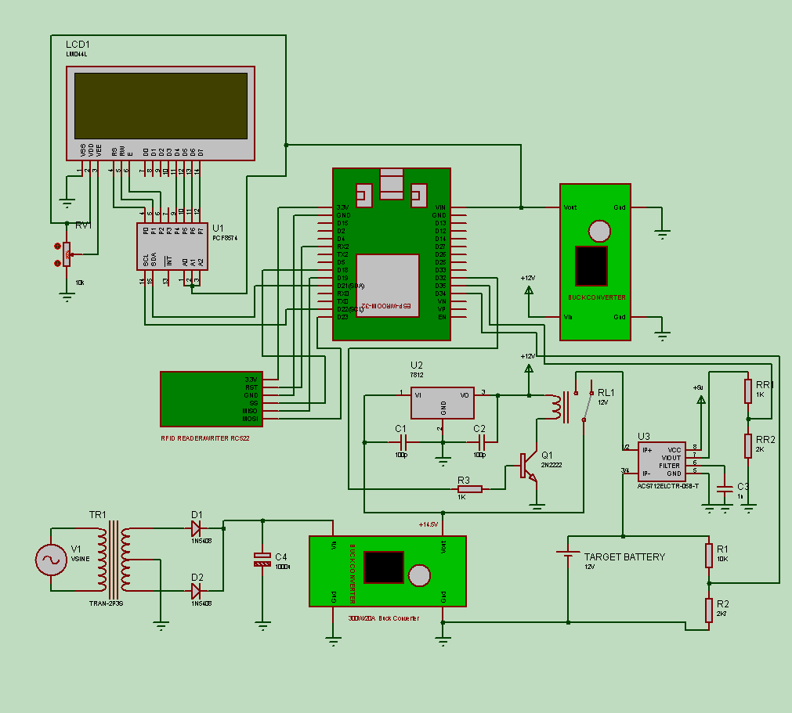
Fig 9.2
9.3 Circuit Description
The smart battery charging system with automatic battery identification is designed with ESP32 based microcontroller which is having inbuilt Bluetooth and Wi-fi communication. This microcontroller board is selected for the circuit as we have to transmit various data from the hardware section to centralized webserver. To power up the microcontroller, LCD and RFID reader we are using a buck converter. The output of the buck converter is set to 5V. To display the status of the battery identification as well as voltage, current and power due to charging we are using a 20x4 LCD module. This module has 8 data line and 3 control signals i.e., RS, RW and E response.
To detect each and every battery distinctly we are using the RFID technique. The RFID reader RC522 is used in our circuit. When the card is placed near to the RFID reader, the internal chip of the card gets powered through induction and transmit the unique id to the RFID reader. The RFID reader hands over the unique id to ESP32, which transmits it to the web application. The web app is responsible for verifying the validity of the card, and return the battery id and vehicle number to the hardware part. After the card is scanned and a valid card with the battery ID is detected, press the charge button. A push-to-momentary tactile switch is connected. to D4 pin of ESP32. The program executing in the microcontroller is responsible for monitoring the button whether it is pressed or not. When the button is pressed it activates a relay which will connect the charging unit with the target battery. We are using a 12V relay. To activate the relay an NPN transistor 2N2222 is used in the circuit. The base of transistors is connected to I/O pin D32 of ESP32 through 1K resistor.
To charge our battery, we are using constant voltage constant current mechanism. To provide the constant current we are using a 300W buck converter for maintaining constant current. The output of this buck converter is set to 14.5V. The buck converter is connected to battery through a voltage regulator. 7812 voltage regulator is connected to battery through a relay. From the battery the ESP32 transmits the data to the database management system. To measure the charging voltage of the battery, we are using a voltage divider circuit. As ESP32 can handle maximum of 3.3V and the charging unit is producing 14.5V. So, to reduce the voltage we have considered resistance R1 = 10kΩ and resistance R2 = 2.7kΩ.
$\frac{R2}{R1+R2}×Vin$ = Vout (i)
$\frac{2.7k}{10k+2.7k}×15$ =3.18V (ii)
As we can see from equation (ii) that 3.18V is less than 3.3V it can be fetched to the microcontroller. After conversion the actual voltage will display on the LCD.
To calculate the flow of current during the charging, we are using current sensor ACS712, 5A variant. The output voltage of the current sensor is also fetched to ESP32 with the help of a voltage divider circuit. Here in equation (iv) we have considered 1kΩ for resistance R1 and 2kΩ for resistance R2. By considering these values, we reduced the 5V into 3.3V.
$\frac{R2}{R1+R2}×Vin$ = Vout (iii)
$\frac{2k}{1k+2k}×5V$ = 3.33V (iv)
After calculating voltage, current and power the ESP32 prepares a http header to transmit this information to a webserver. A specially designed PHP the file is responsible for capturing all the vital information transmitted from the ESP32 and storing it in the database management system.

CHAPTER 9
RESULTS AND DISCUSSION
The performance of IoT, from collecting and sending battery-monitored features to the database and then to the user, is executed here. The battery outputs found during system execution are shown below. Table 3 displays the hourly charging data, and Table 4 presents the discharging data acquired from the BMS-IoT platform. Figures 10.1 and 10.3 below illustrate a comparison of battery charging and discharging performed over a span of a few hours. The graphs depict results of monitored voltage, current, and power collected from the database. The interconnectivity of sensors and software on a network platform helps connect the batteries in real-time, keeping track of their charging conditions.
During Charging:

Fig. 10.1 Battery charging performed for 4 hours

Table 3 Data acquisition from BMS-IoT system

Time | Power
1:13:10 | 0.77
2:43:38 | 2.48
3:44:23 | 3.8
4:55:45 | 7.73
5:41:04 | 8.88

Fig. 10.2 Comparison of data for multiple hours

During Discharging:

Fig. 10.3 Battery discharging performed for 4 hours

Table 4 Data acquisition from BMS-IoT system

Time | Power
04:57:41 | 8.17
05:47:21 | 7.60
06:31:16 | 5.63
07:02:44 | 3.63
08:21:15 | 0.44

Fig. 10.4 Comparison of data for multiple hours
Charging and discharging of batteries vary based on many factors such as capacity of battery, chemistry, age and temperature of the battery. Temperature differences either hot or cold can affect the efficiencies and speed of charging and discharging. Also, the level of charge can impact in the charging and discharging of batteries like a depleted battery charges more quickly than a full capacity battery. Using older batteries that were used for heavy duty gets reduced in its efficiencies and so on.

CHAPTER 10
CONCLUSION
We have focussed our work on automatic detection of individual battery and maintained a charging and discharging data history for analysis. We have implemented an IoT based system using RFID, which has the ability to collect data to generate reports. Our system features an RFID card reader to recognize a battery. Once a registered battery has been identified by the system it then starts charging the battery. But before a user can charge his/her vehicle, he/she has to register their respective cards. After registering, the battery can be connected to the charging port. Once identified as a valid user the system then starts charging the battery. Along with charging, the system also keeps a record of how frequent the user charges their battery. IoT interface in our project detects the voltage and current of the battery. Use of IoT has made the system more user friendly and effective in terms of record keeping. It connects, gathers and processes data in real-time making it beneficial for user.
Our unit constitutes of a hardware model established at a charging station that provides a connectivity between the power supply and the battery. The unit comprises of power electronic devices, charging protocols and sensors. The devices perform operations like engagement and disengagement of the charging port, energy metering and tracking of health status of batteries. IoT in the EV charging system is responsible for connecting the EV charging network to the EV owners. Some of the major operations include battery authentication and charger on boarding. It is a cloud-based platform that gathers data from IoT sensors and devices to perform data analytics. IoT in the EV charging system enables continuous monitoring and gathering of data to present in reports.

REFERENCE
- Maltezo Melbern Rose C., August C. Thio a-c, Castillo Anna May C. Castillo, Leandro E. Gattu, Carmine Ella A. Hernandez, Jonarld John C. Labuan, ... & Lean Karlo S Tolentino, “Arduino-based battery monitoring system with state of charge and remaining useful time estimation, “International Journal of Advanced Technology and Engineering Exploration, Volume 8 Issue 76, April 2021.
- Elie Ayoub and Nabil Karami, “Review on the charging techniques of a Li-Ion battery” 2015 Third International Conference on Technological Advances in Electrical, Electronics and Computer Engineering (TAEECE) pp. 50-55 April 2015.
- Jennifer S. Raj, “Security enhanced blockchain based unmanned aerial vehicle health monitoring system” (2021) Journal of ISMAC, Volume 3 Issue 02 pp.121-131 June 2021.
- L. Chitra, M. Prabhu Raj, B. Keerthivaishnavi, G. Madhusowmiya, P. Rathna Praveen, “Design of Charge Controller for Electric Vehicle” International Journal of Recent Technology and Engineering (IJRTE), Volume-8 Issue-6, ISSN: 2277-3878 pp.355-370, March 2020.
- Tianxiang Jiang, Ghanim Putrus, Zhiwei Gao, Matteo Conti, Steve McDonald, Gillian Lacey “Development of a decentralized smart charge controller for electric vehicles” (2014). International Journal of Electrical Power & Energy Systems, pp. 355-370 March 2014.
- Ebole Alpha F., Prof. Omotosha O. J, “Vehicle Health Monitoring System in A Developing Nation” International Journal of Engineering and Computer Science, Volume 3 Issue 5, ISSN: 2319-7242 May 2014.
- IIario Antonio Azzollini, Valerio Di Felice, Francesco Fraboni, Lorenzo Cavallucci, Marco Breschi, Alberto Dalla Rosa, Gabriele Zini, “Lead-acid battery modeling over full state of charge and discharge range” IEEE Transactions on Power Systems, Volume 33 Issue 6 pp.6422-6429 June 2018.
- Liang Rui Chen, “Design of duty-varied voltage pulse charger for improving Li-ion battery-charging response” IEEE Transactions on Industrial Electronics, Volume 56 Issue 2, pp. 480-487 February 2009.
- Zong-You Hou, Pang-Yen Lou, Chua Chin Wang, “State of charge, state of health, and state of function monitoring for EV BMS” IEEE International Conference on Consumer Electronics (ICCE), ISSN: 2158-4001 (pp. 310-311 March 2017.
- Prakhar Prakash, “Automotive Health Tracking Using IOT and Arduino” International Journal of Engineering Applied Sciences and Technology. IJEAST Volume 6 Issue 5, ISSN No. 2455-2143 September 2021.
- Koko Friansa, Irysad Nashirul Haq, Bening Maria Santi, Brian Yuliarto, Deddy Kurniadi, Edi Leksono, “Development of battery monitoring system in smart microgrid based on internet of things (IoT)” Engineering Physics International Conference, EPIC, Volume 170 pp.482-487 2016.
- Ruben A Sousa, Vitor Monteiro, Joad C. Ferreira, Melendez, Andres A. Nogueiras Melendez, Joao L. Afonso & Jose A. Afonso, “Development of an IOT System Charging current control for Electric vehicles” In IECON 2018-44th Annual Conference of the IEEE Industrial Electronics Society IEEE pp. 4662-4667 October 2018.
- Kasa Sudheer, K Hemanh Kumar, N Puneethkumar, K Vishnuvardhan Reddy, (2020, March), “IOT based intelligent smart controller for electric vehicles” In 2020 6th International Conference on Advanced Computing and Communication Systems (ICACCS) IEEE pp. 539-544. April 2020.
- Zeinab Moghaddam, Iftekhar Ahmad, Daryoushr Habibi, & Quoc Viet Phung, “Smart charging strategy for electric vehicle charging stations”. IEEE Transactions on transportation electrification, Volume 4 Issue 1, pp.76-88 2017.
- Zengquan Yuan, Haiping Xu, Huachun Han, & Yingjie Zhao, “Research of smart charging management system for electric vehicles based on wireless communication networks” In 2012 IEEE 6th International Conference on Information and Automation for Sustainability IEEE pp. 242-247 September 2012.
- Benzai Deng & Zhiqiang Wang, “Research on electric-vehicle charging station technologies based on smart grid” In Asia-Pacific Power and Energy Engineering Conference IEEE Computer Society, pp. 1-4 April 2011.
- Prasetyo Aji, Dionysius Aldon Renanta, & Adisa Larasati, “Development of Electric Vehicle Charging Station Management System in Urban Areas” in 2020 International Conference on Technology and Policy in Energy and Electric Power IEEE pp. 199-203 September 2020.
- Seoung UK Jeon, Jung-Wook, Byung-Kwan Kang, & Hee-Jin Lee, “Study on battery Charging Strategy of Electric Vehicles considering battery capacity” IEEE pp.89757-89767 June 2021.
- Naoui Mohamed, Flah Aymen, Turki E. A. Alharbi, Claude Ziad El-Bayeh, Sbita Lassaad, Sherif S. M. Ghoneim, & Ursula Eicker, “A Comprehensive Analysis of Wireless Charging Systems for Electric Vehicles” IEEE Access, pp.43865-43881 April 2022.
- Meng Di Yin, Jiae Youn, Jeonghun Cho, & Daejin Park, “MCU-based Battery Management System for Fast Charging of IoT-based Large-Scale Battery-Cells” International Journal of Applied Engineering Research, Volume 12 Issue 7, pp.1329-1333 January 2017.
- Llona Madalina Costea, & Vasile Plesca, “Automatic Battery Charging System for Electric Powered Drones” In 2018 IEEE 24th International Symposium for Design and Technology in Electronic Packaging (SIITME) IEEE pp. 377-381 October 2018.
- Bita Arabsalmanabadi, Nima Tashakor, Alireza Javadi, & Kamal Al-Haddad, “Charging techniques in lithium-ion battery charger: Review and new solution” In IECON 2018 44th Annual Conference of the IEEE Industrial Electronics Society IEEE, pp. 5731-5738 October 2018.
- Hany A. Serhan, & Emad M. Ahmed, “Effect of the Different Charging Techiques on battery Life-Time” In 2018 International Conference on Innovative Trends in Computer Engineering (ITCE) IEEE pp. 5731-5738 February 2018.
- Chien-Wulan, Shih-Sung Lin, Sih-Yan Syue, hao-Syue, hao-Yen Hsu, Tien-Cheng Huang, & Kuang-Hsiung Tan, “Development of an Intelligent Lithium-Ion Battery-Charging Management System for Electric Vehicle” In 2017 International Conference on Applied System Innovation (ICSAI) IEEE pp. 1744-1746 May 2017.
- Joao C. Ferreira, Vítor Monteiro, Joao L. Afonso, & Alberto Silva, “Smart electric vehicle charging system” In 2011 IEEE Intelligent Vehicles Symposium (IV) IEEE. pp. 758-763 June 2011.
- Alireza Khaligh, & Zhihao Li, “Battery, ultracapacitor, fuel cell, and hybrid energy storage systems for electric, hybrid electric, fuel cell, and plug-in hybrid electric vehicles: State of the art” IEEE transactions on Vehicular Technology, Volume 59 Issue 6, pp.2806-2814 July 2010.
- Ali Alsalman, Assi, Lateef N. Assi, Shabnam Ghotbi, SeyedAli Ghahari, & Ali Shubbar, “Users, planners, and governments perspectives: A public survey on autonomous vehicles future advancements” Transportation Engineering, 3, 100044 (2021).
- Zengquan Yuan, Haiping Xu, Huachun Han, & Yingjie Zhao, “Research of smart charging management system for electric vehicles based on wireless communication networks” 6th International Conference on Information and Automation for Sustainability (pp. 242-247). IEEE (2012).
- Aoxia Chen, & Sen, Pankaj K. Sen, “Advancement in battery technology: A state-of-the-art review” IEEE Industry Applications Society Annual Meeting pp. 1-10. IEEE (2016).
- Samuel Prajwal Kodali, Dr. Soumitra Das, “Implementation of five level charging scheme in lithium-ion batteries for enabling fast charging in plug-in hybrid electric vehicles” IEEE National Power Electronics Conference (NPEC) pp. 147-152 (2017).
- Muhammad Shahid Mastoi, Shenxian Zhuang, Hafiz Mudassir Munir, Malik Haris, Mannan Hassan, Muhammad Usman, Syed Sabir Hussain Bukhari, Jong-Suk Ro, “An in-depth analysis of electric vehicle charging station infrastructure, policy implications, and future trends” Energy Reports, 8, 11504-11529 (2022).
- Hany A. Serhan, & Emad M. Ahmed. “Effect of the different charging techniques on battery life-time” IEEE. In 2018 International Conference on Innovative Trends in Computer Engineering (ITCE) pp. 421-426 (2018).
- Hirakjyoti Sarma, & Dimpal Huzuri & Manoj Kumar Deka, “A Real Time Implementation of an IOT based Vehicle Health Monitoring System” International Journal of Recent Technology and Engineering (IJRTE). 10. 2277-3878. 10.35940/ijrte.C6338.0910321 (2021).
- Avinash V. Shrivastav, 1Sajidhussain S. Khan, Rahul K. Gupta Gupta, Ekshinge, Prajkta R. Ekshinge & Parmeshwar Suryawanshi, “Electric Vehicle Charging Station (Case study on infrastructure of EV charging station”. Journal of Emerging Technologies and Innovative Research, 7 (2020).

