**A PROJECT REPORT**

**ON**

**Design and Development of IoT Based Transformer Oil Condition Monitoring System**

*Submitted in partial fulfilment of the requirements for the award of Degree of*

**MASTER OF TECHNOLOGY**

*In*

**ELECTRICAL ENGINEERING**

*With Specialization*

*In*

**POWER SYSTEM ENGINEERING**

Session: 2018-2020



*Submitted By*

**Iftikar Rahman**

Roll No: 180620032007

*Under the guidance of*

**Dr. Deba Kumar Mahanta**

Assistant Professor

**DEPARTMENT OF ELECTRICAL ENGINEERING**

**ASSAM ENGINEERING COLLEGE**, **GUWAHATI- 781013, ASSAM (INDIA)**

**CHAPTER 1**

**INTRODUCTION**

**1.1 Why Transformer Oil Monitoring is Important:**

The electrical transmission network is very large and complex. Long and high voltage transmission lines are necessary for transmitting the huge blocks of power from the sources of generation to the load centers. In between the powerhouses and receiving substations, and the ultimate consumers, no. of transformers having capacity of hundreds of MVA to hundreds of KVA or even less (distribution transformers) are installed. Anything going wrong anywhere with any transformer, a very huge area will be affected. Therefore, it becomes very important to monitor the transformer health, which is responsible for uninterrupted power supply. The transmission lines and circuit breakers also contribute for the same, but practically the weak link is transformer. As we all know, the petroleum-based mineral insulating oil is used in transformer as a coolant and as a dielectric medium, i.e., the oil is used for giving cooling effect as well as for providing insulation. Suppose everything else is healthy for a transformer except oil, which is not a part of workman-ship for manufacturing a transformer, the contaminated oil or the deteriorated oil can lead to tripping of transformer or failure of transformer or in the worst-case bursting of transformer. So, it is very important to monitor the condition of transformer oil. Periodic monitoring of transformer oil is necessary to ensure safe, economical, trouble free and uninterrupted power supply.

Deterioration of the transformer oil begins from the moment it is filled into the transformer. The oil produces undesirable products like acids, sludge, moisture etc. Under normal operating conditions a minimal breakdown of oil quality will occur from oxidization and contamination. Oxidization is acid that forms in the oil when it comes in contact with oxygen. The acid will form sludge which get deposited on the transformer windings, tank walls and at the bottom of the tank. Being bad conductor of heat, sludge greatly reduces the heat transfer from the windings to the oil and increases the temperature of the windings. Moreover, sludge blocks the cooling tubes and further increases the temperature which in turn create more sludge and overheating may make the transformer unusable. The high acid content and increased temperatures will accelerate the deterioration of the insulating qualities of the oil and if left untreated will cause the transformer to fail. Sometimes to prevent sludge, certain chemicals called inhibitors are added to the transformer oil.

Contamination commonly found in transformer oil includes moisture and particulate. The presence of either of these contaminants will reduce the insulating qualities of transformer oil. Transformer oil can hold water particles in suspension depending on the temperature of the oil. If the oil is at its saturation point, there is likely to be free water at the bottom of the transformer. The dielectric strength of the oil is decreased with moisture particle present in the oil resulting short circuit between the windings. To remove the moisture content from the oil a degasification of the oil is recommended. If the water content is particularly high, a hot oil dry out should be considered. Although costlier than a degasification, this will also remove any water that may be in the core and coil assembly.

To keep the oil healthy and thus to reduce the chances of faults, the experts suggest certain tips which are mentioned below-

* Highest temperature should be recorded.
* Limit for temperature rise should be monitored.
* Allowable temperature rise should not be crossed.
* Keep temperature well within the limit.
* Moisture content should be monitored.
* Oil level should be monitored.
* Schedule should be prepared for filtering.
* On line monitoring should be adopted.
* Attempt should be made for opportunity maintenance.
* Loading on transformer should be monitored.

Hence, we have chosen two important parameters of transformer oil for monitoring through IOT for this project, they are Temperature and Moisture content.

**1.2 Aim and objective of the project:**

Our objective of the project is to develop a system that is capable of collecting real time data of transformer over the internet falling under the category of Internet of Things (IOT). For this real-time aspect, we take one temperature sensor, one moisture sensor for monitoring temperature of the transformer oil and moisture content present on it and then send the data to a remote location. In our circuit we are using DS18B20 temperature sensor, which is digital by nature i.e. the sensor itself has inbuilt ADC and provide digital data to the microcontroller directly. Therefore, ADC is not needed to interface with DS18B20. But the moisture sensor collects data in multiplexing mode and to convert the analog data to digital we have to use ADC. In our circuit we are using 12-bit ADC MCP3204. The values of the sensors will be sent sequentially as per the frequency of multiplexing of the ADC by Microcontroller. After collecting and converting the input from the sensor into a presentable form it will be displayed on the LCD. At the same time the information will be posting into the WEB server. To establish the communication between the microcontroller and the web server we are using ESP8266. ESP8266 is having number of variants, we are using V1 of ESP8266. It has 8 pins in DIP mode.

The basic block diagram of the system is given below-

MICRO-CONTROLLER

5V DC REGULATOR

ESP8266 WIFI MODULE

MOITURE SENSOR

TEMPERATURE SENSOR

BRIDGE RECTIFIER

230 V AC SUPPLY

ACCESS FROM REMOTE LOCATION

WEB SERVER

Fig 1.1: block diagram of proposed system

**1.3**. **Source of motivation**

The drawbacks of the conventional transformer monitoring system and the major problems in the electricity distribution grid are

* Most of the distribution transformers are remotely located in a rural area, hills etc. where regular monitoring by human observation is difficult to perform due to insufficient manpower and geographic constraints.
* Manual monitoring systems are not supported for real time operations. Thus, we can’t detect any pre fault conditions and can’t take timely actions, therefore many transformer failures occur every year.
* In Generation and Transmission system it is very important to monitor the winding and oil temperature of the power transformers at a regular time interval which is done only manually by going to the transformer location which is laborious, time taking and not very safe.
* Distribution transformers don’t have any internal oil monitoring system.

To overcome these drawbacks, we need a smart and reliable solution to monitor the transformer parameters and send it to the server which can be accessed by the operating Engineers at the control room.

**1.4 What is Internet of Things (IoT):**

Internet of things is a system of systems that means all the devices will be connected to each other and those devices we can able to access remotely through a smartphone or through a computer. All IoT based devices perform without human intervention, and even people can interact with devices as shown in Figure 1.2



Figure 1.2 Overall operation of Internet of Things

**1.4.1 Building blocks of IoT:**

**A. End Devices/Nodes:** These are the ‘Things’ of IoT. Mostly these are the active sensing devices and actuators which collects the data and perform ground level processing. A few examples could be temperature sensors at the homes, RFID sensors at the stores, cameras at the highways and so on.

**B. Gateways/local processing nodes:**

It connects the end nodes to the network or clouds. In case of ideal IoT it should not only transfer the data collected from the sensors to the cloud but should process it to some extent and then forward the relevant information to the cloud for making predictions and inferences. It also provides the intelligence to the end nodes when sending back the data received from the applications or clouds.

**C. connectivity:**

As IoT is a network system, connectivity is an essential part of it. Service providers are coming up with many solutions around IoT to connect the end nodes to the gateways and gateways to the cloud. As this is a duplex system means the communication works bi-directionally between applications and hardware. Data or signal also flows in reverse. The connectivity could be combination of wireless or wired mechanism. eg. Bluetooth, wi-fi, GSM, Zigbee and so on.

**D. Cloud-based application or storage:**

Cloud or cloud-based application’s job is to compute the collected data, analyses it and make inferences and predictions.

* + 1. **How IoT works:**

Various sensors or the end nodes collected data from the field, provides to the gateway or the local processing units for a low-level processing and filtering and then the gateways send the signal to the connected cloud for in depth data analysis and to make inferences. The inferences drawn can be fed back to the sensors or end node and can also be sent to the business application foe continuous improvement. The devices are connected via the internet all the while and communicate seamlessly with each other so that they can make any real time change while required.

**1.4.3** **Application of IoT in Power System:**

1. **IoT in Energy Generation:**

Automating industrial processes and supervisory control and data acquisition systems (SCADA) became popular in the power sector in India in 1990s. Reliability, efficiency, environmental impacts, and maintenance issues are the main challenges of our conventional power plants. By monitoring and controlling the equipment associated with power system, the risk of loss of production or blackout or any kind of fault can be reduced. Connected sensors are being used to measure the electrical parameters like active and reactive power flow, current, voltages, phase angle, frequency etc. and physical parameters like wear and tear, vibration, temperature, and other to determine the overall health of assets from transformers to transmission lines. IoT sensors, Internet-connected devices are able to distinguish any failure in the operation or abnormal decrease in energy efficiency, alarming the need for maintenance. Thus, reliability and efficiency of the plant can be improved. Apart from these in Phasor Measurement Units (PMUs), Asset Management via NTAMC, Renewable Integration, in Energy Storage systems IoT is used satisfactorily. The important area where IoT deals with energy management systems is the smart grid. IoT extends smart grid benefits beyond the automation, distribution and monitoring being done by the utilities. Various tasks of IoT in the field of electrical energy includes:

1. advanced metering infrastructure (AMI)
2. SCADA (supervisory control and data acquisition)
3. smart inverters
4. remote control operation of energy consuming devices
5. **IoT Application in Transmission Systems:**

High voltage transmission lines come under many natural disasters as they are exposed to the nature, which can affect stability and reliability of the system. Smart transmission includes early fault detection and isolation, location recovery and outage detection. These can be fulfilled by using IoT based wireless sensor network along with transmission lines. These sensors are placed on top of the towers to detect the condition of transmission lines and send real time information even from unapproachable location like mountains, rivers, hazardous areas etc. These wireless sensors increase the reliability of the overall Power System. These transmission lines are monitored using WSN and collects parameters like current, voltage, frequency and communication to central monitoring unit at periodic intervals. IoT monitoring of transmission lines is composed of two parts: one is to monitor the transmission line conductor state while the other is to monitor tower condition state.

1. **IoT Application in Distribution System:**

The challenges of distribution companies are high electricity theft, Low billing efficiency, high human errors, inability to perform real time energy accounting, increasing tariff, low customer satisfaction etc. The solution for electricity is that remote reading of consumption data and events and remote control of electricity supply to premises. The billing efficiency can be improved by using IPv6 mandated prepaid smart meters. Low-CAPEX business models to reduce financial strain. Consumption Patterns, Load Forecasting, Power qualities, Infrastructure Investment, Outage Detection, etc. are analyzed to increase the customer satisfaction. These are done by the industrial internet of things by installing low-cost sensors and wireless communication gates that collect and process the data locally.

The most important element of a distribution system is distribution transformers. They exist everywhere from our homes to the industries. Power distribution companies are very keen to monitor transformer to keep up reliability and efficiency. Distribution’s transformer life can be predicted by monitoring the health of its oil and winding. The transformers life reduces because of high temperature of the winding and oil, presence of moisture level in the insulating oil, aging of insulating oil etc. Monitoring vital parameters improves the reliability of a power system by regularly keeping an eye over them. The electricity distribution network is mostly monitored in high and medium voltage areas. In low-voltage networks, where most customers are connected, there is no monitoring capability, so operators generally do not know what happens when a client's load profile changes. In addition, the affected network devices may be 30, 40, or even 50 years old and may have a significant impact on non-project working conditions, such as reverse energy flow. As a result, monitoring is utmost necessary to understand the design and distribution of patterns. The maintenance engineers should aware to the condition of the equipment so that they can manage their property and can avoid working conditions which are harmful for them.

**1.5 Literature Review:**

Chan et al. describe that various predicament can be faced by distribution transformers if their health is not monitored periodically. The operating parameters such as temperature of winding and insulating oil, voltage and current, moisture level of oil of a distribution transformer are vital measurement criterion which can tell about the health of the transformer. The operating condition depends on several factors such as overloading, loss of supply, voltage imbalance, oil level etc. Earlier the health monitoring system of power line or transformer was not much prevalent and the faults could only be detected after a complete blackout. It was the major disadvantage as it leads to huge amount of financial loss for the distribution or transmission company [1].

T. Leibfried describes in his paper that for the above-mentioned requirements, we need a monitoring system to analyze real time data associated with the distribution transformer to characterize various operating parameters and further provide the information to the monitoring center in requisite time [2]. This is when Internet of Things (IOT) comes into picture.

Xiao-hui Cheng et al. describes that IoT helps to invigilate the data online of the key functional factors of the distribution transformers which grants constructive data about the health of distribution-transformers which in turn will facilitate the services to use their transformers in a best possible way and increase the life of a transformer [3].

Tai-Yeon Ku et al. proposed IoT smart energy management services provide energy efficiency enhancement, energy sharing and trading services through interconnection and integration of energy supply-transfer utilization energy systems using the Internet of things [4].

F. van der Wall et al: This paper reports the development of an IoT-based condition monitoring system that offers advanced protection and control features. The condition monitoring system is intended to directly contribute to enhancing the lifespan of the transformer by detecting fault conditions at an early stage before catastrophic failure can occur and by ensuring that the quality of the transformer’s insulation is preserved for a greater period through improved cooling techniques [5].

Leny Thangiah et al: This paper proposes an architectural approach that combines the key aspects of edge computing and intelligent agents and presents experiment results using a Proof of Concept (PoC) on condition monitoring of distribution transformers in an industrial setting [6].

Divyank Srivastava et al proposed a health monitoring system that works in real time and uses temperature-sensor, potential transformer and current transformer for monitoring temperature, voltage and current of the distribution transformer and send the information to a remote server where it can be monitored and necessary action may be taken to avoid the outage of the electricity supply [7].

Rohit R. Pawar et al proposed a system where If any emergency condition occurs, immediately a message is sent to the corresponding engineer through GSM and similarly on webpage we can get alert about it through GPRS. Near the remote terminal unit buzzer will beep and LCD gives notification about emergency condition. An engineer at transformer cannot continuously keep an eye on transformer therefore given proposed system does communication with us at emergency conditions of distribution transformer through GSM/GPRS module [8].

Pawarand Wagh designed an IoT base health monitoring system for DT using the GPRS technology. The system enables the two-way communication between the transformer and the operator by sending SMS alerts [9].

Silviu C. Folea and George Mois presents the development of a compact battery-powered system that monitors the carbon dioxide level, temperature, relative humidity, absolute pressure, and intensity of light in indoor spaces, and that sends the measurement data using the existent wireless infrastructure based on the IEEE 802.11 b/g standards [10].

**CHAPTER 2**

**Temperature & Moisture Monitoring**

**Hardware System Design:**

**2.1 Overall circuit diagram:** the circuit is designed and simulated in Proteus software. The overall circuit diagram is shown below-

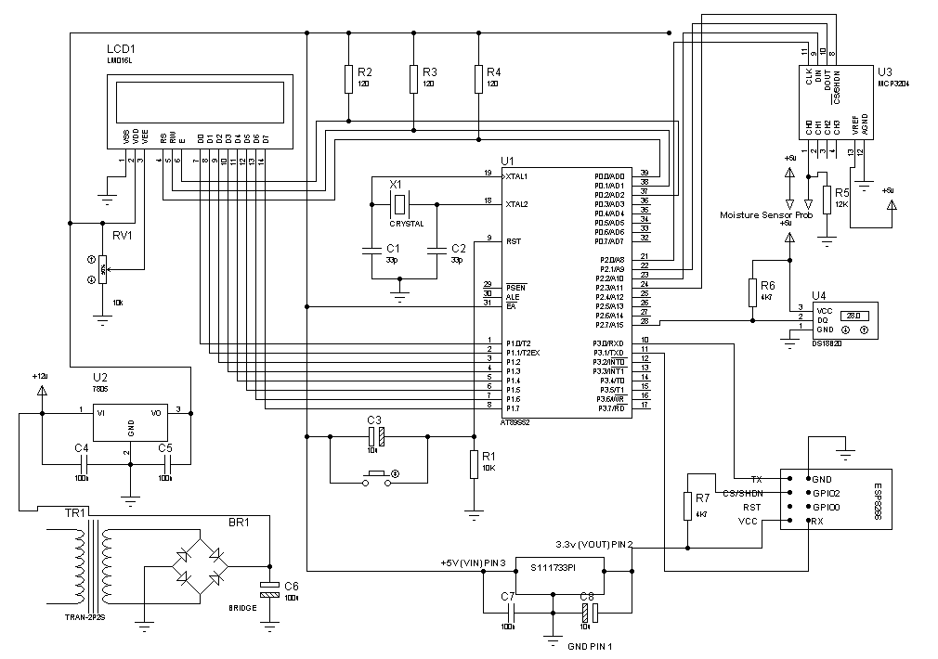

Fig 2.1: overall circuit diagram

**2.2 Circuit Description**:

The circuit designed for the oil parameters measurement/monitoring with IOT implementation is based on popular and easily available components. The heart of the system is an 8 bit microcontroller from 8052 family and the communication is established with the help of widely used and economical solution for IOT. Because of ESP8266, IOT become popular and widely used in industry. The main components of the circuit are discussed below:

**2.2.1** **Power Supply**:

The power supply to the entire system is provided from a step-down transformer TR1. We are using 220/12 V step down transformer having 760mA current rating. To convert AC to DC a bridge rectifier BR1 is used. The bridge is built with 4 rectifier diodes 1N4007.

# Bridge Rectifier:

# A bridge rectifier is formed by using four diodes in a bridge arrangement to achieve full-wave rectification. This is a widely used configuration, both with individual diodes wired as shown and with single component bridges where the diode bridge is wired internally.

**Operation:**

During positive half cycle of secondary, the diodes D2 and D3 are in forward biased while D1 and D4 are in reverse biased as shown in the fig(b). The current flow direction is shown in the fig (b) with dotted arrows.

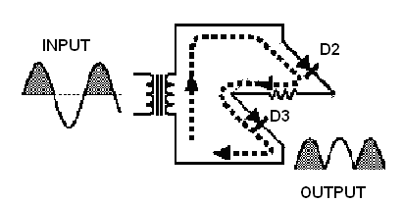

Figure (a)

During negative half cycle of secondary voltage, the diodes D1 and D4 are in forward biased while D2 and D3 are in reverse biased as shown in the fig(b). The current flow direction is shown in the fig (b) with dotted arrows.

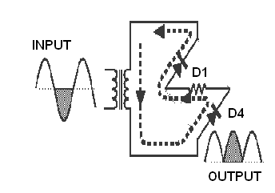

Fig (b)

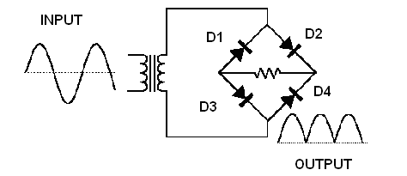

Fig(c)

Fig 2.2: Single phase full wave bridge rectifier.

**Capacitor Filter:**

After converting AC to DC, we have pulsating DC which is not suitable to power up the digital circuit. Hence to reduce the ripple and noise, a 1000µF electrolytic capacitor is connected between unregulated +12V and the ground.We have seen that the ripple content in the rectified output of half wave rectifier is 121%or that of full-wave or bridge rectifier or bridge rectifier is 48%. Such high percentage of ripples is not acceptable for most of the applications. Ripples can be removed by one of the following methods of filtering.

**(a)** A capacitor, in parallel to the load, provides an easier by-pass for the ripple voltage though it due to low impedance at ripple frequency and leave the d.c.to appear through the load.

**(b)** An inductor, in series with the load, prevents the passage of the ripple current (due to high impedance at ripple frequency) while allowing the dc (due to low resistance to dc).

**(c)** Various combinations of capacitor and inductor, such as L-section filter and π section filter, multiple section filter etc. which make use of both the properties mentioned in (a) and (b) above. Two cases of capacitor filter, one applied on half wave rectifier and another with full wave rectifier.

Filtering is performed by a large value electrolytic capacitor connected across the DC supply to act as a reservoir, supplying current to the output when the varying DC voltage from the rectifier is falling. The capacitor charges quickly near the peak of the varying DC, and then discharges as it supplies current to the output. Filtering significantly increases the average DC voltage to almost the peak value (1.4 × RMS value).

To calculate the value of capacitor(C) we have used the below formula,

C = ¼*√3*f*r* RL

Where,

f = supply frequency,

r = ripple factor,

RL = load resistance

Note: In our circuit we are using 1000µF. Hence large value of capacitor is placed to reduce ripples and to improve the DC component.

Voltage Regulator:

The microcontroller, LCD and the ADC required regulated +5V. hence a voltage regulator LM**7805** is used. Voltage regulator ICs is available with fixed (typically 5, 12 and 15V) or variable output voltages. The maximum current they can pass also rates them. Negative voltage regulators are available, mainly for use in dual supplies. Most regulators include some automatic protection from excessive current ('overload protection') and overheating ('thermal protection'). Many of the fixed voltage regulator ICs have 3 leads and look like power transistors, such as the LM7805, +5V,1A regulator shown on the right. The LM7805 is simple to use. We simply have to connect the positive lead of our unregulated DC power supply (anything from 9VDC to 24VDC) to the input pin, the negative lead need to be connected with the Common pin and then when we turn on the power, we will get a 5 volt supply from the output pin.

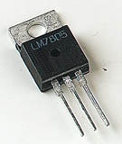

Figure 2.3: Three Terminal Voltage Regulator

**78XX:**

The Bay Linear LM78XX is integrated linear positive regulator with three terminals. The LM78XX offer several fixed output voltages making them useful in wide range of applications. When used as a Zener diode/resistor combination replacement, the LM78XX usually results in an effective output impedance improvement of two orders of magnitude, lower quiescent current. The LM78XX is available in the TO-252, TO-220 & TO-263packages,

7805 is having 3 pins. Pin1 is Vin where we can provide +5V to +18V, pin2 is ground, pin3 is regulated output. Irrespective of input voltage at pin1(+5V to +18V). the output voltage at Vout is always 5V(±0.1V). to reduce minor ripple two ceramic capacitors of value 100nF are connected from Vin & Vout to the ground as decoupling capacitors, in the circuit wherever we need regulated +5V, it can be drawn from pin3 of 7805.

**Features of LM78XX:**

• Output Current of 1.5A

• Output Voltage Tolerance of 5%

• Internal thermal overload protection.

• Internal Short-Circuit Limited.

• No External Component.

• Output Voltage 5.0V, 6V, 8V, 9V, 10V,12V, 15V, 18V, 24V

• Offer in plastic TO-252, TO-220 & TO-263

• Direct Replacement for LM78XX

**2.2.2 Microcontroller SST89E516RD2:**

The heart of the circuit is 8bit microcontroller SST89E516RD2 from MICROCHIP. The microcontroller has 40 pins in DIP package, pin 40 is Vcc and pin 20 is ground. According to datasheet, SST89E516RD2 can operate at minimum of 4V, maximum of 5.5V and typically 5V is used. Therefore, pin 40 is connected to pin3 of 7805. (Pin 40 and Pin 20 are not displayed in the circuit diagram as PROTEUS keeps some pins hidden).

Any microcontroller or microprocessor requires clock pulse to fetch instruction and execute it. Few microcontrollers have inbuilt clock source like ATMEGA328, ATMEGA16, ATMEGA32 from AVR family. Similarly, some of the PIC microcontroller has internal oscillator, but SST89E516RD2 has not any clock source. Hence, we must have to use external clock source. To provide clock pulse, we can use crystal oscillator, resonator, timer, function generator or even another microcontroller. According to the datasheet, SST89E516RD2 can operate at clock speed of 0 MHz to 33 MHz pin18 and pin 19 of AT8NS2 are XTAL2 and XTAL1 respectively. At pin 18 and 19 we have used a crystal oscillator of value 11.0592 MHz this frequency is very crucial to generate error free baud rate to establish error free UART communication. If don’t have to perform any UART communication, we could have used any crystal oscillator like 8MHz, 12MHz. But as the microprocessor have to communicate with the ESP8266 through serial communication we must have to use 11.0592 MHz crystal only. From pin 18 and 19 two ceramic capacitors (C1 and C2) of value 33Pf are connected to ground as decoupling capacitors of value 33 pF. (According to datasheet this C1 and C2 could be anything between 20 pF to 40 pF)

Pin 9 of SST89E516RD2 is reset pin. According to the datasheet if we provide high (2.6V-5.5V) at pin 9 for two machine cycles (12*2=24 clock pulses) the device will restart and for normal operation pin 9 must be pulled down. To create the reset circuit a push to ON momentary tactile switch is connected between pin 9 and VCC (+5V) and resistance R1(10K) is used as pulled down resistance to execute the program.

Pin 31 is EA, according to datasheet if we have to use external memory, pin 31 must be strapped to ground and to use the internal memory pin 31 must be pulled up or connected to VCC. As we are using internal 8kb of flash memory to store the program and 256 byte of RAM, pin 31 is connected to +5V in our circuit.

The pin diagram of SST89E516RD2 is shown below-

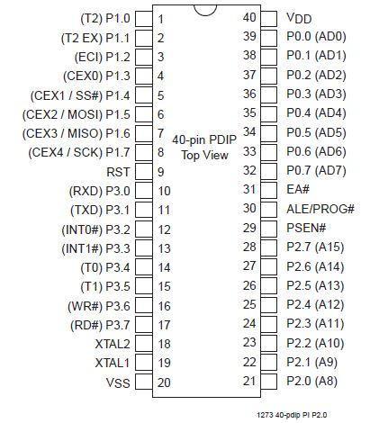

Fig 2.4: pin diagram of SST89E516RD2

**2.2.3 LCD Module:**

To display the relevant information like temperature, moisture of the oil and any other information we are using a 16x2 LCD. The LCD module is having 16 pins. Pin 1 and 2 are ground and VDD respectively. We are using +5V to power up the LCD hence pin 2 is connected to regulated +5V. pin 3 is VEE, which is used to adjust the contrast of the LCD by providing referral voltage, we are using 10k variable resistance to adjust the contrast of the LCD. The center terminal of the potentiometer is connected to pin 3 of the LCD, 1 terminal is connected to VDD and other terminal is connected to ground. By rotating the potentiometer clockwise/anticlockwise we can set the required contrast level.

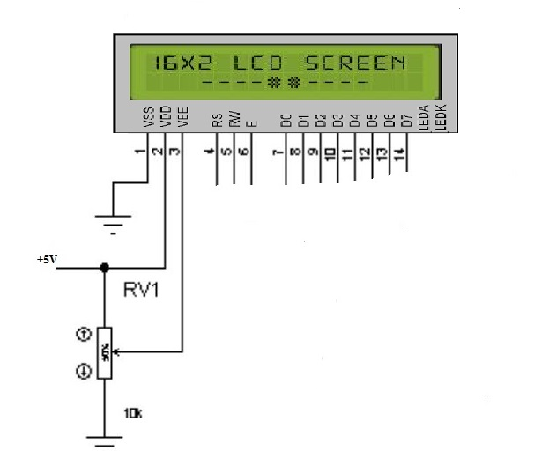

Fig 2.5: 16x2 LCD display

Pin 4,5 and 6 are the most important pin to work with LCD. They are RS, RW and E respectively. This RS is specified as register selector. At the time of sending command form microcontroller to LCD, RS must be pulled down (RS=0). On the other hand, at the time of sending data from microcontroller to LCD, RS must be pulled up (RS=1). The RW represents Read/Write mode. At the time of sending data / command from microcontroller to LCD RW pin must be pulled down (RW=0). On the other hand, at the time of reading acknowledgement on busy bit from microcontroller to LCD, RW pin must be pulled up (RW=1). The E or EN pin represents Enable. After / during providing data / command from microcontroller to LCD a high to low pulse has to be provided.

Pin 7 to pin 14 of the LCD modules are data bus (D0-D7). These pins are used to provide data or command from microcontroller to LCD. Pin 15 and 16 are not having any relation with programming. It is used to provide power supply to the backlight of the LCD. Pin 15 and 16 are marked as K and A respectively but in certain LCD module it may be marked as BL+ and BL- or LED+ and LED-. In our circuit pin 15 is connected to +5V and pin 16 is connected to ground. [Pin 15 and 16 are not displayed in the circuit diagram]. The RS, RW and EN pin of the LCD is connected to pin 39, 38 and 37 respectively of the microcontroller [P0.0, P0.1, P0.2]. The SST89E516RD2 is having 4 IO ports P0, P1, P2 and P3. The internal pull up of P1 and P2 and P3 are activated, but the internal pull up of port 0 is not activated, hence it is called open drain and we must have to use external pull up if any IO pin of port 0 is used. As we are using P0.0, P0.1, P0.2 to provide RS, RS and EN signal in our circuit. Three 10k resistance (R2, R3, R4) are connected from 39,38,37 to VCC. P1 of the microcontroller is used to provide data and command from microcontroller to LCD hence pin 7 to pin 14 of the LCD are connected to pin 1 to pin 8 of the microcontrollers.

**2.2.4 Temperature Sensor:**

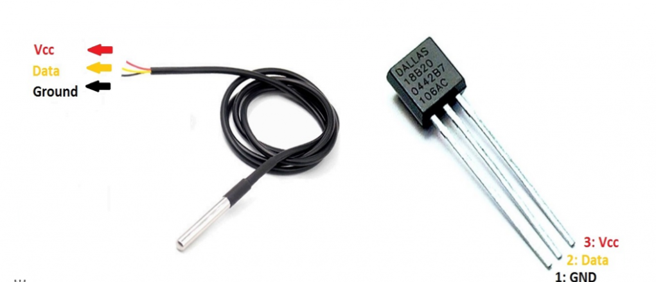

Fig 2.6: DS18B20 Temperature sensor with probe

For measuring the temperature, a digital temperature sensor DS18B20 is used in the circuit. This sensor is a programmable. The communication of this sensor can be done with the help of a 1-Wire method. The range of power supply in which it can operate is 3.0V – 5.5V. The accuracy of this sensor is ±0.5°C. The output resolution will range from 9-bit to 12-bit. It changes the 12-bit temperature to digital word within 750 m second time.

This sensor can be power-driven from the data line. The temperature can be measured by this sensor is from -55°C to +125°C. These are obtainable like SOP, To-92, and also as a waterproof sensor. Pin 1 of this sensor is ground, pin 2 is DQ and pin 3 is VDD. The DQ pin is again an open drain hence it is recommended to use an external pull up by the datasheet. Therefore, a 4.7k resistance is connected from +5V to DQ. The connection diagram of the temperature sensor is shown below-

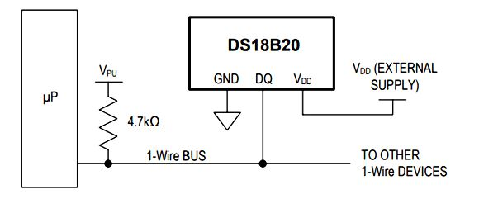

Fig 2.7: connection diagram of DS18B20

* + 1. **Moisture Sensor:**

We are using the conductivity (resistivity) method to measure the moisture level in the oil. As we know the oil is a bad conductor of electricity. But presence of moisture will make it conductive to some extent i.e., the resistance of the medium will vary depending on the amount of moisture present in the oil. To design the sensor a +5V is connected to one probe of the sensor and another probe is connected to the CH0. As if we have an open ADC probe there will be random values as well as the result will fluctuate. Therefore, a 10K resistance is used as pull-down resistance connected to CH0. Due to this pull-down resistance the ADC result will deflect with a minor value from the actual ADC calculation. We have noticed that this voltage difference is less than 0.10 V. The conductance value is calculated by converting the digital data collected form ADC into the microcontroller.

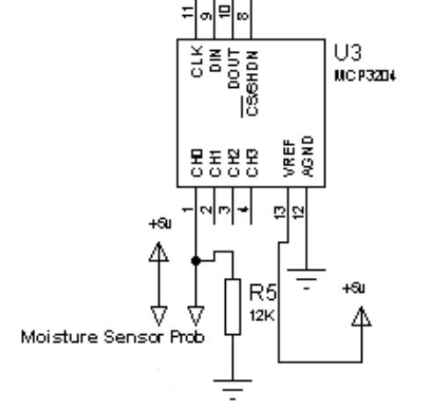

Fig 2.8:connection diagram of moisture sensor

**2.2.6 Analog to Digital Converter (ADC):**

As we have to measure the moisture, we have to implement ADC, as all the natural parameters are analog but microcontroller understands only digital signal. An ADC is a device that converts analog signal to digital data which can be used by microcontroller and microprocessor. In our circuit we are using DS18B20 temperature sensor, which is digital by nature i.e. the sensor itself has inbuilt ADC and provide digital data to the microcontroller directly. Therefore, ADC is not needed to interface with temperature sensor DS18B20. For moisture we have to use ADC. In our circuit we are using 12-bit ADC MCP3204. MCP3204 is a 14 pin DIP type IC. Pin 1,2,3 and 4 are CH0-CH3 respectively. Pin 5 and 6 are not in use and pin 7 is a DGND. Pin 8,9,10 and 11 are CS/SHDN, DIN, DOUT and CLK respectively.

In general, SPI protocol used term MISO and MOSI for communication but Microchip Corporation used MISO as DOUT and MOSI as DIN. Pin 8,9,10 and 11 of MCP3204 is connected to pin 24 to pin 21 of the microcontroller respectively.

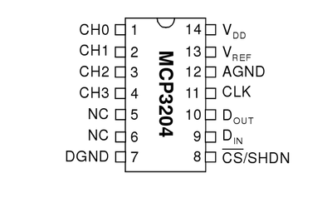

Fig 2.9: pin diagram of ADC MCP3204

**2.2.7 Wi-Fi Module ESP8266:**

After collecting and converting the input from the sensor into a presentable form we are displaying on the LCD. At the same time the information is posting into the WEB server. To establish the communication between the microcontroller and the web server we are using ESP8266. ESP8266 has been designed for mobile, wearable electronics and Internet of Things applications etc. It is an ultra-low power consumption device with a combination of several proprietary techniques. ESP8266 is having number of variants, we are using V1 of ESP8266. It has 8 pins in DIP mode.

The pins are described in the table given below-

|  |  |  |
| --- | --- | --- |
| No | Pin name | Function |
| 1 | GND | Ground |
| 2 | GPIO2 | General Purpose Input/Output, internal pull up |
| 3 | GPIO 0 | General Purpose Input/Output, internal pull up |
| 4 | RXD | UART0, data received pin RXD |
| 5 | VCC | 3.3V power supply (VDD) |
| 6 | RST | 1) External reset pin, active low  2) Can loft or external MCU |
| 7 | CH-PD | Chip enable pin, active high |
| 8 | TXD | UART0, data send pin TXD |

Table 2.1: Pin description of ESP8266

The Tx pin and the Rx pin of ESP8266 is connected to Rx and Tx pin of the microcontroller, i.e. pin 10 and pin 11 of SST89E516RD2. ESP8266 is having two GPIO such as GPIO0 and GPIO2. ESP8266 can be used either is standalone mode or can be used as Wi-Fi modem. In our circuit we are using ESP8266 only for data transmission. Hence GPIO0 and GPIO2 are not in use.

ESP8266 is embedded with internal SRAM (Static random-access memory) and ROM (Read only memory). According to the current version of SDK provided, SRAM provided is less than 36kb and there is no programmable ROM in the SoC, therefore the user program must be stored in an external SPI (serial peripheral interface) flash. This ESP8266 module is mounted with an 1MB external SPI flash to store the user program.

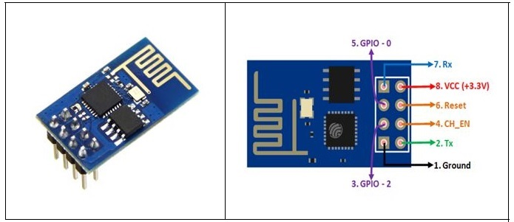

Fig 2.10: ESP8266 Wi-Fi module

ESP8266 requires 3.3V hence we must have to use a voltage regulator on the circuit which can provide regulated 3.3V. we are using S111733PI voltage regulation which is LDO (Low drop output) type regulator. S111733PI can handle maximum 20V as input and the output is always 3.3V. to prevent form certain voltage drop a 10µF electrolytic capacitor is connected between 1st and 2nd pin of the voltage regulator. The RST and CH-PD pin of ESP8266 represents reset pin and wi-fi. Communication enables. To activate the Wi-Fi communication i.e. to start the modem the CH-PD must be pulled up. Hence a 4.7k resistance is connected from 3.3V to CH-PD pin. The circuit will alive only after designing the proper firmware (software) which is written in embedded C.

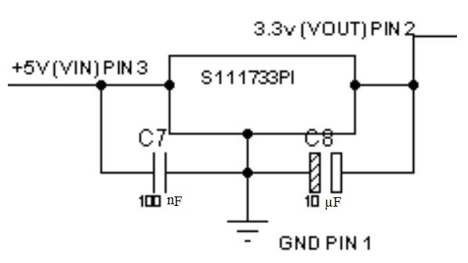

Fig 2.11: S111733PI voltage regulator

**CHAPTER 3**

**SOFTWARE IMPLIMENTATION**

To accomplish the project work we have used multiple software tools starting from firmware designing to IoT implementation. As our project work is proper blending of hardware and software, we have tested the validity of the circuit with proteus. The program designed for the Microcontroller is written in Keil Compiler with Embedded Cas programming language. After receiving signal from the sensors, the microcontroller needs to process it and transfer the data to the web server. The microcontroller transmits the data to the web server through the wi-fi module ESP8266. A web server is nothing but a special software that always propagate the web resources to the client. There are different web servers available like Apache, JAVA web server, IIS etc. but we have used Apache as it is available for window as well as Linux platform. The web server is responsible for handling incoming request and provide response to the client in terms of web content and web data. A webserver works as carriage and return forward (C&F) on agent and it can’t process data. So, to handle the web request we must need server-side scripting or server-side programs ASP, JSP, PHP or python can be used to process in server side. In our project we have selected PHP as server-side environment because of supporting of different platform i.e., without changing the PHP coding it can operate both in windows and Linux environment. The PHP is responsible for processing all incoming and outgoing data but it doesn’t have the capability to store data permanently. So, we need to introduce a database management system for our project work. There are different database servers on database management system available like ORACLE, MYSQL, SQL server, MariaDB etc. We have selected MYSQL in our project work as it is again operable both in windows as well as Linux.

The database management system is responsible for storing the data permanently and provide easy and efficient access of data. To provide user interface as well as data entry and report presentation HTML is used. The HTML can specify where to display and provide hyperlink for navigation. But it can’t specify the looks and feelings of the site. So, we have used CSS (Cascading Style Sheets) in our web pages. The brief descriptions of all software/programming languages used in the project are given below.

**3.1 Proteus:**

For designing and simulating the circuit we used Proteus software. It is a very popular software which can be used to simulate almost every circuit on electrical fields. It is very easy to use because of the GUI interface that is similar to the real prototype board. It has a Virtual System Modeling (VSM) named Proteus ISIS which offers the ability to simulate micro-controller code and also circuits. Therefor it is possible to develop a virtual prototype and testing it before a physical prototype is constructed. The simulation allows human intervention during run time, thus providing real time simulation. ARES is used for PCB designing. It also has the feature of viewing output in 3D view of the designed PCB along with components. The designer can develop 2D drawings for the products. Features ISIS has wide range of components pre-loaded in its library. It has sources, signal generators, measurement and analysis tools like oscilloscope, voltmeter, ammeter etc., probes for real time monitoring of the parameters of the circuit, switches, displays, loads like motors and lamps, discrete components like resistors, capacitors, inductors, transformers, digital and analog Integrated circuits, semi-conductor switches, relays, microcontrollers, processors, sensors etc. ARES offers PCB designing up to 14 inner layers, with surface mount and through hole packages. It is embedded with the foot prints of different category of components like ICs, transistors, headers, connectors and other discrete components. It offers Auto routing and manual routing options to the PCB Designer. The schematic drawn in the ISIS can be directly transferred ARES.

**3.2 Keil Micro Vision (µVision):**

Keil is used to write the embedded C program for the microprocessor. This software is an example of integrated development environment (IDE), which integrated a text editor to write programs, a compiler and it will also convert our source code to hex files. The hex file is fed to the microprocessor through Proteus ISIS.

Keil Software development tools are used to create products for such industries like consumer electronics, industrial control, networking, office automation, automotive, space exploration. Micro Vision II is a 2nd-generation IDE that simplifies project development and application testing. With Micro Vision II, we can easily create embedded applications in a mixture of C and assembly language. Real-time applications benefit from highly optimized C libraries and real-time kernels.

Micro Vision III provides a centralized front-end interface for the compiler, assembler, linker, debugger, and other development tools. The Project Window in Micro Vision III displays the current target, groups, and source files that comprise our project. Rather than creating a single target for each project, Micro Vision II allows multiple targets for each project file. So, with a single project file, we can create a target for simulating, a target for our emulator, and a production target for programming into EPROM {E-PROM}.

Each target is composed of one or more groups which are in turn composed of one or more source files. Groups let us divide the source files into functional blocks or assign source files to different team members. Options may be configured at each level of the project. This gives us a great deal of freedom and flexibility when organizing our application. In addition to the on-line help, MicroVision3 provides on-line versions of the development tool manuals as well as the device manuals.

Keil C Compilers are based on the ANSI standard and include extensions necessary to support the 8051, 251, and 166 microcontroller families. The optimizer in our compiler is tuned for each specific architecture and provides the highest level of code density and execution speed.

The Keil C compilers give us full control over our embedded platform. We decide which register banks will be used, when to access certain memory areas, which variables will be stored in bits, when and how to use special function registers, and so on. Without ever writing any assembly code we may even write interrupt service routines in C Code generated by the Keil C Compiler compares with that of a professional assembly programmer. This is due to the level of optimizations that are performed. One such optimization is global register optimization.

By analyzing which registers are used in each function, the compiler can better optimize register usage program-wide and generate smaller, faster programs. This is accomplished by iterative compilation steps during the make process.

The MicroVision3 debugger is designed to make testing our programs as efficient as possible. While editing and debugging our programs, text and code attributes are displayed in the source window. As we step through our program, the current line is marked with a yellow arrow. Code coverage shows us which lines of our program have been executed. Green means the line has been run. Grey means it has not.

**3.3 Embedded C:**

Embedded C program is used to program the microprocessor. It is the soul of the micro-processor for functioning. Inside each and every [embedded system](https://www.elprocus.com/ieee-projects-on-embedded-systems/) we come across in our daily life such as mobile phones, laptops, digital camera etc. are designed with embedded C program.

Earlier, many embedded applications were developed with the help of assembly level programming (ALP). As assembly language programs are specific to a processor, assembly language didn’t offer portability across system. These disadvantages were overcome by the advent of several high-level languages, including C. Some other languages like PLM, Modula-2, Pascal, etc. also came but couldn’t find wide acceptance. Amongst those it was the C language which got wide acceptance for embedded system. Due to reliability and wide acceptance of **C in the embedded systems,** various kinds of support tools like compilers & cross-compilers, ICE, etc came up and all these facilitated the development of **embedded systems using C.**

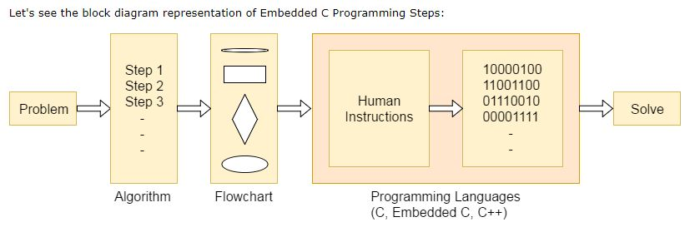

Fig 3.1: Embedded C block diagram

**3.3.1 Embedded C Data types:**

|  |  |  |
| --- | --- | --- |
| **Data Types** | **Size in Bits** | **Data Range/Usage** |
| unsigned char | 8-bit | 0-255 |
| signed char | 8-bit | -128 to +127 |
| unsigned int | 16-bit | 0 to 65535 |
| signed int | 16-bit | -32,768 to +32,767 |
| sbit | 1-bit | SFR bit addressable only |
| Bit | 1-bit | RAM bit addressable only |
| sfr | 8-bit | RAM addresses 80-FFH only |

Table 3.1: Embedded C data types size & Range

**Unsigned char:** The unsigned char is an 8-bit data type that takes a value in the range of 0-255(00-FFH) i.e. total of 256. It is used in many situations, such as setting a counter value, where there is no need for signed data we should use the unsigned char instead of the signed char. Remember that C compilers use the signed char as the default if we do not put the key word.

**Signed char:** The signed char is an 8-bit data type that uses the most significant bit (D7 of D7-D0) to represent the – or + values. As a result, we have only 7 bits for the magnitude of the signed number, giving us values from -128 to +127. In situations where + and – are needed to represent a given quantity such as temperature, the use of the signed char data type is a must.

**Unsigned int:** The unsigned int is a 16-bit data type that takes a value in the range of 0 to 65535 (0000-FFFFH). It is also used to set counter values of more than 256. We must use the int data type unless we have to. Since registers and memory are in 8-bit chunks, the misuse of int variables will result in a larger hex file. To overcome this, we can use the unsigned char in place of unsigned int.

**Signed int:** Signed int is a 16-bit data type that uses the most significant bit (D15 of D15-D0) to represent the – or + value. As a result, we have only 15 bits for the magnitude of the number or values from -32,768 to +32,767.

**Sbit (single bit):** The sbit data type is widely used and designed specifically to access single bit addressable registers. It allows access to the single bits of the SFR registers.

|  |  |  |  |  |  |  |  |  |
| --- | --- | --- | --- | --- | --- | --- | --- | --- |
| **P0** | **Addr** | **P1** | **Addr** | **P2** | **Addr** | **P3** | **Addr** | **Ports Bit** |
| P0.0 | 80H | P1.0 | 90H | P2.0 | A0H | P3.0 | B0H | D0 |
| P0.1 | 81H | P1.1 | 91H | P2.1 | A1H | P3.1 | B1H | D1 |
| P0.2 | 82H | P1.2 | 92H | P2.2 | A2H | P3.2 | B2H | D2 |
| P0.3 | 83H | P1.3 | 93H | P2.3 | A3H | P3.3 | B3H | D3 |
| P0.4 | 84H | P1.4 | 94H | P2.4 | A4H | P3.4 | B4H | D4 |
| P0.5 | 85H | P1.5 | 95H | P2.5 | A5H | P3.5 | B5H | D5 |
| P0.6 | 86H | P1.6 | 96H | P2.6 | A6H | P3.6 | B6H | D6 |
| P0.7 | 87H | P1.7 | 97H | P2.7 | A7H | P3.7 | B7H | D7 |

Table 3.2: Single Bit Addresses of ports

**3.3.2 Data Conversion Programs in Embedded C:**

Many micro-controllers have a real time clock (RTC) where the time and date are kept even when the power is off. These time and date are often in packed BCD by RTC. To display them they must be converted to ASCII. So, in this topic we will be discussing application of logic and instructions in the conversion of BCD and ASCII.

**ASCII numbers:** On ASCII key boards, when the key “0” is activated, “0110000” (30h) is provided to the system. Similarly, 31h (0110001) is provided for the key “1”, and so on as shown in the table

**Packed BCD to ASCII conversion:** The RTC provides the time of day (hour, minutes, seconds) and the date (year, month, day) continuously, regardless of whether the power is ON or OFF. In the conversion procedure the packed BCD is first converted to unpacked BCD. Then it is tagged with 0110000 (30h).

|  |  |  |  |
| --- | --- | --- | --- |
| **Key** | **ASCII (hex)** | **Binary** | **BCD (unpacked)** |
| 0 | 30 | 011 0000 | 0000 0000 |
| 1 | 31 | 011 0001 | 0000 0001 |
| 2 | 32 | 011 0010 | 0000 0010 |
| 3 | 33 | 011 0011 | 0000 0011 |
| 4 | 34 | 011 0100 | 0000 0100 |
| 5 | 35 | 011 0101 | 0000 0101 |
| 6 | 36 | 011 0110 | 0000 0110 |
| 7 | 37 | 011 0111 | 0000 0111 |
| 8 | 38 | 011 1000 | 0000 1000 |
| 9 | 39 | 011 1001 | 0000 1001 |

Table 3.3: ASCII code for Digits 0-9

**ASCII to packed BCD conversion:** To convert ASCII to packed BCD it is first converted to unpacked and then combined to make packed BCD. e.g., 4 and 7 on the keyboard give 34h and 37h respectively the goal is to produce 47h or “0100 0111” which is packed BCD.

|  |  |  |  |
| --- | --- | --- | --- |
| Key | ASCII | Unpacked BCD | Packed BCD |
| 4 | 34 | 00000100 | 01000111or 47h |
| 7 | 37 | 00000111 |

Table 3.4: ACII to Packed BCD

**Binary (hex) to decimal and ASCII conversion in embedded C:**

In C-language we use a function call “printf” which is standard IO library function doing the conversions of data from binary to decimal, or vice versa. But here we are using our own functions for conversions because it occupies much of memory.

One of the most commonly used is binary to decimal conversion. In devices such as ADC chips the data is provided to the controller in binary. In order to display binary data, we need to convert it to decimal and then to ASCII. Since the hexadecimal format is a convenient way of representing binary data, we refer to binary data as hex. The binary data 00-FFH converted to decimal will give us 000 to 255.

One way to do this is to divide it by 10 and keep the remainder, for example 11111101 or FDH is 253 in decimal. The following is one version of the algorithm for conversion of hex (binary) to decimal.

**3.4 WAMP Server:**

WAMP Server is a Web development platform on Windows that allows you to create dynamic Web applications with Apache2, PHP, and MySQL. WAMP Server automatically installs everything you need to intuitively developed Web applications. You will be able to tune your server without even touching its setting files. Best of all, WAMP Server is available for free (under GPML license) in both 32 and 64-bit versions. W Server is not compatible with Windows XP, SP3, or Windows Server 2003.

Features

* Manage your Apache and MySQL services
* Switch online/offline (give access to everyone or only localhost)
* Install and switch Apache, MySQL and PHP releases
* Manage servers’ settings
* Access logs
* Access settings files
  1. **MySQL & PHP:**

The PHP is responsible for processing all incoming and outgoing data but it doesn’t have the capability to store data permanently. So, we need to introduce a database management system for our project work. There are different database servers on database management system available like ORACLE, MySQL, SQL server, MARIA DB etc. we have selected MySQL in our project work as it is operable both in windows and Linux. MySQL is an open-source relational database management system (RDBMS) which is freely available. It uses structured query language (SQL). SQL is the most popular language which is used for adding, accessing and managing content in a database. **MySQL** is a necessary part of almost every open-source **PHP** application. MySQL is ideal for both small and large applications and it is very fast, reliable and user-friendly database system.

**PHP (**Hypertext Pre-Processor) is an open-source server-side language which is used for creating dynamic web pages. The PHP reference implementation is now produced by The PHP Group.It performs operations like read data from database, write data into database, modify the data, update the data, display the data on the frontend (HTML PAGE) etc.

PHP and MySQL work together by connecting and querying data from the script we are writing. In our script we can make a connection to a MySQL by using some of the built-in libraries e.g., PDO, MySQLi and others. we can then query the database on that connection and retrieve the result or use stored procedures in MySQL.

We have installed WAMP Server64 which is an open-source web development platform on window to run PHP and MySQL. WAMP stands for Windows Apache MySQL and PHP. By running WAMP Server64 we can test [webpages](https://techterms.com/definition/webpage) in a [web browser](https://techterms.com/definition/web_browser) without publishing them live on the web. MySQL is an open-source relational database management system. Its name is a combination of MY, the name of co-founder Michael Widenius's daughter, and "SQL", the abbreviation for Structured Query Language.

**3.6 HTML:**

HTML stands for Hyper Text Markup Language. It is a computer language used for creating Web pages. The Web browser translates HTML code into Web pages that we can read. An HTML file is text file which contains small markup tag such as open tag is <html>, close tag is </html> and other tags are <head>, <title>, <body>, <li> etc. The markup tags command the Web browser how to display the page. Any internet document consists of three sections, they are title, head, and body. Head includes the information to spot the document, including title and the other important keyword. A title is often seen on the browser’s bar and therefore the body section is that the main

portion of the web site visible to the viewer. Hypertext defines the links that connect webpages with each other, either it is within a same website or among different websites. Links are the important aspects of Web. When we upload any content on the internet and link it to the pages created by other, then we become an active participant in WWW (World Wide Web). Since HTML is a markup language it can be created and viewed in any [text editor](https://www.computerhope.com/jargon/e/editor.htm)s as long as it is saved with a .htm or .html [file extension](https://www.computerhope.com/jargon/f/fileext.htm). We used notepad++ to write the html codes.

**3.7 Wi-Fi Communication:**

Wi-Fi is a popular wireless networking technology. Wi-Fi stands for “wireless fidelity”. The Wi-Fi was invented by NCR corporation/AT&T in Netherlands in 1991. By using this technology, we will exchange the knowledge between two or more devices. Wi-Fi has been developed for laptops, but it's now extensively using for mobile applications and consumer electronics like televisions, DVD players and digital cameras. There should be two possibilities in communicating with the Wi-Fi connection which will be through access point to the client connection or client to client connection. Wi-Fi may be a one sort of wireless technology. It is commonly called as wireless LAN (local area network). Wi-Fi allows local area networks to work without cable and wiring. It is making popular choice for home and business networks. A computer’s wireless adaptor transfers the info into a radio wave and transfers the info into antenna for users.

**3.7.1 Working Principle:**

Wi-Fi is a high-speed internet connection and network connection without use of any cables or wires. The wireless network is working three essential elements that are radio signals, antenna and router. The radio waves are keys which make the Wi-Fi networking possible. The computers and cell phones are ready with Wi-Fi cards. Wi-Fi compatibility has been employing a new creation to constituent within the bottom connected with community network. The actual broadcast is connected with in sequence actually it's completed by way of stereo surf also because the worth of wires with monitor to classification prone. Wi-Fi allows the person so as to urge access to web anywhere within the actual provided area. You can now generate a system within Resorts, library, schools, colleges, campus, personal institutes, also as espresso stores also as on the open public spot to assist to make your company far more lucrative also as interact with their own customer whenever. Wi-Fi compatibility can make surf with stare to company using their inspiring cable television much a smaller amount force down.

The radio signals are transmitted from antennas and routers that signals are picked up by Wi-Fi receivers, which are available in devices such as computers and cell phones. Whenever the receiver receives the signals within the range of 100-150 feet from router, it connects the device immediately. The range of the Wi-Fi of course depends upon some parameters like environment, indoor or outdoor ranges. The Wi-Fi cards will read the signals and create an internet connection between user and network. The speed of the device using Wi-Fi connection increases as the device gets closer to the main source and speed is decreases if the device gets further away. Many new laptops, mobile phones have inbuilt Wi-Fi card so we don’t have to do anything which is one of the best things.

**3.7.2 Parallel and Serial Communication:**

When electronic devices communicate with each other, they can transfer data in two different ways. One is serial and other one is parallel, when digital data is transferred serially, it is transmitted bit by bit, whereas in parallel transfer, many bits are transmitted at same time. Though parallel transfer of data is much faster but requires many wires. while serial transfer is slower as compared to parallel transfer but requires few wires. Serial communication maybe synchronous or asynchronous. In synchronous communication, transmitter also transmits a clock along with data. This clock is used for synchronization between transmitter and receiver device. In asynchronous transfer of data, there is no clock.

Serial communication maybe simplex, half-duplex or full duplex. simplex communication means that data will be transmitted only in one direction while half duplex means data will be transmitted in both directions but at one time, only one device can transmit, whereas full duplex means data may be transmitted in both directions at one time, while one device is transmitting, it can also receive data transmitted from other device at same time. As mentioned before, transmitter and receiver are configured to communicate at some data transfer rate before communication starts. This data transfer rate or number of bits transmitted per second is called baud rate for handling serial communication.

Parallel communication is fast but it is not applicable for long distances (for printers). Moreover, it is also expensive. Serial is not much fast as parallel communication but it can deal with transmission of data over longer distances (for telephone line, ADC, DAC). It is also cheaper and requires fewer physical wires, that’s why we use serial communication. This article also deals with how to serially communicate in 8051 micro-controllers.

**3.7.3 Types of Serial Communication:**

**A. Synchronous Communication:**

Transfer the block of data (characters) between sender and receiver spaced by fixed time interval.  This transmission is synchronized by an external clock.

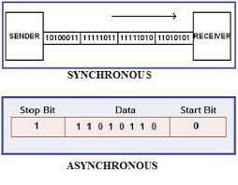

Figure 3.2: Types of communication

**I2C Protocol:**

The term I2C or IIC abbreviation is an inter integrated circuit and it is called as I squared C. I2C is a serial computer bus, which is invented by NXP semiconductors. Previously it is named as Philips semiconductors. The I2C bus is used to attach low speed peripheral integrated circuits to microcontrollers and processors.

I2C bus uses two bidirectional open-drain lines such as SDA (serial data line) and SCI (serial clock line) and these are pulled up with resistors. I2C bus permits a master device to start communication with a slave device. Data is interchanged between these two devices. Typical voltages used are +3.3V or +5V although systems with extra voltages are allowed.

**SPI Communication:**

The SPI communication stands for serial peripheral interface [communication protocol](https://www.elprocus.com/communication-protocols/), which was developed by the Motorola in 1972. SPI interface is available on popular communication controllers such as PIC, AVR, and [ARM controller](https://www.elprocus.com/arm-architecture/), etc. It has synchronous serial communication data link that operates in full duplex, which means the data signals carry on both the directions simultaneously.

SPI protocol consists of four wires such as MISO, MOSI, CLK, SS used for master/slave communication. The master is a microcontroller, and the slaves are other peripherals like sensors, [GSM modem](https://www.elprocus.com/gsm-architecture-features-working/) and GPS modem, etc. The multiple slaves are interfaced to the master through a SPI serial bus. The SPI protocol does not support the multi-master communication and it is used for a short distance within a circuit board.

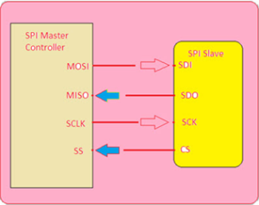

Figure 3.3: SPI communication

1. **MISO (Master in Slave out)**: The MISO line is configured as an input in a master device and as an output in a slave device.
2. **MOSI (Master out Slave in)**: The MOSI is a line configured as an output in a master device and as an input in a slave device wherein it is used to synchronize the data movement.
3. **SCK (serial clock)**: This signal is always driven by the master for synchronous data transfer between the master and the slave. It is used to synchronize the data movement both in and out through the MOSI and MISO lines.
4. **SS (Slave Select) and CS (Chip Select)**: This signal is driven by the master to select individual slaves/Peripheral devices. It is an input line used to select the slave devices.

**Master Slave Communication with SPI Serial Bus:**

**Single Master and Single Slave SPI Implementation:** Here, the communication is always initiated by the master. The master device first configures the clock frequency which is less than or equal to the maximum frequency that the slave device supports. The master then selects the desired slave for communication by dragging the chip select line (SS) of that particular slave device to go low state and active. The master generates the information on to the MOSI line that carries the data from master to slave.

**B. Asynchronous Communication:**

There is no clock involved here and transmission is synchronized by special signals along the transmission medium. It transfers a single byte at a time between sender and receiver along with inserting a start bit before each data character and a stop bit at its termination so that to inform the receiver where the data begins and ends. An example is the interface between a keyboard and a computer. Keyboard is the transmitter and the computer is the receiver. We use USART and UART for serial communications. USART or UART is a microcontroller peripheral which converts incoming and outgoing bytes of data into a serial bit stream. Both have same work but with different methods which is explained below.

1. **USART:**

USART stands for Universal Synchronous/Asynchronous Receiver-Transmitter. USART uses external clock so it needs separate line to carry the clock signal. Sending peripheral generates a clock and the receiving peripheral recover from the data stream without knowing the baud rate ahead of time. By use of external clock, USART’s data rate can be much higher (up to rates of 4 Mbps) than that of a standard UART.

1. **UART:**

It stands for Universal Asynchronous Receiver-Transmitter. A UART generates its internal data clock to the microcontroller. It synchronizes that clock with the data stream by using the start bit transition. The receiver needs the baud rate to know ahead of time to properly receive the data stream.

**CHAPTER 4**

**RESULTS & DISCUSSION**

**4.1. MONITORING IN THE HARDWARE CIRCUIT:**

The hardware circuit is designed and set up with the required components. Then the working of the circuit is tested for transformer mineral oil at different temperature and moisture level. Moisture content is created by adding water and temperature is increased through an immersion rod. The complete set up of the hardware circuit and the results in the LCD display is shown below.

1. Monitoring of transformer mineral oil at room temperature and without adding any water is shown in fig (4.1). Here the conductivity is found 1.86%. Hence, we got to know that moisture level is very low in the fresh transformer mineral oil sample.

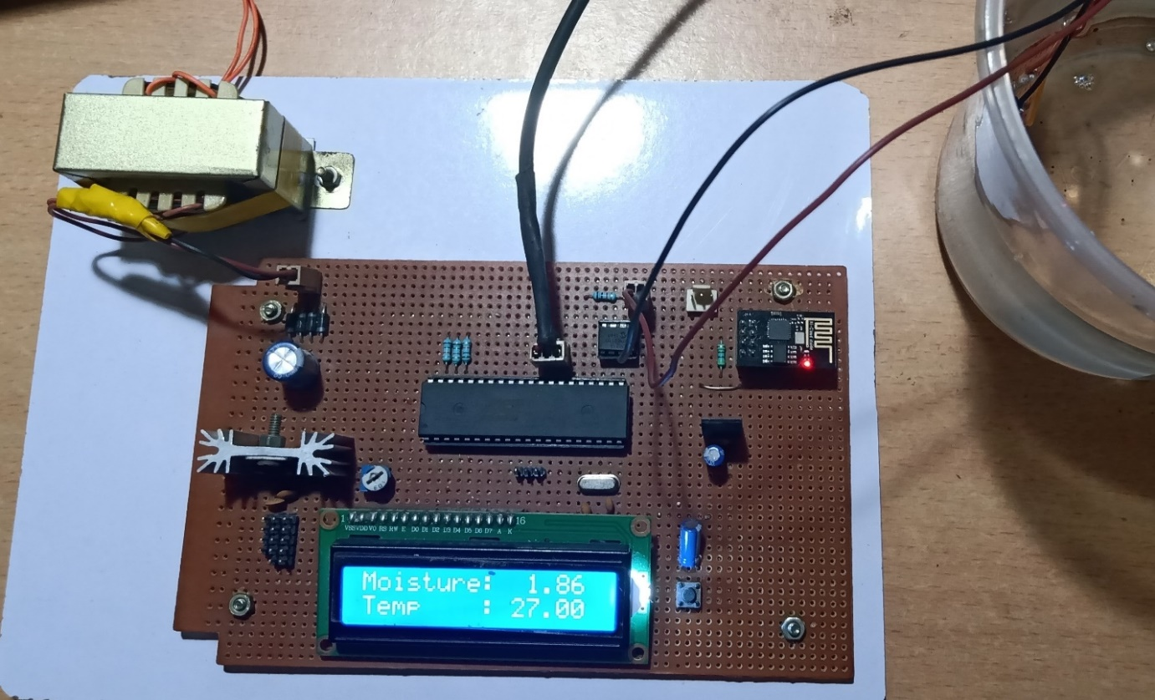

Fig (4.1)

1. Monitoring of temperature and moisture by the circuit after adding some water is shown in fig (4.2). Since specific gravity of water (1.0) is greater than the mineral oil (0.89) the water droplets will slowly settled down in the bottom. So, the sensor probe should touch the bottom of the tank to get the actual result of water content.

In practical situation if the specific gravity of insulating oil is greater than water (e.g. Askarel (SG=1.5) then we should monitor from the top of the tank if the specific gravity of oil is less than that of water then we should monitor from the bottom of the tank. In our experiment it is seen that the conductivity level increased is 6.84% and temperature is 27℃. Hence we know that the moisture level is increased to some extent.

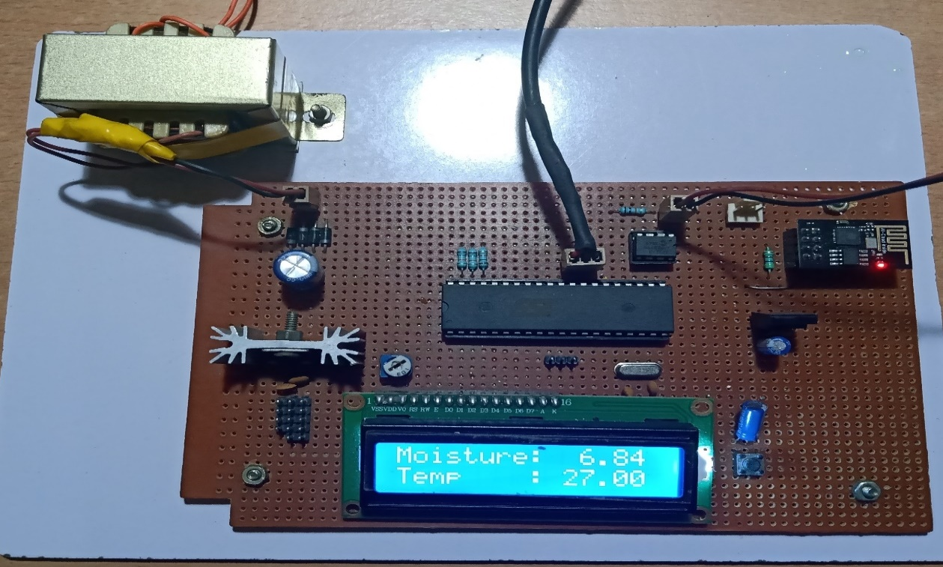

Fig (4.2)

1. Monitoring of mineral oil after heating and adding some water is shown in fig (4.3).

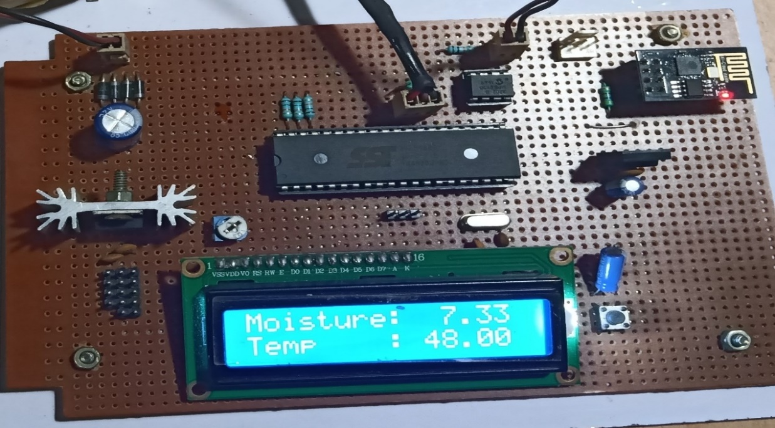

Fig (4.3)

The conductivity level found is 7.33% and temperature is 48℃. Due to increase in temperature, the water droplets are broken down and scattered throughout the oil, so the conductivity level of the oil is seen to be increased.

From the experiment it has been observed that our circuit is measuring transformer mineral oil temperature and moisture level correctly. At the same time the wi-fi module is sending the data to our IoT server. The later part (monitoring in the IoT server) is discussed in the next section.

**4.2. MONITORING IN THE IOT SERVER:**

**A. Index page:** The index page of our IoT web-server is shown in figure (4.4). It is the first page that will appear when we enter into our web-server. After clicking in the log-in button in this page, we will be redirected to the log-in menu.

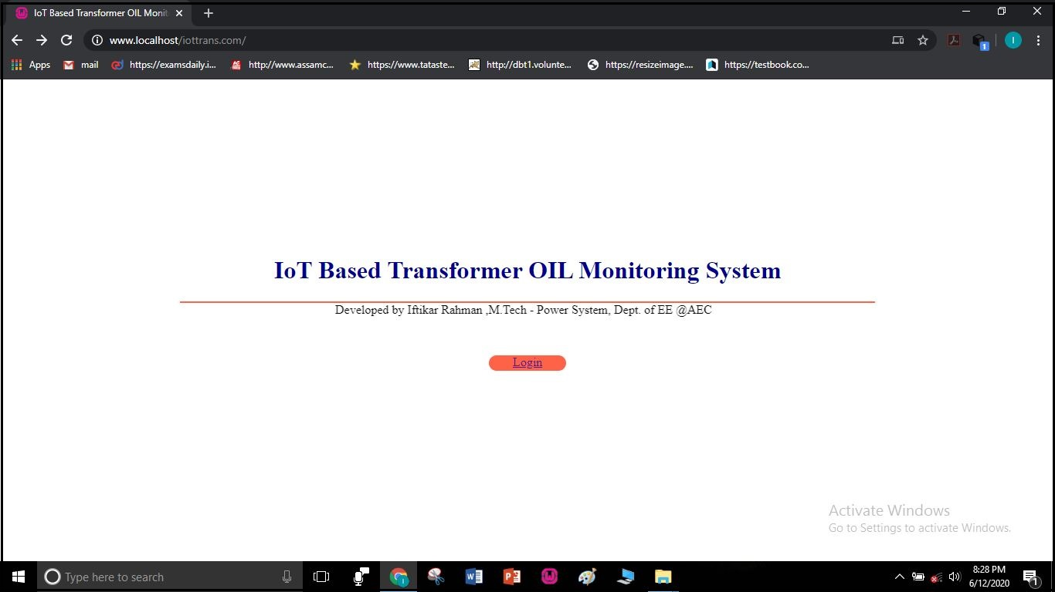

Fig (4.4)

**B. Log in menu:** The users which are verified and granted access to the server by the Administrator can only monitor the parameters by securely logging in to the server. It is important to secure the server from cyber-attack and for privacy purpose. The login menu is shown in figure (4.5).

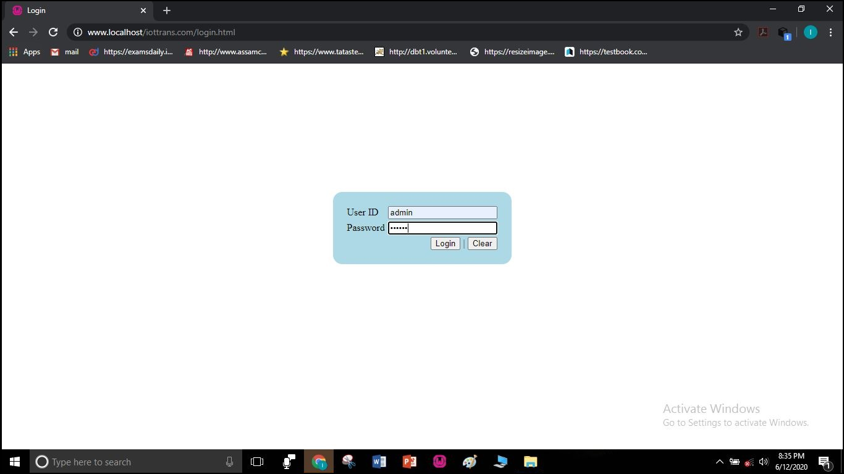

Fig (4.5)

**3. USERLIST:** Here the permitted users with their user ID and usernames are available. The ADMIN can add a new user and can remove a pre-existing user. The admin can also deactivate or reactivate a user temporarily when it is required.

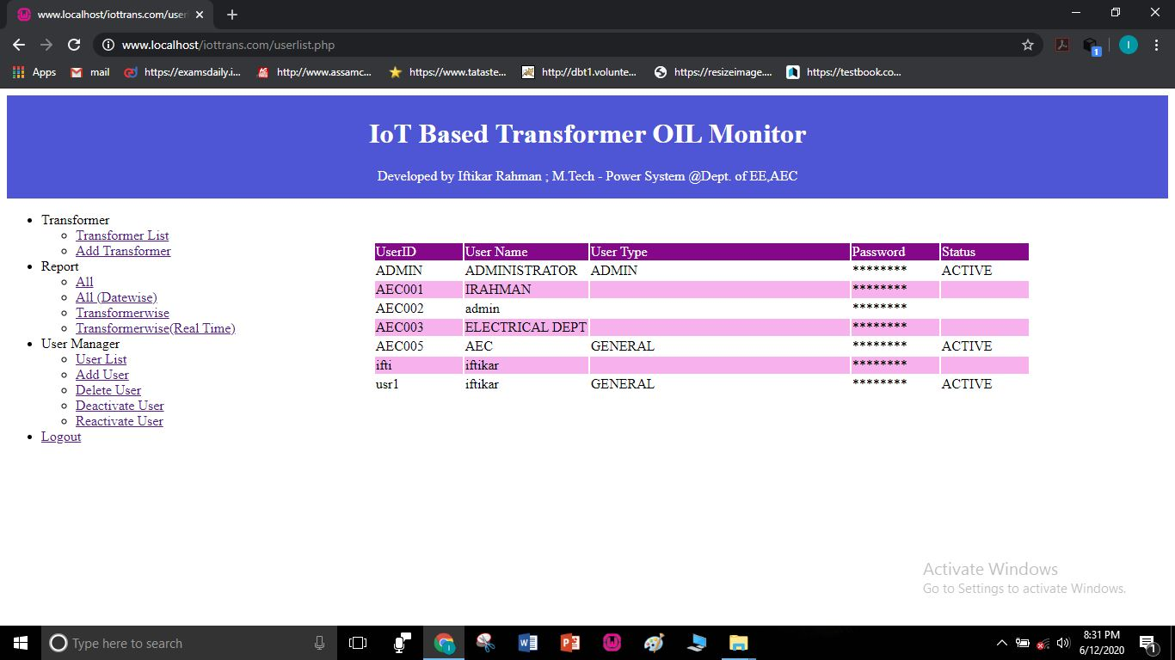Fig (4.6)

**4.Transformer list**: Here all the transformer list with their addresses, capacity will be available. If we want to include any other name plate details then also, we can add here. The webpage is shown in fig (4.7).

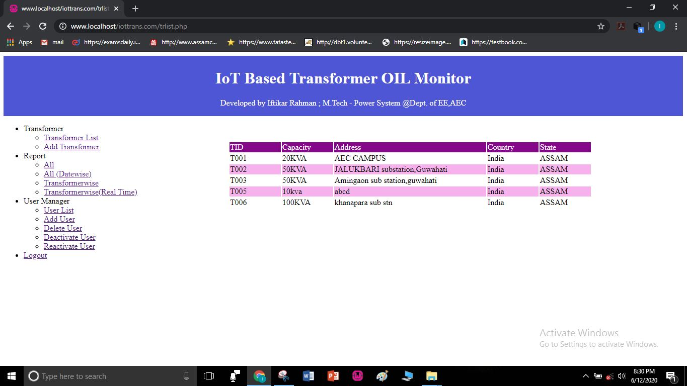

Fig (4.7)

**5. Adding new transformer:** Here we can add a new transformer with its TID, address, capacity

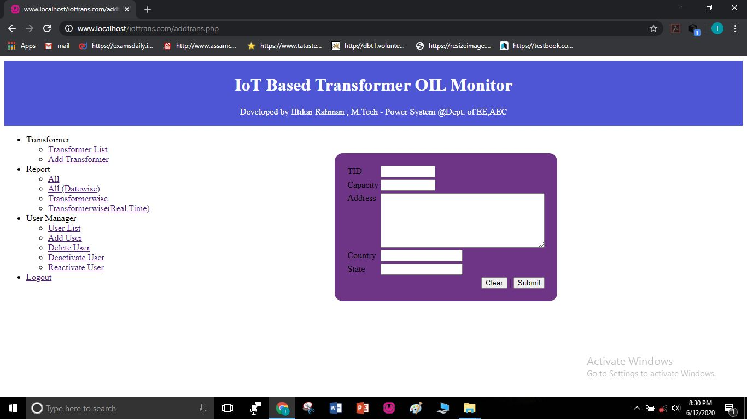

Fig (4.8)

6. Real time monitoring of our mineral oil sample at web server. The web page is shown in figure (4.9)

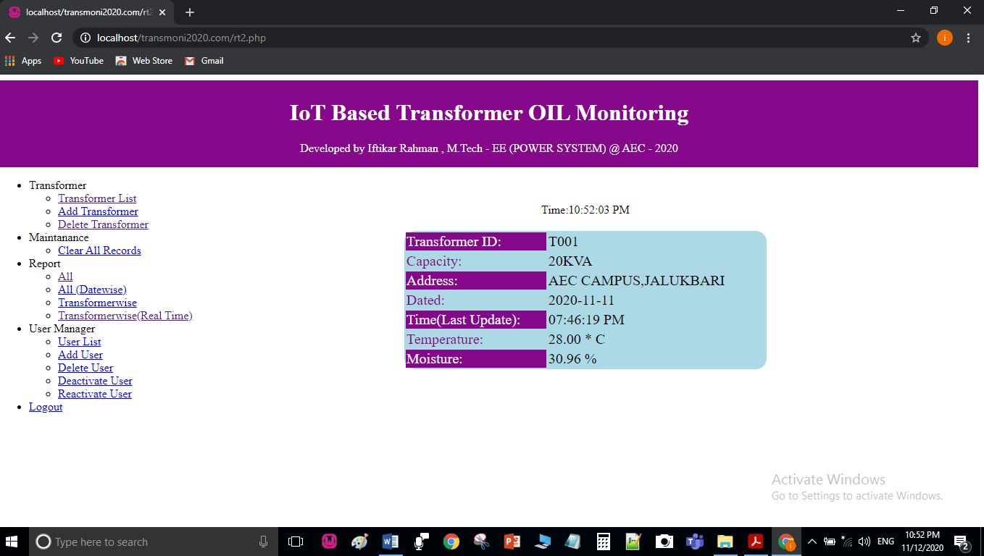

Fig (4.9)

8. All monitored data saved in the web server: The data are saved and stored in the server. The Administrator can clear the data periodically if he wants. The webpage is shown in figure (4.9)

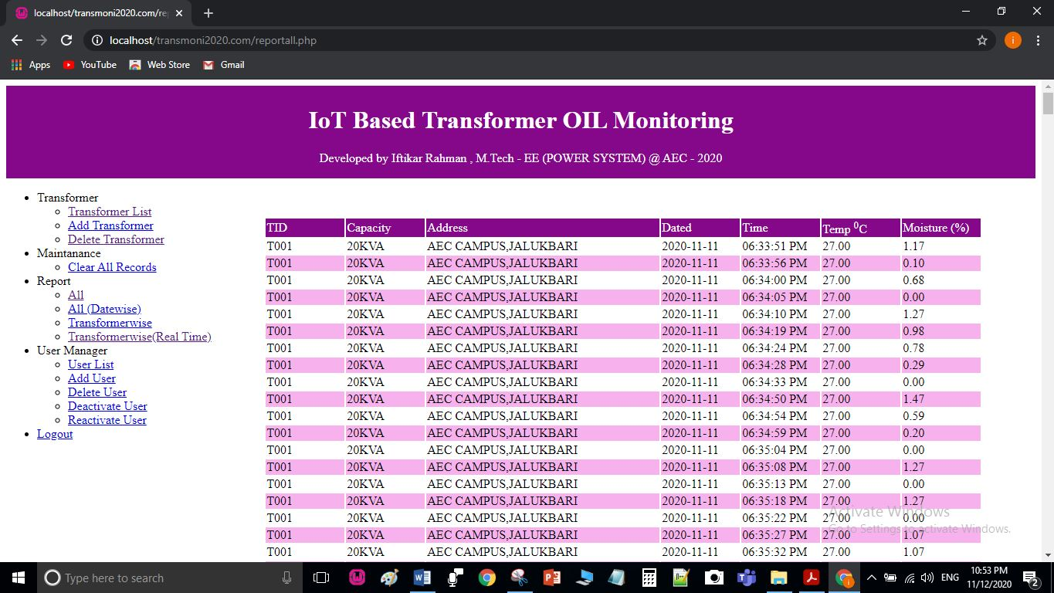

Fig (4.10)

**CHAPTER 5**

**CONCLUSION**

The IoT based monitoring system of transformer oil is quite useful as compared to manual monitoring systems and also it is reliable.All disadvantages of manual monitoring of distribution transformer can be overcome by the proposed system. Employing IoT with this system for real time monitoring of transformer oil will identify any abnormal conditions and necessary action can be taken immediately and catastrophic failures can be prevented. The maintenance can be done when required. Thus, this system keeps maintenance and regulation costs down. We can also save the data safely in the cloud and use it for future reference. As details about the transformer will be updated to the webpage at a regular time interval there is no human power requires for the monitoring at the site of the transformer instead the maintenance and control engineer can access it from anywhere and anytime. Thus, the maintenance and regulating costs will be reduced. Apart from these advantages, the data saved in the cloud can be used for future reference.

To implement the concept, we could have used different or other microcontroller family MSP430, ATMEGA or PIC though MSP430 is 16bit low power advanced microcontroller, it is not available easily in local market as well as online store. Similarly PIC and AVR has their own advantages and limitation. Finally, we have decided to go with popular 8051/52 series Microcontroller because of easy availability, maximum alternative as well as cost effective. Initially we started with AT89S52 Microcontroller from ATMEL, it was having 8kb of flash memory and 256 bytes of RAM. It was enough for the project work until we introduce the IOT. When we added the features of IOT and enhanced the accuracy by increasing sampling size it demands more RAM and code memory. Hence, we have replaced the AT89S52 by SST89E516RD2 from Microchip which is provided 64kb of flash memory with 1kb of RAM along with 6T turbo mode.

**REFERENCES**

[1] Chan W. L, So A.T.P. and Lai L. L.; “Internet Based Transmission Substation Monitoring”, *IEEE Transaction on Power Systems, Vol. 14, No. 1, February 2014, pp. 293-298.*

[2] T. Leibfried, “Online monitors keep transformers in service”, *Computer Applications in Power, IEEE, Volume: 11 Issue: 3, July 1998 Page(s): 36-42.*

[3] Xiao-hui Cheng, Yang Wang, “The remote monitoring system of transformer fault based on the internet of Things,” in *IEEE International Conference on Computer Science and Network Technology, 2011, pp. 84-87.*

[4] Tai-Yeon Ku, Wan-Ki Park and Hoon Choi, “IoT Energy Management Platform for Micro-Grid”, *2017 IEEE 7th International Conference on Power and Energy Systems.*

[5] F. van der Walt, and W. Doorsamy, “Analytical Condition Monitoring System for Liquid-immersed Transformers”, *2018 IEEE PES/IAS Power Africa.*

[6] Leny Thangiah, Prof. Dr. Chandrashekar Ramanathan and Lakshmi Sirisha Chodisetty, “Distribution Transformer Condition Monitoring based on Edge Intelligence for Industrial IoT”, *2019 IEEE 5th World Forum on Internet of Things (WF-IoT).*

[7] Divyank Srivastava and M. M. Tripathi, “Transformer Health Monitoring System Using Internet of Things”, *2nd IEEE International conference on power Electronics, Intelligent Control and Energy systems (ICPEICES-2018).*

[8] Rohit R. Pawar, Priyanka A. Wagh, Dr. S.B. Deosarkar, “Distribution Transformer Monitoring System Using Internet of Things (IoT)”, 2017 *International Conference on Computational Intelligence in Data Science (ICCIDS).*

[9] R. R. Pawar and S. B. Deosarkar, “Health Condition Monitoring System For Distribution Transformer Using Internet of Things (IoT),” in *IEEE International Conference on Computing Methodologies and Communication, 2017, pp. 117-122.*

[10] Silviu C. Folea and George Mois, “A Low-Power Wireless Sensor for Online Ambient Monitoring,” in *IEEE Sensors Journal Vol: 15, Issue: 2, pp. 742 – 749, Feb. 2015.*

[11] H. Jamal, M. Waseem, I. A. Sajjad, A. Anjum and M. S. Khan, “Low-Cost Feedback Control Thermal Protection System for 3-Phase Distribution Transformer using Microcontroller,” in *6th IEEE International conference on Smart Energy Grid Engineering, 2018, pp.200-204.*

[12] A. I. Abdul-Rahman and C. A. Graves, “Internet of Things Application Using Tethered MSP430 to Thing speak Cloud,” in *IEEE Symposium on Service-Oriented System Engineering, 19 May, 2016.*

[13] I. Fofana, V. Wasserberg, H. Borsi and E. Gockenbach, “Drying of Transformer Insulation using Zeolite,” in *IEEE Electrical Insulation Magazine Vol: 20, Issue: 1, Jan.-Feb. 2004.*

[14] Avinash Nelson A, Gajanan C Jaiswal, Makarand S Ballal, and D. R Tutakne, “Remote Condition Monitoring System for Distribution Transformer”, *978-1-4799-5141-3/14/$31.00 ©2014 IEEE*.

[15] Abdul-Rahman AI-Ali, Abdul Khaliq and Muhammad Arshad “GSM Based Distribution Transformer Monitoring System”, *IEEE MELECON 2004, May 12-15,2004, Dubrovnik, Croatia*

[16] Hongyan Mao, “Research of Wireless Monitoring System in Power Distribution Transformer Station Based on GPRS”, *Volume 5, C 2010 IEEE.*