Project Report

on

DESIGN AND OPTIMISATION OF A STANDALONE SOLAR-WIND HYBRID ENERGY SYSTEM

Submitted in partial fulfillment of the requirements for the award of the degree of Master of Engineering in Electrical Engineering (Power Systems) under Gauhati University

Session: 2016



***By***

**PRATIBHA DAS**

**EE-16/13**

**M.E 3rd SEMESTER**

***Under the guidance of***

**MR. DEBA KUMAR MAHANTA**

**Professor**

**Department of Electrical & Instrumentation Engineering**

**Assam Engineering College**

**Guwahati-781013, Assam**

**DECLARATION**

I hereby declare that the work which is being presented in this report titled

**“**DESIGN AND OPTIMISATION OF A STANDALONE SOLAR-WIND HYBRID ENERGY SYSTEM”

towards partial fulfilment of the requirements for the award of the degree of Master of Engineering in Electrical Power Systems, submitted in the Department of Electrical and Instrumentation Engineering, Assam Engineering College, under Gauhati University, is an authentic record of my own work under the supervision of Mr. Deba Kumar Mahanta, Professor, Electrical and Instrumentation Engineering Department, Assam Engineering College.

I have not submitted the matter embodied in this report for the award of any other degree or diploma.

**Date:**

**Place:** Guwahati

**Certificate from the Supervisor**

This is to certify that the project entitled

“DESIGN AND OPTIMISATION OF A STANDALONE SOLAR-WIND HYBRID ENERGY SYSTEM”

has been carried out and presented by:

PRATIBHA DAS

Roll No.PG/EE/16/13

student of Master of Engineering (Power Systems), Electrical Engineering Department, Assam Engineering College, under my supervision and guidance in a manner satisfactory to warrant its acceptance as a prerequisite for the award of the degree of Master of Engineering in Electrical Engineering(Power Systems) of the Gauhati University.

Further, the report has not been submitted/ reproduced in any form for the award of any other degree/diploma.

Date: (DEBA KUMAR MAHANTA)

Place: Guwahati Professor

Deptt.of Electrical & Instrumentation Engineering

Assam Engineering College

Guwahati-781013

**Certificate from the Head of the Department**

This is to certify that the project report entitled

“DESIGN AND OPTIMISATION OF A STANDALONE SOLAR-WIND HYBRID ENERGY SYSTEM”

has been submitted by the following ME 3rd semester student:

**PRATIBHA DAS**

Roll No.PG/EE/16/13

in partial fulfilment of the requirements for the award of the degree of Master of Engineering in Electrical Engineering of Gauhati University.

Date: (Dr.Damodar Agarwal)

Place: Guwahati Head of the Department

Deptt.of Electrical & Instrumentation Engineering

Assam Engineering College

Guwahati-781013

**ACKNOWLEDGEMENT**

I would like to show immense gratitude to my supervisor, **Mr**.**DEBA KUMAR MAHANTA**, Professor, Department of Electrical & Instrumentation Engineering, Assam Engineering College. I sincerely thank him for his exemplary guidance and encouragement, without whose guidance and persistent help, this project would not have materialized.

I am indebted to the Deptt.of Electrical & Instrumentation Engineering, the faculty of which provided enthusiastic support and assisted towards the completion of the project.

I am indebted to my friends for their help and moral support all throughout the project.

Finally I would like to thank my Parents for their moral support and encouragement.

**ABSTRACT**

Renewable energy systems are likely to become widespread in the future  
due to adverse environmental impacts and escalation in energy costs linked with the exercise of established energy sources. Solar and wind energy resources are alternative to each other which will have the actual potential to satisfy the load dilemma to some degree. However, such solutions any time researched independently are not entirely trustworthy because of their unstable nature. In this context, autonomous photovoltaic and wind hybrid energy system have been found to be more economically viable alternative to fulfil the energy demands of numerous isolated consumers worldwide. The aim of this report is to present a design and simulation of solar PV and wind stand-alone hybrid energy system. The entire hybrid system is described and given along with comprehensive simulation results that discover the feasibility of the system. A simulation model is developed in Matlab/Simulink.

CONTENTS

CHAPTER-1 9

1.1 INTRODUCTION 9

1.2 OBJECTIVE 10

1.3 MOTIVATION 10

1.4 ORGANISATION OF THE REPORT 10

2 CHAPTER-2 11

2.1 HYBRID RENEWABLE ENERGY SYSTEM 11

2.2 CLASSIFICATION OF HRES 11

2.3 ADVANTAGES 13

2.4 DISADVANTAGES 13

2.5 STANDALONE SOLAR PV/WIND HYBRID ENERGY SYSTEM 13

2.6 PROPOSED MODEL 15

3 CHAPTER-3 16

3.1 SOLAR ENERGY 16

3.2 PHOTOVOLTAICS 16

3.3 SOLAR CELL 17

3.4 SOLAR PANEL 17

3.5 SOLAR PV ARRAY 18

3.6 Mathematical Model of Solar Cell 18

4 CHAPTER-4 20

4.1 WIND ENERGY 20

4.2 ADVANTAGES 20

4.3 DISADVANTAGES 21

4.4 WIND TURBINES 22

4.5 TYPES OF WIND TURBINES 22

4.5.1 HORIZONTAL AXIS WIND TURBINES (HAWT) 22

4.5.2 VERTICAL AXIS WIND TURBINE (VAWT) 24

4.6 WIND GENERATOR 26

4.7 TYPES OF WIND GENERATOR 26

4.8 PERMANENT MAGNET DC GENERATOR (PMDCG) 27

4.9 MATHEMATICAL MODEL OF WIND TURBINE 27

4.10 MATHEMATICAL MODELING OF PMDC GENERATOR 27

5 CHAPTER-5 29

5.1 SIMULATION 29

5.2 Load Analysis 29

5.3 SIMULINK MODEL OF SOLAR PV ARRAY 31

5.4 SIMULINK MODEL OF WIND TURBINE AND GENERATOR 34

5.5 WIND TURBINE 34

5.6 PERMANENT MAGNET DC GENERATOR 35

5.7 SIMULINK MODEL OF SOLAR PV-WIND HYBRID ENERGY SYSTEM 38

5.7.1 BATTERY BANK 38

5.7.2 INVERTER 39

5.8 COMPLETE MODEL 40

6 CHAPTER-6 42

6.1 CONCLUSION 42

6.2 FURTHER WORK 42

REFERENCE 43

# CHAPTER-1

## INTRODUCTION

Due to the critical condition of industrial fuels which include oil, gas and others, the development of renewable energy sources is continuously improving. This is the reason why renewable energy sources have become more important these days. Few other reasons include advantages like abundant availability in nature, eco-friendly and recyclable. Many renewable energy sources like solar, wind, hydel and tidal are there. Among these renewable sources solar and wind energy are the world’s fastest growing energy resources. With no emission of pollutants, energy conversion is done through wind turbine and PV cells.

Many remote communities cannot be physically or economically connected to an electric power grid. The electricity demand in these areas is conventionally supplied by small isolated diesel generators. The operating costs associated with these diesel generators may be unacceptably high due to discounted fossil fuel costs together with difficulties in fuel delivery and maintenance of generators. In such situations, renewable energy sources, such as solar photovoltaic (PV) and wind turbine generator provide a realistic alternative to supplement engine-driven generators for electricity generation in oﬀ-grid areas. It has been demonstrated that hybrid energy systems can significantly reduce the total life cycle cost of standalone power supplies in many oﬀ-grid situations, while at the same time providing a reliable supply of electricity using a combination of energy sources. Numerous hybrid systems have been installed across the world, and the expanding renewable energy industry has now developed reliable and cost competitive systems using a variety of technologies.

The term hybrid energy system refers to those applications in which multiple energy conversion devices are used together to supply an energy requirement. These systems are often used in isolated applications and normally include at least one renewable energy source in the configuration. Hybrid energy systems are used as an alternative to conventional systems, which typically are based on a single fossil fuel source. Hybrid energy systems may also be used as part of distributed generation application in conventional electricity grid.

## OBJECTIVE

* Design and Simulation of a stand-alone PV-Wind hybrid energy system.

## MOTIVATION

* Renewable energy sources will reduce dependency on fossil fuels leading to a cleaner environment.
* Will allow far flung places to have electricity.
* Suitable for a solar and wind energy rich country like ours.

## ORGANISATION OF THE REPORT

The report is divided into six chapters.

Chapter 1 gives a brief introduction to the topic and its objective.

Chapter 2 includes information of hybrid renewable energy system, its classification, advantages, disadvantages,and about the configuration-Solar PV and Wind HRES.

Chapter 3 presents information about solar energy,its mathematical modeling.

Chapter 4 presents information about wind energy,its mathematical modeling.

Chapter 5 presents simulation and load analysis of the proposed system.

Chapter 6 includes conclusion and further work.

# CHAPTER-2

## HYBRID RENEWABLE ENERGY SYSTEM

Hybrid renewable energy system (HRES) combines two or more renewable energy resources with or without some conventional source along with storage, in order to fulfill the demands of an area. It is an integrated system that utilizes different renewable energy sources such as solar energy, wind energy or micro hydro power together to operate under changing natural condition to provide a quality power supply.

Thus we can define a hybrid energy system as a power system, using one renewable and one conventional energy source or more than one renewable with or without conventional energy sources, that works in “standalone” or “grid connected mode.

**Need of HRES:**

* To overcome the disadvantage of single renewable energy source.
* To maximize the use of renewable energy sources.

## CLASSIFICATION OF HRES

**According to the presence of conventional energy sources:**

* Hybrid systems with conventional sources – these systems, use conventional sources are more powerful and responsible.
* Hybrid systems without conventional sources – these kinds of systems are relatively low power and/or tend to be more irresponsible. If the systems are correctly designed and if energy storage is provided, they would be able to generate sustainable energy. These systems are independent of energy sources, which make them especially preferred. Hence is the need to develop reliable optimization model.

**According to the number of the sources:**

The number of the energy sources is one of the factors that define the complexity of the HRES as well as its sustainability and efficiency. The large number of sources makes the system more complicated, but at the same time leads to an increase in the sustainability and energy efficiency.

**According to the type of the produced energy:**

* Mechanical – each turbine, regardless of its kind generates mechanical energy, which later is converted to electrical. That mechanical energy can be also consumed directly, e.g. for pumping water;
* Electrical – the electrical energy can be easy distributed and converted to another type. It can be stored and consumed, when is needed. All these features rouse a deep interest for the electrical HRES;
* Thermal – it is used for heating and warming up water. Here can be assigned both the systems with solar thermal collectors and the ones, using geothermal energy;
* Light – providing daylight in buildings through the medium of a concentric collector and optic cable ;
* Fuel production – a case in point can be hydrogen production by means of electrolysis;
* Mixed – a typical example is a power system with solar thermal collector, combined with wind turbine and photovoltaic.

**According to distribution system:**

* Standalone or off Grid- It is located at load center and dedicated to meet all the electrical loads of a village/community or a specific set of loads. Energy storage is generally essential.
* Grid connected energy system- This system is connected to the utility grid with two way metering system.

**According to the energy storage:**

* Without storage – they are not profitable, because the needs do not coincide with the energy availability. Thus, certain amount of the available energy remains unused and also the load can easily remain without supply;
* With storage – the surplus of the generated electric power is stored and used when needed. In this way, the fluctuating nature of the RES is buffered which enables the hybrid system to work more effectively. The stored energy can be electrical (batteries, superconductive magnetic energy storage (SMES)),thermal (boiler), mechanical (flywheel), fuel conversion (hydrogen) and potential (water tower).The fuel cells (FC) provide a clean technology that uses hydrogen (from a fuel source) and oxygen(from the air) to generate electricity and heat, the only basic emission being water vapor. FCs suitable for DG operate between 80 and

1000 ºC and in CHP mode can deliver efficiencies of over 80%. Small (1-10 kW) FCs could be developed for residential power generation.

## ADVANTAGES

The advantages of the HRES are as follow:

* Two or more renewable energy sources can be integrated in one system, based on the local renewable energy potential.
* No any form of emission is produced from all renewable energy hybrid system (like PV, Wind and Hydro integrated)
* Modular (PV and wind system) are easy to install and in most case needs no design for domestic use.
* Smaller hybrid systems are cheaper than larger and complex systems like nuclear system.
* Small hybrid system is best suited for off-grid electrification.
* Fuel for HRES is abundant, free and inexhaustible hence electric energy produced by these systems is independent of fuel price.
* Integration of multiple resources makes the system more stable and reliable throughout the year.

## DISADVANTAGES

* Hybrid system is highly location dependent.
* The system becomes more complex by using multiple renewable resources than a single resource.

## STANDALONE SOLAR PV/WIND HYBRID ENERGY SYSTEM

Hybrid solar PV and wind generation system become very attractive solution in particular for stand-alone applications. Combining the two sources of solar and wind can provide better reliability and their hybrid system becomes more economical to run since the weakness of one system can be complemented by the strength of the other one. The integration of hybrid solar and wind power in a stand-alone system can reduce the size of energy storage needed to supply continuous power.

The system is a combination of solar PV, wind turbine, inverter, battery, and other additional component. Once the power resources (solar and wind energy) are sufficient excess generated power is fed to the battery unit. The battery comes into play when the renewable energy sources (PV–wind) power is not able to satisfy the load demand until the storage is depleted. The operation of hybrid PV–wind system depends on the individual element. In order to evaluate the maximum output from each component, first the single component is modeled, thereafter their combination can be evaluated to meet the required dependability.

## PROPOSED MODEL

The proposed model consists of solar PV panels and wind generators connected to a battery bank and inverter for supplying the load.

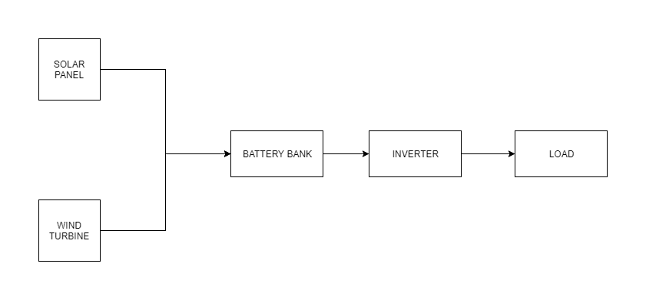

Fig 1: Proposed Model

# CHAPTER-3

## SOLAR ENERGY

Solar energy is radiant light and heat from the Sun that is harnessed using a range of ever-evolving technologies such as solar heating, photovoltaics, solar thermal energy, solar architecture, molten salt power plants and artificial photosynthesis.

It is an important source of renewable energy and its technologies are broadly characterized as either passive solar or active solar depending on how they capture and distribute solar energy or convert it into solar power. Active solar techniques include the use of photovoltaic systems, concentrated solar power and solar water heating to harness the energy. Passive solar techniques include orienting a building to the Sun, selecting materials with favorable thermal mass or light-dispersing properties, and designing spaces that naturally circulate air.

It is a clean, inexhaustible, abundantly and universally available renewable energy source. Major drawbacks of solar energy are: it is a dilute form of energy, which is available intermittently, uncertainly and not steadily and continuously. The output of sun is 2.8*10^23 KW. The energy reaching the earth is 1.5*10^18kWh/year.

## PHOTOVOLTAICS

Photovoltaics (PVs) are arrays of cells containing a solar photovoltaic material that converts solar radiation or energy from the sun into direct current electricity. Due to the growing demand for renewable energy sources, the manufacturing of solar cells and photovoltaic arrays has advanced considerably in recent years, and costs have dropped.

Installations may be ground-mounted (and sometimes integrated with farming and grazing) or built into the roof or walls of a building.

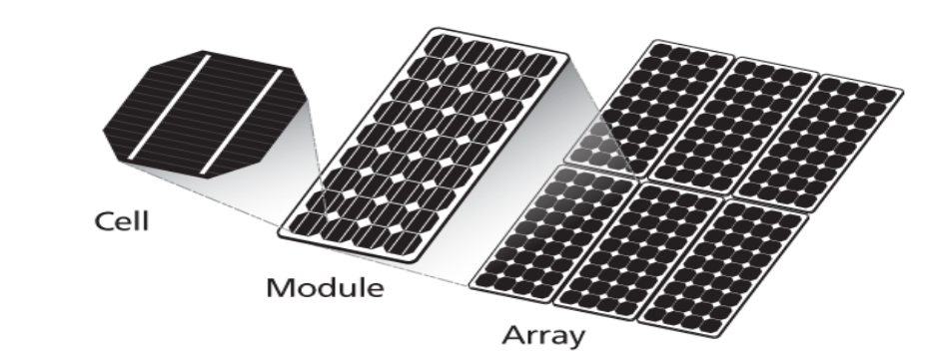

FIG-Photovoltaic system

## SOLAR CELL

A solar cell or photovoltaic cell is a device that changes light energy into electricity. Solar cell is the most expensive component in a solar PV system. Photovoltaic cell is the building block of the PV system and semiconductor material such as silicon and germanium are the building block of PV cell. Silicon is used for photovoltaic cell due to its advantages over germanium. When photons hit the surface of solar cell, the electrons and holes are generated by breaking the covalent bond inside the atom of semiconductor material and in response electric field is generated by creating positive and negative terminals. When these terminals are connected by a conductor an electric current will start flowing. This electricity is used to power a load. Commercial photocells may have efficiencies in the range of 10-20 per cent and can approximately produce an electrical energy of about 1kWh per sq.m per day in ordinary sunshine.

## SOLAR PANEL

Several solar modules are connected in series/parallel to increase the voltage/current ratings. Solar panel is a group of several modules connected in series-parallel combination in a frame that can be mounted on a structure. Photovoltaic solar panels come in many different voltages. The most common are 12 volts, 24 volts, and 48 volts. Like batteries, multiple solar panels can be connected together to produce higher voltages, for example, two 48 volt panels connected together would produce 96 volts. The inverter, batteries, and solar panels in a system are usually all of the same voltage. The advantage of a higher-voltage system is that thinner wire is used, which is less expensive and easier to pull through conduit. The disadvantage of a higher-voltage installation is that electric shock and arc flash become more of a hazard, so installations above 48 volts are usually only found in solar power plants or commercial buildings.

## SOLAR PV ARRAY

In general, a large number of interconnected solar panels, known as solar PV array are installed in an array field. These panels may be installed as stationary or with sun tracking mechanism. The layout and mechanical design of the array such as tilt angle of panels, height of panels, clearance among the panels, etc. are carried out taking into consideration the local climatic conditions, ease of maintenance, etc.

## Mathematical Model of Solar Cell

Solar cells are made of semiconductors material, which are specially treated to form an electric field, positive and negative side. The model of the solar cell can be realized by an equivalent circuit that consists of a current source in parallel with a diode. The current source represents the current generated by photons (often denoted as Iph or IL), and its output is constant under constant temperature and constant incident radiation of light. Rs and Rsh components can be neglected for the ideal model.

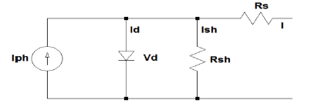

FIG-Model of a solar PV cell

The characteristic equation for a photovoltaic cell is given by

I = Iph –Is [exp $\frac{q\left(V+IRs\right)}{kTA}-1]-\frac{V+IRs}{Rsh}$

Where

Iph = (Isc+ki*(T-Tr))* ($\frac{λ}{1000}$)

Is = Irs * ((T/Tr)^3) * exp(q*Eg/(k*A) * ((1/Tr)-(1/T))

I = Load current

Iph = light generated current

Is = cell/diode saturation current

λ = Insolation

V = terminal voltage

Tr = Reference temperature

Irs = Cell reverse saturation current;

T = Cell temperature in Celsius;

k = Boltzmann's constant: 1.38 * 10^-19 J/K;

q =Electron charge: 1.6*10^-23 C

# CHAPTER-4

## WIND ENERGY

Wind energy is the kinetic energy associated with movement of large masses of air. These motions result from uneven heating of atmosphere by the sun, creating temperature, density and pressure differences. It is a clean, cheap and eco-friendly renewable energy source. Main disadvantages are: it is a dispersed, erratic and location-specific source.

Wind energy is the use of air flow through wind turbines to mechanically power generators for electric power. Moderate to high speed winds, typically from 5m/s to about 25m/s are considered favorable for most wind turbines. Wind power, as an alternative to burning fossil fuels, is plentiful, renewable, widely distributed, clean, produces no greenhouse gas emissions during operation, consumes no water, and uses little land. The net effects on the environment are far less problematic than those of nonrenewable power sources.

Wind farms consist of many individual wind turbines which are connected to the electric power transmission network. Onshore wind is an inexpensive source of electric power, competitive with or in many places cheaper than coal or gas plants. Offshore wind is steadier and stronger than on land, and offshore farms have less visual impact, but construction and maintenance costs are considerably higher. Small onshore wind farms can feed some energy into the grid or provide electric power to isolated off-grid locations.

Wind energy is green energy. Wind turbines use wind energy, which is created by atmospheric heating from the sun, to generate electricity. Using the advantages of wind energy we can convert the inexhaustible supply of wind to electricity without creating additional greenhouse gases and other pollutants.

## ADVANTAGES

• Wind energy is free.

• The wind is a renewable supply and cannot be exhausted.

• Converting wind energy into electrical energy doesn’t create any greenhouse gases or add chemical pollutants to the environment.

• Wind turbines can be installed in remote locations where other forms of energy generation may not be practical.

• Wind turbines cost less and require less space than solar panels (PV) per kilowatt generated (if placed in a proper area)

## DISADVANTAGES

It wouldn’t be fair to list all the wind energy advantages without mentioning some of the disadvantages.

• The wind is not always constant or predictable causing the energy created from wind turbines to be less reliable than other energy generation technology.

• Almost all wind turbines create some form of noise pollutions, the large commercial VAWT will create a high frequency noises (still within human hearing). Large commercial wind turbines are not generally placed next to homes though. The smaller wind turbines make a much louder noise, similar to an airplane.

• Wind turbines have a higher upfront cost than other energy generation technology.

## WIND TURBINES

Generally a wind turbine consists of a set of rotor blades rotating around a hub, a gearbox-generator set placed inside the nacelle. Based on axes the wind turbines are categorized into two kinds: the vertical axis wind turbine and the horizontal axis wind turbine.

The basic components of a wind turbine system are shown in figure below.

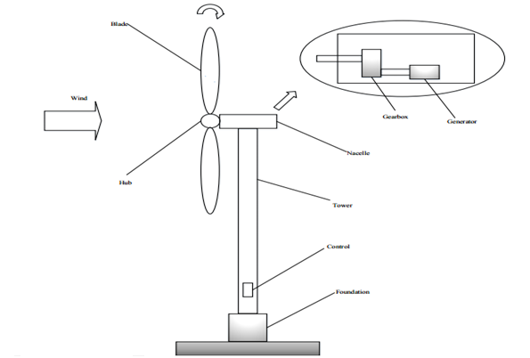

Fig 2: Major wind turbine components

## TYPES OF WIND TURBINES

The two general types of wind turbines are: the horizontal axis wind turbine (HAWT) and the vertical axis wind turbine (VAWT).

### HORIZONTAL AXIS WIND TURBINES (HAWT)

Horizontal axis wind turbines, also shortened to HAWT, are the common style that most of us think of when we think of a wind turbine. A HAWT has a similar design to a windmill; it has blades that look like a propeller that spin on the horizontal axis.

Horizontal axis wind turbines have the main rotor shaft and electrical generator at the top of a tower, and they must be pointed into the wind. Small turbines are pointed by a simple wind vane placed square with the rotor (blades), while large turbines generally use a wind sensor coupled with a servo motor to turn the turbine into the wind. Most large wind turbines have a gearbox, which turns the slow rotation of the rotor into a faster rotation that is more suitable to drive an electrical generator.

Since a tower produces turbulence behind it, the turbine is usually pointed upwind of the tower. Wind turbine blades are made stiff to prevent the blades from being pushed into the tower by high winds. Additionally, the blades are placed at a considerable distance in front of the tower and are sometimes tilted up a small amount.

Downwind machines have been built, despite the problem of turbulence, because they don't need an additional mechanism for keeping them in line with the wind. Additionally, in high winds the blades can be allowed to bend which reduces their swept area and thus their wind resistance. Since turbulence leads to fatigue failures, and reliability is so important, most HAWTs are upwind machines.

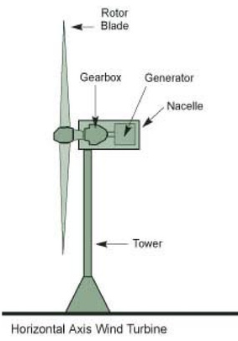

Fig 3: Horizontal Axis Wind Turbine

**HAWT Advantages**

• The tall tower base allows access to stronger wind in sites with wind shear. In some wind shear sites, every ten meters up the wind speed can increase by 20% and the power output by 34%.

• High efficiency, since the blades always moves perpendicularly to the wind, receiving power through the whole rotation. In contrast, all vertical axis wind turbines, and most proposed airborne wind turbine designs, involve various types of reciprocating actions, requiring airfoil surfaces to backtrack against the wind for part of the cycle. Backtracking against the wind leads to inherently lower efficiency.

**HAWT Disadvantages**

• Massive tower construction is required to support the heavy blades, gearbox, and generator.

• Components of a horizontal axis wind turbine (gearbox, rotor shaft and brake assembly) being lifted into position.

• Their height makes them obtrusively visible across large areas, disrupting the appearance of the landscape and sometimes creating local opposition.

• Downwind variants suffer from fatigue and structural failure caused by turbulence when a blade passes through the tower's wind shadow (for this reason, the majority of HAWTs use an upwind design, with the rotor facing the wind in front of the tower).

• HAWTs require an additional yaw control mechanism to turn the blades toward the wind.

• HAWTs generally require a braking or yawing device in high winds to stop the turbine from spinning and destroying or damaging itself.

### VERTICAL AXIS WIND TURBINE (VAWT)

Vertical axis wind turbines, as shortened to VAWTs, have the main rotor shaft arranged vertically. The main advantage of this arrangement is that the wind turbine does not need to be pointed into the wind. This is an advantage on sites where the wind direction is highly variable or has turbulent winds.

With a vertical axis, the generator and other primary components can be placed near the ground, so the tower does not need to support it, also makes maintenance easier. The main drawback of a VAWT generally creates drag when rotating into the wind.

It is difficult to mount vertical-axis turbines on towers, meaning they are often installed nearer to the base on which they rest, such as the ground or a building rooftop. The wind speed is slower at a lower altitude, so less wind energy is available for a given size turbine. Air flow near the ground and other objects can create turbulent flow, which can introduce issues of vibration, including noise and bearing wear which may increase the maintenance or shorten its service life. However, when a turbine is mounted on a rooftop, the building generally redirects wind over the roof and this can double the wind speed at the turbine. If the height of the rooftop mounted turbine tower is approximately 50% of the building height, this is near the optimum for maximum wind energy and minimum wind turbulence.

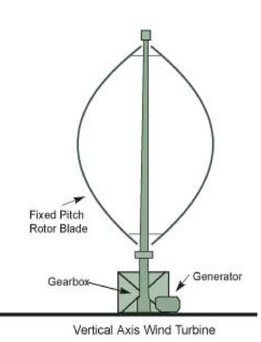

Fig 4: Vertical Axis Wind Turbine

**VAWT Advantages**

• No yaw mechanism is needed.

• A VAWT can be located nearer the ground, making it easier to maintain the moving parts.

• VAWTs have lower wind startup speeds than the typical the HAWTs.

• VAWTs may be built at locations where taller structures are prohibited.

• VAWTs situated close to the ground can take advantage of locations where rooftops, mesas, hilltops, ridgelines, and passes funnel the wind and increase wind velocity.

**VAWT Disadvantages**

• Most VAWTs have an average decreased efficiency from a common HAWT, mainly because of the additional drag that they have as their blades rotate into the wind. Versions that reduce drag produce more energy, especially those that funnel wind into the collector area.

• Having rotors located close to the ground where wind speeds are lower and do not take advantage of higher wind speeds above.

• Because VAWTs are not commonly deployed due mainly to the serious disadvantages mentioned above, they appear novel to those not familiar with the wind industry. This has often made them the subject of wild claims and investment scams over the last 50 years.

## WIND GENERATOR

The shaft of the wind turbine is mechanically coupled to the rotor shaft of the generator, so that the mechanical power developed by the wind turbine (by kinetic energy to mechanical energy conversion) is transmitted to the rotor shaft. This rotor structure has a rotor winding (either field or armature). In both the cases, we get a moving conductor in a stationary magnetic field or a stationary conductor in moving magnetic field. In either case, electric voltage is generated by the generator principle.

## TYPES OF WIND GENERATOR

Generators can be basically classified on the type of current. There are alternating current generators and direct current generators.

In the AC generators, we can further classify them based on the rotor speed. There are synchronous generators (constant speed machine) and asynchronous generators (variable speed machine or the induction machine).

Another classification is based on the magnetic field. The magnetism can be done by either permanent magnet or an electro-magnet. In our case we are using permanent magnet dc generator.

## PERMANENT MAGNET DC GENERATOR (PMDCG)

PMDC generator is an electro-mechanical device that converts the mechanical energy to electrical energy. The field of the PMDC is made up of permanent magnet, so there is no need of separate excitation. So the losses associated with the field winding are avoided. The main advantage of using PMDC generator over AC generator is, less power conversion stages. In AC generators the output is rectified and boosted up and converted to AC. Whereas in DC generators it needs one regulator stage and inverter stage, so the efficiency is high. The disadvantage of using PMDC is it is suitable for only low power applications.

## MATHEMATICAL MODEL OF WIND TURBINE

In the wind power generation system, wind turbine is used to extract the power from the blowing wind. The power can be calculated by-

Pm = ½ ρACpVω3 Where

Cp: Power coefficient

A: Area swept by turbine

ρ: Air density

Vω: Speed of the wind

Based on the rated power wind power calculation can be done.

The amount of aerodynamic torque Tw in (N-m) is given by the ratio between the power extracted from the wind Pw and turbine rotor speed Ww in (rad /s) as follows

Tw = Pw*Ww

## MATHEMATICAL MODELING OF PMDC GENERATOR

Eg = Vo+IaRa

Eg = (PφZN)/(60A)

Eg α N

Vo = Eg – IaRa

Where,

Eg is the generated emf in the PMDC generator,

Ra is the armature resistance

Ia is armature current,

N is the speed of rotation,

Vo is the output voltage of PMDC generator.

# CHAPTER-5

## SIMULATION

The simulation is carried out in Simulink based on the load analysis carried out as presented below.

## Load Analysis

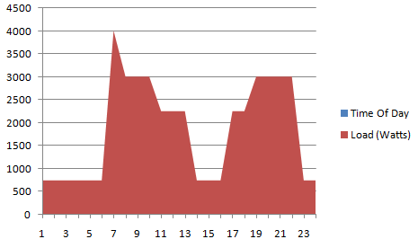

Fig 5: Summer Load

The typical load profile for summer is shown in the figure 5; it is observed that there is a peak of 4KW. The average demand during summer is 1.8 KW.

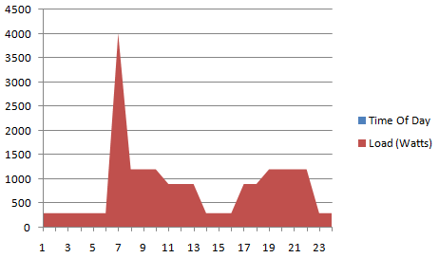

Fig 6: Winter Load

The typical load profile for winter is shown in figure 6. A peak of 4 KW is observed. The average demand during winter is 841.66 W

* Average load-1.2 KW (0.3 KW per household)
* Peak load-4 KW
* Planned capacity-5 KW

Considering both solar and wind systems will supply 50% of the load each. The simulation is based on this load analysis.

## SIMULINK MODEL OF SOLAR PV ARRAY

For this simulation, the “Solar Cell” model which is available as part of Simulink [Simscape > SimElectronics > Sources > Solar Cell] is used.

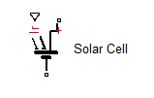

Fig 7: Solar Cell

The solar cell model has three terminals, one for irradiance, one for +ve and one for –ve. Multiple solar cells are connected together to form the solar panel. Solar irradiation is given as input to PV panel. The PV panel converts this irradiation into DC power.

Individual solar cell parameters are as given below:

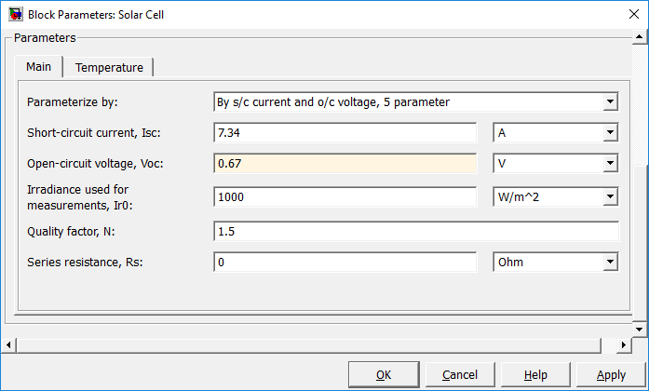

Fig 8: Solar Cell Parameters

The PV panel consists of 72 solar cells connected in series and parallel to produce the required voltage of 24 volts and wattage of 300 watts. The PV panel has three terminals, one for irradiance, one for +ve and one for –ve.

The Solar Cells in the PV array are connected based on the below calculation.

Total power of the solar PV panel: 350 Watts

Voltage of the solar PV panel: 24 V

Current Supplied by the PV panel = 350/24 = 14.6 A

36 cells connected in series produces 36 * 0.67V = 24v

36 cells connected in series 36 * 0.67V = 24v

The pair of 36 cells connected in series is connected in parallel to produce the desired current output =7.3A + 7.3A = 14.6A.

Total wattage: 24 * 14.6 = 350

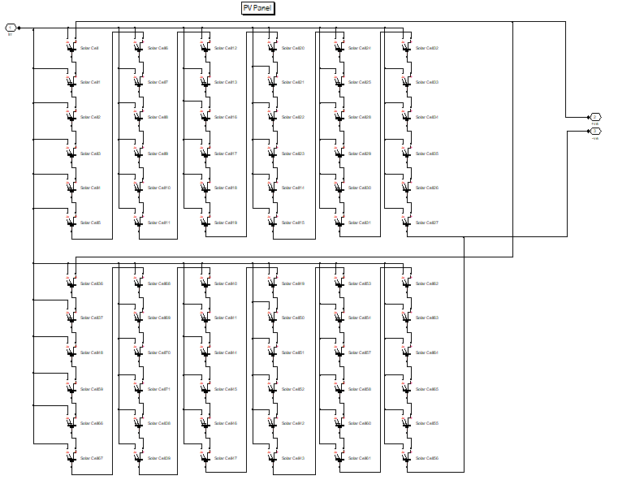

Fig 9: Solar 72 Cell Solar PV Panel

The IV and PV characteristics of the solar panel are presented below:

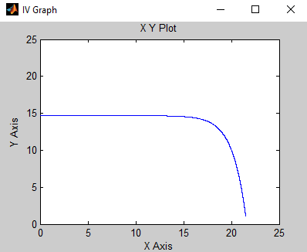

Fig 10: I-V Characteristics of the Solar Panel

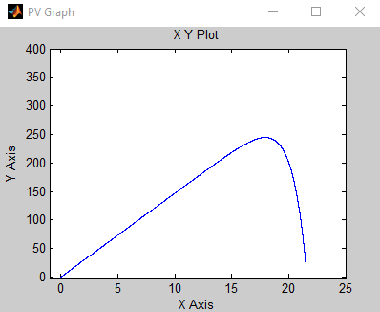

Fig 11: P-V Characteristics of the Solar Panel

## SIMULINK MODEL OF WIND TURBINE AND GENERATOR

For simulating the wind generator, the Wind Turbine model [SimPowerSystems > Application Libraries > Renewable nergy Library > Wind Generation > Wind Turbine] and DC Machine model [SimPowerSystems > Machines > DC Machine] available as part of Simulink is used.

## WIND TURBINE

For the wind turbine the first input is the generator speed in per unit of the generator base speed. For a synchronous or asynchronous generator, the base speed is the synchronous speed. For a permanent-magnet generator, the base speed is defined as the speed producing nominal voltage at no load. The second input is the blade pitch angle (beta) in degrees. The third input is the wind speed in m/s.

The output is the torque applied to the generator shaft in per unit of the generator ratings.

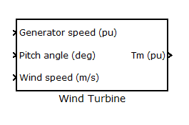

Fig 12: Simulink Wind Turbine Model

The model parameters are as below:

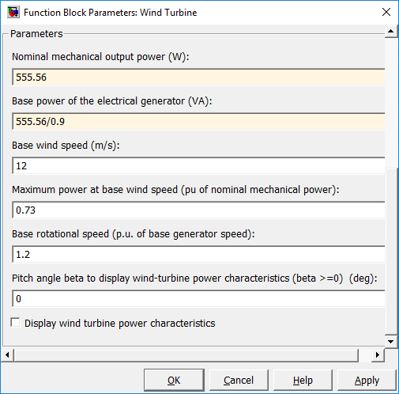

Fig 13: Wind Turbine Model Parameters

## PERMANENT MAGNET DC GENERATOR

For the DC generator the input is torque and output is voltage/current. The convention for running the dc machine as a generator is by providing a –ve value of torque. The generator field type is permanent magnet.

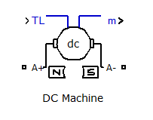

Fig 14: Simulink DC Machine Model

The model parameters are as below:

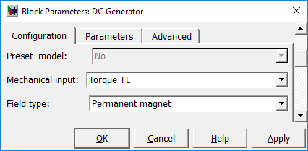

Fig 15a: DC Machine Model Parameters

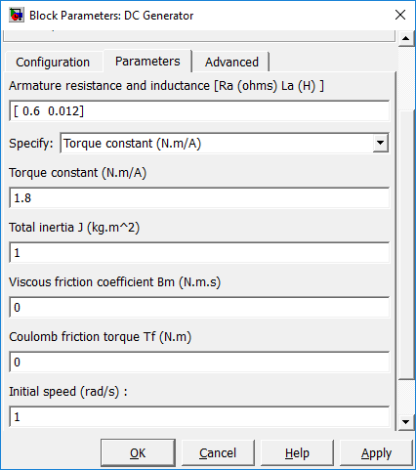

Fig 15b: DC Machine Model Parameters

The wind speed is converted to mechanical energy by the wind turbine. The wind turbine is connected to a generator which converts the mechanical energy into electrical energy.

The wind turbine and dc generator are connected in Simulink to create the model of the wind generator.

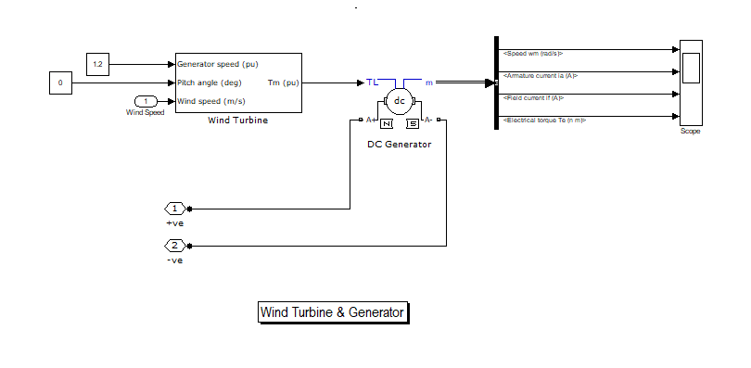

Fig 16: Wind Generator Model

The PMDC generator characteristics are presented below:

The generated voltage has a direct relationship with the RPM. For a specific generator at lower RPMs the voltage generated is low whereas at higher RPMs the generated voltage increases. The generators must be rotated at the nominal RPM to produce the nominal voltage. The simulated DC generator produces 24 V at 600 RPM as seen in the graph below.

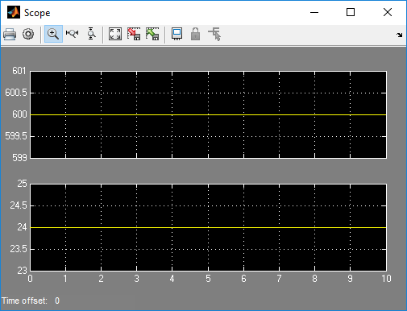

Fig 17: RPM & Generated Voltage

The torque at which the generator is rotated has a direct relationship with the current that the generator can produce. The simulated generator can produce 20 A of current under loaded conditions if rotated with a torque of about 7.5 Nm.

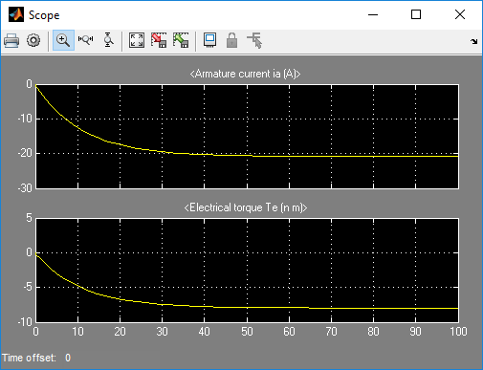

Fig 18: Torque & Armature Current

## SIMULINK MODEL OF SOLAR PV-WIND HYBRID ENERGY SYSTEM

The solar model and wind model are combined to form the model of the Solar PV & Wind Hybrid Energy System. The output of the solar and wind models are connected to a battery bank and inverter.

### BATTERY BANK

The battery bank consists of 6 batteries [SimPowerSystems > Electrical Sources > Battery] of 24 V 120 AH connected in parallel. The battery bank has two terminals one for +ve and one for –ve.

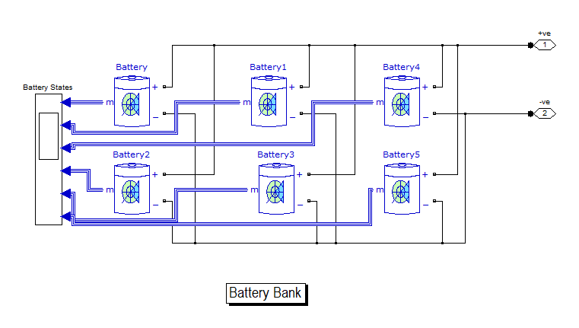

Fig 19: Battery Bank

### INVERTER

The inverter model consists of 4 IGBTs [SimPowerSystems > Power Electronics > IGBT/Diode] connected to a step up tranformer to output 230 volts AC from 24 V DC source. Pulse generators are used to control the wave form. The inverter has 4 terminals two for DC input and 2 for AC output.

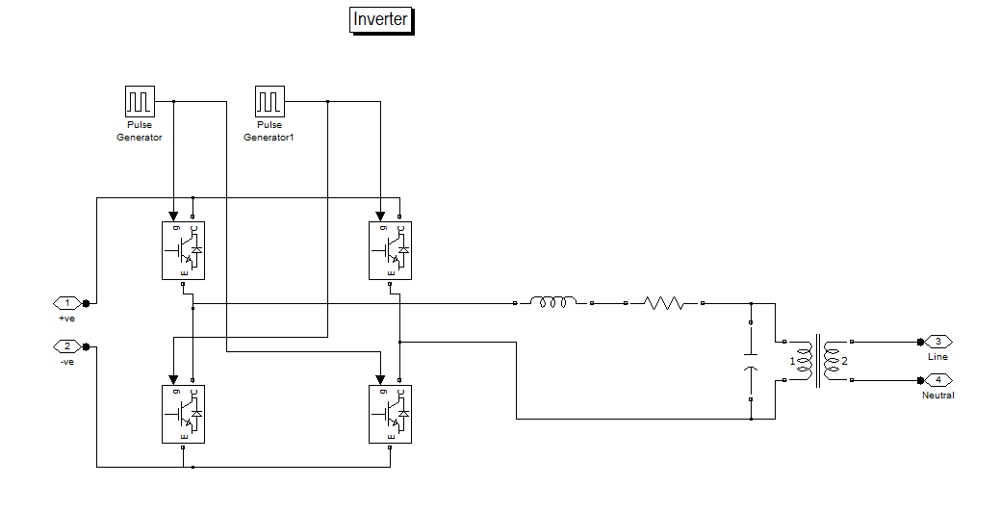

Fig 20: IGBT Based Inverter

## COMPLETE MODEL

In the complete model the various components are connected. DC power from the PV and Wind system is supplied to the battery bank, which is connected to an inverter. The inverter converts 24 V DC to 230 V AC which is used to supply the load.

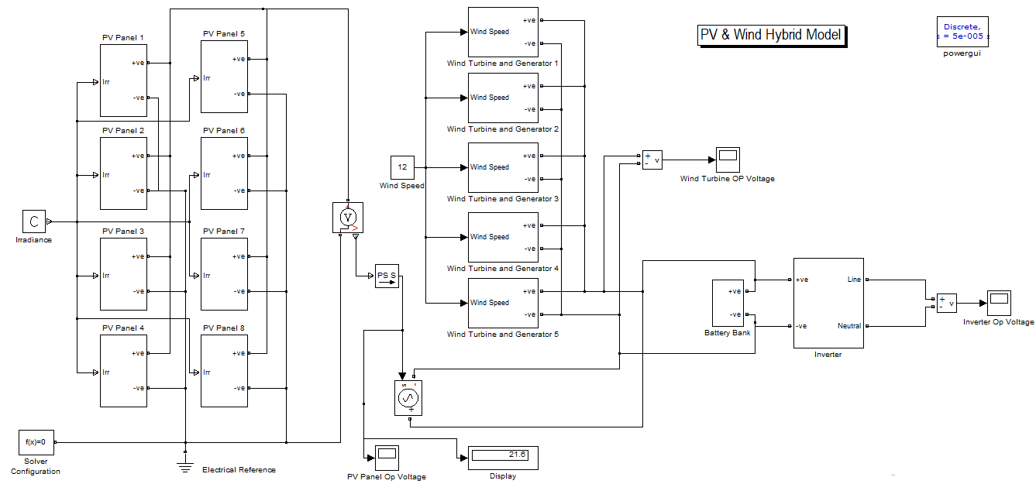

Fig 21: Simulated Model of Standalone Solar/Wind Hybrid Energy System

The input voltage and output voltage of the inverter is presented below:

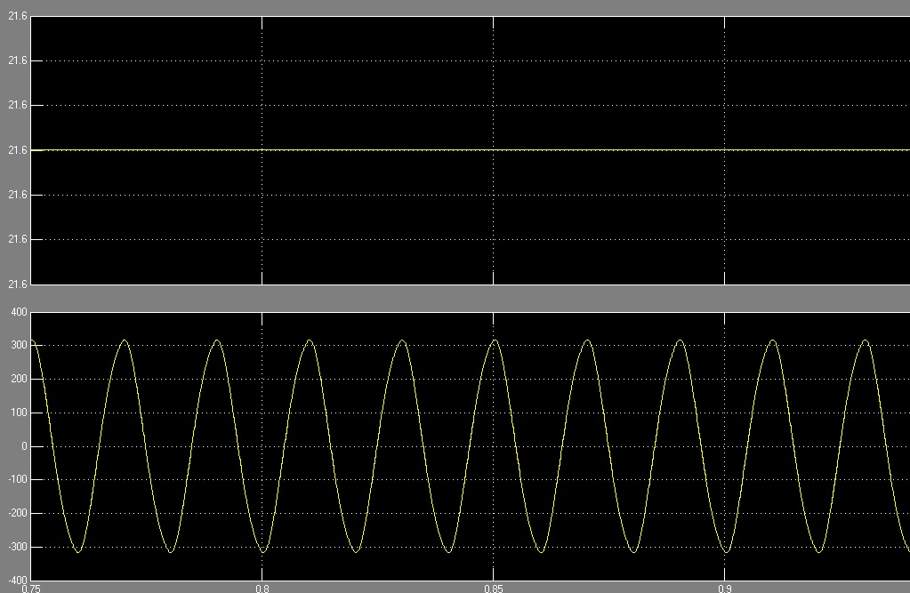

Fig 22: Inverter Input & Output Voltage

# CHAPTER-6

## CONCLUSION

This report presents the modelling and simulation of standalone solar PV/Wind hybrid system using MATLAB/SIMULINK. It includes the design of PV panel with equation and includes the equation that forms the wind turbine. The two systems are combined to operate individually and simultaneously. Finally the simulated result of the hybrid system is presented.

## FURTHER WORK

* Optimisation.
* Cost analysis.

# REFERENCE

1. Modeling and Simulation of Solar Photovoltaic Module Using MATLAB /SIMULINK

Jay Patel1, Gaurag Sharma2, IJRET

2. Hybrid Renewable energy systems and their suitability in rural regions.

Shumank Deep Srivastava,Rajiv Banerjee

IOSR Journal of Mechanical and Civil Engineering

Vol.12, Issue 3

3. Modelling Simulation and performance analysis of Hybrid power generation system.

Shashi Kala Kumari,Rekha Jha

International Journal of Innovative Research in Science, Engineering and Technology

Vol.4, Issue 7, July 2015

4. The Hybrid (Wind and Solar) Renewable Energy Resources in Distribution System: A current status.

Pradeep Maheshwari, Dr. Sushma Gupta,International Journal of Science and Research.

5. Implementation of Wind/PV Hybrid System using MATLAB/SIMULINK.

Anjali Rana,Mohammad IIyas

International Journal of Advanced Research in Electrical Electronics and Instrumentation Engineering

Vol.4, Issue 7, July 2015

6. A Review of Hybrid Renewable Energy Systems for Electric Power Generation.

Md. Ibrahim,Abul Khair,Shaheer Ansari

*Int. Journal of Engineering Research and application*, vol.5, Issue8, (Part1)   
August 2015

7. Single Phase Grid Connected Wind Power Using Chopper Based Pi Controller

Sivamurugan.R,Dhayalini.K,Sathyamoorthy.S

International Journal of Innovative Research in Science, Engineering and Technology,Volume 3, Special Issue 3, March 2014

8.Simulation of Standalone PV/Wind Hybrid System

K.V.Induji, Mr. Vinamzi Paul Samuel

International Journal of Engineering Research & Technology (IJERT)

Vol. 3 Issue 1, January – 2014

9. Modeling and Simulation of Wind-PV Hybrid Power System using MATLAB/Simulink

Jitendra Kasera, Ankit Chaplot, Jai Kumar Maherchandani

2012 IEEE Students’ Conference on Electrical, Electronics and Computer Science

10. Hybrid Power Systems with Renewable Energy Sources – Types, Structures, Trends for Research and Development

Vladimir Lazarov, Gilles Notton, Zahari Zarkov, Ivan Bochev

11. Simulation And Performance Analysis Of Solar PV-Wind Hybrid Energy System Using MATLAB/SIMULINK

B. Kanagasakthivel , Dr. D.Devaraj

2015 International Conference on Computing and Communications Technologies

12. Hybrid Wind Photovoltaic Standalone System

Mr. Siddharth Joshi, Dr. Vivek Pandya, Dr. Bhavesh Bhalja