Impact of Distributed Generation on Reliability of
Distribution System



A Thesis Submitted to Gauhati University for
the Award of Degree of Doctor of Philosophy
in the Faculty of Engineering
by
Basudev Das
2016

Dedicated
To
My Parents

CERTIFICATE

This is to certify that the thesis entitled “Impact of Distributed Generation on Reliability of Distribution System” is submitted to the Gauhati University for the award of the degree of Doctor of Philosophy in Faculty of Engineering by Basudev Das. The thesis is based on his own work under my supervision. He has included all recommendations and suggestions of the pre-submission seminar. The thesis has fulfilled all requirements for the award of the Degree of Doctor of Philosophy.

Dr. Bimal C. Deka
Associate Professor,
Department of Electrical Engineering,
Assam Engineering College
Guwahati - 13, Assam

DECLARATION

I do hereby declare that the work presented in this thesis, entitled “Impact of Distributed Generation on Reliability of Distribution System” is submitted in fulfillment of the requirement for the award of degree of Doctor of Philosophy in Faculty of Engineering. The work presented in this thesis is completely my own work under the supervision of Dr. Bimal C. Deka, Associate professor, Electrical Engineering Department, Assam Engineering College, Guwahati.
The work presented in this thesis has not been submitted by me to any university or any Institute for the award of any degree or any academic award.

Date: 4th August, 2016 BASUDEV DAS

ACKNOWLEDGEMENT

At the very beginning, I take the opportunity to express my sincere thanks and deepest sense of indebtedness to Dr. Bimal C. Deka. I am extremely grateful to him for his sincere support, guidance and advice during the entire course of my research work. His help enables me to complete the thesis in its present form. Once again I would like to express my profound gratitude to him.
I would like to thank Dr. Damodar Agarwal, Professor and Head, Electrical Engineering Department, Assam Engineering College, for his support and help during the course of this work. I am also grateful to all faculty members and staffs of Electrical Engineering Department, Assam Engineering College for their help and encouragement.
I am grateful to Kangka Chakravarty, Dhiman Seal and Dhrubajyoti Bora for their co-operation, help and encouragement for this work.
I express my sincere thanks to my wife, Jahanara and to my son, Rohan for their support help and co-operation for completing this research work.

DATE: 4th August, 2016 BASUDEV DAS

ABSTRACT
The goal of a power system is to supply electricity to its customers in an economical and reliable manner and to meet this goal any power distribution utility is to operate the system in a cost-effective manner with minimum interruption of customer loads. The cost of power interruptions and outages may have severe impact on the utility and its customers. Almost 85% of interruptions of customers take place due to failures of distribution system. Therefore, it is important to plan and maintain reliable power systems to minimize the interruptions of electric power supply. It is also important to assess the reliability of the power system for planning and design reliable system.
There are ways to upgrade the power system to meet the extended demand of energy to minimize the use of fossil fuels. One of the ways is to develop local generating stations either using conventional energy sources or renewable energy sources in the distribution side. These types of generators are usually small scale power sources (10 MW or less) and are connected in the distribution side to supply power to the consumers. This type of generation is termed as the Embedded Generation (EG) or Distributed Generation (DG). It is considered as 3rd generation of power sector reform and it will provide for the wide spread deployment of power generation directly at the sides of customers. There is an increasing trend to interconnect DG with the existing distribution networks to meet various energy needs and to offer more services to customers and the distribution networks. This research work proposes to evaluate reliability of distribution system when distributed generators (DG) inject powers to the system.
The present study is concerned only with adequacy assessment of electrical power distribution system. This is an important issue in system operation and planning. The reliability of distribution system is evaluated by considering the ability of the network fed from bulk supply points or other local infeeds in supplying the load demands. Various reliability indices are defined in literatures to quantify the reliability of distribution systems. These indices are very useful for assessing the severity of system failures in future reliability prediction analysis and past performance of a system. Assessment of all these indices helps us to identify weak areas and give directions for reinforcement of the system, serves as a guide for future reliability predictions and helps us for comparison with actual operating experience. Further, power regulating agencies also use these indices to monitor performance of utilities and also fix rewards or penalties based on these indices.
The distribution system consists of various feeders, laterals, circuit breakers, switches, transformers and other protective devices. The impact of length of laterals, failure and isolation process of all these devices definitely influence the performance at the load points where different types of customers are connected. The load point failure depends on the isolation process of the faulty sections. If disconnects are not installed properly then all components connected with the distribution system, all the sections of the distributors, total length of the lateral connected to the load point , all components connected with the lateral have the contribution on failure of load points. Thus there is a need to properly formulate basic reliability indices including the influence of failures of all associated components. In this study, two basic reliability indices, failure rates and annual outage time of load points, are modeled under different operating conditions of the distribution system. The specific operating conditions considered in this study are basically related to tripping of main circuit breakers under various fault conditions and operational mode of DG. Load point reliability indices for distribution systems are evaluated under above mentioned operating conditions and using those indices some of the well known system reliability indices, SAIFI, SAIDI, CAIFI, CAIDI, ASAI and EENS are also evaluated and comparison has been made to see the impact of isolation process of faulty sections and DG power injection on distribution reliability.
In this research work, Markovian reliability models are also proposed when a DG is connected to a load point. The availability of such DG always depends on the failure and repair history of the components associated with the system. Markov processes are easily applied since failure rates and repair rates of components are equivalent to state transition rates. If the failure and repair density functions of components are exponentially distributed then failure and repair rates are assumed to be constant and Markov models are applicable for the systems. The proposed model has been used to estimate the availability of DG during operation.
Two distribution systems are considered for evaluating reliability indices. A local distribution system of Chandmari-Milanpur area of Guwahati, Assam, India, is considered and the impact of DG on reliability has been studied. DGs are placed at some specific locations and load point and system reliability indices are calculated and compared. Another standard test system, popularly known as Roy-Billinton Test Systems (RBTS), is also considered for the study. Using the reliability data available with this system, reliability indices are calculated by implementing all the developed reliability models in this study. DGs are placed at different locations of the distribution system to meet the feeder requirements and reliability indices are calculated and compared under all the operating conditions proposed in this study.

CONTENTS
- Certificate iii
- Declaration iv
- Acknowledgement v
- Abstract vi
- List of Figures xiv
- List of Tables xvi
- List of Abbreviations xix
- List of symbols xxi
Chapter 1: Introduction 1
1.1. General 1
1.2. Power System Reliability 2
1.3. Distributed Generation 4
1.4. Reliability Indices for Distribution Systems 7
1.5. Reliability of DG Connected Distribution System 10
1.6. Markov Process 11
1.7. Objectives of Research work 13
1.8. Organization of the Report 14
Chapter 2: Literature Review 15
2.1 Introduction 15
2.2 DG in Distribution Systems 17
2.3 Islanding and Role of DG 18
2.4 Optimal Location of DG in Distribution Systems 18
2.5 Optimal Allocation of DG and Capacity 19
2.6 DG Adequacy Assessment Model 20
2.7 Switching and Fault Isolation Processes 20
2.8 Impact of DG Location on Reliability 23
2.9 Impact of Loading on Reliability 24
2.10 Reliability Test Systems 24
Chapter 3: Reliability Modeling and Evaluation Techniques 26
3.1. Introduction 26
3.2. Proposed Reliability Indices 27
3.2.1 Main CB Trips and Manually Started DG 28
3.2.2 Main CB does not Trip and Manually Started DG 29
3.2.3 Main CB does not Trip and Auto-started DG 30
3.2.4 Evaluation of Average Duration of Failures 31
3.3. Reliability Modeling of Load Point Connected DG 31
3.4. Reliability Modeling of Renewable DG 35

Chapter 4: Reliability Assessment of DG Integrated
Distribution Systems 38
4.1. Introduction 38
4.2. Reliability Test System 38
4.2.1. Roy Billinton Test System (RBTS) 39
4.2.2. Local Distribution Systems 40
4.3. Criterions for Reliability Evaluation 41
4.3.1. Main CB trips for fault at any section 42
4.3.2. Main CB does not trip for fault at any section 42
4.3.3. System reliability indices 43
4.4. Results and Analysis 43
4.4.1. Main CB trips and DG started manually 44
4.4.2. Main CB does not trip and DG started manually 49
4.4.3. Main CB does not trip and DG auto-started 54
4.4.4 Reliability indices without connecting DG 58
4.5. Comparison of System Reliability Indices 63
4.5.1. Comparison of SAIFI (case 1) 63
4.5.2. Comparison of SAIFI (Case 2) 66
4.5.3. Comparison of SAIDI (case 1) 68
4.5.4. Comparison of SAIDI (Case 2) 71
4.5.5. Comparison of CAIDI (case 1) 74
4.5.6. Comparison of CAIDI (Case 2) 76
4.5.7. Comparison of ASAI (case 1) 79
4.5.8. Comparison of ASAI (Case 2 ) 81
4.5.9. Comparison of EENS (case 1) 83
4.5.10. Comparison of EENS (Case 2) 85
4.6. Study on Local Distribution System 87
4.7. Results and Analysis for Local Distribution System 89
4.7.1. Main CB trips and manually started DG (Case 1) 89
4.7.2. Main CB does not trip and manually started DG (Case 2) 4.7.3. Main CB does not trip and auto started DG (Case 3) 92
4.8. Comparison of System Reliability Indices 93 4.8.1. Comparison of SAIFI 93
4.8.2. Comparison of SAIDI 94
4.8.3. Comparison of CAIDI 95
4.8.4. Comparison of ASAI 96
4.8.5. Comparison of EENS 97
4.9. Availability Analysis of Load Point Connected DG 98
Chapter 5: Conclusion and Future Scope 102
5.1. Conclusion 102 5.1.1. General conclusion 102
5.1.2. Specific conclusion 104
5.2. Future Scope 106
References 108
Appendix 114
Publications 118

List of Figures

Figure No. Title of the Figure Page No.
Fig. 1.1 Hierarchical Levels 3
Fig. 1.2 A simple radial distribution system 12
Fig. 1.3 State space diagram of the system shown in Fig. 1.2 13
Fig. 3.1 State space diagram of load point connected DG 32
Fig. 3.2 State space diagram of standby DG 35
Fig. 3.3 Markov model of renewable DG 36
Fig. 4.1 Single line diagram of RBTS 39
Fig. 4.2 Distribution system for Bus 2 of RBTS 40
Fig. 4.3 Single line diagram of local distribution system 41
Fig. 4.4 Comparison of SAIFI (DG at D, F, J, N) 65
Fig. 4.5 Comparison of SAIFI (DG at A, E, G, K) 65
Fig. 4.6 Comparison of SAIFI (considering replacement time of transformer) 67
Fig. 4.7 Comparison of SAIFI (considering repairing time of transformer) 68
Fig. 4.8 Comparison of SAIDI (DG at D, F, J, N) 70
Fig. 4.9 Comparison of SAIDI (DG at A, E, G, K) 71
Fig. 4.10 Comparison of SAIDI (considering replacement of transformer) 73
Fig. 4.11 Comparison of SAIDI (considering repairing of transformer) 73
Fig. 4.12 Comparison of CAIDI (DG at D, F, J, N) 75
Fig. 4.13 Comparison of CAIDI (DG at A, E, G, K) 76
Fig. 4.14 Comparison of CAIDI (considering replacement of transformer) 78
Fig. 4.15 Comparison of CAIDI (considering repairing of transformer) 78
Fig. 4.16 Comparison of ASAI (DG at D, F, J, N) 80
Fig. 4.17 Comparison of ASAI (DG at A, E, G, K) 80
Fig. 4.18 Comparison of ASAI (considering replacement of transformer) 82
Fig. 4.19 Comparison of ASAI (considering repairing of transformer) 82
Fig. 4.20 Comparison of EENS (DG at D, F, J, N) 84
Fig. 4.21 Comparison of EENS (DG at A, E, G, K) 84
Fig. 4.22 Comparison of EENS (considering replacement of transformer) 86
Fig. 4.23 Comparison of EENS (considering repairing of transformer) 86
Fig4.24 Comparison of SAIFI for local distribution system 94
Fig4.25 Comparison of SAIDI for local distribution system 95
Fig4.26 Comparison of CAIDI for local distribution system 96
Fig4.27 Comparison of ASAI for local distribution system 97
Fig4.28 Comparison of EENS for local distribution system 98

List of Tables

Table No. Title of Table Page No.
Table 4.1 Customer related load point indices for Case 1 45
Table 4.2 System reliability indices for Case 1 46
Table 4.3 Customer related load point indices for Case 2 46
Table 4.4 System reliability indices for Case 2 47
Table 4.5 Customer related load point indices for Case 3 47
Table 4.6 System reliability indices for Case 3 48
Table 4.7 Customer related load point indices for Case 4 48
Table 4.8 System reliability indices Case 4 49
Table 4.9 Customer related load point indices for Case 1 50
Table 4.10 System reliability indices for Case 1 50
Table 4.11 Customer related load point indices for Case 2 51
Table 4.12 System reliability indices Case 2 52
Table 4.13 Customer related load point indices for Case 3 52
Table 4.14 System reliability indices for Case 3 53
Table 4.15 Customer related load point indices for Case 4 53
Table 4.16 System reliability indices for Case 4 53
Table 4.17 Customer related load point indices for Case 1 54
Table 4.18 System reliability indices for Case 1 55
Table 4.19 Customer related load point indices for Case 2 55
Table 4.20 System reliability indices for Case 2 56
Table 4.21 Customer related load point indices for Case 3 56
Table 4.22 System reliability indices for Case 3 57
Table 4.23 Customer related load point indices for Case 4 57
Table 4.24 System reliability indices for Case 4 58
Table 4.25 Customer related load point indices for Case I 59
Table 4.26 System reliability indices for Case I 59
Table 4.27 Customer related load point indices for Case II 60
Table 4.28 System reliability indices for Case II 60
Table 4.29 Customer related load point indices for Case III 61
Table 4.30 System reliability indices for Case III 62
Table 4.31 Customer related load point indices for Case IV 62
Table 4.32 System reliability indices for Case IV 63
Table 4.33 Comparison of SAIFI (DG at D, F, J, N) 64
Table 4.34 Comparison of SAIFI (DG at A, E, G, K) 64
Table 4.35 Comparison of SAIFI (considering replacement time of transformer) 66
Table 4.36 Comparison of SAIFI (considering repairing time of transformer) 67
Table 4.37 Comparison of SAIDI (DG at D, F, J. N) 69
Table 4.38 Comparison of SAIDI (DG at A, E, G, K) 69
Table 4.39 Comparison of SAIDI (considering replacement time of transformer) 72
Table 4.40 Comparison of SAIDI (considering repairing time of transformer) 72
Table 4.41 Comparison of CAIDI (DG at D, F, J. N) 74
Table 4.42 Comparison of CAIDI (DG at A, E, G, K) 75
Table 4.43 Comparison of CAIDI (considering replacement time of transformer) 77
Table 4.44 Comparison of CAIDI (considering repairing time of transformer) 77
Table 4.45 Comparison of ASAI (DG at D, F, J. N) 79
Table 4.46 Comparison of ASAI (DG at A, E, G, K) 79
Table 4.47 Comparison of ASAI (considering replacement time of transformer) 81
Table 4.48 Comparison of ASAI (considering repairing time of transformer) 81
Table 4.49 Comparison of EENS (DG at D, F, J. N) 83
Table 4.50 Comparison of EENS (DG at A, E, G, K) 83
Table 4.51 Comparison of EENS (considering replacement time of transformer) 85
Table 4.52 Comparison of EENS (considering repairing time of transformer) 85
Table 4.53 Load point indices for local distribution system (Case 1) 90
Table 4.54 Comparison of system indices for local distribution system (Case1) 90
Table 4.55 Load point indices for local distribution system (Case 2) 91
Table 4.56 Comparison of system indices for local distribution system (Case2) 92
Table 4.57 Load point indices for local distribution system (Case 3) 92
Table 4.58 Comparison of system indices for local distribution system (Case3) 93
Table 4.59 Comparison of SAIFI for local distribution system 93
Table 4.60 Comparison of SAIDI for local distribution system 94
Table 4.61 Comparison of CAIDI for local distribution system 95
Table 4.62 Comparison of ASAI for local distribution system 96
Table 4.63 Comparison of EENS for local distribution system 97
Table 4.64 Reliability data for Markov models 98
Table 4.65 Effects of λ_{i} and μ_{i} on steady state probabilities 99
Table 4.66 Effects of λ_{DG} and μ_{DG} on steady state probabilities 99
Table 4.67 Effects of c values on steady state probabilities 100
Table 4.68 Effects of λ and μ on steady state probabilities 101

List of Abbreviations

Abbreviation Description
ADLC Average Duration of Load Curtailment
AENS Average Energy Not Supplied
ASAI Average Service Availability Index
ASUI Average Service Unavailability Index
BPII Bulk Power Interruption Index
BSP Bulk Supply Point
CAIDI Customer Average Interruption Duration Index
CAIFI Customer Average Interruption Frequency Index
CB Circuit Breaker
CIGRE International Council for Large Electric System
CIRED International Conference for Electric Distribution
DER Distributed Energy Resources
DG Distributed Generation
EG Embedded Generation
EDLC Expected Duration of Load Curtailment
EDNS Expected Demand Not Supplied
EENS Expected Energy Not Supplied
EIR Energy Index of Reliability
EIU Energy Index of unreliability
EUE Expected Unreserved Energy
FACTS Flexible Alternating Current Transmission System
HLI Hierarchical Level I
HLII Hierarchical Level II
HLIII Hierarchical Level III
IEA International Energy Agency
IEEE- RTS IEEE – Reliability Test System
LOEE Loss of Energy Expectation
LOLE Loss of Load Expectation
LOLP Loss of Load Probability
MTTF Mean Time to Failure
Abbreviation Description
MTTR Mean Time to Repair
MTBF Mean Time Between Failures
PLC Probability of Load Curtailment
RBTS R. Billinton Test System
SAIFI System Average Interruption Frequency Index
SAIDI System Average Interruption Duration Index

List of Symbols

Symbol Description
λ Frequency of Failure
λ_{i} Load Point Failure Rate at Load Point i
µ Repair rate of the component
F_{ecl} Failure rate each affected component connected
to lateral
F_{ecs} Failure rate each affected component connected
to section
∑F_{ecs} Summation of failure rate each affected component
of section
F_{ps} Failure rate of previous section
∑F_{ps} Summation of failure rate of previous section(s)
F_{psc} Failure rate of previous affected component of section
∑F_{psc} Summation of failure rate of previous affected
component(s) of section(s)
L_{a(i)} Average Load Connected To Load Point i
L_{e} Length of the affected section(s) due to failure
L_{T} Total length of all section in meter
m Mean Operating Time of The Component
U_{i} Annual outage time at Load Point i
U Annual outage Time
N_{i} Number of Customer of Load Point i
P₀ Probability of Availability
P₁ Probability of Unavailability r Average Outage Duration
r/ Failure rate of the lateral per year
r_{i} Average Outage Duration at Load Point i
r_{i}/ Failure rate of lateral connected to load point i
r// Repairing time of lateral

Symbol Description
∑r_{cf} Summation of failure rate of all components
installed at feeder
∑r_{i(cl)} Summation of failure rate of all components
installed at the lateral to which the load point i is
connected
R Repairing time of the section
R/ Switching time of the section
R_{ecl} Repairing/replacement time of component(s)
Connected to lateral at load point i
R_{ecs} Repairing/replacement time of affected
component(s) connected to section
S_{cs} Switching time of each component connected to
section
S_{g} Starting time of DG
∑F_{ecl}R_{ecl} Summation of product of failure rate of each
affected component of lateral to which load
point i is connected and repairing time/ replacement
time of that component ∑F_{ecs}R_{ecs} Summation of product of failure rate of each of
affected component(s) of each section and repairing/
replacement time of that component
∑F_{uecs}R_{uecs} Summation of product of failure rate of each un-
affected component(s) of other sections and
switching time of each component.
∑F_{ps}S_{g} Summation of product of failure rate of previous
sections and switching time of DG
∑F_{psc}S_{g} Summation of product of failure rate of previous
affected component of section and switching
time of DG

Chapter 1
Introduction
1.1. General
Generally, power is generated by centrally located large power plant. There are many problems in transmission and distribution of power among the consumers due to the large distance of the power plants from the consumers. The main function of the power system is to supply power with acceptable degree of reliability and quality as economical as possible. The consumers expect continuous supply of power on demand. The system adequacy only will not help in this case if the system failure is large. It can be reduced by increased investment either planning phase, operating phase or both.
In case of large power plants, there are many problems which are also the causes of low reliability. The efficiency of these plants is not high. It is minimum 28% to maximum 35% [1]. Usually large power plants are far away from the consumers. The power is transmitted to the load centre through interconnected transmission line. It is distributed amongst the consumers from the load centre through interconnected distribution lines. There are many technical and financial constraints in building new transmission line for meeting increased load demands. Of course, power transfer capacity of existing line can be increased by using FACTS devices. The conventional sources of energy are oil, coal, gas, hydel, nuclear etc. Fossil fuels have been the main sources of energy so far. Other major problem of large power station is the production of green house gases due to the use of fossil fuels. The availability of fossil fuels in near future is another major cause of concern. The world energy consumption is not static and it is increasing by 2% per year [1]. The demand of electrical energy is increasing more rapidly in developing countries. Therefore it demands the alternative arrangement in case of fossil fuels. Otherwise the world will have to face severe problems in near future. Distributed generation is one of the alternatives to help in reducing these problems as well as to improve the reliability of the system.
1.2. Power System Reliability
There are two aspects in case of power system reliability assessment. These are system adequacy and system security. The main function of power system is to supply power to the customers. The customers need continuous uninterrupted power. If there is sufficient generation of power, sufficient transmission and distribution facilities then only the customers get power according to their need. Thus adequacy means the sufficient capacity of the system so that it can meet the customer demand [2].
There are different types of disturbances within the system. These may develop different types of affect for the system. These disturbances may be the cause for generation and transmission losses. The power system should have the capacity to respond these disturbances. The security is the ability of the system to respond any disturbance the system is subjected to. As per [2], security means the system capacity to overcome the dynamic or transient disturbances if developed in the system.
The power system is to supply power to all type of customers reliably and economically. There are three functional zones in the complete power system: generation, transmission and distribution. For reliability analysis, these three functional zones are divided into three hierarchical levels – HLI, HLII and HLIII as shown in Fig. 1.1 [2]. HLI includes only generation facilities. HLII includes both generation and transmission facilities. But HLIII includes all three functional zones namely generation, transmission and distribution.
It is necessary to examine the adequacy of generation facilities to satisfy the system demand through reliability evaluation. It is known as reliability evaluation of generation capacity [2].
The function of transmission system is to transmit power to the load centre. In HLI, generating capacity is analyzed so that it can satisfy the load demand of customers. But transmission and distribution of power to the customers is ignored in HLI. There are many indices for reliability analysis for HLI. The most widely used indices for HL I are Loss of Load Probability (LOLP), Loss of Load Expectation (LOLE) and Expected Energy Not Supplied (EENS). HLI reliability study can be performed under two conditions: either including or excluding the DG connected with the distribution system [3]. Thus HLI reliability study will be different if DG is included in the distribution system.

GENERATION FACILITIES
HIERARCHICAL LEVEL I
HIERARCHICAL LEVEL II
TRANSMISSION FACILITIES

DISTRIBUTION FACILITIES
HIERARCHICAL LEVEL III

Fig. 1.1: Hierarchical Levels

The hierarchical level HLII is also known as Composite System. It includes generation and transmission facilities. In the composite generation and transmission system (HLII), the reliability is analyzed whether the system is able to meet the load demand at the major load points. In a power system, the generating system must be able to produce sufficient power. The transmission system supplies this generated power to the major supply point. HLII includes generation as well as transmission facilities; therefore reliability analysis of HLII is not easy. The indices used for HLII reliability analysis are Probability of Load Curtailment (PLC), expected Duration of Load Curtailment (EDLC), Average Duration of Load Curtailment (ADLC), Expected Demand Not Supplied (EDNS), Expected Energy Not Supplied (EENS), and Bulk Power Interruption Index (BPII) etc [4]. The ability of power system to perform its function to transmit power from the generating station to the major supply point is assessed using these indices.
The hierarchical level III includes all three functional zones: generation, transmission and distribution. It starts at generating station and finishes at end consumers. As such HLIII is very much complex. Therefore, reliability analysis of HLIII is not done directly due to the seriousness of problems in a practical system. To solve the problem, reliability analysis of distribution functional zone is performed independently. It is possible to get HLIII reliability indices by using HLII load point indices as the input values of distribution functional zone under consideration [5]
The adequacy indices of different hierarchical level are not same. The reliability indices of HLI show the capability of generating station to meet the load demand. The indices of HLII shows the ability of the generating station to meet the load demand as well as the capacity of the transmission line to transmit power from the generating station to the bulk supply point. Thus these indices show the capacity of the system to meet the individual load requirement at bulk supply point.
Generally, HLII indices have small effect on individual customer load points. The reliability indices of HLIII show the adequacy of individual customers and distribution system is responsible for it.
1.3. Distributed Generation
Distributed Generation (DG) plays an important role in solving energy problem. It helps to reduce environmental pollution by replacing fossil fuel through renewable energy sources. The renewable energy sources are solar, photovoltaic, wind, geothermal, tidal, micro-hydel and biomass etc. Non-renewable energy sources can also be used for DG. Internal combustion engine, combustion turbine, fuel cell etc are the non-renewable technologies. Renewable sources have small energy density and due to intermittent nature DG plants are usually small and geographically wide spread. It can be installed throughout an electric distribution system to meet the energy and reliability needs of the customer connected to the system. DG can be installed both in consumer side and in the utility side [6].
There is no any universally accepted definition for DG. It is termed as Embedded Generation (EG) in U. K. and some other countries. The International Energy Agency (IEA) defines DG as the generating plant serving at customer site. But the agency does not consider the wind power generation as DG. The IEA defines another type of generation termed as Dispersed Generation which includes DG plus other generation either connected to a distribution network or completely independent of the grid. The term “Dispersed Generation” is used in North American countries. But in Europe and some other countries of Asia, the term “Decentralized Generation” is used [7]. T. Ackermann et al suggest another definition of DG that is connected directly to the distribution network or on the customer side of the meter [7]. However, the common characteristics of all types DGs are: not centrally located, not centrally dispatched, having capacity less than 50-100 MW and normally connected to the distribution network [8].
Besides the improvement of reliability of the system, DG helps in many other ways as reported by The International Conference on Electricity Distribution Network (CIRED) [9]. These include:
i) It helps to reduce the production of green house gases
ii) It helps to increase the energy efficiency
iii) Use different sources of energy
iv) It accelerates more deregulation of the system etc
The report of International Conference on Large High Voltage Electric Systems (CIGRE) [8] considers DG from the commercial points of view:
i) Many DGs can be connected to the distribution system separately
ii) DG requires small area and hence easy to find site for DG construction
iii) Low capital investment
iv) Can be commissioned in a short span of time
v) Transmission cost can be reduced due to the closeness of DG to the load
The IEA has identified five major factors which contribute to the increased interest in DG [10]. These are:
- Rapid development in DG technologies,
- Eliminates the need of construction of new transmission lines,
- Helps to improve the reliability
- Helps in liberalization of electricity market
- Helps in the reduction of green house gas production
Technical impact of DG on distribution system is discussed in [1, 3, 6, 7]. In case of conventional power system, power flow is from higher voltage level to lower voltage level. But due to the connection of DG, power flow may become reverse. Generally distribution network is a passive network. But the connection of DG converts the distribution network into active network. Its power flow and voltages depend on the load and generation. The voltage received by the customers from the distribution system should be within specific limit.
When DG is connected with the existing distribution system, many technical issues are developed. It may change the profile of the network voltage and it increases the fault level of the distribution system. Induction generator and synchronous generator are the main sources in increasing the fault of the distribution system. DG may also influence the power quality. The main aspect of power quality is the transient voltage variation and harmonic distribution of the network voltage. When DG is connected, it develops those effects and additional steps are necessary for reducing those effects [3].
There are two types of operation of DG: It cannot run independently at the time of interruption of supply from major supply points. There are many causes for interruption of supply such as failure of the major supply point, failure of transmission system or failure of distribution system connected with the major supply points. DG may be run independently at the time of interruption of supply. At the time of failure between major supply points and load centre, DG can supply all or some of the load. This helps to improve the reliability of the system.
1.4 Reliability Indices for Distribution System
In HLIII study, consumer related load point indices are evaluated. The main consumer related load point indices are expected frequency (or rate) of failure, average duration of failure and the annual unavailability (or outage time) [2, 4]. These are adequacy indices at the consumer load points. The load point failure depends on the failure rate as well as automatic isolation of failed components. There are many customer oriented additional reliability indices that are also termed as system reliability indices. These are: System Average Interruption Frequency Index (SAIFI), Customer Average Interruption Frequency Index (CAIFI), System Average Interruption Duration Index (SAIDI), Customer Average Interruption Duration Index (CAIDI), Average Service Availability Index (ASAI), Average Service Unavailability Index (ASUI), Expected Energy Not Supplied (EENS), and Average Energy Not Supplied (AENS) [4, 11]. The most widely used customer oriented reliability indices are explained in the following section:
i) System Average Interruption Frequency Index (SAIFI)
It is the average number of sustained outages, per year, per customer over a defined area. It is a measure of how many sustained interruptions an average customer will experience over the course of a year. For a fixed number of customers, the only way to improve the SAIFI is to reduce the number of sustained interruptions experienced by customers.
$\text{SAIFI}=\frac{\sum{λ_{i}N_{i}}}{\sum{}N_{i}}$ (1.1)
where, λ_{i} is the failure rate and N_{i} is number of customer of load point i.
ii) Customer Average Interruption Frequency Index (CAIFI)
It is the average number of interruptions per customer affected per year.
$\text{CAIFI}=\frac{\sum{λ_{i}N_{i}}}{N_{a}}$ (1.2)
where N_{a} is the total number of customers affected.
iii) System Average Interruption Duration Index (SAIDI)
It is the average length of a sustained customer outage experienced by a customer. SAIDI is a measure of how many interruption hours an average customer will experience over the course of a year. For a fixed number of customers, SAIDI can be improved by reducing the number of interruptions or by reducing the duration of these interruptions.
$\text{SAIDI}=\frac{\sum{(U_{i}×N_{i})}}{\sum{N_{i}}}$ (1.3)
where, U_{i} is the annual outage time.
iv) Customer Average Interruption Duration Index (CAIDI)
It is average interruption duration per customer interruption. CAIDI is a measure of how long an average interruption lasts, and is used as a measure of utility response time to contingencies.
$\text{CAIDI}=\frac{\sum{U_{i}∗N_{i}}}{\sum{λ_{i}N_{i}}}$ (1.4)
v) Average Service Availability Index (ASAI)
It is the ratio of total number of customer hours that service was available during a year to the total customer hours demanded. ASAI is the customer-weighted availability of the system and provides the same information as SAIDI. Higher ASAI values reflect higher levels of reliability.
$\text{ASAI}=\frac{\sum{N_{i}∗\text{8760}−\sum{U_{i}∗N_{i}}}}{\sum{N_{i}∗\text{8760}}}$ (1.5)
vi) Average Service Unavailability Index (ASUI)
It is the ratio of total number of customer hours that service was unavailable during a year to the total customer hours demanded.
$\text{ASUI}=\frac{\sum{U_{i}∗N_{i}}}{\sum{N_{i}∗\text{8760}}}$ (1.6)
vii) Expected Energy Not Supplied (EENS)
It is the total energy not supplied per year by the system.
$\text{EENS}=\sum{L_{a(i)}∗U_{i}}$ (1.7)
where L_{a(i)} is the average load connected to the load point i.
viii) Average Energy Not Supplied (AENS)
It is the average energy not supplied per customer served per year by the system.
$\text{AENS}=\frac{\sum{L_{a(i)}∗U_{i}}}{\sum{N_{i}}}$ (1.8)
There are few more indices found in the literature [3, 4, 11] applicable to distribution systems.
1.5. Reliability of DG Connected Distribution System
A distribution system consists of main feeders and lateral distributors connected to the main feeders. The main feeder may be single, meshed or parallel circuits. Single circuit main feeders are widely used and these are known as radial feeder. The distribution system has many series components between bulk supply point and individual load points. Some of these components are protective components; some are switching and isolating components. The load point failure depends on the failure rate and automatic isolation of failed components. In case of alternate supply, there is also some switching arrangement at the lateral which connects the source with the feeder.
The reliability indices of HLIII can be evaluated using the reliability indices evaluated in HLII. But this is not so applicable when DG is connected to the distribution system [3]. The failure in HLI or HLII affect the large part of the system but failures in these are not frequent. In case of rural area, there is only single radial distribution line. The failure in distribution system is more due to adverse environmental condition. Outage may occur due to the failure of other components installed at sections and lateral of the radial distributor. These result in more failure and long outage time. If DG is connected to the distribution system and if isolation process of faulty section and lateral of radial distribution line is proper then these help to supply power to the consumer continuously. Again, if the capacity of main generation is low or if there is outage in HLI or HLII or in both then DG can meet the load demand of the consumer. Thus DG helps to improve the reliability of the system.
There are many factors on which reliability improvement of distribution system depends. The improvement of reliability of the distribution system depends on the capacity and location of DG, isolation process of the faulty sections of main feeder, isolation process of the lateral distributor, failure rate of feeder, failure rate of lateral, failure rate of different components installed at different sections of the feeder and lateral, location and number of isolating switches, tripping process of main circuit breaker (CB), adequacy and capacity of DG, and starting process of DG etc. It is assumed that the DG runs independently and it is connected to the system under two conditions: either DG is auto started or manually started. The capacity of DG is sufficient to meet the load demand. All sections of the main feeders are equipped with Circuit Breakers (CB) which can isolate the faulty sections. The CB is also installed at each lateral.
1.6. Markov Process
The random behavior of systems that vary discretely or continuously with respect to time and space can be modeled using the Markov process [12]. It is a powerful method based on system states and transition between these states and has been successfully applied to many areas related to reliability analysis. Markov models make two basic assumptions regarding system behavior.
- The system is memory less. This means that the future states of a system are independent of all past states except the immediately preceding one.
- The system is stationary, which means that transition probabilities between states are constant and do not vary with time.
It is evident from the above two assumptions that Markov approach is applicable to those systems whose behavior can be described by an exponential probability distribution, i.e., the system is characterized by a constant failure rate (λ). Markov models can be either discrete or continuous. Discrete models have state transitions that occur at specific time steps while continuous models have constant state transitions. The most reliability modeling applications utilize continuous Markov models. These models are easily applied to distribution systems since failure rates are equivalent to state transition rates which are constant. Other than failure rate, switching rate (σ) and repair rate (μ) are also included in the model [11].
A typical Markov model is shown in Fig. 1.3 for a simple distribution system shown in Fig. 1.2. The system consists of two substations S₁ and S_{2,} a circuit breaker CB, two distribution lines L₁ and L₂, a normally closed switch Sw₁ and normally open switch Sw₂. The system is normally in state 1. If L₁ fails, CB opens and system transit to state 2 with a constant transition probability λ₁. The switching operation is done and the system then transit to state 4 with a probability σ₁and after repairing the line the system restores to normal state, i.e., state 1with a probability μ₁. A similar sequence of events occurs when L₂ fails. A

CB
S₁
S₂
Sw₁
Sw₂
L₁
L₂
Load

Fig. 1.2: A simple radial distribution system

State 1
Normal
λ₁
λ₂
State 5
Switching
State

State 4
Switching
State
State 3
L₂ fails

State2
L₁ fails

μ₁
μ₂
σ₁
σ₂

Fig 1.3: State space diagram of the system given in Fig. 1.2

A stochastic transitional probability matrix (STPM)[12] is developed and assuming state probability vectors ω = [P₁ P₂ P₃ P₄ P₅] for steady state probabilities of states 1, 2, 3, 4 and 5, and using the following two equations, the steady state probabilities of each state are determined and from these values the availability of the system is obtained.
ω[STPM]= ω (1.9)
$\sum_{i=1}^{5}{P_{i}=1}$ (2.0)
This matrix method has been elaborately explained in [12]. In this research work, the Markov model approach has been used for formulating reliability models for DG that are operating in different conditions as explained in sections 1.3, 1.4 and 1.5.

1.7. Objectives of Research Work
The aim of this research work is to evaluate the reliability of distribution system when DGs are integrated to the system. The existing basic reliability indices used in reliability evaluation of distribution system are modified and applied to study the impact of isolation process of faulty sections of the system. These basic indices are also used to calculate the system reliability indices such as SAIFI, SAIDI, CAIFI, CAIDI, ASAI, EENS etc. According to the authors of [13], these system indices are valuable because they identify weak areas, show the trends in reliability performance, serve as a guide for acceptable value in future reliability assessment and helps previous predictions to be compared with actual operating experience. Moreover, power regulating agencies use these indices to monitor performance of utilities and also fix rewards or penalties based on these indices.
The level of reliability in the customer side is enhanced by supplying the local load using DG during interruptions. The DG may not be able to supply the demand completely due to the availability and the capacity of the DG. So, the availability analysis of DG is one of the concerns in this study. Markov based reliability models are proposed for load point connected conventional DG when it is operating either in active redundant mode or in standby mode. A Markov model is also proposed for a renewable DG.
1.8. Organization of the Report
This thesis consists of five chapters. A brief introduction of different topics with reference to the present study is described in this chapter. A detail literature survey has been conducted to know the reliability evaluation methodologies, reliability improvement & optimization, faulty section isolation process, impact of DG in reliability improvement are elaborately presented in Chapter 2. Based on literature review, the problem are identified, formulated and presented in Chapter 3. The proposed basic reliability indices after modification of the existing indices are presented in this chapter. The Markov based reliability models for DG are also included in this chapter. In Chapter 4, the models are exemplified using two test systems. One is the standard test system obtained from literature and another is a local distribution system. The results that obtained are analyzed and presented in this chapter. Finally, the conclusion drawn from this study has been presented in Chapter 5 followed by list of references, appendices and the list of publications.
Chapter 2
Literature Review
2.1. Introduction
During the early years of development, power systems were developed in the form of local generation supplying local demands. It was then quite sufficient. But later on it was found that the energy thus produced was not sufficient and economical. This contributes to the development of centrally located generating stations meeting the demands through transmission and distribution systems. The produced power is first transmitted to the load centre and from the load centre it is distributed amongst the consumers. But the distance from the generating station to the consumer is practically very large. This large distance develops different types of technical problems and financial constraints. There are many ways to upgrade the distribution and transmission systems to meet the extended demand of energy. There are many constraints such as obtaining approval to site due to environmental concern, effects of electric and magnetic fields on health of human and animals, value of land property along the route in building new transmission lines. One way to improve the transmission capacity in the existing system is the application of Flexible AC Transmission Systems (FACTS).

The greatest threat to the world in the 21st century is the climate change. One main reason for the climate change is the centrally located power stations using fossil fuels. This leads to develop local generating stations using renewable energy sources. But the localized generating stations using renewable energy sources cannot produce constant power due to its intermittent behavior. These problems lead to embed these localized generating stations in the distribution networks and it is termed as the Embedded Generation (EG) or Distributed Generation (DG).

The efficiency of centrally located power plant is not high. These power plants are having near about 28% to 35% efficiency [1]. The main sources of energy for the centrally located plants are fossil fuels so far. If alternative arrangement is not made in case of source of energy, the world will face severe problem in near future as because the energy demand is regularly increasing at a rate of approximately 2% per annum [14]. New transmission line is necessary to transmit power from the power plants to the load centre to meet the increased demand. The different types of constraints raise the question in building new transmission line. The problems developed from centrally located big plants may be overcome by using distributed energy resources (DER) like solar, wind, biomass, tidal, mini hydel, geo-thermal etc. The non-renewable energy sources like gas, diesel etc may be used also for DG. Therefore, renewable as well as non-renewable technologies can be used for DG [6]. There are different types of DG technology using renewable energy. In paper [15], the authors have focused on the technology that utilizes a continuous fuel source like reciprocating engine, micro-turbine etc. DG using renewable energy sources helps to control global warming. This increases the demand of DG using renewable energy sources. The European Union targets to produce 20% of the generated energy from renewable energy sources. More than half of the world’s electrical energy is expected from renewable sources by the year 2060 [14].

The importance of DG is increasing day by day with increased liberalization of economy and deregulation of energy sectors. There are many research works on DG for the last several decades with lot of reforms. There is three generation of reforms. In the 1st generation of reforms, independent power producers are created. They sold power to the utilities. In the 2nd generation of reforms whole sale and retail markets were created. DG is considered as 3rd generation of power sector reform. The 3rd generation provides the wide spread deployment of power generation directly at the sides of customers [10].
The penetration of DG has many impacts on distribution systems. It supports the system voltage and improves power quality. It helps to reduce the losses, decrease the burden of transmission and distribution. It supports to put off the installation of new transmission and distribution line and improves reliability of the system. But it is not easy to obtain these benefits. However, there are certain issues like voltage flicker, harmonics, increased impact of short circuit level etc. to be addressed so that DG does not lead to degrade the system.

An extensive review of literature has been conducted and presented in this chapter. It focuses on DG technologies, its operations and active role in improvement of power system performance specifically the reliability of distribution system. The review of literature broadly categorize into the following sections that are only relevant to the present study.

2.2. DG in Distribution Systems

Generally, the distribution network is a passive network. But the connection of DG converts the distribution network into an active network [3]. The power flow and voltage of the DG connected distribution network are regulated by the generation & loads. The distribution system with DG develops different power quality issues like flicker, transient voltage variations, harmonics etc [16]. In this paper, the author simulates a system with a mini-hydel generating system and a wind generator to study the effect of various power quality problems arising from DG while it is fed to the distribution system. It was observed that DG leads to severe power quality problem like flicker, voltage dip etc. The authors have showed that the power quality of the local grid may be improved by employing some energy storage system. If the penetration of DG is high, the power flow may become reverse. In that case power flows from low voltage to high voltage [3]. DG usually provides support to the distribution network and always connected at distribution level voltage. It is mainly used as back up generation and also started after isolation of the faulty section to continue the supply to the healthy sections. DG can also be used as peak shaving unit to satisfy the consumers and switch off during the period of low demand [10].
2.3. Islanding and Role of DG
The operation of DG during islanding helps to increase the reliability of the system. There are two types of islanding operation: intentional and unintentional. In [17], islanding operation is explained briefly. In case of islanding operation, one part of the distribution system is isolated from the rest of the power system to which it is connected and the DG is connected to the system to energize the isolated part. The authors, in this paper, have used dynamic modeling of the distribution system connected with DG. The authors also studied the islanding behavior in steady state and transient state and study the impact of different type of DG (induction & synchronous) on the IEEE 34 bus radial distribution system. It was found that in case of induction generator, reactive power compensation is necessary. The important advantage is that the overall network loss is reduced and there is also improvement of voltage profile. From the study, authors have observed that induction generator maintains active and reactive power under short time islanding. The study shows that the islanding of main supply must be shorter than stability margin in networks with most penetration of induction generators. The advantage of synchronous generator is that it injects reactive power to the external grid. Use of synchronous generator with power frequency control and automatic voltage regulator helps to maintain the frequency deviation within the limit.
2.4. Optimal Location of DG in Distribution System
The reliability improvement of distribution system depends on the location of DG in the system [18]. Improvement of system reliability, reduction of losses, delaying of new generation, improvement of power quality depend on the location of DG, capacity of DG and operating condition of the system [19,20]. In paper [21], the authors have critically analyzed the optimal value based location for DG connected to weak grid distribution system. The study assesses the reliability performance considering the reactive support requirement and distribution losses. They have considered the cost due to the distribution system losses and cost of additional reactive power in addition to reliability performance. These cost elements vary if DG location is changed. The authors have observed that reactive power support and power losses are more sensitive to the location of DG compared to reliability. The reactive power support, power losses and reliability cannot be optimized at the same location of DG. The optimum location for reliability may be the very poor location for reactive power compensation. In case of distribution losses it may be the same.
According to [21], optimum value based location of DG depends on the system and load distribution. The sensitivity of reliability depends on the factors like load curtailment scheme and use of renewable energy sources. These factors affect the sensitivity of reliability for different location of DG. But these cannot change the optimum location. The authors have also showed that the reliability improvement will be maximum if the location of DG is such that it provides maximum access to the customers in terms of customer numbers, overall demand and priority of customer.
In [22], the authors have applied analytical method to determine the optimal location of DG connecting with the distribution network to minimize the power losses. In this paper, resistance and inductance per unit length of overhead transmission line are considered for optimal placement of DGs.

2.5. Optimal allocation of DG and Capacity
In [23], a methodology is proposed for optimal allocation of DG on distribution network with respect to different technical constraints. These constraints include thermal constraint, equipment ratings (transformer capacity and short- circuit level), SCR (ratio of generator power at each bus to the short-circuit level at each bus), voltage rise effect, energy resource and customer initiative constraint. The authors have observed that in case of bus nearer to the bulk supply point, it is less sensitive to DG.
A method is proposed in [24] for optimal DG unit allocation and sizing in order to maximize the benefit against cost. In this paper, the authors optimized the allocation as well as sizing of DG for minimizing the primary distribution losses and for guaranteed acceptable reliability level and voltage profile. They critically analyzed the improvement of distribution system reliability with DG of different capacity by installing at different locations. They observed that the duration and cost related indices improve with DG installation. But there is no change of frequency related indices as because the breaker connected with DG is also tripped when there is a fault in the system. DG connection also helps in reduction of the losses in the system. These depend on the amount of penetration of DG. With the larger penetration of DG, power loss is significantly less and there is an improvement in voltage profile.
2.6. DG Adequacy Assessment Model
A Markov model is proposed in [25] to assess the reliability of a future networked power distribution system. The study is performed with conventional and non-conventional DG units. The DG adequacy is assessed and included in the reliability study when the system is islanded. In this paper, separate reliability models are considered for conventional DG unit and non-conventional DG unit. The conventional DG unit is used as a backup generator. It runs during outages to meet the consumers load demand. It helps to improve the reliability of the system. The renewable DG unit behaves intermittently. In this paper, the annual per unit power output data for renewable DG unit is used in the evaluation process to model the renewable DG unit for the adequacy assessment. The ability of DG to supply the load demands completely during interruptions depends on the availability and capacity of DG. The authors in this paper analyzed that the DG may not be able to supply the load demand completely during interruption if the DG is based on intermittent renewable resources. This paper also explains that DG improves the interruption duration when it operates in an islanding condition during outage. But it can also contribute to increase in interruption frequency.
2.7. Switching and Fault Isolation Processes
The authors of [26] study the impact of protective devices on reliability of distribution system. They have demonstrated that the reliability improvement may be due to the use of each of all these devices and also the use of combination of these devices. Different types of switching devices, sectionalizers, reclosers are used for reliability improvement of the distribution system. In [27], the author advocates the planning for applying the different types switching devices in distribution lines. The other factors which affect the reliability of the system are failure rate of the different components, isolation process for the faulty sections, whether the main Circuit Breaker (CB) connected to the section near the bulk supply point (BSP) trips for failure at any other section or trips for failure of the section to which it is connected only (section near the bulk supply point) [28, 29, 30]. The paper [31] studies the affects of the type and location of switches on the reliability of the system as well as of the individual loads. It examines the impact of disconnector switches and circuit breakers on the network reliability. In this paper, failure mode effect analysis (FMEA) is used to measure reliability indices. It is a systematic technique for failure analysis. The authors have used to identify the failure modes of each of the functional component of the system. They have observed that if the manual switches used to isolate the faulty sections are replaced by automated switches then reliability improvement is more. For the study they have considered that during normal operation, the CB installed at the section connecting the bulk supply point remains closed and the switch which connected the alternative supply to the radial distribution system remains opened. But when fault occurs at any section, the main CB opens. Thus all loads are interrupted and the faulty section is isolated from the healthy sections. In this condition the main CB and the switch connecting the alternative supply to the radial distribution system is closed. Thus the loads connected to the healthy sections get the supply. The authors have found from their research that penetration of DG helps to improve SAIDI and EENS. But it does not have any effect on the interruption frequency of the system. On the other hand, their result shows that when switch types are changed, SAIFI of the system has improved.

There are several papers found in literature, in which switch placement problems were formulated to improve the reliability of the system while DG is connected. In paper [32], the switch placement was developed for reliability improvement of the system without connecting the DG. While connecting DGs with the system, these DGs feed the isolated area of the system at the time of fault. The area is isolated by opening the switches located in supply side. These switches operate during up-stream fault. These are shown in papers [33, 34]. Automated restoration process may be used for improvement of reliability of the system. It is studied in paper [35]. The automated fault location system may be used in distribution system for reliability improvement [36]. This paper also shows that protective devices used for protection have the effect on DG connected to the system.

The switches are to be placed in a way to form self-supported area after fault isolation. It helps to improve the reliability of the radial distribution system having DG [37]. The main objective of this paper is to identify corresponding switch locations and customer priority is also considered. The switch placement problem is formulated as a non- differentiable, multi-objective optimization problem. The authors have developed graph-based algorithms to locate switches. The switch placement problem is formulated with four objectives: to minimize the number of new switches to be installed, to maximize the priority load in the island, to maximize the amount of total load in the island and to minimize the number of switch operations. In this paper graph–based two algorithms are used. One algorithm is for maximizing priority loads and other algorithm is for serving all priority loads. The results of these two algorithms show the usefulness of this paper in the sizing and location of DG. The authors have performed extensive testing on an unbalanced 394 bus radial distribution system. The method adopted by the authors can be used to study for implementing direct load control versus new switch expenditures. The minimization of number of switches helps in cost/benefit analysis of islanding in distribution system. In papers [38, 39], the authors discuss the optimum allocation of reclosers, sectionalisers and other switching devices in distribution system. All these papers study the reliability improvement of distribution system after applying the different types of these devices. An Algorithm [40] is also be developed to select the location of sectionalizing switch, for identification of sectionalizing switch to be opened or closed and identification of priority loads. Total time of fault detection, isolation and restoration determine the improvement of reliability of DG connected distribution system. This time can be reduced by optimal allocation of switches in the distribution system. In paper [41], an algorithm is developed for optimal allocation and location of sectionalizing and breaker switches.
2.8. Impact of DG Location on Reliability
In [42], the authors studied the impact of DG on distribution system with different capacities of DG at different locations of the system. The authors observed that improvement of SAIDI, CAIDI and EENS depends on the location of DG. There will be no any improvement of these regardless of the capacity of DG and number of DG if it is installed at the distribution sub-station. The improvement is maximum when the DG is installed at the end of the radial distribution line. The radial distribution line with DG without disconnects do not have any impact on reliability. Disconnect connected to the main line increases the reliability of the system while DG connected to the line as backup generator. The DG can supply power to the load which are cut off from the bulk supply point due to the failure of sections or laterals if disconnects are installed properly. The authors observed the location of DG is the best in case of the reliability improvement if it is connected at the end of the line. The reason is, after the isolation of the faulty section, the downstream consumers get supply from the DG and the upstream consumers can get supply from the bulk supply point. Instead of installing a group of distributed generators of large capacity, more numbers of distributed generators of small capacity can be installed. In this case also, the system reliability depends on the location of distributed generators, number of consumers and load of the consumers.

In [43], the authors described a methodology to estimate the impact of DG on the reliability indices considering the isolated and interconnected operation of DG. In case of isolated operation, the continuity of the supply to the sections isolated from the faulty section can be maintained by DG having enough capacity connected to these sections. On the other hand during interconnected operation, DG provides voltage support and it relieves over loads during a load transfer. The authors, in this paper, have considered these two network constraints: voltage support and overload, in analyzing the impact of distributed generation on reliability of radial distribution system. They find that the network constraints are having good impact on the reliability of the system. The authors observe that there are changes of values of SAIDI, and EENS without DG and with DG. But there is no change of the value of SAIFI. In their paper, two DGs are normally connected to the feeders but not as backup units. During the fault, DGs are disconnected from the system by their protection system. After the isolation of fault, DG units are used as alternative power supply. Due to this, same numbers of customers are interrupted with and without DGs. Thus they have observed that duration related reliability indices of the distribution network can be improved by connecting DGs. For these switches, reclosers are necessary to restore power supply. DGs also improve the load point indices.

2.9. Impact of Loading on Reliability
In [44] the authors discussed two criteria: maximization of reliability improvement and the minimization of power losses, for the optimal placement of DG for time varying load. The system losses vary as a function of load. The segments are considered to model the power system and there are a group of components in a segment. The first component may be a switch or a protective device. SAIDI is evaluated for time varying load and values of SAIDI evaluated for different load conditions are different. The authors have established that SAIDI is a function of load. The system reliability has a relation with system loading during different time period of a day. Their results show that the increase of SAIDI indicates the decrease of the system reliability. It is also seen with the increase of the system loading, system reliability decreases. DG helps to improve the system reliability more during light load period than the heavy load period.

2.10. Reliability Test Systems
The IEEE Reliability Test System [45] was originally developed to satisfy the need for a standardize database to test and compare results for different power system reliability evaluation methodologies. With the objective of making the test system more useful in assessing different reliability modeling and evaluation methodologies, the modified version was developed and published [46]. There are many changes in the electric utility industry taken place since the publication of [45]. It was again developed and published [47] incorporating additional data.
The IEEE- Reliability Test System requires the application of computer programs to obtain indices and therefore is not entirely suited to the development of basic concepts and appreciation of the assumptions associated with conducting practical system reliability studies. A basic reliability test system, known as Roy Billinton Test System (RBTS) has evolved from the reliability education and research programs conducted by the Power System Research Group at the University of Saskatchewan, Canada. The entire test systems with extended versions are available in [48 – 51]. The RBTS was developed for educational purpose only. The RBTS has 5 load busbars (BUS2-BUS6). BUS2 and BUS4 are selected and separate distribution networks are developed for these two buses. Residential, commercial and government/institution load are considered for the analysis. The authors have considered that feeders are radial feeders but connected as mesh through normally open sectionalizing points.
An extensive review of literature on the various topics relevant to propose area of research has been conducted and presented in this chapter. This review helps to find the research gap in the proposed area. The problem has been identified very precisely from the gap and presented in the next chapter. The formulation and solution methodology has also been presented in that chapter.

Chapter 3
Reliability Modeling and Evaluation Techniques
3.1. Introduction
There are many components in a distribution system. The major components are circuit breaker, transformer, sectionalizing switches, fuse cut out, overhead lines, and underground cables etc. The failure characteristics of these components have the important role on reliability of the distribution system. Reliability models of these components are to be developed using components’ reliability data to assess the adequacy of the system. Some of the most common reliability data such as permanent short circuit failure rate, temporary short circuit failure rate, open circuit failure rate, mean time to repair, mean time to switches etc are available in [11]. Expectation of high reliability means more investment of capital. For example, installation of sectionalizing switches at every section of the feeder definitely improves reliability but needs more capital investment. So, a reliability-cost compromising solution is needed. In [37], for example, an algorithm for switch placement optimization problem has formulated to improve the reliability of a radial distribution system connected with DG.
This research work is to study the impact of DG on reliability of distribution system. The improvement of reliability has been studied with different types of isolation processes of faulty sections and starting processes of DG. It is assumed in this study that all sections are equipped with sectionalizing switches. The DG will be manually operated when main CB trips for fault at any section. But when main CB does not trip for fault at any section, the study is performed under two conditions. Either DG is manually started or auto started. DG is considered to be 100% reliable. In case of feeder and lateral distributor, switching and repairing time of DG are considered when necessary. But in case of transformer, replacement or repairing time is used.
Markov processes [12] are easily applied to reliability evaluation of distribution system since failure rates and repair rates of components are equivalent to state transition rates. If the failure and repair density functions of components are exponentially distributed then failure and repair rates are assumed to be constant and Markov models are applicable for the systems. In this research work, Markovian reliability models are proposed for load point connected DG; either it may be a conventional DG or a renewable DG.
3.2. Proposed Reliability Indices
In this work, the existing customer related reliability indices are modified and proposed new reliability indices for frequency of failure (λ), the average duration of failure(r) and annual duration of outage (U) at load points. These three customers’ related indices are used to get the other additional indices for distribution system reliability evaluation.
A radial distributor consists of sections and lateral distributors. It assumed that disconnects are installed properly in every section including the laterals. One transformer is connected with each lateral. The study has been performed under two conditions: i) the main circuit breaker (CB) trips for fault at any section of the feeder ii) the main CB does not trip for fault at any section of the feeder. It trips only when there is a fault at the section to which it is connected. The CB which is installed at the section connecting the bulk supply point is identified as main CB. Here, lateral distributors are considered with separate lateral protection for each lateral distributor.
The load point failure depends on the isolation process of the faulty sections. If disconnects are not installed properly then all components connected with the distribution system, all the sections of the distributor, total length of the laterals, all components connected with the laterals have the contribution on failure rate of load point. The proposed modified indices are presented in the following sections for three different conditions:

- Main CB trips and manually started DG
- Main CB does not trip and manually started DG
- Main CB does not trip and automatically started DG

3.2.1 Main CB trips and manually started DG
In case of trip of main CB for fault at any section, the circuit breakers installed at other sections also trip. In this case failure rate of all sections, failure rate of disconnects & other equipments installed at each section of the distributor and failure rate of lateral connected to the faulty section of the distributor and failure rate of other equipments installed at that lateral have the contribution to the failure rate of that particular load point which is connected to the faulty section of the distributor through the lateral. The load point failure rate λ_{i} can be calculated using equation (3.1).
$λ_{i}={\text{rL}}_{T}+\sum{r_{\text{cf}}+r_{i^{}}+\sum{r_{i(\text{cl})}}}$ (3.1)
The annual outage time (U_{i}) for the load point i can be calculated by adding the affect of outage of all sections on that point plus the outage of laterals and components connected to that load points by using equation (3.2) in case of manually started DG.
$U_{i}={\text{rL}}_{e}R+r(L_{T}−L_{e})R^{}+\sum{F_{\text{ecs}}R_{\text{ecs}}+\sum{F_{\text{uecs}}S_{\text{cs}}+\sum{F_{\text{ecl}}R_{\text{ecl}}+r_{i^{}}r^{\text{//}}}}}$ (3.2)
In the above equations as shown in [52], the failure rate of section and lateral are considered. If the failure rate of the components connected to the sections and laterals are negligible then the load point failure rate λ_{i} can be obtained using equation (3.3)
$λ_{i}={\text{rL}}_{T}+r_{i^{}}$ (3.3)
The annual outage time for the load point i can be calculated by adding the affect of outage of all sections on that point plus the outage time of lateral connected to that point [52] as shown in equation (3.4)
$U_{i}={\text{rL}}_{e}R+r(L_{T}−L_{e})R^{}+r_{i^{}}r^{\text{//}}$ (3.4)
3.2.2 Main CB does not trip and manually started DG
If the CB trips only for the fault at the section to which it is connected and main CB does not trip, the failure rate of that section, failure rate of the components connected to that section, and lateral distributor connected to the faulty section through which load point is connected to the faulty section and failure rate of equipments connected to that lateral have the contribution to the failure rate of that particular load point. The load point failure rate λ_{i} can be determined using equation (3.5).
$λ_{i}={\text{rL}}_{e}+\sum{F_{\text{ps}}+\sum{F_{\text{ecs}}+\sum{F_{\text{psc}}+r^{}+\sum{r_{i(\text{cl})}}}}}$ (3.5)
Annual outage time (U_{i}) depends on the starting process of DG. If DG starting time is large then the U_{i} will be high. DG may be started manually or it may be started automatically. If it starts automatically as soon as there is a fault in any section then starting time is considered as nil. The value of U_{i} for the load point i can be calculated using equation (3.6) when the DG is not auto-starting i.e. it is to start manually.
$U_{i}={\text{rL}}_{e}R+\sum{F_{\text{ps}}S_{g}+\sum{F_{\text{ecs}}R_{\text{ecs}}+\sum{F_{\text{psc}}S_{g}+r_{i^{}}r^{\text{//}}+\sum{F_{\text{cl}}r_{\text{cl}}}}}}$ (3.6)
As discussed above, the CB trips when there is a fault at which it is installed. The disconnects connected to the sections only isolates the faulty section of the feeder. This does not trip for fault at any section. When failure rate of other components connected to sections and laterals are neglected as shown in [52], the load point failure rate can be obtained using equation (3.7)
$λ_{i}={\text{rL}}_{e}+\sum{F_{\text{ps}}+r_{i^{}}}$ (3.7)
For this condition annual outage duration for the load point i can be calculated by adding the affect of outage of all sections on that point plus the outage time of lateral connected to that point as shown in equation(3.8). In this case the DG is not auto – starting i.e. it is to start manually as soon as the bulk supply is off [52].
$U_{i}={\text{rL}}_{e}R+\sum{F_{\text{ps}}S_{g}+r_{i^{}}r^{\text{//}}}$ (3.8)

3.2.3 Main CB does not trip and automatically started DG
In this case the load point failure will decrease and it can be determined by the equation (3.9)
$λ_{i}={\text{rL}}_{e}+\sum{F_{\text{ecs}}+r_{i^{}}+\sum{r_{i(\text{cl})}}}$ (3.9)
∑F_{ecs} = Summation of Failure rate of all components connected to that section.
If the DG is auto - starting i.e. it starts automatically as soon as the bulk supply is off then annual outage duration can be obtained using equation (3.10)
$U_{i}={\text{rL}}_{e}R+\sum{{F_{\text{ecs}}R}_{\text{ecs}}}+r_{i^{}}r^{\text{//}}+\sum{F_{\text{ecl}}R_{\text{ecl}}}$ (3.10)
Due to auto started DG there is an improvement of U_{i}. It helps to improve the reliability of the distribution system. But there is no any change of failure frequency of load point i.
The equation (3.9) and (3.10) are reduced to equation (3.11) and (3.12) respectively [52] when the failure rate of feeders and laterals are only considered and the failure rate of all other components is neglected. In this case load point failure rate is decreased. It can be calculated by the equation (3.11)
$λ_{i}={\text{rL}}_{e}+r_{i^{}}$ (3.11)
The annual outage duration is expressed by equation (3.12)
$U_{i}={\text{rL}}_{e}R+r_{i^{}}r^{\text{//}}$ (3.12)
In this case, the annual load point outage duration is reduced due to auto started DG. It helps to improve the reliability of the system.
3.2.4. Evaluation of average duration of failure
Average outage time (or average duration of failure) r_{i} of load point i can be determined by the equation (3.13) using the values of λ_{i} and U_{i} for respective conditions as explained in above sections
$r_{i}=\frac{U_{i}}{λ_{i}}$ (3.13)
3.3 Reliability Modeling of Load Point Connected DG
A four-state Markov model has been developed for a conventional DG connected to a load point of a distribution system. This model assumes that a DG can reside in two states: either it gives “full output” or “zero output”. When a DG is connected to a load point, the system can be considered to reside in four possible states:
- State 1: DG is operating normally and the load point receives electric service from the transmission system
- State 2: Component failures occur in the system of state 1 and the load point is separated from substation.
- State 3: DG is only failed but the load point is not separated from substation
- State 4: Failure due to DG outage and separation of load point
The state-space diagram of the model is presented in Fig. 3.1. In the model, λ_{i} and μ_{i} are designated respectively as constant failure rate and repair rate of load point i. Similarly, λ_{DG} and μ_{DG} are constant failure and repair rate respectively for a DG. The probable transition from a state to another state is shown by the arrow lines.
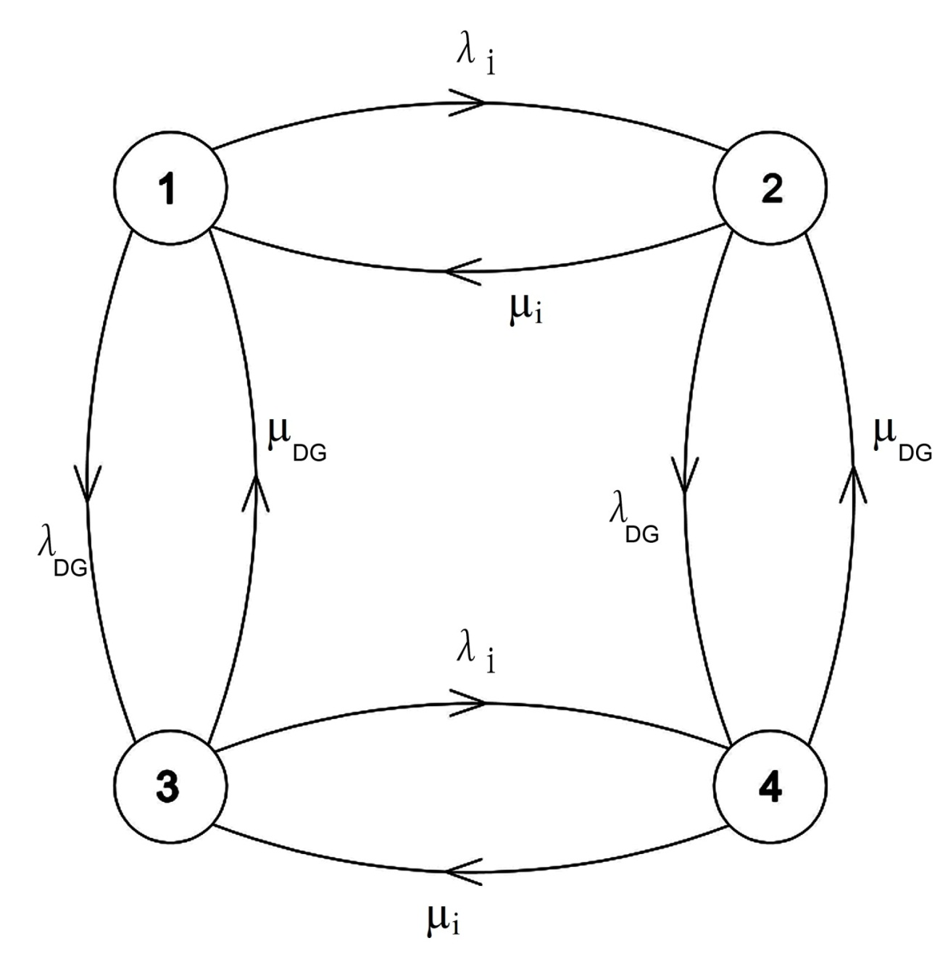
Fig. 3.1: State-space diagram of load point connected DG

A matrix method [12] can be applied to deduce the steady state probability of each state. In this method, a matrix is formed by deducing the probability of making transitions from one state to another. The elements of the matrix are represented by p_{ij} where i is the row position of the matrix from which the transition occurs and j is the column position representing the state to which it enters. This matrix is known as stochastic transitional probability matrix as shown below.
$\text{STPM}=\left[\begin{matrix}1−λ_{i}−λ_{\text{DG}} & λ_{i} & λ_{\text{DG}} & 0 \\ μ_{i} & 1−μ_{i}−λ_{\text{DG}} & 0 & λ_{\text{DG}} \\ μ_{\text{DG}} & 0 & 1−λ_{i}−μ_{\text{DG}} & λ_{i} \\ 0 & μ_{\text{DG}} & μ_{i} & 1−μ_{i}−μ_{\text{DG}}\end{matrix}\right]$ (3.14)
The technique follows the principle that, once the steady state probabilities have been reached by the matrix multiplication method, any further multiplication by the STPM does not change the steady state values of probabilities of each state. Let us assume that the steady state probabilities of all the four states 1, 2, 3 and 4 in Fig. 3.1 are P₁, P₂, P₃, and P₄ respectively and it is represented by a row vector ω = [P₁ P₂ P₃ P₄], then rewriting equation (1.9) [12]
ω[STPM] = ω (3.15)
The equation (3.15) gives four identical simultaneous equations with four unknowns, P₁, P₂, P₃, and P₄. An additional equation is needed to solve the equation (3.15), which is given by
P₁+P₂+P₃+P₄=1 (3.16)
One equation from (3.15) is to be replaced by equation (3.16) and then solving the equations we have the following steady state probability values for the states.
$P_{1}=\frac{μ_{i}μ_{\text{DG}}}{(λ_{i}+μ_{i})(λ_{\text{DG}}+μ_{\text{DG}})}$ (3.17)
$P_{2}=\frac{λ_{i}μ_{\text{DG}}}{(λ_{i}+μ_{i})(λ_{\text{DG}}+μ_{\text{DG}})}$ (3.18)
$P_{3}=\frac{μ_{i}λ_{\text{DG}}}{(λ_{i}+μ_{i})(λ_{\text{DG}}+μ_{\text{DG}})}$ (3.19)
$P_{4}=\frac{λ_{i}λ_{\text{DG}}}{(λ_{i}+μ_{i})(λ_{\text{DG}}+μ_{\text{DG}})}$ (3.20)
The system unavailability can be obtained by the summation of probabilities of the states constituting system failure, i.e.,
$P_{f}=\sum_{s∈F}{P_{s}}$ (3.21)
where P_{f} is the probability of system failure and F is the subset of failed states.
The DG may also be operated in standby mode. Standby redundancy exists when the redundant components remain in a standby state and are only switched into the system when the main operating component(s) fail. The load point connected DG will operate if normal power is not available. The four-state Markov model described in Fig. 3.1 has been modified and presented in Fig. 3.2. In the figure, λ_{NP} and μ_{NP} are failure and repair rates of the normal power source, λ_{DG} and μ_{DG} are for standby DG and c = probability of the standby DG to start when needed and c̄ = 1- c. In this model, the four Markovian states are described as given below:
State 1: Normal power source is available and the DG is in standby mode, i.e., the DG is ready to operate when normal power source goes offline.
State 2: Normal source fails and the DG starts operating to meet the power demand.
State 3: Normal source is available but the standby DG in failed state.
State 4: Both the sources are not available.
When the main power source fails, the system state transition occurs from state 1 to either state 2 or 4. It will be in state 2 if the DG starts successfully or in state 4 if the DG fails to start when an attempt is made to do so.
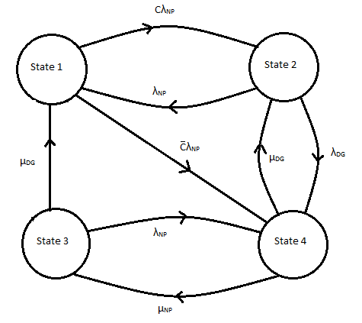
Fig.3.2: State space diagram of standby DG

As discussed above, the stochastic transitional probability matrix has been developed for the system and steady state probabilities of each state can be calculated using the STPM. The STPM is shown in equation (3.22). In this case, reliability of changeover switch is assumed to be 100%.
$\text{STPM}=\left[\begin{matrix}1−{cλ}_{\text{NP}}−\bar{c}λ_{\text{NP}} & {cλ}_{\text{NP}} & 0 & \bar{c}λ_{\text{NP}} \\ λ_{\text{NP}} & 1−λ_{\text{NP}}−λ_{\text{DG}} & 0 & λ_{\text{DG}} \\ μ_{\text{DG}} & 0 & 1−λ_{\text{NP}}−μ_{\text{DG}} & λ_{\text{NP}} \\ 0 & μ_{\text{DG}} & μ_{\text{NP}} & 1−μ_{\text{DG}}−μ_{\text{NP}}\end{matrix}\right]$ (3.22)
3.4 Reliability Modeling of Renewable DG
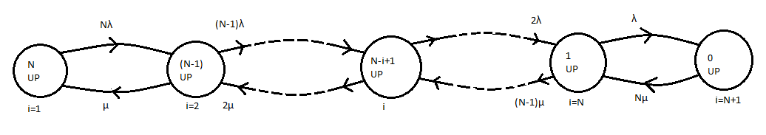
The conventional DG generates the rated power while it is operational but renewable DG always depends on the intermittent energy sources such as solar radiation intensity in case of PV and wind velocity in case of wind power system, even if the DG is in a working state. In the present study a Markov based reliability model has been proposed for a renewable DG. The model is applicable for both PV system and wind energy system. For example, the PV energy sources are usually a series combination of some arrays and all these arrays are again a combination of some modules. Thus the reliability model of a PV generating unit can be considered as a series combination of some identical arrays if more number of arrays is connected for a big plant. Similarly, for a small energy sources, it may be considered as a series combination of some modules.
Fig. 3.3: Markov model of Renewable DG

A Markov reliability model is proposed for a PV energy source with N identical units, either arrays or modules, and its state space diagram is presented in Fig.3.3. The transition probability between two consecutive states for failure of a component can be calculated using equation 3.23 and for repair of a component using equation 3.24.
$λ_{i(i+1)}=(N+1−i)λ$ (3.23)
$μ_{(i+1)i}=iμ$ (3.24)
where i is the state number and λ and μ represents failure and repair rate respectively for an individual unit. There are (N+1) numbers of states with transition rates as shown in the figure. For any state i, the number of units that are in operation is (N+1-i). The steady state probabilities, P₁, P₂, P₃, ......., P_{N+1} can be evaluated using (N+1) numbers of equations derived from the model using the STPM as described in equation (3.22) and modifying the equations (3.15) and (3.16) for (N+1) states.
$\text{STPM}=\left[\begin{matrix}1−Nλ & Nλ & 0 & \text{.}\text{.}\text{.}\text{.}\text{.}\text{.}\text{.}\text{.}\text{.}\text{.}\text{.}\text{.}\text{.}\text{.}\text{.}\text{.}\text{.}\text{.}\text{.}\text{.}\text{.}\text{.}\text{.}\text{.}\text{.}\text{.}\text{.}\text{.}\text{.}\text{.}0 \\ μ & 1−μ−(N−1)λ & (N−1)λ & \text{.}\text{.}\text{.}\text{.}\text{.}\text{.}\text{.}\text{.}\text{.}\text{.}\text{.}\text{.}\text{.}\text{.}\text{.}\text{.}\text{.}\text{.}\text{.}\text{.}\text{.}\text{.}\text{.}\text{.}\text{.}\text{.}\text{.}\text{.}\text{.}\text{.}0 \\ 0 & 2μ & 1−2μ−(N−2)λ & (N−2)λ\text{.}\text{.}\text{.}\text{.}\text{.}\text{.}\text{.}\text{.}\text{.}\text{.}\text{.}\text{.}\text{.}\text{.}\text{.}\text{.}0 \\ \begin{aligned} \\ 0\end{aligned} & \begin{aligned} \\ 0\end{aligned} & \begin{aligned} \\ 0\end{aligned} & \begin{aligned}\text{.} \\ \text{.}\text{.}\text{.}\text{.}\text{.}\text{.}\text{.}\text{.}\text{.}\text{.}\text{.}\text{.}\text{.}\text{.}\text{.}\text{.}Nμ\text{.}\text{.}\text{.}\text{.}\text{.}\text{.}\text{.}1−Nμ\end{aligned}\end{matrix}\right]$ (3.25)
This model helps us to know the steady state availability of the system while a certain numbers of units are in the operating states. The unit availability (A) and unavailability (U) can be evaluated using the relations (3.26) and (3.27).
$A=\frac{μ}{λ+μ}$ (3.26)
$U=\frac{λ}{λ+μ}$ (3.27)
In addition, to meet a particular demand, suppose at least K numbers of units out of N units are to be in operation, then the overall availability of the system can be evaluated using equation (3.28).
$A_{s}=\sum_{i=K}^{N}{{}^{N}C_{i}(A)^{i}(U)^{N−i}}$ (3.28)
This chapter proposes modified reliability models for some basic indices used in distribution system reliability evaluation under various operating conditions. In addition, Markov based reliability models are also proposed for conventional DG and renewable DG.
The proposed reliability models have been exemplified using Roy-Billinton Test System (RBTS) and a local distribution system and presented in the next chapter. The distribution system connected to bus 2 of RBTS has been considered for the present study.
Chapter 4
Reliability Assessment of DG Integrated Distribution Systems
4.1. Introduction
Reliability assessment is of primary importance in designing and planning distribution systems that operate economically with minimum interruption of customer loads. The main concern for power utilities to evaluate reliability of distribution system is in supplying continuous power to customers. The electricity regulating authorities also used reliability indices to monitor the annual performance of power utilities. The impact of reliability of distribution system on customers is more profound than cost. This is largely due to radial nature of distribution systems, involvement of large number of components, the sparsity of protection devices, sectionalizing switches and the proximity of the customers to the system.

With the growth of distributed generation (DG), the power sector is becoming more sophisticated; its diverse impact on power system is becoming attractive for power system designers. DG is becoming the source of capacity during emergency and it can be used to defer the extension of local network. It can be made available during the failure of distribution system to ensure more reliable supply. The level of reliability has enhanced due to DG supply during interruptions.

4.2 Reliability Test Systems
The proposed reliability models developed in Chapter 3 are exemplified using the following two systems:
- Roy- Billinton Test System[51]
- A local distribution system [28, 29, 30, 52]
4.2.1 Roy-Billinton Test System
The RBTS is a six bus composite test system. It was developed for educational purpose at the University of Saskatchewan, Saskatoon, Canada in 1989. It has two generator buses. There are five load buses. It has 11 generators and nine transmission line. The bus 3 has a distribution network with industrial, large user, office buildings, residential and commercial customers. The bus 5 is having distribution network with urban type distribution network comprising of residential, government & institutional, office & buildings and commercial customers. At bus 6, the distribution network is rural network having agricultural, small industrial, commercial and residential customers. Bus 2 is having generation with it. The distribution network connected to this bus is having residential customers, small user, governmental & industrial and commercial customers. There are four radial feeders connected to this bus. Bus 4 is also having same type of customers like the bus 2. But there is no generation at bus 4. The single line diagram of RBTS is given in Fig. 4.1.

Fig. 4.1: Single Line Diagram of Roy Billinton Test System (RBTS)

The distribution network connected to Bus 2 of RBTS has been considered to study the impact of DG on distribution system. The single line diagram of distribution system in bus 2 of RBTS is given in Fig.4.2. The distribution network connected to this bus is having residential customers, small user, governmental & industrial and commercial customers. There are four normally open radial feeders connected to this bus. The system peak load on Bus 2 is 20 MW and average load is 12.29 MW. The system and reliability data sets of RBTS bus 2 are given in Table A1, A2, and A3 (Appendix).
Fig. 4.2: Distribution System for Bus 2 of RBTS

4.2.2 Local distribution system
A local distribution system of Chandmari-Milonpur area of Guwahati, Assam is also considered for this study. The single line diagram of this distribution system is given in Fig. 4.3. The data have been collected and are presented in Table A4, A5, and A6 (Appendix).

Fig. 4.3: Single line diagram of local distribution system

4.3. Criterions for Reliability Evaluation
The load point reliability indices and system indices are evaluated using the proposed methods presented in the previous chapter. All these indices are evaluated for the systems described in section 4.2 under the operating condition that the main circuit breaker (CB) of the radial distribution line, which is connected to the bulk supply point, trips for occurrence of fault at any section of the distribution lines. On the other hand, the main CB does not trip but the CB which is connected to the section where the fault occurs will only trip. The reliability analysis are also performed under two conditions, either connected DG operates automatically or manually.
The customer related reliability indices, frequency of failure (λ), average outage duration(r) and annual unavailability (U) at individual load points are calculated using the equations described in section 3.2 of the previous chapter. These indices are used to get the system reliability indices of the distribution systems. DGs of different capacities are connected at some specified load points of the systems.
4.3.1. Main CB trips for fault at any section
Each section and lateral is provided with CB as shown in the Fig. 4.2. The CB installed at the section which connects the bulk supply point and 1st lateral distributor is termed as main CB. In this condition, this CB trips for fault at any section. In case of main CB trips, the customer related indices and additional indices are analyzed under the condition that the DG is started manually. In this condition, main CB trips for fault at any section of the feeder. The CB connected to the faulty section isolates that section as well as the load connected to that section. The fault at any lateral does not have any effect on the section and also on the other lateral. The switching time of DG is considered as 1 hr.
4.3.2. Main CB does not trip for fault at any section
In this case, it trips only when there is a fault at the section connecting the bulk supply point and the 1st lateral. CB connected at sections isolates the faulty section at the time of fault and healthy sections get supply from either bulk supply point or alternate supply. In this condition reliability indices are evaluated under two conditions:
- DG manually started
In this case, the unaffected areas get supply when there is a fault in a section. For the fault, some sections are cut off from the bulk supply point and other healthy sections near the bulk supply point get supply. The lateral distributor connected with the faulty section is isolated and other affected healthy sections away from the bulk supply point get supply from the DG. For manually started DG, starting time is considered as 1 hr.
- DG auto-started
In this case DG is started automatically for supplying the unaffected when there is a fault in a section. In this case also, for the fault, some sections are cut off from the bulk supply point and other healthy sections are getting supply from the bulk supply point. The lateral distributor connected with the faulty section is isolated and other affected healthy sections away from the bulk supply point get supply from the DG. Since the DG is started automatically, starting time is considered as nil.
4.3.3 System reliability indices
The customer related individual load point reliability indices are used to get the system reliability indices or system indices of the distribution systems. The descriptions of these indices are given in section 1.4 of Chapter 1. The reliability indices calculated and analyzed in this research work are SAIFI, SAIDI, CAIDI, ASAI, ASUI, EENS and AENS [2] for all the above mentioned conditions.
Reliability indices of the distribution system designed at RBTS Bus 2 are also calculated without connecting DG with the system. This calculation is made to see the reliability benefit of the system when DGs are connected to the system.
4.4. Results and Analysis
In case of RBTS BUS 2, the study has been performed under three different feeder failure rates: 0.065 (f/yr-km), 0.13 (f/yr-km) and 0.195 (f/yr-km). The reliability study has been performed considering either replacement time or repairing time of transformer. The DGs are either placed at far ends (locations D, F, J and N) of the feeders or near the bulk supply point (locations A, E, G and K). The capacities of DGs are chosen according to the requirements of the feeders. These specific locations have been identified on the basis of certain criterion found in literature.
The following cases have been considered to calculate load point reliability indices and system indices using the proposed reliability models described in chapter 3 for all criterions mentioned in sections 4.3.2 and 4.3.3:
- Case 1: DG placed at location D, F, J and N when transformer replaced
- Case 2: DG placed at location A, E, G and K when transformer replaced
- Case 3: DG placed at location D, F, J and N when transformer repaired
- Case 4: DG placed at location A, E, G and K when transformer repaired
4.4.1. Main CB trips and DG started manually
In this condition the main CB trips as soon as there is fault at any section. The DG is started manually for the healthy sections. In case of replacement of transformer, the individual load point reliability indices λ, r and U are calculated for the location of DG at far ends (D, F, J, N) and near the bulk supply points (A, E, G, K) of the four feeders using the proposed models that explain in chapter 3 and additional reliability indices are also calculated for distribution system connected to Bus 2 of RBTS.
In this system of faulty section isolation process, failure rate of any section of the feeder, failure rate of any component installed at that feeder, failure rate of lateral which connects the considered load point with the feeder and failure rate of components which installed at this lateral have the contribution to the failure rate of a load point considered.
Case 1:
When manually started DGs are placed at the far ends of the feeders and main breaker trips for fault at any section of the feeder, the customer related load point indices λ, r and U are calculated and results are presented in Table 4.1. Using load point indices, the additional reliability indices are also calculated and summarized in Table 4.2. In every section of the feeder same types of components are installed. Except feeder 2, same types of components are installed at laterals for feeders 1, 3 and 4. Therefore, in this study, the difference of load point failure rates of different load points depends on the difference of length of the laterals. In this study, the load point failure is high for the large length of laterals and equal for same the length of the laterals. The annual unavailability depends on the length of the faulty sections and length of the laterals connected to that section. Table 4.2 shows that with the increase of feeder failure rates, additional reliability indices: SAIFI, SAIDI, ASUI, EENS increases whereas ASAI and CAIDI decrease. CAIDI decreases because, the increase of the SAIFI is less than the increase of SAIDI with the increase of feeder failure rate considered for the same switching time and repairing time of feeder and other components installed with the feeder and lateral in the present study. Thus feeder failure rate plays a major role in reliability of the system when DGs are connected with feeders.
Table 4.1: Customer related load point indices for Case 1
Load Points | Feeder failure rate  0.065 |  |  | Feeder failure rate  0.13 |  |  | Feeder failure rate  0.195
Load Points | λ | r | U | λ | r | U | λ | r | U
1 | 0.2713 | 2.9314 | 0.7953 | 0.4955 | 2.7658 | 1.3705 | 0.7198 | 2.7032 | 1.9458
2 | 0.2843 | 3.0260 | 0.8603 | 0.5215 | 2.8772 | 1.5005 | 0.7588 | 2.8212 | 2.1408
4 | 0.2713 | 2.9241 | 0.7933 | 0.4955 | 2.7618 | 1.3685 | 0.7198 | 2.7004 | 1.9438
5 | 0.2843 | 3.0189 | 0.8583 | 0.5215 | 2.8734 | 1.4985 | 0.7588 | 2.8186 | 2.1388
6 | 0.2810 | 2.9964 | 0.8420 | 0.5150 | 2.8466 | 1.4660 | 0.7490 | 2.7903 | 2.0900
8 | 0.1598 | 3.7596 | 0.6008 | 0.2995 | 3.8180 | 1.1435 | 0.4393 | 3.8386 | 1.6863
9 | 0.1598 | 3.5031 | 0.5598 | 0.2995 | 3.5509 | 1.0635 | 0.4393 | 3.5677 | 1.5673
11 | 0.2843 | 3.0189 | 0.8583 | 0.5215 | 2.8734 | 1.4985 | 0.7588 | 2.8186 | 2.1388
12 | 0.2875 | 3.0417 | 0.8745 | 0.5280 | 2.8996 | 1.5310 | 0.7685 | 2.8464 | 2.1875
13 | 0.2843 | 2.8361 | 0.8063 | 0.5215 | 2.6740 | 1.3945 | 0.7588 | 2.6131 | 1.9828
14 | 0.2875 | 2.8608 | 0.8225 | 0.5280 | 2.7026 | 1.4270 | 0.7685 | 2.6434 | 2.0315
16 | 0.2843 | 3.0260 | 0.8603 | 0.5215 | 2.8772 | 1.5005 | 0.7588 | 2.8212 | 2.1408
17 | 0.2745 | 2.9562 | 0.8115 | 0.5020 | 2.7948 | 1.4030 | 0.7295 | 2.7341 | 1.9945
18 | 0.2745 | 2.9016 | 0.7965 | 0.5020 | 2.7390 | 1.3750 | 0.7295 | 2.6778 | 1.9535
20 | 0.2875 | 2.9965 | 0.8615 | 0.5280 | 2.8503 | 1.5050 | 0.7685 | 2.7957 | 2.1485
21 | 0.2843 | 2.8361 | 0.8063 | 0.5215 | 2.6740 | 1.3945 | 0.7588 | 2.6131 | 1.9828
22 | 0.2875 | 2.8608 | 0.8225 | 0.5280 | 2.7026 | 1.4270 | 0.7685 | 2.6434 | 2.0315
Table 4.2: System reliability indices for Case 1
Feeder failure rate | SAIFI  Interr./  Custo.yr | SAIDI in Min./  Custo.yr | CAIDI in Min./  Custo.interr. | ASAI | ASUI | EENS in KWh/ year | AENS in KWh/ Custo.yr
0.065 | 0.2802 | 50.067 | 178.68 | 0.999904 | 0.000096 | 9660.836 | 5.063
0.13 | 0.5134 | 87.01 | 169.48 | 0.99984 | 0.00016 | 16983.515 | 8.901
0.195 | 0.747 | 123.956 | 165.936 | 0.99976 | 0.00024 | 24306.193 | 12.74

Case 2:
The results obtained under this condition are presented in Table 4.3 and 4.4. The load points with odd numbers are shown in the table. In this case λ for all load points are same for both the cases. But r and U are not same. It is because, when there is a failure in the first section nearest to the bulk supply point, all other load points are affected and when there is a failure in any other section then also all load points towards the far ends are affected which contribute to increase of r and U. On the other hand, SAIDI, ASUI, EENS increase with the increase of feeder failure rate. But CAIDI decreases with the increase of feeder failure rate due to the reason mentioned in Case 1 of 4.4.1 and SAIFI remains same.
Table 4.3: Customer related load point indices for Case 2
Load Points | Feeder failure rate  0.065 |  |  | Feeder failure rate  0.13 |  |  | Feeder failure rate  0.195
Load Points | λ | r | U | λ | r | U | λ | r | U
1 | 0.2713 | 2.9314 | 0.7953 | 0.4955 | 2.7658 | 1.3705 | 0.7198 | 2.7032 | 1.9458
3 | 0.2843 | 3.7752 | 1.0733 | 0.5215 | 3.6596 | 1.9085 | 0.7588 | 3.6159 | 2.7438
5 | 0.2843 | 4.5244 | 1.2863 | 0.5215 | 4.4419 | 2.3165 | 0.7588 | 4.4106 | 3.3468
7 | 0.2843 | 5.1364 | 1.4603 | 0.5215 | 5.0747 | 2.6465 | 0.7588 | 5.0511 | 3.8328
9 | 0.1598 | 4.8485 | 0.7748 | 0.2995 | 4.9198 | 1.4735 | 0.4393 | 4.9449 | 2.1723
11 | 0.2843 | 3.7752 | 1.0733 | 0.5215 | 3.6596 | 1.9085 | 0.7588 | 3.6159 | 2.7438
13 | 0.2843 | 4.3872 | 1.2473 | 0.5215 | 4.2924 | 2.2385 | 0.7588 | 4.2564 | 3.2298
15 | 0.2745 | 5.1420 | 1.4115 | 0.5020 | 5.0776 | 2.5490 | 0.7295 | 5.0534 | 3.6865
17 | 0.2745 | 2.9562 | 0.8115 | 0.5020 | 2.7948 | 1.4030 | 0.7295 | 2.7341 | 1.9945
19 | 0.2875 | 3.7895 | 1.0895 | 0.5280 | 3.6761 | 1.9410 | 0.7685 | 3.6337 | 2.7925
21 | 0.2843 | 5.1364 | 1.4603 | 0.5215 | 5.0747 | 2.6465 | 0.7588 | 5.0511 | 3.8328

Table 4.4: System reliability indices for Case 2
Feeder failure rate | SAIFI | SAIDI in Minute | CAIDI in Minute | ASAI | ASUI | EENS in KWh | AENS in KWh per customer
0.065 | 0.2802 | 58.087 | 207.1 | 0.99988 | 0.00012 | 12984.46 | 6.805
0.13 | 0.5134 | 102.06 | 198.79 | 0.9998 | 0.0002 | 23336.787 | 12.23
0.195 | 0.747 | 145.86 | 195.35 | 0.99972 | 0.00028 | 33689.115 | 17.657

Case 3:
In this case, instead of replacement time, repairing time of transformer is considered. The results are presented in Table 4.5 and 4.6. There is no change of λ, but there is a large change of load point outage duration and annual unavailability due to high repairing time. It affects SAIDI, CAIDI, EENS, and ASAI and thus the reliability is affected. CAIDI is also decreased with the increase of feeder failure rate.
Table 4.5: Customer related load point indices for Case 3
Load Points | Feeder failure rate  0.065 |  |  | Feeder failure rate  0.13 |  |  | Feeder failure rate  0.195
Load Points | λ | r | U | λ | r | U | λ | r | U
1 | 0.2713 | 13.4364 | 3.6453 | 0.4955 | 8.5716 | 4.2205 | 0.7198 | 6.6627 | 4.7958
2 | 0.2843 | 13.0506 | 3.7103 | 0.5215 | 8.3423 | 4.3505 | 0.7588 | 6.5772 | 4.9908
4 | 0.2713 | 13.4290 | 3.6433 | 0.4955 | 8.5136 | 4.2185 | 0.7198 | 6.6599 | 4.7938
5 | 0.2843 | 13.0436 | 3.7083 | 0.5215 | 8.3384 | 4.3485 | 0.7588 | 6.5746 | 4.9888
6 | 0.2810 | 13.1388 | 3.6920 | 0.5150 | 8.3806 | 4.3160 | 0.7490 | 6.5954 | 4.9400
8 | 0.1598 | 3.7597 | 0.6008 | 0.2995 | 3.8180 | 1.1435 | 0.4393 | 3.8386 | 1.6863
9 | 0.1598 | 3.5031 | 0.5598 | 0.2995 | 3.5509 | 1.0635 | 0.4393 | 3.5677 | 1.5673
10 | 0.2745 | 13.2914 | 3.6485 | 0.5020 | 8.4203 | 4.2270 | 0.7295 | 6.5874 | 4.8055
11 | 0.2843 | 13.0436 | 3.7083 | 0.5215 | 8.3384 | 4.3485 | 0.7588 | 6.5746 | 4.9888
12 | 0.2875 | 12.9548 | 3.7245 | 0.5280 | 8.2973 | 4.3810 | 0.7685 | 6.5549 | 5.0375
14 | 0.2875 | 12.7739 | 3.6725 | 0.5280 | 8.1003 | 4.2770 | 0.7685 | 6.3519 | 4.8815
15 | 0.2745 | 13.2841 | 3.6465 | 0.5020 | 8.4163 | 4.2250 | 0.7295 | 6.5846 | 4.8035
16 | 0.2843 | 13.0506 | 3.7103 | 0.5215 | 8.3423 | 4.3505 | 0.7588 | 6.5772 | 4.9908
18 | 0.2745 | 13.2841 | 3.6465 | 0.5020 | 8.4163 | 4.2250 | 0.7295 | 6.5846 | 4.8035
20 | 0.2875 | 12.9095 | 3.7115 | 0.5280 | 8.2481 | 4.3550 | 0.7685 | 6.5042 | 4.9985
21 | 0.2843 | 12.8607 | 3.6563 | 0.5215 | 8.1390 | 4.2445 | 0.7588 | 6.3690 | 4.8328
22 | 0.2875 | 12.7739 | 3.6725 | 0.5280 | 8.1003 | 4.2770 | 0.7685 | 6.3519 | 4.8815

Table 4.6: System reliability indices for Case 3
Feeder failure rate | SAIFI | SAIDI in Minute | CAIDI in Minute | ASAI | ASUI | EENS in KWh | AENS in KWh per customer
0.065 | 0.2802 | 220.89 | 788.3 | 0.999579 | 0.000421 | 38562.686 | 20.21
0.13 | 0.5134 | 257.83 | 502.2 | 0.999509 | 0.000491 | 45885.365 | 24.049
0.195 | 0.747 | 294.78 | 394.83 | 0.999439 | 0.000561 | 53208.043 | 27.89

Case 4:
Considering repairing time of transformer with location of DG at A, E, G & K, all indices are calculated and results are presented in Table 4.7 and 4.8. There is no any change of λ but there is increase of load point outage duration and annual availability due to high repairing time. It affects SAIDI, CAIDI, EENS, and ASUI etc. These values are more than the previous cases. Thus reliability is affected though DG is connected when repairing of transformer is considered. In this case the CAIDI is also decrease with the increase of feeder failure rate.
Table 4.7: Customer related load point indices for Case 4
Load Points | Feeder failure rate  0.065 |  |  | Feeder failure rate  0.13 |  |  | Feeder failure rate  0.195
Load Points | λ | r | U | λ | r | U | λ | r | U
2 | 0.2843 | 13.0506 | 3.7103 | 0.5215 | 8.3423 | 4.3505 | 0.7588 | 6.5772 | 4.9908
4 | 0.2713 | 14.2215 | 3.8583 | 0.4955 | 9.3411 | 4.6285 | 0.7198 | 7.5004 | 5.3988
6 | 0.2810 | 14.6619 | 4.1200 | 0.5150 | 9.9689 | 5.1340 | 0.7490 | 8.2082 | 6.1480
8 | 0.1598 | 3.7597 | 0.6008 | 0.2995 | 3.8180 | 1.1435 | 0.4393 | 3.8386 | 1.6863
10 | 0.2745 | 13.2914 | 3.6485 | 0.5020 | 8.4203 | 4.2270 | 0.7295 | 6.5874 | 4.8055
12 | 0.2875 | 13.7026 | 3.9395 | 0.5280 | 9.0738 | 4.7910 | 0.7685 | 7.3422 | 5.6425
14 | 0.2875 | 14.3078 | 4.1135 | 0.5280 | 9.6988 | 5.1210 | 0.7685 | 7.9746 | 6.1285
16 | 0.2843 | 13.0506 | 3.7103 | 0.5215 | 8.3423 | 4.3505 | 0.7588 | 6.5772 | 4.9908
18 | 0.2745 | 14.1147 | 3.8745 | 0.5020 | 9.2848 | 4.6610 | 0.7295 | 7.4674 | 5.4475
20 | 0.2875 | 14.4435 | 4.1525 | 0.5280 | 9.8466 | 5.1990 | 0.7685 | 8.1268 | 6.2455
22 | 0.2875 | 15.0486 | 4.3265 | 0.5280 | 10.4716 | 5.5290 | 0.7685 | 8.7993 | 6.7315

Table 4.8: System reliability indices for Case 4
Feeder failure rate | SAIFI | SAIDI in Minute | CAIDI in Minute | ASAI | ASUI | EENS in KWh | AENS in KWh per customer
0.065 | 0.2802 | 228.77 | 816.45 | 0.99956 | 0.00044 | 41886.31 | 21.95
0.13 | 0.5134 | 272.88 | 531.52 | 0.99948 | 0.00052 | 52238.64 | 27.38
0.195 | 0.747 | 317 | 424.93 | 0.999368 | 0.000631 | 62596.96 | 32.8

4.4.2. Main CB does not trip, DG starts manually
In this case main breaker does not trip for failure at any section. It trips only when there is a fault at the section where it is installed (the section connecting the 1st load point and bulk supply point). It helps to reduce the load point failure rate. But with the reduction of load point failure rate (λ), average outage duration (r) increases. All the cases that mentioned at the beginning of this section are considered again for calculation of reliability indices.
Case 1:
The load point failure rate, average outage duration and annual unavailability are shown in Table 4.9 when the distributed generators are connected to D, F, J and N. The additional reliability indices are shown in Table 4.10. The load point failure rate is reduced in this case because the main CB does not trip for fault at any section other than the section at which it is installed. The reduced value of load point failure rate contributes in reduction of SAIFI in this case. The SAIDI, ASUI and EENS are also reduced in this case. Thus this process of faulty section isolation helps to improve the reliability of the system, though SAIDI, ASUI and EENS increase with the increase of feeder failure rate. The value of CAIDI is also decrease in this case. But CAIDI is high in comparison with main CB trips, manually started DG located at far end.

Table 4.9: Customer related load point indices for Case 1
Load Points | Feeder failure rate  0.065 |  |  | Feeder failure rate  0.13 |  |  | Feeder failure rate  0.195
Load Points | λ | r | U | λ | r | U | λ | r | U
1 | 0.1168 | 5.4692 | 0.6388 | 0.2045 | 5.2689 | 1.0775 | 0.2923 | 5.1874 | 1.5163
2 | 0.1298 | 5.4222 | 0.7038 | 0.2305 | 5.2386 | 1.2075 | 0.3313 | 5.1654 | 1.7113
3 | 0.1845 | 4.1111 | 0.7585 | 0.3340 | 3.9251 | 1.3110 | 0.4835 | 3.8542 | 1.8635
4 | 0.1715 | 3.7288 | 0.6935 | 0.3080 | 3.8344 | 1.1810 | 0.4445 | 3.7536 | 1.6685
5 | 0.2393 | 3.3986 | 0.8133 | 0.4375 | 3.2331 | 1.4145 | 0.6358 | 3.1704 | 2.0158
6 | 0.2360 | 3.3771 | 0.7970 | 0.4310 | 3.2064 | 1.3820 | 0.6260 | 3.1421 | 1.9670
7 | 0.2843 | 2.8818 | 0.8193 | 0.5215 | 2.7238 | 1.4205 | 0.7588 | 2.6644 | 2.0218
8 | 0.1148 | 4.8240 | 0.5538 | 0.2155 | 4.9072 | 1.0575 | 0.3163 | 4.9361 | 1.5613
9 | 0.1598 | 3.5031 | 0.5598 | 0.2995 | 3.5509 | 1.0635 | 0.4393 | 3.5677 | 1.5673
10 | 0.1168 | 5.4692 | 0.6388 | 0.2045 | 5.2689 | 1.0775 | 0.2923 | 5.1874 | 1.5163
11 | 0.1845 | 4.1111 | 0.7585 | 0.3340 | 3.9251 | 1.3110 | 0.4835 | 3.8542 | 1.8635
12 | 0.1878 | 4.1256 | 0.7748 | 0.3405 | 3.9456 | 1.3435 | 0.4933 | 3.8765 | 1.9123
13 | 0.2295 | 3.7245 | 0.7515 | 0.4180 | 3.0885 | 1.2910 | 0.6065 | 3.0181 | 1.8305
14 | 0.2328 | 3.2981 | 0.7678 | 0.4245 | 3.1178 | 1.3235 | 0.6163 | 3.0493 | 1.8793
15 | 0.2745 | 2.9016 | 0.7965 | 0.5020 | 2.7390 | 1.3750 | 0.7295 | 2.6778 | 1.9535
16 | 0.1298 | 5.422 | 0.7038 | 0.2305 | 5.2386 | 1.2075 | 0.3313 | 5.1654 | 1.7113
17 | 0.1200 | 5.4583 | 0.6550 | 0.2110 | 5.2606 | 1.1100 | 0.3020 | 5.1821 | 1.5650
18 | 0.1748 | 3.9862 | 0.6968 | 0.3145 | 3.7758 | 1.1875 | 0.4543 | 3.6942 | 1.6783
19 | 0.1878 | 4.0564 | 0.7618 | 0.3405 | 3.8693 | 1.3175 | 0.4933 | 3.7974 | 1.8733
20 | 0.2425 | 3.3670 | 0.8165 | 0.4440 | 3.2004 | 1.4210 | 0.6455 | 3.1378 | 2.0255
21 | 0.2843 | 2.8361 | 0.8063 | 0.5215 | 2.6740 | 1.3945 | 0.7588 | 2.6130 | 1.9828
22 | 0.2875 | 2.8608 | 0.8225 | 0.5280 | 2.7026 | 1.4270 | 0.7685 | 2.6435 | 2.0315

Table 4.10: System reliability indices for Case 1
Feeder failure rate | SAIFI | SAIDI in Minute | CAIDI in Minute | ASAI | ASUI | EENS in KWh | AENS in KWh per customer
0.065 | 0.158 | 42.69 | 270.19 | 0.999918 | 0.000082 | 8788.238 | 4.6059
0.13 | 0.2835 | 73.17 | 258.1 | 0.99986 | 0.00014 | 15348.64 | 8.0444
0.195 | 0.409 | 103.65 | 253.42 | 0.99982 | 0.00018 | 21909.04 | 11.483

Case 2:
The load point failure rate, average outage duration and annual unavailability are shown in Table 4.11 when the DGs are connected to A, E, G and K. The additional reliability indices are shown in Table 4.12. In this case load point failure rate is same as that for the location of DG at D, F, J and N. The value of SAIFI is also same. The reduced value of load point failure rate contributes in reduction of SAIFI in this case also. The SAIDI, ASUI and EENS are also reduced in this case, but more than those for the location of DG at D, F, J and N. Thus this faulty section isolation process helps to improve the reliability of the system. Though SAIDI, ASUI and EENS increase with the increase of feeder failure rate, CAIDI decreases in this case also.

Table 4.11: Customer related load point indices for Case 2
Load Points | Feeder failure rate  0.065 |  |  | Feeder failure rate  0.13 |  |  | Feeder failure rate  0.195
Load Points | λ | r | U | λ | r | U | λ | r | U
1 | 0.1168 | 5.4692 | 0.6388 | 0.2045 | 5.2689 | 1.0775 | 0.2923 | 5.1874 | 1.5163
2 | 0.1298 | 5.4221 | 0.7038 | 0.2305 | 5.2386 | 1.2075 | 0.3313 | 5.1654 | 1.7113
3 | 0.1845 | 5.2656 | 0.9715 | 0.3340 | 5.1467 | 1.7190 | 0.4835 | 5.1013 | 2.4665
4 | 0.1715 | 5.2857 | 0.9065 | 0.3080 | 5.1591 | 1.5890 | 0.4445 | 5.1102 | 2.2715
5 | 0.2393 | 5.1788 | 1.2393 | 0.4375 | 5.0983 | 2.2305 | 0.6358 | 5.0673 | 3.2218
6 | 0.2360 | 5.1822 | 1.2230 | 0.4310 | 5.0997 | 2.1980 | 0.6260 | 5.0687 | 3.1730
7 | 0.2843 | 5.1294 | 1.4583 | 0.5215 | 5.0709 | 2.6445 | 0.7588 | 5.0485 | 3.8308
8 | 0.1148 | 4.8240 | 0.5538 | 0.2155 | 4.9072 | 1.0575 | 0.3163 | 4.9361 | 1.5613
9 | 0.1598 | 4.8360 | 0.7728 | 0.2995 | 4.9132 | 1.4715 | 0.4393 | 4.9403 | 2.1703
10 | 0.1168 | 5.4692 | 0.6388 | 0.2045 | 5.2689 | 1.0775 | 0.2923 | 5.1874 | 1.5163
11 | 0.1845 | 5.2656 | 0.9715 | 0.3340 | 5.1467 | 1.7190 | 0.4835 | 5.1013 | 2.4665
12 | 0.1878 | 5.2598 | 0.9878 | 0.3405 | 5.1439 | 1.7515 | 0.4933 | 5.0989 | 2.5153
13 | 0.2295 | 5.1873 | 1.1905 | 0.4180 | 5.1028 | 2.1330 | 0.6065 | 5.0709 | 3.0755
14 | 0.2328 | 5.1838 | 1.2068 | 0.4245 | 5.1013 | 2.1655 | 0.6163 | 5.0694 | 3.1243
15 | 0.2745 | 5.1348 | 1.4095 | 0.5020 | 5.0737 | 2.5470 | 0.7295 | 5.0507 | 3.6845
16 | 0.1298 | 5.4222 | 0.7038 | 0.2305 | 5.2386 | 1.2075 | 0.3313 | 5.1654 | 1.7113
17 | 0.1200 | 5.4583 | 0.6550 | 0.2110 | 5.2606 | 1.1100 | 0.3020 | 5.1821 | 1.5650
18 | 0.1748 | 5.2906 | 0.9248 | 0.3145 | 5.1621 | 1.6235 | 0.4543 | 5.1118 | 2.3223
19 | 0.1878 | 5.2598 | 0.9878 | 0.3405 | 5.1439 | 1.7515 | 0.4933 | 5.0983 | 2.5153
20 | 0.2425 | 5.1773 | 1.2555 | 0.4440 | 5.0968 | 2.2630 | 0.6455 | 5.0666 | 3.2705
21 | 0.2843 | 5.1294 | 1.4583 | 0.5215 | 5.0709 | 2.6445 | 0.7588 | 5.0485 | 3.8308
22 | 0.2875 | 5.1287 | 1.4745 | 0.5280 | 5.0701 | 2.6770 | 0.7685 | 5.0481 | 3.8795

Table 4.12: System reliability indices for Case 2
Feeder failure rate | SAIFI | SAIDI in Minute | CAIDI in Minute | ASAI | ASUI | EENS in KWh | AENS in KWh per customer
0.065 | 0.158 | 50.5 | 319.62 | 0.999903 | 0.000097 | 12095.194 | 6.339
0.13 | 0.2835 | 88.16 | 310.99 | 0.99983 | 0.00017 | 21685.247 | 11.365
0.195 | 0.409 | 125.819 | 307.62 | 0.99975 | 0.00025 | 31275.298 | 16.391

Case 3:
The load point failure rate, average outage duration and annual unavailability are summarized in Table 4.13. The additional reliability indices are shown in Table 4.14. The load point failure rate is similar to that of the case of replacement of transformer. Hence SAIFI is same. But average outage duration and annual unavailability are more for this condition since the repairing time of the transformer is large. It results in increase in SAIDI, CAIDI, ASUI, and EENS. Thus it deteriorates the reliability of the system when repairing of transformer is considered. Except CAIDI, all these additional indices increase with the increase of feeder failure rate. But CAIDI decreases with the increase of feeder failure rate.
Table 4.13: Customer related load point indices for Case 3
Load Points | Feeder failure rate  0.065 |  |  | Feeder failure rate  0.13 |  |  | Feeder failure rate  0.195
Load Points | λ | r | U | λ | r | U | λ | r | U
1 | 0.1168 | 29.8698 | 3.4888 | 0.2045 | 19.2054 | 3.9275 | 0.2923 | 14.9377 | 4.3663
3 | 0.1845 | 19.5583 | 3.6085 | 0.3340 | 12.4581 | 4.1610 | 0.4835 | 9.7487 | 4.7135
5 | 0.2393 | 15.3084 | 3.6633 | 0.4375 | 9.7543 | 4.2675 | 0.6358 | 7.6530 | 4.8658
7 | 0.2843 | 12.9064 | 3.6693 | 0.5215 | 8.1888 | 4.2705 | 0.7588 | 6.4204 | 4.8718
9 | 0.1598 | 3.5031 | 0.5598 | 0.2995 | 3.5509 | 1.0635 | 0.4393 | 3.5677 | 1.5673
11 | 0.1845 | 19.5583 | 3.6085 | 0.3340 | 12.4581 | 4.1610 | 0.4835 | 9.7487 | 4.7135
13 | 0.2295 | 15.6928 | 3.6015 | 0.4180 | 9.9067 | 4.1410 | 0.6065 | 7.7172 | 4.6805
15 | 0.2745 | 13.2841 | 3.6465 | 0.5020 | 8.4163 | 4.2250 | 0.7295 | 6.5846 | 4.8035
17 | 0.1200 | 29.2083 | 3.5050 | 0.2110 | 18.7677 | 3.9600 | 0.3020 | 14.6192 | 4.4150
19 | 0.1878 | 19.2321 | 3.6118 | 0.3405 | 12.2393 | 4.1675 | 0.4933 | 9.5749 | 4.7233
21 | 0.2843 | 12.8607 | 3.6563 | 0.5215 | 8.1390 | 4.2445 | 0.7588 | 6.3690 | 4.8328

Table 4.14: System reliability indices for Case 3
Feeder failure rate | SAIFI | SAIDI in Minute | CAIDI in Minute | ASAI | ASUI | EENS in KWh | AENS in KWh per customer
0.065 | 0.158 | 213.5 | 1351.26 | 0.999593 | 0.000407 | 37690.1 | 19.75
0.13 | 0.2835 | 244 | 860.4 | 0.99953 | 0.00047 | 44250.49 | 23.19
0.195 | 0.409 | 275.5 | 670.9 | 0.999477 | 0.000523 | 50810.89 | 26.63

Case 4:
The results obtained under these conditions are summarized in Table 4.15 and Table 4.16. The average outage duration and annual unavailability for many load points are more in this condition than for the location of DG at D, F, J and N when repairing of the transformer is considered.
Table 4.15: Customer related load point indices for Case 4
Load Points | Feeder failure rate  0.065 |  |  | Feeder failure rate  0.13 |  |  | Feeder failure rate  0.195
Load Points | λ | r | U | λ | r | U | λ | r | U
2 | 0.1298 | 27.3790 | 3.5538 | 0.2305 | 17.6030 | 4.0575 | 0.3313 | 13.7678 | 4.5613
4 | 0.1715 | 21.9037 | 3.7565 | 0.3080 | 14.4123 | 4.4390 | 0.4445 | 11.5219 | 5.1215
6 | 0.2360 | 17.2584 | 4.0730 | 0.4310 | 11.7122 | 5.0480 | 0.6260 | 9.6214 | 6.0230
8 | 0.1148 | 4.8240 | 0.5538 | 0.2155 | 4.9071 | 1.0575 | 0.3163 | 4.9361 | 1.5613
10 | 0.1168 | 29.8698 | 3.4888 | 0.2045 | 19.2053 | 3.9275 | 0.2923 | 14.9377 | 4.3663
12 | 0.1878 | 20.4355 | 3.8378 | 0.3405 | 13.5139 | 4.6015 | 0.4933 | 10.8763 | 5.3653
14 | 0.2328 | 17.4261 | 4.0568 | 0.4245 | 11.8151 | 5.0155 | 0.6163 | 9.6938 | 5.9743
16 | 0.1298 | 27.3790 | 3.5538 | 0.2305 | 17.6030 | 4.0575 | 0.3313 | 13.7678 | 4.5613
18 | 0.1748 | 21.5835 | 3.7728 | 0.3145 | 14.2178 | 4.4715 | 0.4543 | 11.3808 | 5.1703
20 | 0.2425 | 16.9298 | 4.1055 | 0.4440 | 11.5157 | 5.1130 | 0.6455 | 9.4818 | 6.1205

Table 4.16: System reliability indices for Case 4
Feeder failure rate | SAIFI | SAIDI in Minute | CAIDI in Minute | ASAI | ASUI | EENS in KWh | AENS in KWh per customer
0.065 | 0.1580 | 221.31 | 1400.7 | 0.999578 | 0.000422 | 40996.093 | 21.486
0.13 | 0.2835 | 258.97 | 913.50 | 0.99950 | 0.00050 | 50586.969 | 26.510
0.195 | 0.4090 | 296.63 | 725.08 | 0.999435 | 0.000565 | 60176.243 | 31.530

4.4.3. Main CB does not trip and DG auto started
In this case DG starts automatically and main breaker does not trip for failure at any section. The reliability models proposed in chapter 3 are used to evaluate the indices under different conditions described in previous sections of this chapter.
Case 1:
Under these conditions and location of DG at D, F, J, and N with different feeder failure rates, λ, r and U are calculated and shown in Table 4.17. The additional reliability indices are also calculated and presented in Table 4.18. Auto starting of DG helps in reducing λ and U. The values of additional reliability indices SAIFI, SAIDI, ASUI, and EENS, except CAIDI, are also less. Thus auto started DG helps to improve the reliability of the system. Except CAIDI, all these indices increase with the increase of feeder failure rate.

Table 4.17: Customer related load point indices for Case 1
Load Points | Feeder failure rate  0.065 |  |  | Feeder failure rate  0.13 |  |  | Feeder failure rate  0.195
Load Points | λ | r | U | λ | r | U | λ | r | U
1 | 0.1148 | 5.5470 | 0.6368 | 0.2025 | 5.3111 | 1.0755 | 0.2903 | 5.2163 | 1.5143
3 | 0.1278 | 5.4913 | 0.7018 | 0.2285 | 5.2757 | 1.2055 | 0.3293 | 5.1907 | 1.7093
5 | 0.1278 | 5.4913 | 0.7018 | 0.2285 | 5.2757 | 1.2055 | 0.3293 | 5.1907 | 1.7093
7 | 0.1180 | 5.5338 | 0.6530 | 0.2090 | 5.3014 | 1.1080 | 0.3000 | 5.2100 | 1.5630
9 | 0.1030 | 4.8835 | 0.5030 | 0.1940 | 4.9381 | 0.9580 | 0.2850 | 4.9579 | 1.4130
11 | 0.1278 | 5.4913 | 0.7018 | 0.2285 | 5.2757 | 1.2055 | 0.3293 | 5.1907 | 1.7093
13 | 0.1148 | 5.5470 | 0.6368 | 0.2025 | 5.3111 | 1.0755 | 0.2903 | 5.2163 | 1.5143
15 | 0.1148 | 5.5470 | 0.6368 | 0.2025 | 5.3111 | 1.0755 | 0.2903 | 5.2163 | 1.5143
17 | 0.1180 | 5.5338 | 0.6530 | 0.2090 | 5.3014 | 1.1080 | 0.3000 | 5.2100 | 1.563
19 | 0.1278 | 5.4913 | 0.7018 | 0.2285 | 5.2757 | 1.2055 | 0.3293 | 5.1907 | 1.7093
21 | 0.1148 | 5.5470 | 0.6368 | 0.2025 | 5.3111 | 1.0755 | 0.2903 | 5.2163 | 1.5143

Table 4.18: System reliability indices for Case 1
Feeder failure rate | SAIFI | SAIDI in Minute | CAIDI in Minute | ASAI | ASUI | EENS in KWh | AENS in KWh per customer
0.065 | 0.1226 | 40.560 | 330.832 | 0.99992 | 0.00008 | 7914.108 | 4.148
0.13 | 0.2180 | 69.185 | 317.362 | 0.99987 | 0.00013 | 13717.1 | 7.19
0.195 | 0.313 | 97.81 | 312.492 | 0.99981 | 0.00019 | 19520.1 | 10.23

Case 2:
Under these conditions and location of DG at A, E, G, and K with different feeder failure rates, λ, r and U are calculated and shown in Table 4.19. The additional reliability indices are shown in the Table 4.20. It has been seen that auto started DG for both the conditions helps to improve the reliability of the system. Except CAIDI, all these indices increase with the increase of feeder failure rate.
Table 4.19: Customer related load point indices for Case 2
Load Points | Feeder failure rate  0.065 |  |  | Feeder failure rate  0.13 |  |  | Feeder failure rate  0.195
Load Points | λ | r | U | λ | r | U | λ | r | U
1 | 0.1148 | 5.5470 | 0.6368 | 0.2025 | 5.3111 | 1.0755 | 0.2903 | 5.2163 | 1.5143
2 | 0.1278 | 5.4914 | 0.7018 | 0.2285 | 5.2757 | 1.2055 | 0.3293 | 5.1907 | 1.7093
3 | 0.1825 | 5.3123 | 0.9695 | 0.3320 | 5.1717 | 1.7170 | 0.4815 | 5.1183 | 2.4645
4 | 0.1695 | 5.3363 | 0.9045 | 0.3060 | 5.1862 | 1.5870 | 0.4425 | 5.1288 | 2.2695
5 | 0.2373 | 5.2141 | 1.2373 | 0.4355 | 5.1171 | 2.2285 | 0.6338 | 5.0801 | 3.2198
6 | 0.2340 | 5.2179 | 1.2210 | 0.4290 | 5.1189 | 2.1960 | 0.6240 | 5.0817 | 3.1710
7 | 0.2823 | 5.1587 | 1.4563 | 0.5195 | 5.0866 | 2.6425 | 0.7568 | 5.0591 | 3.8288
8 | 0.1128 | 4.8918 | 0.5518 | 0.2135 | 4.9438 | 1.0555 | 0.3143 | 4.9611 | 1.5593
9 | 0.1578 | 4.8846 | 0.7708 | 0.2975 | 4.9395 | 1.4695 | 0.4373 | 4.9583 | 2.1683
10 | 0.1148 | 5.5470 | 0.6368 | 0.2025 | 5.3111 | 1.0755 | 0.2903 | 5.2163 | 1.5143
11 | 0.1825 | 5.3123 | 0.9695 | 0.3320 | 5.1717 | 1.7170 | 0.4815 | 5.1183 | 2.4645
12 | 0.1858 | 5.3057 | 0.9858 | 0.3385 | 5.1684 | 1.7495 | 0.4913 | 5.1156 | 2.5133
13 | 0.2275 | 5.2242 | 1.1885 | 0.4160 | 5.1226 | 2.1310 | 0.6045 | 5.0844 | 3.0735
14 | 0.2308 | 5.2201 | 1.2048 | 0.4225 | 5.1207 | 2.1635 | 0.6143 | 5.0826 | 3.1223
15 | 0.2725 | 5.1651 | 1.4075 | 0.5000 | 5.0900 | 2.5450 | 0.7275 | 5.0618 | 3.6825
16 | 0.1278 | 5.4914 | 0.7018 | 0.2285 | 5.2757 | 1.2055 | 0.3293 | 5.1907 | 1.7093
17 | 0.1180 | 5.5339 | 0.6530 | 0.2090 | 5.3014 | 1.1080 | 0.3000 | 5.2100 | 1.563

Table 4.20: System reliability indices for Case 2
Feeder failure rate | SAIFI | SAIDI in Minute | CAIDI in Minute | ASAI | ASUI | EENS in KWh | AENS in KWh per customer
0.065 | 0.156 | 50.38 | 322.95 | 0.99991 | 0.00009 | 12069.714 | 6.325
0.13 | 0.281 | 88.03 | 313.27 | 0.99985 | 0.00015 | 21659.765 | 11.352
0.195 | 0.407 | 125.68 | 308.8 | 0.99977 | 0.00023 | 31249.816 | 16.378
Case 3:
The results under these conditions are presented in Table 4.21 and 4.22. Instead of replacement if repairing is considered then r and U are high. Additional reliability indices are also high except SAIFI.
Table 4.21: Customer related load point indices for Case 3
Load Points | Feeder failure rate  0.065 |  |  | Feeder failure rate  0.13 |  |  |  |  | Feeder failure rate  0.195
Load Points | λ | r | U | λ |  | r | U |  | λ | r |  |  | U
1 | 0.1148 | 30.3728 | 3.4868 | 0.2025 | 19.3851 |  | 3.9255 | 0.2903 |  |  | 15.0337 | 4.3643
2 | 0.1278 | 27.7918 | 3.5518 | 0.2285 | 17.7483 |  | 4.0555 | 0.3293 |  |  | 13.8454 | 4.5593
3 | 0.1278 | 27.7918 | 3.5518 | 0.2285 | 17.7483 |  | 4.0555 | 0.3293 |  |  | 13.8454 | 4.5593
4 | 0.1148 | 30.3728 | 3.4868 | 0.2025 | 19.3851 |  | 3.9255 | 0.2903 |  |  | 15.0337 | 4.3643
5 | 0.1278 | 27.7918 | 3.5518 | 0.2285 | 17.7483 |  | 4.0555 | 0.3293 |  |  | 13.8454 | 4.5593
6 | 0.1245 | 28.3975 | 3.5355 | 0.2220 | 18.1216 |  | 4.0230 | 0.3195 |  |  | 14.1173 | 4.5105
7 | 0.1180 | 29.6864 | 3.5030 | 0.2090 | 18.9377 |  | 3.9580 | 0.3000 |  |  | 14.7100 | 4.4130
8 | 0.1128 | 4.8918 | 0.5518 | 0.2135 | 4.9437 |  | 1.0555 | 0.3143 |  |  | 4.9611 | 1.5593
9 | 0.1030 | 4.8835 | 0.5030 | 0.1940 | 4.9381 |  | 0.9580 | 0.2850 |  |  | 4.9578 | 1.4130
10 | 0.1148 | 30.3728 | 3.4868 | 0.2025 | 19.3851 |  | 3.9255 | 0.2903 |  |  | 15.0337 | 4.3643
11 | 0.1278 | 27.7918 | 3.5518 | 0.2285 | 17.7483 |  | 4.0555 | 0.3293 |  |  | 13.8454 | 4.5593
12 | 0.1310 | 27.2366 | 3.5680 | 0.2350 | 17.3957 |  | 4.0880 | 0.3390 |  |  | 13.5929 | 4.6080
13 | 0.1148 | 30.3728 | 3.4868 | 0.2025 | 19.3851 |  | 3.9255 | 0.2903 |  |  | 15.0337 | 4.3643
14 | 0.1180 | 29.6864 | 3.5030 | 0.2090 | 18.9377 |  | 3.9580 | 0.3000 |  |  | 14.7100 | 4.4130
15 | 0.1148 | 30.3728 | 3.4868 | 0.2025 | 19.3851 |  | 3.9255 | 0.2903 |  |  | 15.0337 | 4.3643
16 | 0.1278 | 27.7918 | 3.5518 | 0.2285 | 17.7483 |  | 4.0555 | 0.3293 |  |  | 13.8454 | 4.5593
17 | 0.1180 | 29.6864 | 3.5030 | 0.2090 | 18.9377 |  | 3.9580 | 0.3000 |  |  | 14.7100 | 4.4130
18 | 0.1148 | 30.3728 | 3.4868 | 0.2025 | 19.3851 |  | 3.9255 | 0.2903 |  |  | 15.0337 | 4.3643
19 | 0.1278 | 27.7918 | 3.5518 | 0.2285 | 17.7483 |  | 4.0555 | 0.3293 |  |  | 13.8454 | 4.5593
20 | 0.1278 | 27.7918 | 3.5518 | 0.2285 | 17.7483 |  | 4.0555 | 0.3293 |  |  | 13.8454 | 4.5593
21 | 0.1148 | 30.3728 | 3.4868 | 0.2025 | 19.3851 |  | 3.9255 | 0.2903 |  |  | 15.0337 | 4.3643
22 | 0.1180 | 29.6864 | 3.5030 | 0.2090 | 18.9377 |  | 3.9580 | 0.3000 |  |  | 14.7100 | 4.4130
Table 4.22: System reliability indices for Case 3
Feeder failure rate | SAIFI | SAIDI in Minute | CAIDI in Minute | ASAI | ASUI | EENS in KWh | AENS in KWh per customer
0.065 | 0.1226 | 208.96 | 1704.4 | 0.9996 | 0.0004 | 36815.958 | 19.295
0.13 | 0.218 | 240 | 110.9 | 0.99954 | 0.00046 | 42618.94 | 22.33
0.195 | 0.3135 | 268.63 | 856.87 | 0.99948 | 0.00052 | 48421.93 | 25.37

Case 4:
The results under these conditions are presented in Table 4.23 and 4.24. In this case also r and U are high and all additional reliability indices are high except SAIFI.
Table 4.23: Customer related load point indices for Case 4
Load Points | Feeder failure rate  0.065 |  |  | Feeder failure rate  0.13 |  |  | Feeder failure rate  0.195
Load Points | λ | r | U | λ | r | U | λ | r | U
1 | 0.1148 | 30.3728 | 3.4868 | 0.2025 | 19.3852 | 3.9255 | 0.2903 | 15.0337 | 4.3643
2 | 0.1278 | 27.7918 | 3.5518 | 0.2285 | 17.7483 | 4.0555 | 0.3293 | 13.8454 | 4.5593
3 | 0.1825 | 20.9287 | 3.8195 | 0.3220 | 13.7560 | 4.5670 | 0.4815 | 11.0373 | 5.3145
4 | 0.1695 | 22.1504 | 3.7545 | 0.3060 | 14.5000 | 4.4370 | 0.4425 | 11.5694 | 5.1195
5 | 0.2373 | 17.2250 | 4.0875 | 0.4355 | 11.6613 | 5.0785 | 0.6338 | 9.5768 | 6.0698
6 | 0.2340 | 17.3974 | 4.0710 | 0.4290 | 11.7622 | 5.0460 | 0.6240 | 9.6490 | 6.0210
7 | 0.2823 | 15.2543 | 4.3063 | 0.5195 | 10.5726 | 5.4925 | 0.7568 | 8.8250 | 6.6788
8 | 0.1128 | 4.8918 | 0.5518 | 0.2135 | 4.9437 | 1.0555 | 0.3143 | 4.9611 | 1.5593
9 | 0.1578 | 4.8846 | 0.7708 | 0.2975 | 4.9394 | 1.4695 | 0.4373 | 4.9583 | 2.1683
10 | 0.1148 | 30.3728 | 3.4868 | 0.2025 | 19.3852 | 3.9255 | 0.2903 | 15.0337 | 4.3643
11 | 0.1825 | 20.9287 | 3.8195 | 0.3320 | 13.7560 | 4.5670 | 0.4815 | 11.0373 | 5.3145
12 | 0.1858 | 20.6447 | 3.8358 | 0.3385 | 13.5878 | 4.5995 | 0.4913 | 10.9165 | 5.3633
13 | 0.2275 | 17.7516 | 4.0385 | 0.4160 | 11.9735 | 4.9810 | 0.6045 | 9.7990 | 5.9235
14 | 0.2308 | 17.5684 | 4.0548 | 0.4225 | 11.8662 | 5.0135 | 0.6143 | 9.7221 | 5.9723
15 | 0.2725 | 15.6238 | 4.2575 | 0.5000 | 10.7900 | 5.3950 | 0.7275 | 8.9793 | 6.5325
16 | 0.1278 | 27.7918 | 3.5518 | 0.2285 | 17.7483 | 4.0555 | 0.3293 | 13.8454 | 4.5593
17 | 0.1180 | 29.6864 | 3.5030 | 0.2090 | 18.9377 | 3.9580 | 0.3000 | 14.7100 | 4.4130
18 | 0.1728 | 21.8217 | 3.7708 | 0.3125 | 14.3024 | 4.4695 | 0.4523 | 11.4267 | 5.1683
19 | 0.1858 | 20.6447 | 3.8358 | 0.3385 | 13.5878 | 4.5995 | 0.4913 | 10.9165 | 5.3633
20 | 0.2405 | 21.8217 | 4.1035 | 0.4420 | 11.5633 | 5.1110 | 0.6435 | 9.5081 | 6.1185
21 | 0.2823 | 15.2543 | 4.3063 | 0.5195 | 10.5726 | 5.4925 | 0.7568 | 8.8250 | 6.6788
22 | 0.2855 | 15.1401 | 4.3225 | 0.5260 | 10.5038 | 5.5250 | 0.7665 | 8.7769 | 6.7275

Table 4.24: System reliability indices for Case 4
Feeder failure rate | SAIFI | SAIDI in Minute | CAIDI in Minute | ASAI | ASUI | EENS in KWh | AENS in KWh per customer
0.065 | 0.156 | 221.206 | 1417.98 | 0.99958 | 0.00042 | 40971.564 | 21.47
0.13 | 0.2804 | 258.85 | 923.145 | 0.99951 | 0.00049 | 50561.615 | 26.5
0.195 | 0.4071 | 296.5 | 728.32 | 0.99943 | 0.00057 | 60151.64 | 31.52

4.4.4. Reliability indices evaluation without connecting DG
In this section, analysis has been performed without connecting DG to the system and studied the effect of isolation process on the reliability of the system. In this analysis four cases have been considered to evaluate the indices:
- Case I: Main CB trips and when transformer replaced
- Case II: Main CB does not trip and when transformer replaced
- Case III: Main CB trips and when transformer repaired
- Case IV: Main CB does not trip and when transformer repaired

Case I:
When main breaker trips without DG, load point reliability indices are evaluated and summarized in Table 4.25. These values are same with the value of load point indices of the system where main breaker trips, manually started DG located at A, E, G and K when replacement of transformer is considered. Additional reliability indices, SAIFI, SAIDI, CAIDI, ASAI, EENS are also same. The additional reliability indices are shown in Table 4.26.

Table 4.25: Customer related load point indices for Case I
Load Points | Feeder failure rate  0.065 |  |  | Feeder failure rate  0.13 |  |  | Feeder failure rate  0.195
Load Points | λ | r | U | λ | r | U | λ | r | U
1 | 0.2713 | 2.9314 | 0.7953 | 0.4955 | 2.7658 | 1.3705 | 0.7198 | 2.7032 | 1.9458
2 | 0.2843 | 3.0260 | 0.8603 | 0.5215 | 2.8772 | 1.5005 | 0.7588 | 2.8212 | 2.1408
3 | 0.2843 | 3.7752 | 1.0733 | 0.5215 | 3.6596 | 1.9085 | 0.7588 | 3.6159 | 2.7438
4 | 0.2713 | 3.716 | 1.0083 | 0.4955 | 3.5893 | 1.7785 | 0.7198 | 3.5409 | 2.5488
5 | 0.2843 | 4.5244 | 1.2863 | 0.5215 | 4.4419 | 2.3165 | 0.7588 | 4.4106 | 3.3468
6 | 0.2810 | 4.5195 | 1.2700 | 0.5150 | 4.4349 | 2.2840 | 0.7490 | 3.0681 | 2.2980
7 | 0.2843 | 5.1364 | 1.4603 | 0.5215 | 5.0747 | 2.6465 | 0.7588 | 5.0511 | 3.8328
8 | 0.1598 | 3.7596 | 0.6008 | 0.2995 | 3.8180 | 1.1435 | 0.4393 | 3.8386 | 1.6863
9 | 0.1598 | 4.8485 | 0.7748 | 0.2995 | 4.9198 | 1.4735 | 0.4393 | 4.9449 | 2.1723
10 | 0.2745 | 2.9089 | 0.7985 | 0.5020 | 2.7430 | 1.3770 | 0.7295 | 2.6806 | 1.9555
11 | 0.2843 | 3.7752 | 1.0733 | 0.5215 | 3.6596 | 1.9085 | 0.7588 | 3.6159 | 2.7438
12 | 0.2875 | 3.7895 | 1.0895 | 0.5280 | 3.6761 | 1.9410 | 0.7685 | 3.6337 | 2.7925
13 | 0.2843 | 4.3872 | 1.2473 | 0.5215 | 4.2924 | 2.2385 | 0.7588 | 4.2564 | 3.2298
14 | 0.2875 | 4.3947 | 1.2635 | 0.5280 | 4.3011 | 2.2710 | 0.7685 | 4.2661 | 3.2785
15 | 0.2745 | 5.1241 | 1.4115 | 0.5020 | 5.0776 | 2.5490 | 0.7295 | 5.0534 | 3.6865
16 | 0.2843 | 3.0260 | 0.8603 | 0.5215 | 2.8772 | 1.5005 | 0.7588 | 2.8212 | 2.1408
17 | 0.2745 | 2.9563 | 0.8115 | 0.5020 | 2.7948 | 1.4030 | 0.7295 | 2.7340 | 1.9945
18 | 0.2745 | 3.7322 | 1.0245 | 0.5020 | 3.6075 | 1.8110 | 0.7295 | 3.5606 | 2.5975
19 | 0.2875 | 3.7895 | 1.0895 | 0.5280 | 3.6761 | 1.9410 | 0.7685 | 3.6337 | 2.7925
20 | 0.2875 | 4.5304 | 1.3025 | 0.5280 | 4.4488 | 2.3490 | 0.7685 | 4.4183 | 3.3955
21 | 0.2843 | 5.1364 | 1.4603 | 0.5215 | 5.0747 | 2.6465 | 0.7588 | 5.0511 | 3.8328
22 | 0.2875 | 5.1356 | 1.4765 | 0.5280 | 5.0738 | 2.6790 | 0.7685 | 5.0507 | 3.8815

Table 4.26: System reliability indices for Case I
Feeder failure rate | SAIFI | SAIDI in Minute | CAIDI in Minute | ASAI | ASUI | EENS in KWh | AENS in KWh per customer
0.065 | 0.2802 | 58.087 | 207.1 | 0.99988 | 0.00012 | 12984.46 | 6.805
0.13 | 0.5134 | 102.06 | 198.79 | 0.9998 | 0.0002 | 23336.787 | 12.23
0.195 | 0.747 | 145.86 | 195.35 | 0.99972 | 0.00028 | 33869.115 | 17.657

Case II:
In this case, load point reliability indices are summarized in Table 4.27. In this case only load points failure rate and SAIFI are same with that of the system where main breaker does not trip, manually started DG located at A, E, G and K when replacement of transformer is considered. But load point average outage duration, load point annual outage and additional reliability indices, SAIDI, CAIDI, ASAI, EENS are almost same with that of the system where main breaker does not trip, manually started DG located at A, E, G and K when replacement of transformer is considered. The additional reliability indices are shown in Table 4.28.
Table 4.27: Customer related load point indices for Case II
Load Points | Feeder failure rate  0.065 |  |  | Feeder failure rate  0.13 |  |  | Feeder failure rate  0.195
Load Points | λ | r | U | λ | r | U | λ | r | U
1 | 0.1168 | 5.4863 | 0.6408 | 0.2045 | 5.2787 | 1.0795 | 0.2923 | 5.1943 | 1.5183
2 | 0.1298 | 5.4375 | 0.7058 | 0.2305 | 5.2472 | 1.2095 | 0.3313 | 5.1714 | 1.7133
3 | 0.1845 | 5.2764 | 0.9735 | 0.3340 | 5.1526 | 1.7210 | 0.4835 | 5.1054 | 2.4685
4 | 0.1715 | 5.2973 | 0.9085 | 0.3080 | 5.1655 | 1.5910 | 0.4445 | 5.1147 | 2.2735
5 | 0.2393 | 5.1872 | 1.2413 | 0.4375 | 5.1028 | 2.2325 | 0.6358 | 5.0704 | 3.2238
6 | 0.2360 | 5.1906 | 1.2250 | 0.4310 | 5.1044 | 2.2000 | 0.6260 | 5.0718 | 3.1750
7 | 0.2843 | 5.1364 | 1.4603 | 0.5215 | 5.0747 | 2.6465 | 0.7588 | 5.0511 | 3.8328
8 | 0.1148 | 4.8414 | 0.5558 | 0.2155 | 4.9164 | 1.0595 | 0.3163 | 4.9424 | 1.5633
9 | 0.1598 | 4.8485 | 0.7748 | 0.2995 | 4.9198 | 1.4735 | 0.4393 | 4.9449 | 2.1723
10 | 0.1168 | 5.4863 | 0.6408 | 0.2045 | 5.2787 | 1.0795 | 0.2923 | 5.1943 | 1.5183
11 | 0.1845 | 5.2764 | 0.9735 | 0.3340 | 5.1526 | 1.7210 | 0.4835 | 5.1054 | 2.4685
12 | 0.1878 | 5.2705 | 0.9898 | 0.3405 | 5.1497 | 1.7535 | 0.4933 | 5.1029 | 2.5173
13 | 0.2295 | 5.1960 | 1.1925 | 0.4180 | 5.1076 | 2.1350 | 0.6065 | 5.0742 | 3.0775
14 | 0.2328 | 5.1924 | 1.2088 | 0.4245 | 5.1060 | 2.1675 | 0.6163 | 5.0727 | 3.1263
15 | 0.2745 | 5.1420 | 1.4115 | 0.5020 | 5.0776 | 2.5490 | 0.7295 | 5.0534 | 3.6865
16 | 0.1298 | 5.4375 | 0.7058 | 0.2305 | 5.2472 | 1.2095 | 0.3315 | 5.1683 | 1.7133
17 | 0.1200 | 5.4750 | 0.6570 | 0.2110 | 5.2701 | 1.1120 | 0.3020 | 5.4867 | 1.5670
18 | 0.1748 | 5.2906 | 0.9248 | 0.3145 | 5.1621 | 1.6235 | 0.4543 | 5.1118 | 2.3223
19 | 0.1878 | 5.2705 | 0.9898 | 0.3405 | 5.1497 | 1.7535 | 0.4933 | 5.1029 | 2.5173
20 | 0.2425 | 5.1855 | 1.2575 | 0.4440 | 5.1013 | 2.2650 | 0.6455 | 5.0697 | 3.2725
21 | 0.2843 | 5.1364 | 1.4603 | 0.5215 | 5.0747 | 2.6465 | 0.7588 | 5.0511 | 3.8328
22 | 0.2875 | 5.1356 | 1.4765 | 0.5280 | 5.0738 | 2.6790 | 0.7685 | 5.0507 | 3.8815

Table 4.28: System reliability indices for Case II
Feeder failure rate | SAIFI | SAIDI in Minute | CAIDI in Minute | ASAI | ASUI | EENS in KWh | AENS in KWh per customer
0.065 | 0.158 | 50.62 | 320.38 | 0.999902 | 0.000098 | 12118.878 | 6.35
0.13 | 0.2835 | 88.27 | 311.35 | 0.99982 | 0.00018 | 21708.9 | 11.32
0.195 | 0.409 | 125.92 | 307.84 | 0.999704 | 0.000296 | 31298.983 | 16.288
Case III:
For this case, load point reliability indices are summarized in Table 4.29. These values are same with the value of load point indices of the system where main breaker trips for fault at any section of the feeder, manually started DG located at A, E, G and K when repairing of transformer is considered. Additional reliability indices are also remaining same. The additional reliability indices are shown in Table 4.30.
Table 4.29: Customer related load point indices for Case III
Load Points | Feeder failure rate  0.065 |  |  | Feeder failure rate  0.13 |  |  | Feeder failure rate  0.195
Load Points | λ | r | U | λ | r | U | λ | r | U
1 | 0.2713 | 13.4364 | 3.6453 | 0.4955 | 8.5176 | 4.2205 | 0.7198 | 6.6626 | 4.7958
2 | 0.2843 | 13.0506 | 3.7103 | 0.5215 | 8.3423 | 4.3505 | 0.7588 | 6.5772 | 4.9908
3 | 0.2843 | 13.7998 | 3.9233 | 0.5215 | 9.1246 | 4.7585 | 0.7588 | 7.3719 | 5.5938
4 | 0.2713 | 14.2215 | 3.8583 | 0.4955 | 9.3410 | 4.6285 | 0.7198 | 7.5004 | 5.3988
5 | 0.2843 | 14.5490 | 4.1363 | 0.5215 | 9.9069 | 5.1665 | 0.7588 | 8.1665 | 6.1968
6 | 0.2810 | 14.6619 | 4.1200 | 0.5150 | 9.9689 | 5.1340 | 0.7490 | 8.2082 | 6.1480
7 | 0.2843 | 15.1611 | 4.3103 | 0.5215 | 10.5397 | 5.4965 | 0.7588 | 8.8071 | 6.6828
8 | 0.1598 | 3.7596 | 0.6008 | 0.2995 | 3.8180 | 1.1435 | 0.4393 | 3.8386 | 1.6863
9 | 0.1598 | 4.8485 | 0.7748 | 0.2995 | 4.9198 | 1.4735 | 0.4393 | 4.9449 | 2.1723
10 | 0.2745 | 13.2914 | 3.6485 | 0.5020 | 8.4203 | 4.2270 | 0.7295 | 6.5873 | 4.8055
11 | 0.2843 | 13.7998 | 3.9233 | 0.5215 | 9.1264 | 4.7585 | 0.7588 | 7.3719 | 5.5938
12 | 0.2875 | 13.7026 | 3.9395 | 0.5280 | 9.0738 | 4.7910 | 0.7685 | 7.3422 | 5.6425
13 | 0.2843 | 14.4118 | 4.0973 | 0.5215 | 9.7574 | 5.0885 | 0.7588 | 8.0124 | 6.0798
14 | 0.2875 | 14.3078 | 4.1135 | 0.5280 | 9.6988 | 5.1210 | 0.7685 | 7.9746 | 6.1285
15 | 0.2745 | 15.5245 | 4.2615 | 0.5020 | 10.7549 | 5.3990 | 0.7295 | 8.9602 | 6.5365
16 | 0.2843 | 13.0506 | 3.7103 | 0.5215 | 8.3423 | 4.3505 | 0.7588 | 6.5772 | 4.9908
17 | 0.2745 | 13.3387 | 3.6615 | 0.5020 | 8.4721 | 4.2530 | 0.7295 | 6.6408 | 4.8445
18 | 0.2745 | 14.1147 | 3.8745 | 0.5020 | 9.2848 | 4.6610 | 0.7295 | 7.4674 | 5.4475
19 | 0.2875 | 13.7026 | 3.9395 | 0.5280 | 9.0738 | 4.7910 | 0.7685 | 7.3422 | 5.6425
20 | 0.2875 | 14.4434 | 4.1525 | 0.5280 | 9.8466 | 5.1990 | 0.7685 | 8.1268 | 6.2455
21 | 0.2843 | 15.1611 | 4.3103 | 0.5215 | 10.5397 | 5.4965 | 0.7588 | 8.8071 | 6.6828
22 | 0.2875 | 15.0486 | 4.3265 | 0.5280 | 10.4715 | 5.5290 | 0.7685 | 8.7592 | 6.7315

Table 4.30: System reliability indices for Case III
Feeder failure rate | SAIFI | SAIDI in Minute | CAIDI in Minute | ASAI | ASUI | EENS in KWh | AENS in KWh per customer
0.065 | 0.2802 | 228.77 | 816.45 | 0.999564 | 0.000436 | 41886.308 | 21.95
0.13 | 0.5134 | 272.88 | 531.93 | 0.99948 | 0.00052 | 52238.637 | 27.38
0.195 | 0.747 | 317 | 424.9 | 0.999368 | 0.000632 | 62590.965 | 32.8

Case IV:
The basic indices for this case are calculated and presented in Table 4.31. These values are same with the value of load point indices of the system where main breaker does not trip, manually started DG located at A, E, G and K when repairing of transformer is considered. Additional reliability indices are also same and shown in Table 4.32. In this condition reliability has improved.
Table 4.31: Customer related load point indices for Case IV
Load Points | Feeder failure rate  0.065 |  |  | Feeder failure rate  0.13 |  |  | Feeder failure rate  0.195
Load Points | λ | r | U | λ | r | U | λ | r | U
1 | 0.1168 | 29.8869 | 3.4908 | 0.2045 | 19.2151 | 3.9295 | 0.2923 | 14.9445 | 4.3683
3 | 0.1845 | 20.7235 | 3.8235 | 0.3340 | 13.6856 | 4.5710 | 0.4835 | 11.0000 | 5.3185
5 | 0.2393 | 17.0969 | 4.0913 | 0.4375 | 11.6171 | 5.0825 | 0.6358 | 9.5530 | 6.0738
7 | 0.2843 | 15.1611 | 4.3103 | 0.5215 | 10.5397 | 5.4965 | 0.7588 | 8.8066 | 6.6825
9 | 0.1598 | 4.8485 | 0.7748 | 0.2995 | 4.9198 | 1.4735 | 0.4393 | 4.9449 | 2.1723
11 | 0.1845 | 20.7235 | 3.8235 | 0.3340 | 13.6856 | 4.5710 | 0.4835 | 11.0000 | 5.3185
13 | 0.2295 | 17.6143 | 4.0425 | 0.4180 | 11.9258 | 4.9850 | 0.6065 | 9.7732 | 5.9275
15 | 0.2745 | 15.5245 | 4.2615 | 0.5020 | 10.7549 | 5.3990 | 0.7295 | 8.9602 | 6.5365
17 | 0.1200 | 29.225 | 3.5070 | 0.2110 | 18.7772 | 3.9620 | 0.3020 | 14.6258 | 4.4170
19 | 0.1878 | 20.4462 | 3.8398 | 0.3405 | 13.5198 | 4.6035 | 0.4933 | 10.8803 | 5.3673
21 | 0.2843 | 15.1611 | 4.3103 | 0.5215 | 10.5397 | 5.4965 | 0.7588 | 8.8070 | 6.6828

Table 4.32: System reliability indices for Case IV
Feeder failure rate | SAIFI | SAIDI in Minute | CAIDI in Minute | ASAI | ASUI | EENS in KWh | AENS in KWh per customer
0.065 | 0.158 | 221.446 | 1401.56 | 0.999578 | 0.000422 | 41020.728 | 21.499
0.13 | 0.2835 | 259.1 | 913.9 | 0.999507 | 0.000493 | 50610.779 | 26.52
0.195 | 0.409 | 296.746 | 725.5 | 0.999435 | 0.000565 | 60200.83 | 31.55

4.5. Comparison of System Reliability Indices
The load point reliability indices depend on the isolation process of the faulty sections and starting process of DG and these indices determine the value of additional reliability indices for distribution system such as SAIFI, SAIDI, CAIDI, EENS etc. In this section the system reliability indices are compared under the conditions that have been considered in this study.
4.5.1. Comparison of SAIFI (case 1)
The SAIFI values are calculated under different conditions and presented in Table 4.33 and 4.34 and graphically presented in Fig. 4.4 and 4.5. The values of SAIFI are decreased when main CB does not trip for a failure and this is because the failure of any other sections and components connected to that section may not have contribution to failure of other load point connected to the failed section.
It is observed from this comparison that the SAIFI is influenced only by the tripping process of main CB, not by connecting DG, location of DG and restoration policy of transformers when DG is started manually.

Table 4.33: Comparison of SAIFI (DG at D, F, J, N)
SAIFI
Failure rate of feeder | DG at D,F,J & N |  |  |  | W/O DG
Failure rate of feeder | Replacement of Transformer |  | Repairing of Transformer |  | Replacement of Transformer |  | Repairing of Transformer
Failure rate of feeder | Main CB Trip | Main CB not Trip | Main CB Trip | Main CB not Trip | Main CB Trip | Main CB not Trip | Main CB Trip | Main CB not Trip
0.065 | 0.2802 | 0.158 | 0.2802 | 0.158 | 0.2802 | 0.158 | 0.2802 | 0.158
0.13 | 0.5134 | 0.2835 | 0.5134 | 0.2835 | 0.5134 | 0.2835 | 0.5134 | 0.2835
0.195 | 0.747 | 0.409 | 0.747 | 0.409 | 0.747 | 0.409 | 0.747 | 0.409

Table 4.34: Comparison of SAIFI (DG at A, E, G, K)
SAIFI
Failure rate of feeder | DG at A,E,G & K |  |  |  | W/O DG
Failure rate of feeder | Replacement of Transformer |  | Repairing of Transformer |  | Replacement of Transformer |  | Repairing of Transformer
Failure rate of feeder | Main CB Trip | Main CB not Trip | Main CB Trip | Main CB not Trip | Main CB Trip | Main CB not Trip | Main CB Trip | Main CB not Trip
0.065 | 0.2802 | 0.158 | 0.2802 | 0.158 | 0.2802 | 0.158 | 0.2802 | 0.158
0.13 | 0.5134 | 0.2835 | 0.5134 | 0.2835 | 0.5134 | 0.2835 | 0.5134 | 0.2835
0.195 | 0.747 | 0.409 | 0.747 | 0.409 | 0.747 | 0.409 | 0.747 | 0.409

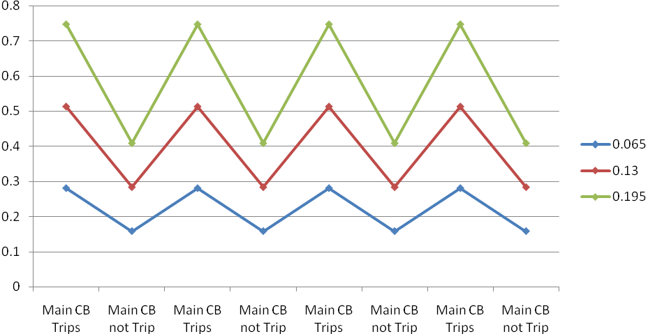
Feeder failure
Rate:
Replacement Repairing Replacement Repairing
of Transformer of Transformer of Transformer of Transformer
DG at D,F,J & N W/O DG

Of Transformer of Transformer

Fig. 4.4: Comparison of SAIFI (DG at D, F, J, N)
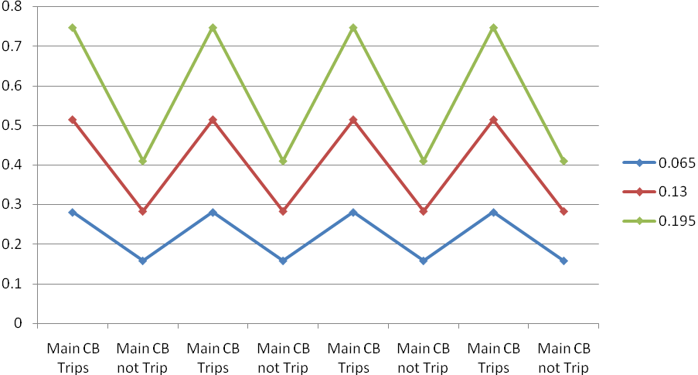
Feeder failure
rate
Replacement Repairing Replacement Repairing
of Transformer of Transformer of Transformer of Transformer

DG at A,E,G &K W/O DG

Of Transformer of Transformer

Fig. 4.5: Comparison of SAIFI (DG at A, E, G, K)
4.5.2. Comparison of SAIFI (Case 2)
The comparative results, similar to previous case, have been presented in Table 4.35 and 4.36. SAIFI is reduced and having same values when main CB does not trip and manually started DG for the location of DG at (D, F, J, N) and (A, E, G, K) for both repairing and replacement of transformer. SAIFI is again reduced when main CB does not trip and auto started DG. But the values of SAIFI are different for the location of DG at (D, F, J, N) and (A, E, G, K) under this condition. SAIFI values are low when DG at (D, F, J, N) and it is the lowest for feeder failure rate 0.065. The reduction of SAIFI is 22.4% for feeder failure rate of 0.065, 24.16% for feeder failure rate of 0.13 and 23.47% for feeder failure rate of 0.195. The value of SAIFI when main CB does not trip & auto started DG for the location of DG at (A, E, G, K) is lower than the value at same location for main CB does not trip and manually started DG. In case of location of DG at (A, E, G, K) the reduction is 1.26% for feeder failure rate of 0.065, 0.88% for feeder failure rate of 0.13 and 0.5% for feeder failure rate of 0.195. When the values of SAIFI for location of DG at (D, F, J, N) for main CB does not trip & auto started DG is compared with the condition main CB does not trip & manually started DG for the same location, it is found that SAIFI decreases 22.4% for feeder failure rate 0.065, 24.1% for feeder failure rate 0.13 and 35.6% for feeder failure rate 0.195. These SAIFI values are represented by the curves shown in Fig. 4.6 and Fig. 4.7. The replacement and repairing time of transformer do not have any effect on SAIFI.
Table 4.35: Comparison of SAIFI (considering replacement time of transformer)
Feeder failure rate | Main CB trips |  | Main CB does not trip
Feeder failure rate | DG manually started |  | DG manually started |  | DG auto-started
Feeder failure rate | DG at  D, F, J, N | DG at  A, E, G, K | DG at  D, F, J, N | DG at  A, E, G, K | DG at  D, F, J, N | DG at  A, E, G, K
0.065 | 0.2802 | 0.2802 | 0.158 | 0.158 | 0.1226 | 0.156
0.13 | 0.513 | 0.513 | 0.2835 | 0.2835 | 0.2150 | 0.281
0.195 | 0.747 | 0.747 | 0.409 | 0.409 | 0.313 | 0.407

Table 4.36: Comparison of SAIFI (considering repairing time of transformer)
Feeder failure rate | Main CB trips |  | Main CB does not trip
Feeder failure rate | DG manually started |  | DG manually started |  | DG automatically started
Feeder failure rate | DG at  D, F, J, N | DG at  A, E, G, K | DG at  D, F, J, N | DG at  A, E, G, K | DG at  D, F, J, N | DG at  A, E, G, K
0.065 | 0.2802 | 0.2802 | 0.158 | 0.158 | 0.1226 | 0.156
0.13 | 0.513 | 0.513 | 0.2835 | 0.2835 | 0.2150 | 0.281
0.195 | 0.747 | 0.747 | 0.409 | 0.409 | 0.313 | 0.407

DG manually started DG manually started DG auto-started
Feeder Failure Rate

Main CB Trips Main CB does not trip

Fig. 4.6: Comparison of SAIFI (considering replacement time of transformer)
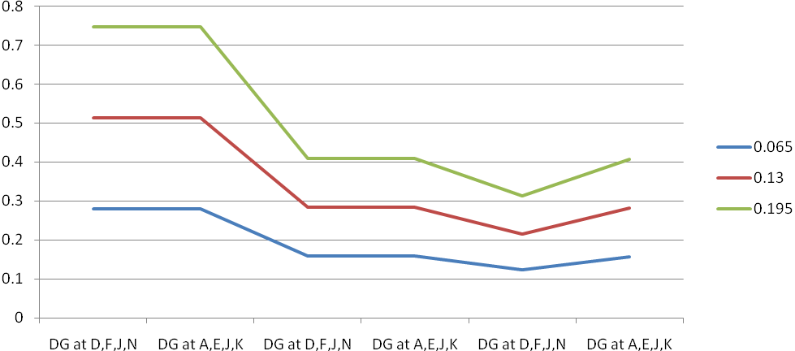 DG manually started DG manually started DG automatically started
Feeder
Failure
Rate

Main CB Trips Main CB does not trip

Fig. 4.7: Comparison of SAIFI (considering repairing time of transformer)

4.5.3. Comparison of SAIDI (Case 1)
The values of SAIDI for the location of DG at (D, F, J, N) and (A, E, G, K) and without considering DG are shown in the Table 4.37 and 4.38 respectively. SAIDI is calculated considering repairing time of transformer and replacement of transformer for the given feeder failure rates. The value of SAIDI is the lowest for main CB does not trip and manually started DG located at (D, F, J, N) in case of replacement of transformer. But SAIDI is very large in case of repairing of transformer for the location of DG at (D, F, J, N) and (A, E, G, K). It is due to the large repairing time of the transformer. For the location of DG at (D, F, J, N), SAIDI increment is 14.73% for feeder failure rate 0.065, 15.9% for 0.13 and 16.38% for 0.195. In case of repairing of transformer these values for the location of DG at (D, F, J, N) are 3.34%, 5.36% and 6.5% respectively.
SAIDI is same for main CB trips and manually started DG located at (A, E, G, K) and without DG in case of replacement of transformer. It is also same for main CB trips and manually started DG located at (A, E, G, K) and without DG in case of repairing of transformer. Again SAIDI is nearly same for DG located at (A, E, G, K) and without DG in case of replacement of transformer. SAIDI increment depends on the location of DG. The value of SAIDI is the lowest while DG location is at (D, F, J, N). In case of repairing of transformer, SAIDI values are also the lowest for the locations of manually started DGs at (D, F, J, N). But location of DG at (A, E, G, K) and without DG, SAIDI values are nearly equal, i.e., there is no meaning of connection of DG at (A, E, G, K). On the other hand, if the main CB trips only when there is a fault at the section to which it is connected, then SAIDI decreases for all cases. These are illustrated in Fig. 4.8 and 4.9.
Table 4.37: Comparison of SAIDI (DG at D, F, J, N)
SAIDI ( in Minute)
Failure rate of feeder | DG at D,F,J & N |  |  |  | W/O DG
Failure rate of feeder | Replacement of Transformer |  | Repairing of Transformer |  | Replacement of Transformer |  | Repairing of Transformer
Failure rate of feeder | Main CB Trip | Main CB not Trip | Main CB Trip | Main CB not Trip | Main CB Trip | Main CB not Trip | Main CB Trip | Main CB not Trip
0.065 | 50.067 | 42.69 | 220.89 | 213.5 | 58.087 | 50.5 | 228.77 | 221.31
0.13 | 87.01 | 73.17 | 257.83 | 244 | 102.06 | 88.16 | 272.88 | 258.97
0.195 | 123.956 | 103.65 | 294.78 | 275.5 | 145.86 | 125.89 | 317 | 296.63

Table 4.38: Comparison of SAIDI (DG at A, E, G, K)
SAIDI ( in Minute)
Failure rate of feeder | DG at A,E,G & K |  |  |  | W/O DG
Failure rate of feeder | Replacement of Transformer |  | Repairing of Transformer |  | Replacement of Transformer |  | Repairing of Transformer
Failure rate of feeder | Main CB Trip | Main CB not Trip | Main CB Trip | Main CB not Trip | Main CB Trip | Main CB not Trip | Main CB Trip | Main CB not Trip
0.065 | 58.087 | 50.5 | 228.77 | 221.31 | 58.087 | 50.5 | 228.77 | 221.31
0.13 | 102.06 | 88.16 | 272.88 | 258.97 | 102.06 | 88.16 | 272.88 | 258.97
0.195 | 145.86 | 125.89 | 317 | 296.63 | 145.86 | 125.89 | 317 | 296.63
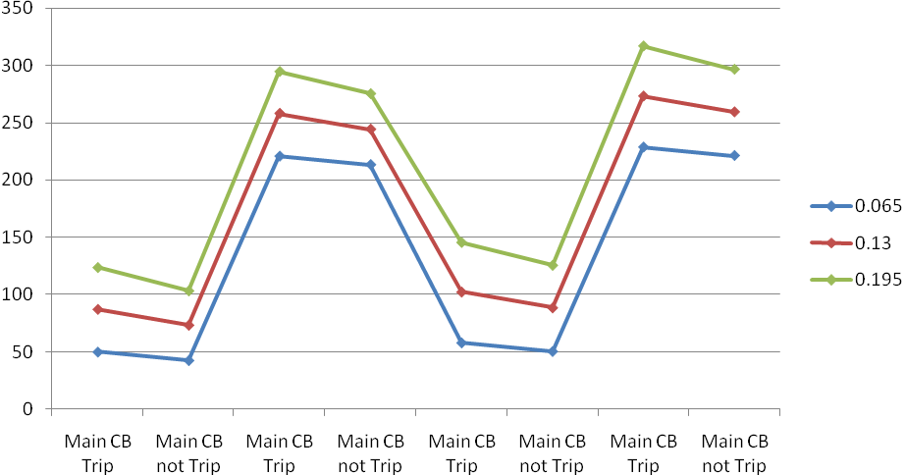
Feeder failure
rate
Replacement Repairing Replacement Repairing
of Transformer of Transformer of Transformer of Transformer

DG at D,F,J &N W/O DG

Of Transformer of Transformer

Fig. 4.8: Comparison of SAIDI (DG at D, F, J. N)
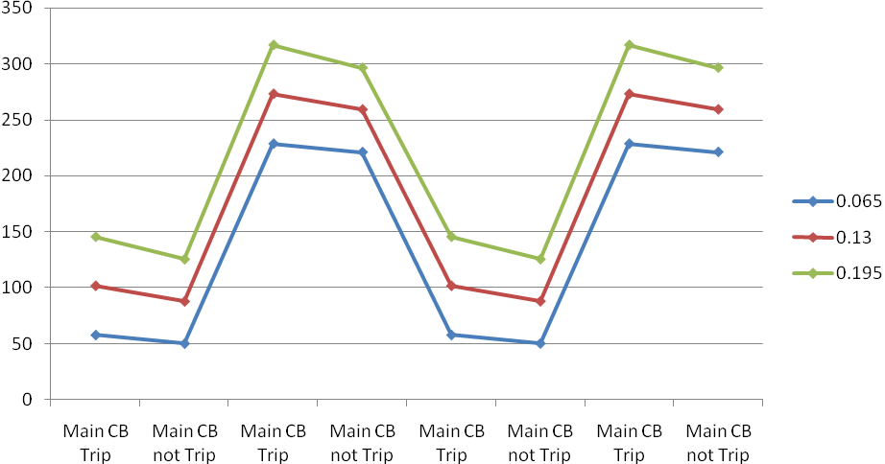
Feeder failure rate
Replacement Repairing Replacement Repairing
of Transformer of Transformer of Transformer of Transformer

DG at A,E,G & K W/O DG

Of Transformer of Transformer

Fig. 4.9: Comparison of SAIDI (DG at A, E, G, K)
4.5.4. Comparison of SAIDI (Case 2)
The values of SAIDI are again compared in Table 4.39 and 4.40. These are calculated considering repairing of transformer and replacement of transformer for the given feeder failure rate. The value of SAIDI is the lowest when main CB does not trip and auto started DG located at (D, F, J, N). But SAIDI values are very large in case of repairing of transformer for the same location of DG at (D, F, J, N) as well as for the location of DG at (A, E, G, K). It is due to the large repairing time of the transformer. For the location of DG at (D, F, J, N), SAIDI increment is 4.98% at feeder failure rate 0.065, 5.44% for 0.13 and 11.4% for 0.195. The increment of SAIDI for the DG location at (D, F, J, N) and (A, E, G, K), considering replacement of transformer when main CB does not trip and auto started DG is19.49% for feeder failure rate 0.065, 21.4% for 0.13 and 22.17% for 0.195. But SAIDI is the lowest for the location of DG at (D, F, J, N).
For the location of DG at (D, F, J, N), SAIDI improvement considering repairing of transformer is 2.25% when main CB does not trip and auto started DG at feeder failure rate 0.065, 1.63% for feeder failure rate 0.13 and 2.49% for feeder failure rate 0.195. The SAIDI values are represented by the curves shown in Fig. 4.10 and 4.11.

Table 4.39: Comparison of SAIDI (considering replacement time of transformer)
Feeder failure rate | Main CB trips |  | Main CB does not trip
Feeder failure rate | DG manually started |  | DG manually started |  | DG automatically started
Feeder failure rate | DG at  D, F, J, N | DG at  A, E, G, K | DG at  D, F, J, N | DG at  A, E, G, K | DG at  D, F, J, N | DG at  A, E, G, K
0.065 | 50.067 | 58.01 | 42.69 | 50.5 | 40.56 | 50.38
0.13 | 87.01 | 102.06 | 73.17 | 88.16 | 69.185 | 88.03
0.195 | 123.956 | 145.86 | 103.65 | 125.819 | 97.81 | 125.68

Table 4.40: Comparison of SAIDI (considering repairing time of transformer)
Feeder failure rate | Main CB trips |  | Main CB does not trip
Feeder failure rate | DG manually started |  | DG manually started |  | DG automatically started
Feeder failure rate | DG at  D, F, J, N | DG at  A, E, G, K | DG at  D, F, J, N | DG at  A, E, G, K | DG at  D, F, J, N | DG at  A, E, G, K
0.065 | 220.89 | 228.77 | 213.5 | 221.31 | 208.69 | 221.21
0.13 | 257.83 | 272.88 | 244.00 | 258.97 | 240.00 | 258.85
0.195 | 294.78 | 317.00 | 275.5 | 296.63 | 268.63 | 296.5

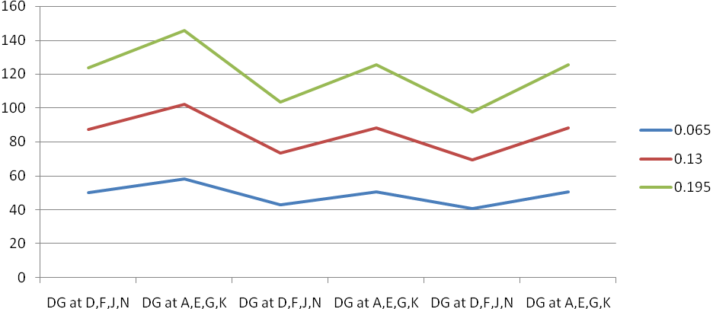 DG manually started DG manually started DG automatically started
Feeder
Failure
Rate
Main CB Trips Main CB does not trip
Fig. 4.10: Comparison of SAIDI (considering replacement time of transformer)
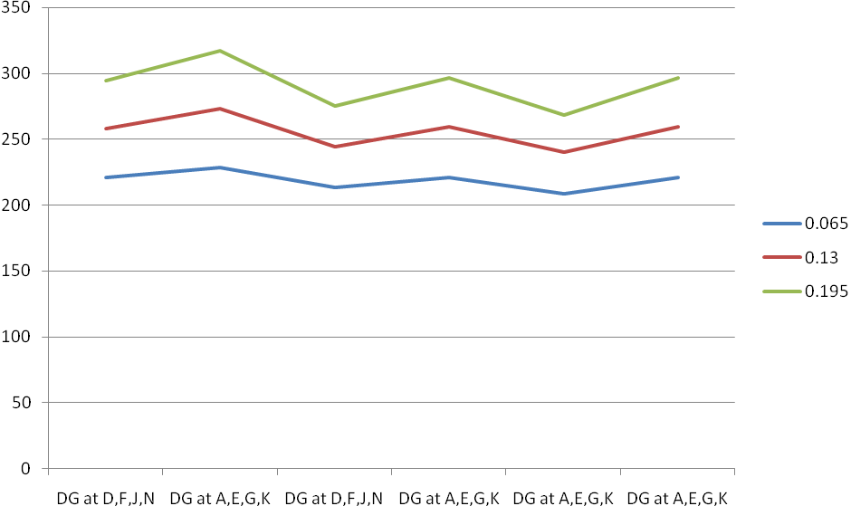
Feeder
Failure
Rate
DG manually started DG manually started DG automatically started

Main CB Trips Main CB does not trip
Fig. 4.11: Comparison of SAIDI (considering repairing time of transformer)
4.5.5. Comparison of CAIDI (Case 1)
The comparison of CAIDI for the location of DG at (D, F, J, N) and (A, E, G, K) are shown in the Table 4.41 and 4.42. The value of CAIDI is the lowest for main CB trips and manually started DG located at (D, F, J, N) in case of replacement of transformer. But CAIDI is very large in case of repairing of transformer. CAIDI is low for the location of DG at (D, F, J, N) for main breaker trips and manually started DG in case of repairing of transformer. Table 4.41 and 4.42 show that with the increase of feeder failure rate, CAIDI decreases. It is because, the increase of the SAIFI is more than the increase of SAIDI with the increase of feeder failure rate considered for the same switching time and repairing time of feeder as well as other components installed with the feeder in our research work. It is also seen that CAIDI increases with the decrease of SAIFI under the same conditions. CAIDI is very large due to the large repairing time of the transformer. For the location of DG at (D, F, J, N), CAIDI increment than the location of DG at (A, E, G, K) for replacement of transformer and manually started DG is 13.72%, 14.74% and 15.05% for feeder failure rate 0.065, 0.13 and 0.195 respectively.
CAIDI increment depends on the location of DG. Here, CAIDI is the lowest while DG location is at (D, F, J, N). But there is no influence of DG at location (A, E, G, K) on the value of CAIDI. i.e., there is no meaning of connecting DG at (A, E, G, K) as far as the CAIDI is concerned. The results are presented graphically in Fig. 4.12 and 4.13.
Table 4.41: Comparison of CAIDI (DG at D, F, J, N)
CAIDI ( in Minute)
Failure rate of feeder | DG at D,F,J & N |  |  |  | W/O DG
Failure rate of feeder | Replacement of Transformer |  | Repairing of Transformer |  | Replacement of Transformer |  | Repairing of Transformer
Failure rate of feeder | Main CB Trip | Main CB not Trip | Main CB Trip | Main CB not Trip | Main CB Trip | Main CB not Trip | Main CB Trip | Main CB not Trip
0.065 | 178.68 | 270.19 | 788.3 | 1351.26 | 207.1 | 320.38 | 816.45 | 1401.56
0.13 | 169.48 | 258.1 | 502.2 | 860.4 | 198.79 | 311.35 | 531.93 | 913.9
0.195 | 165.936 | 253.42 | 394.83 | 670.9 | 195.35 | 307.84 | 424.9 | 725.5

Table 4.42: Comparison of CAIDI (DG at A, E, G, K)
CAIDI ( in Minute)
Failure rate of feeder | DG at A,E,G & K |  |  |  | W/O DG
Failure rate of feeder | Replacement of Transformer |  | Repairing of Transformer |  | Replacement of Transformer |  | Repairing of Transformer
Failure rate of feeder | Main CB Trip | Main CB not Trip | Main CB Trip | Main CB not Trip | Main CB Trip | Main CB not Trip | Main CB Trip | Main CB not Trip
0.065 | 207.1 | 319.62 | 816.45 | 1400.7 | 207.1 | 320.38 | 816.45 | 1401.56
0.13 | 198.79 | 310.99 | 531.52 | 913.5 | 198.79 | 311.35 | 531.93 | 913.9
0.195 | 195.35 | 307.62 | 424.93 | 725.08 | 195.35 | 307.84 | 424.9 | 725.5

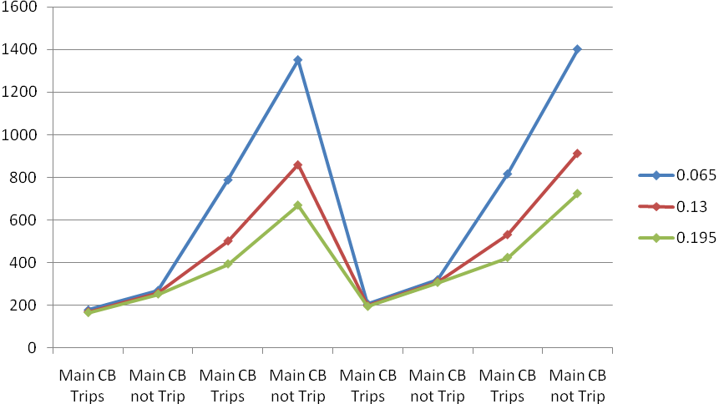
Feeder
Failure
Rate
Replacement Repairing Replacement Repairing
of Transformer of Transformer of Transformer of Transformer

DG at D,F,J &N W/O DG

Of Transformer of Transformer

Fig. 4.12: Comparison of CAIDI (DG at D, F, J, N)
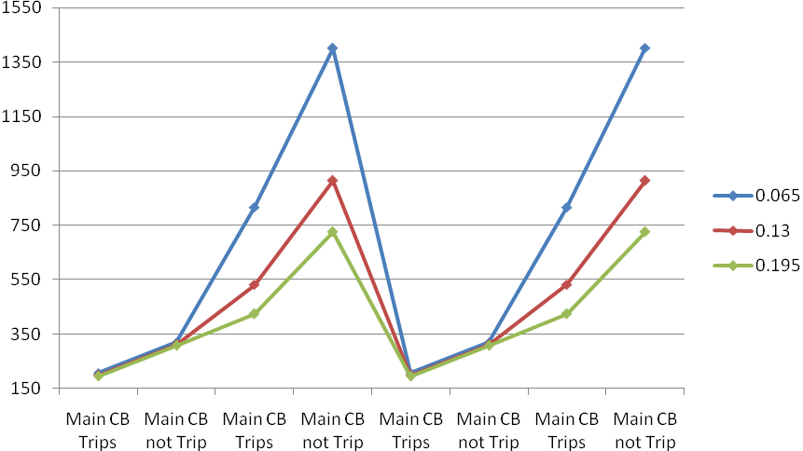
Replacement Repairing Replacement Repairing
of Transformer of Transformer of Transformer of Transformer

DG at A, E, G & K W/O DG

Of Transformer of Transformer
Feeder
Failure
Rate
Fig. 4.13: Comparison of CAIDI (DG at A, E, G, K)

Fig. 4.13: Comparison of CAIDI (DG at A, E, G, K)
4.5.6. Comparison of CAIDI (Case 2)
The Table 4.43 and 4.44 show the values of system reliability index CAIDI calculated under the conditions that the main CB trips and manually started DG as well as main CB does not trip, manually started DG and auto started DG. The values of CAIDI are the lowest when main CB trips and DG started manually located at (D, F, J, N). The values of CAIDI are very large in case of repairing of transformer. Table 4.43 and 4.44 show that with the increase of feeder failure rate, CAIDI decreases. It is because, the increase of the SAIFI is more than the increase of SAIDI with the increase of feeder failure rate considered for the same switching time and repairing time of feeder as well as of other components of the feeder. It is also seen that CAIDI increases with the decrease of SAIFI caused by decreased feeder failure rates under the same conditions. But for the same feeder failure rate, SAIFI is same for DG location at (D, F, J, N) and (A, E, G, K) in case of main CB trips & manually started DG. It is also same in case of main CB does not trip and manually started DG. But the values of SAIDI for DG location (A, E, G, K) is more than that of DG location (D, F, J, N) in both the cases. It results in high CAIDI for location of DG at (A, E, G, K). Thus it depends on the location of DG. But when SAIFI is low then CAIDI is high. In case of main CB does not trip and auto started DG located at (D, F, J, N), SAIFI is lower than that of DG location at (A, E, G, K). It results in high value of CAIDI for location of DG at (D, F, J, N). In case of repairing of transformer, SAIDI values are very high and thus CAIDI. In this case, CAIDI is the highest for auto started DG located at (D, F, J, N) with main CB does not trip. The Fig. 4.14 and 4.15 show the trends of CAIDI for replacement of transformer and repairing of transformer respectively.
Table 4.43: Comparison of CAIDI (considering replacement time of transformer)
Feeder failure rate | Main CB trips |  | Main CB does not trip
Feeder failure rate | DG manually started |  | DG manually started |  | DG automatically started
Feeder failure rate | DG at  D, F, J, N | DG at  A, E, G, K | DG at  D, F, J, N | DG at  A, E, G, K | DG at  D, F, J, N | DG at  A, E, G, K
0.065 | 178.68 | 207.1 | 270.19 | 319.62 | 330.832 | 322.95
0.13 | 169.48 | 198.79 | 258.1 | 310.99 | 317.362 | 313.27
0.195 | 165.936 | 195.35 | 253.42 | 307.62 | 312.492 | 308.8

Table 4.44: Comparison of CAIDI (considering repairing time of transformer)
Feeder failure rate | Main CB trips |  | Main CB does not trip
Feeder failure rate | DG manually started |  | DG manually started |  | DG automatically started
Feeder failure rate | DG at  D, F, J, N | DG at  A, E, G, K | DG at  D, F, J, N | DG at  A, E, G, K | DG at  D, F, J, N | DG at  A, E, G, K
0.065 | 788.3 | 816.45 | 1351.26 | 1400.7 | 1704.4 | 1417.98
0.13 | 502.2 | 531.52 | 860.4 | 913.5 | 1100.9 | 923.145
0.195 | 394.83 | 424.93 | 670.9 | 725.08 | 856.87 | 728.32

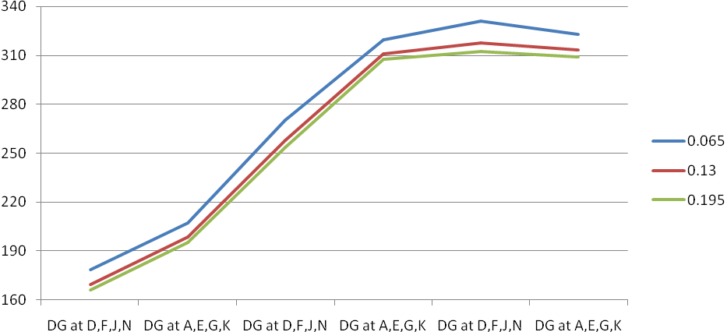
Feeder
Failure
Rate
DG manually started DG manually started DG automatically started
Main CB Trips Main CB does not trip
Fig. 4.14: Comparison of CAIDI (considering replacement time of transformer)

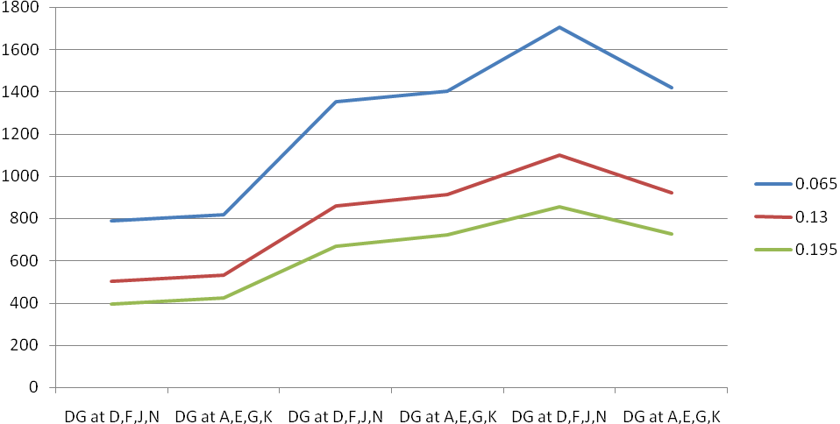
Feeder
Failure
Rate
DG manually started DG manually started DG automatically started

Main CB Trips Main CB does not trip
Fig. 4.15: Comparison of CAIDI (considering repairing time of transformer)
4.5.7. Comparison of ASAI (Case1)
In a similar manner, the Average Service Availability Index (ASAI) are also calculated and presented in Table 4.45 and 4.46. The ASAI values are the highest for the location of manually started DG at (D, F, J, N) with main CB does not trip when replacement of transformer is considered. ASAI decreases with the increase of feeder failure rate. For DG location at (A, E, G, K), ASAI is the lowest for main CB trips and manually started DG when replacement of transformer is considered. It is same in case of repairing of transformer also. The trend of ASAI values are represented by the curves shown in Fig. 4.16 and 4.17.
Table 4.45: Comparison of ASAI (DG at D, F, J, N)
ASAI
Failure rate of feeder | DG at D,F,J & N |  |  |  | W/O DG
Failure rate of feeder | Replacement of Transformer |  | Repairing of Transformer |  | Replacement of Transformer |  | Repairing of Transformer
Failure rate of feeder | Main CB Trip | Main CB not Trip | Main CB Trip | Main CB not Trip | Main CB Trip | Main CB not Trip | Main CB Trip | Main CB not Trip
0.065 | 0.999904 | 0.999918 | 0.999579 | 0.999593 | 0.999880 | 0.999902 | 0.999564 | 0.999578
0.13 | 0.999840 | 0.99986 | 0.999509 | 0.99953 | 0.999800 | .999820 | 0.99948 | 0.999507
0.195 | 0.999760 | 0.99982 | 0.999439 | 0.999477 | 0.999720 | 0.999704 | 0.999368 | 0.999435

Table 4.46: Comparison of ASAI (DG at A, E, G, K)
ASAI
Failure rate of feeder | DG at A,E,G & K |  |  |  | W/O DG
Failure rate of feeder | Replacement of Transformer |  | Repairing of Transformer |  | Replacement of Transformer |  | Repairing of Transformer
Failure rate of feeder | Main CB Trip | Main CB not Trip | Main CB Trip | Main CB not Trip | Main CB Trip | Main CB not Trip | Main CB Trip | Main CB not Trip
0.065 | 0.99988 | 0.999903 | 0.99956 | 0.999578 | 0.99988 | 0.999902 | 0.999564 | 0.999578
0.13 | 0.9998 | 0.99983 | 0.99948 | 0. 9995 | 0.9995 | 0.99982 | 0.99948 | 0.9995
0.195 | 0.99972 | 0.99975 | 0.999368 | 0.999435 | 0.99972 | 0.99974 | 0.999368 | 0.999435

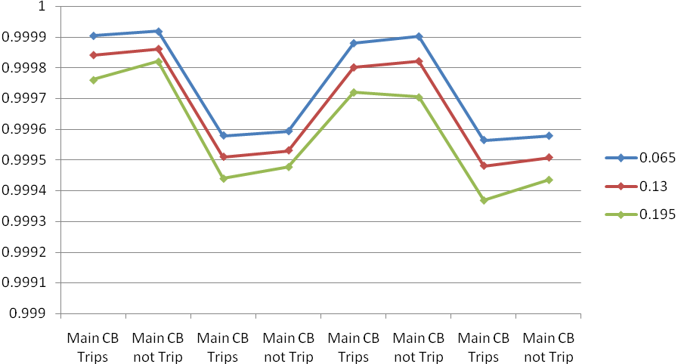
Feeder failure
rate
Replacement Repairing Replacement Repairing
of Transformer of Transformer of Transformer of Transformer
DG at D, F, J & N W/O DG

Of Transformer of Transformer

Fig. 4.16: Comparison of ASAI (DG at D, F, J, N)
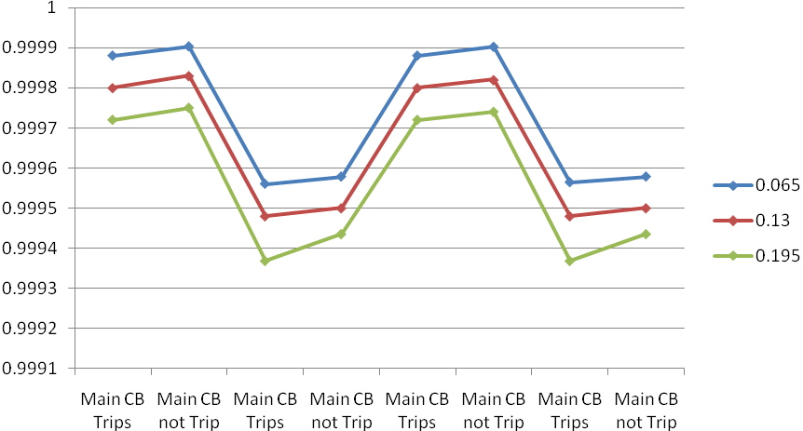
Feeder failure
rate
Fig. 4.17: Comparison of ASAI (DG at A, E, G, K)

4.5.8. Comparison of ASAI (Case 2)
A similar comparison has been made for ASAI and results are shown in Table 4.47 and 4.48. The values of ASAI are the highest for the location of DG at (D, F, J, N) with main CB does not trip and auto started DG when replacement of transformer is considered. In case of repairing of transformer & DG location at (D, F, J, N), ASAI is the lowest for main CB does not trip and manually started DG. For DG location at (A, E, G, K), the ASAI values are the lowest for main CB trips and manually started DG when replacement of transformer is considered. It is same in case of repairing of transformer also. In case of auto started DG and main CB does not trip, ASAI is the highest for both the cases, replacement and repairing of transformer, because for auto started DG, switching time is nil. These ASAI values are represented graphically in Fig. 4.18 and 4.19.
Table 4.47: Comparison ASAI (considering replacement time of transformer)
Feeder failure rate | Main CB trips |  | Main CB does not trip
Feeder failure rate | DG manually started |  | DG manually started |  | DG automatically started
Feeder failure rate | DG at  D, F, J, N | DG at  A, E, G, K | DG at  D, F, J, N | DG at  A, E, G, K | DG at  D, F, J, N | DG at  A, E, G, K
0.065 | 0.999904 | 0.99988 | 0.999918 | 0.999903 | 0.99992 | 0.99991
0.13 | 0.99984 | 0.9998 | 0.99986 | 0.99983 | 0.99987 | 0.99985
0.195 | 0.99976 | 0.9997 | 0.99982 | 0.99975 | 0.99981 | 0.99977

Table 4.48: Comparison ASAI (considering repairing time of transformer)
Feeder failure rate | Main CB trips |  | Main CB does not trip
Feeder failure rate | DG manually started |  | DG manually started |  | DG auto started
Feeder failure rate | DG at  D, F, J, N | DG at  A, E, G, K | DG at  D, F, J, N | DG at  A, E, G, K | DG at  D, F, J, N | DG at  A, E, G, K
0.065 | 0.999579 | 0.99956 | 0.999593 | 0.999578 | 0.9996 | 0.99958
0.13 | 0.999509 | 0.99948 | 0.99953 | 0.9995 | 0.99954 | 0.99951
0.195 | 0.999439 | 0.999369 | 0.999477 | 0.999435 | 0.99948 | 0.99943

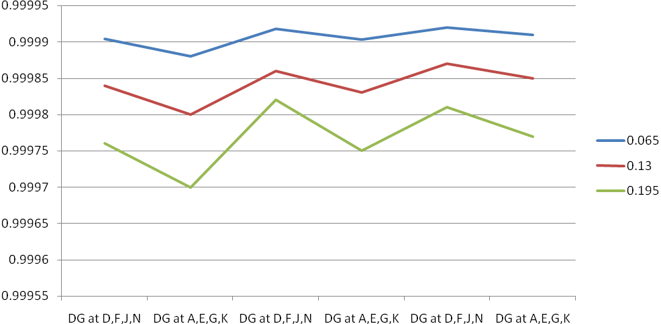 DG manually started DG manually started DG automatically started
Feeder
Failure
Rate

Main CB Trips Main CB does not trip

Fig 4.18: Comparison ASAI (considering replacement time of transformer)
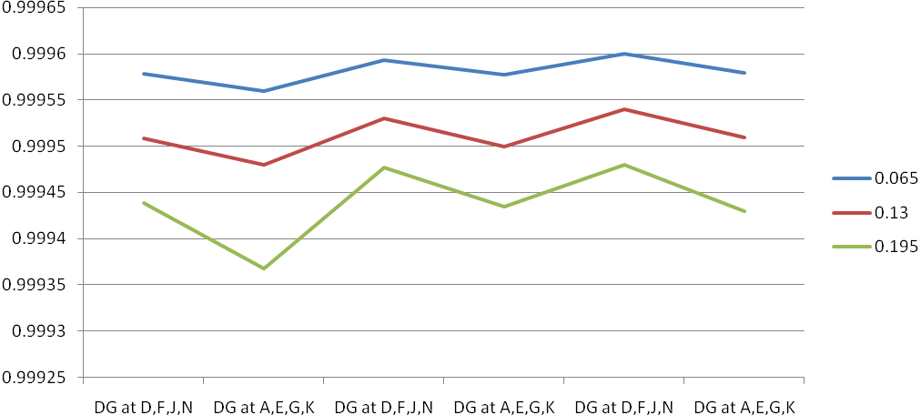 DG manually started DG manually started DG automatically started
Feeder
Failure
Rate
Main CB Trips Main CB does not trip

Fig. 4.19: Comparison ASAI (considering repairing time of transformer)
4.5.9. Comparison of EENS (Case 1)
The comparison of EENS for two given DG locations is presented in Table 4.49 and 4.50. When DGs are located at (A, E, G, K) the values of EENS are the highest for manually started DG while main CB trips and replacement time of transformer is considered.

Table 4.49: Comparison of EENS (DG at D, F, J, N)
EENS ( in Kwh )
Failure rate of feeder | DG at D,F,J & N |  |  |  | W/O DG
Failure rate of feeder | Replacement of Transformer |  | Repairing of Transformer |  | Replacement of Transformer |  | Repairing of Transformer
Failure rate of feeder | Main CB Trip | Main CB not Trip | Main CB Trip | Main CB not Trip | Main CB Trip | Main CB not Trip | Main CB Trip | Main CB not Trip
0.065 | 9660.83 | 8788.23 | 38562.6 | 37690.1 | 12984.4 | 12118.8 | 41886.3 | 41020.728
0.13 | 16983.5 | 15348.6 | 45885.3 | 44250.4 | 23336.7 | 21708.9 | 52238.6 | 50610.779
0.195 | 24306.1 | 21909.0 | 53208.0 | 50810.8 | 33869.1 | 31298.9 | 62590.9 | 60200.83

Table 4.50: Comparison of EENS (DG at A, E, G, K)
EENS ( in KWh )
Failure rate of feeder | DG at A,E,G & K |  |  |  | W/O DG
Failure rate of feeder | Replacement of Transformer |  | Repairing of Transformer |  | Replacement of Transformer |  | Repairing of Transformer
Failure rate of feeder | Main CB Trip | Main CB not Trip | Main CB Trip | Main CB not Trip | Main CB Trip | Main CB not Trip | Main CB Trip | Main CB not Trip
0.065 | 12984.4 | 12095.19 | 41886.31 | 40996.09 | 12984.46 | 12118.87 | 41886.30 | 41020.72
0.13 | 23336.7 | 21685.24 | 52238.64 | 50586.96 | 23336.78 | 21708.9 | 52238.63 | 50610.77
0.195 | 33869.1 | 31275.29 | 62596.96 | 60176.24 | 33869.11 | 31298.98 | 62590.96 | 60200.83

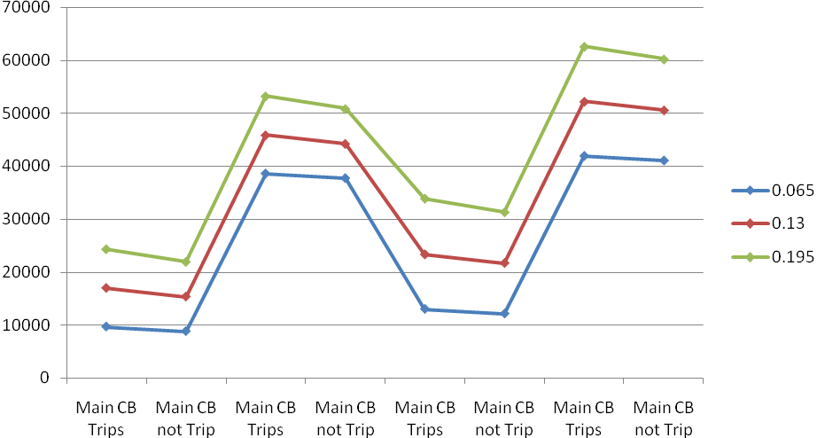
Feeder
Failure
Rate
Replacement Repairing Replacement Repairing
of Transformer of Transformer of Transformer of Transformer
DG at D,F,J& N W/O DG

Of Transformer of Transformer

Fig. 4.20: Comparison of EENS (DG at D, F, J, N)
Feeder
Failure
Rate

Replacement Repairing Replacement Repairing
of Transformer of Transformer of Transformer of Transformer

DG at A,E,G& K W/O DG

Of Transformer of Transformer

Fig
Fig. 4.21: Comparison of EENS (DG at A, E, G, K)
4.5.10. Comparison of EENS (Case 2)
The comparison of EENS at two DG locations considering replacement and repairing time of transformers are presented in Table 4.51 and 4.52. From this comparison it has been observed that EENS values are high while repairing time of transformer is considered.
Table 4.51: Comparison of EENS (considering replacement time of transformer)
Feeder failure rate | Main CB trips |  | Main CB does not trip
Feeder failure rate | DG manually started |  | DG manually started |  | DG automatically started
Feeder failure rate | DG at  D, F, J, N | DG at  A, E, G, K | DG at  D, F, J, N | DG at  A, E, G, K | DG at  D, F, J, N | DG at  A, E, G, K
0.065 | 9660.836 | 12984.46 | 8788.238 | 12095.19 | 7914.108 | 12069.714
0.13 | 16983.515 | 23336.787 | 15348.64 | 21685.25 | 13717.10 | 21659.76
0.195 | 24306.193 | 33689.115 | 21909.04 | 31275.29 | 19520.10 | 31249.816

Table 4.52: Comparison of EENS (considering repairing time of transformer)
Feeder failure rate | Main CB trips |  | Main CB does not trip
Feeder failure rate | DG manually started |  | DG manually started |  | DG automatically started
Feeder failure rate | DG at  D, F, J, N | DG at  A, E, G, K | DG at  D, F, J, N | DG at  A, E, G, K | DG at  D, F, J, N | DG at  A, E, G, K
0.065 | 38562.686 | 41886.31 | 37690.1 | 40996.093 | 36815.96 | 40971.564
0.13 | 45885.365 | 52238.64 | 44250.49 | 50586.969 | 42618.94 | 50561.615
0.195 | 53208.043 | 62590.96 | 50810.89 | 60176.243 | 48421.93 | 60151.64

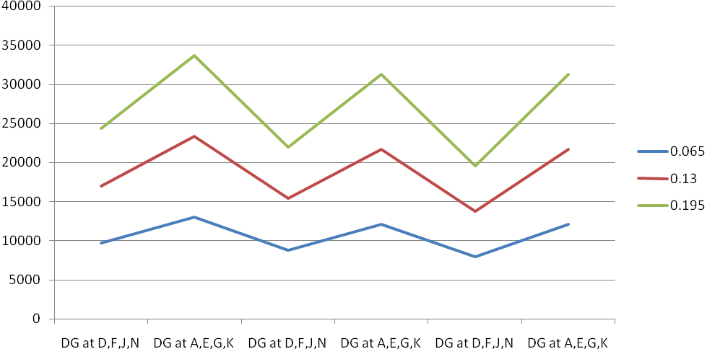 DG manually started DG manually started DG automatically started
Feeder
Failure
Rate
Main CB Trips Main CB does not trip
Fig. 4.22: Comparison of EENS (considering replacement time of transformer)
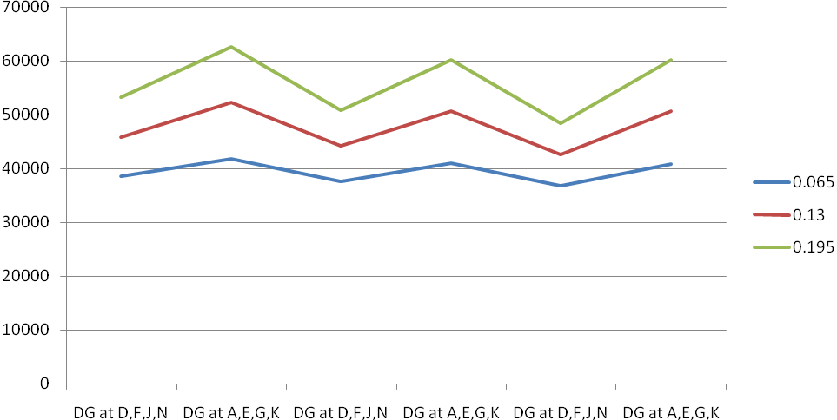 DG manually started DG manually started DG automatically started
Feeder
Failure
Rate
Main CB Trips Main CB does not trip
Fig. 4.23 Comparison of EENS (considering repairing time of transformer)
4.6. Study on Local Distribution System
The study on the local distribution system of Chandmari-Milanpur area of Guwahati, Assam has been performed under the following conditions:
- Main CB trips & manually started DG
- Main CB does not trip and manually started DG
- Main CB does not trip & auto started DG
The single line diagram of this distribution system is given in Fig. 4.3. The radial system is having 23 sections and 22 load points. DGs are connected separately at location X, Y and Z as indicated in the line diagram. These are not connected simultaneously with the distribution system. The capacities of DGs are chosen according to the requirements of the specified feeders. The data sets considered for this distribution system are given in Table A4, A5, and A6 (Appendix).
The following assumptions are made for reliability analysis of the system [28, 29, 52]:
- Only failure rate of sections and laterals are considered for reliability analysis.
- Disconnects installed against each section are 100% reliable. Appropriate disconnect operates in case of a fault in a section and isolates the faulty section with next adjacent load point from the healthy sections.
- Separate disconnects are installed against each lateral. These are 100% reliable. Appropriate disconnects operate in case of a fault on a lateral distributor.
- DGs are 100% reliable.
- For reliability analysis active power flow is considered.
- The repairing time for section is 4 hr and for lateral is 2 hr. The switching time for a section and a lateral is 0.5 hr.
- In case of manual starting, starting time of DG is 0.5 hr and in case of auto started DG, starting time is considered as nil.
- Failure rate for section is 0.0056 f/m yr.
- DGs are considered separately and applied at the end of distribution line and have the sufficient capacity to meet the load demand.
With main CB trips or does not trip, the following situations will arise at sections forming the junctions as shown in Fig.4.3 [28, 29, 52]:
At Junction 1:
- When there is a fault at section 2, section 2 is only isolated.
- When there is a fault at section 3, section 3 is isolated with isolating load at point B.
- When there is a fault at section 17, section 17 is only isolated.
At Junction 2:
- When there is a fault at section 17, section 17 is only isolated.
- When there is a fault at section 18, section 18 is isolated with load at point Q.
- When there is a fault at section 19, section 19 is isolated with load at point R.
At Junction 3:
- When there is a fault at section 9, section 9 is isolated with load at point H.
- When there is a fault at section 12, section 12 is isolated with load at point K.
- When there is a fault at section 10, section 10 is isolated with load at point I.

4.7. Results and Analysis for Local Distribution System
The reliability data required for the analysis are presented in Table A4, A5 and A6 in Appendix. Table A4 presents the length of sections, Table A5 shows the failure rates of laterals and Table A6 shows the loads at different loads points. The study has been performed considering failure rates of feeder and lateral distributors with the assumptions described in section 4.6. The DGs are placed at the far ends of the feeders, and have chosen three load points X, Y and Z. Three cases have been considered for study as described below.

4.7.1. Main CB trips and manually started DG (Case 1)
The CB that installed at section 1 is identified as main CB. A DG is connected at the location X, next Y and then at Z. When main CB trips and the DG started manually the equation (3.7) is used to get the value of load point failure rate, λ, and equation (3.8) to get the value of load point annual outage duration, U. The load point failure rates for particular point are same for the different locations of DG but for different load points, failure rates are different. So in these conditions only the length of the laterals determines the differences of load point failure rate of various load points. But the value of annual outage durations for same load points for different locations of DG is not same.
The Table 4.53 shows the values of λ, r and U for all load points connecting a DG at X, next at Y and then at Z. The system indices SAIFI, SAIDI, CAIDI, ASAI, and EENS are also calculated under the above mentioned conditions and a comparison is illustrated in Table 4.54. It is found that DG location at X is more reliable.

Table 4.53: Load point indices for local distribution system (Case 1)
Load Point | Main CB trips and DG manual started
Load Point | DG at X |  |  | DG at Y |  |  | DG at Z
Load Point | λ | r | U | λ | r | U | λ | r | U
A | 27.15 | 0.85 | 23.075 | 27.15 | 0.85 | 23.075 | 27.15 | 0.85 | 23.075
B | 25.15 | 0.66 | 16.555 | 25.15 | 0.66 | 16.555 | 25.15 | 0.66 | 16.555
C | 26.15 | 0.702 | 18.35 | 26.15 | 0.702 | 18.35 | 26.15 | 0.739 | 19.33
D | 27.15 | 0.757 | 20.555 | 27.15 | 0.757 | 20.555 | 27.15 | 0.822 | 22.305
E | 26.15 | 0.896 | 23.42 | 26.15 | 0.896 | 23.42 | 26.15 | 1.00 | 26.15
F | 25.15 | 0.65 | 16.345 | 25.15 | 0.65 | 16.345 | 25.15 | 0.991 | 24.92
G | 24.15 | 0.843 | 20.365 | 24.15 | 0.843 | 20.365 | 24.15 | 1.23 | 29.71
H | 27.15 | 0.94 | 25.42 | 27.15 | 0.94 | 25.42 | 27.15 | 1.53 | 41.55
I | 26.15 | 0.933 | 24.4 | 26.15 | 0.71 | 18.56 | 26.15 | 1.55 | 40.54
J | 27.15 | 0.994 | 26.15 | 27.15 | 0.743 | 20.17 | 27.15 | 1.589 | 43.13
K | 26.15 | 0.71 | 18.555 | 26.15 | 0.933 | 24.40 | 26.15 | 1.55 | 40.535
L | 25.15 | 0.65 | 16.345 | 25.15 | 0.921 | 23.17 | 25.15 | 11.563 | 39.305
M | 26.15 | 0.896 | 23.42 | 26.15 | 1.186 | 31.015 | 26.15 | 1.803 | 47.15
N | 27.15 | 0.83 | 22.48 | 27.15 | 1.320 | 35.92 | 27.15 | 1.92 | 52.055
O | 26.15 | 0.71 | 18.56 | 26.15 | 1.335 | 34.90 | 26.15 | 1.952 | 51.04
P | 25.15 | 0.928 | 23.345 | 25.15 | 0.928 | 23.345 | 25.15 | 0.619 | 15.575
Q | 26.15 | 0.992 | 25.94 | 26.15 | 0.992 | 25.94 | 26.15 | 0.695 | 18.17
R | 27.15 | 1.043 | 28.325 | 27.15 | 1.043 | 28.325 | 27.15 | 0.757 | 20.555
S | 26.15 | 1.029 | 26.92 | 26.15 | 1.029 | 26.92 | 26.15 | 0.695 | 18.17
T | 24.15 | 1.75 | 42.38 | 24.15 | 1.75 | 42.38 | 24.15 | 1.37 | 33.035
U | 27.15 | 1.8 | 48.87 | 27.15 | 1.8 | 48.87 | 27.15 | 0.739 | 20.07
V | 26.15 | 2.163 | 56.565 | 26.15 | 2.163 | 56.565 | 26.15 | 1.043 | 27.27

Table 4.54: Comparison of system indices for local distribution system (Case 1)
Load Point | SAIFI | SAIDI | CAIDI | ASAI | ASUI | EENS | AENS
X | 25.932 | 1544.7 | 60.00 | 0.997065 | 0.002935 | 121847.1 | 56.515
Y | 25.932 | 1652.2 | 64.00 | 0.996861 | 0.003139 | 130220.5 | 60.399
Z | 25.932 | 1879.1 | 72.00 | 0.99650 | 0.00350 | 147978.6 | 68.6357

4.7.2. Main CB does not trip and manually started DG (Case 2)
In this condition also DG is connected at the location X first, next Y and then Z. The equations (3.9) and (3.10) are used to get the values λ and U respectively. The load point failure rate in this case decreases because the main CB does not trip due to the fault at any section other than the section at which it is installed. The load point failure rates for particular load point are also same for the different locations of DG as found in the previous case. But the values of annual outage durations for a particular load points for different locations of DG are not same. The Table 4.55 shows λ, r and U and Table 4.56 shows the values of SAIFI, SAIDI, CAIDI, ASAI, ASUI, AENS and EENS. In this case also location of DG at X is more reliable. The system is more reliable in this condition than the previous case.
Table 4.55: Load point indices for local distribution system (Case 2)
Load Point | Main CB does not trip and DG manual started
Load Point | DG at X |  |  | DG at Y |  |  | DG at Z
Load Point | λ | r | U | λ | r | U | λ | r | U
A | 5 | 2.4 | 12 | 5 | 2.4 | 12 | 5 | 2.4 | 12
B | 4.11 | 1.47 | 6.055 | 4.11 | 1.47 | 6.055 | 4.11 | 1.47 | 6.055
C | 5.33 | 1.489 | 7.94 | 5.33 | 1.489 | 7.94 | 5.33 | 1.673 | 8.92
E | 7.28 | 1.921 | 13.985 | 7.28 | 1.921 | 13.985 | 7.28 | 2.296 | 16.715
F | 6.5 | 1.08 | 7.02 | 6.5 | 1.08 | 7.02 | 6.5 | 2.399 | 15.595
G | 7.44 | 1.614 | 12.01 | 7.44 | 1.614 | 12.01 | 7.44 | 2.87 | 21.355
H | 12.11 | 1.48 | 17.9 | 12.11 | 1.48 | 17.9 | 12.11 | 2.81 | 34.035
I | 11.39 | 1.494 | 17.02 | 11.39 | 0.981 | 11.18 | 11.39 | 2.911 | 33.16
K | 11.39 | 0.981 | 11.175 | 11.39 | 1.494 | 17.02 | 11.39 | 2.911 | 33.155
L | 10.61 | 0.855 | 9.075 | 10.61 | 1.499 | 15.9 | 10.61 | 3.019 | 32.035
M | 13.28 | 1.279 | 16.985 | 13.28 | 1.851 | 24.58 | 13.28 | 3.066 | 40.715
N | 15.11 | 1.09 | 16.46 | 15.11 | 1.98 | 29.9 | 15.11 | 3.05 | 46.035
O | 14.39 | 0.881 | 12.68 | 14.39 | 2.017 | 29.02 | 14.39 | 3.138 | 45.16
P | 6.05 | 2.28 | 13.795 | 6.05 | 2.28 | 13.795 | 6.05 | 0.996 | 6.025
Q | 7.22 | 2.282 | 16.475 | 7.22 | 2.282 | 16.475 | 7.22 | 1.206 | 8.705
R | 8.33 | 2.271 | 18.915 | 8.33 | 2.271 | 18.915 | 8.33 | 1.338 | 11.145
T | 11.06 | 3.24 | 35.835 | 11.06 | 3.24 | 35.835 | 11.06 | 2.4 | 26.49
U | 14.2 | 2.986 | 42.4 | 14.2 | 2.986 | 42.4 | 14.2 | 0.957 | 13.59
V | 15.97 | 3.223 | 51.475 | 15.97 | 3.223 | 51.475 | 15.97 | 1.389 | 22.18
Table 4.56: Comparison of system indices for local distribution system (Case 2)
Load Point | SAIFI | SAIDI | CAIDI | ASAI | ASUI | EENS | AENS
X | 9.735 | 1058.8 | 109 | 0.9979 | 0.0021 | 83875.24 | 38.903
Y | 9.735 | 1166.3 | 120 | 0.99779 | 0.00221 | 92248.605 | 42.787
Z | 9.735 | 1393.2 | 143 | 0.99744 | 0.00256 | 110006.73 | 51.0235

4.7.3. Main CB does not trip and auto started DG (Case 3)
In this condition DG is auto started. For main CB does not trip and auto started DG, the equation (3.11) is used to get the value of load point failure rate, λ, equation (3.12) is used to get the value of load point annual outage duration, U. Same locations for DG are considered and all the indices described earlier are calculated and presented in Table 4.57 and 4.58. Similar analysis can be given in this case also.
Table 4.57: Load point indices for local distribution system (Case 3)
Load Point | Main CB does not trip, DG auto starting
Load Point | DG at X |  |  | DG at Y |  |  | DG at Z
Load Point | λ | r | U | λ | r | U | λ | r | U
A | 5 | 2.4 | 12 | 5 | 2.4 | 12 | 5 | 2.4 | 12
B | 2.28 | 2.25 | 5.12 | 2.28 | 2.25 | 5.12 | 2.28 | 2.25 | 5.12
C | 3.22 | 2.137 | 6.88 | 3.22 | 2.137 | 6.88 | 3.5 | 2.286 | 8
D | 4.28 | 2.131 | 9.12 | 4.28 | 2.131 | 9.12 | 4.78 | 2.326 | 11.12
E | 4.67 | 2.715 | 12.68 | 4.67 | 2.715 | 12.68 | 5.45 | 2.899 | 15.8
F | 2.22 | 2.198 | 4.88 | 2.22 | 2.198 | 4.88 | 4.67 | 3.143 | 14.68
G | 2.94 | 2.32 | 9.76 | 2.94 | 3.32 | 9.76 | 5.61 | 3.643 | 20.44
H | 5.67 | 2.59 | 14.68 | 5.67 | 2.56 | 14.68 | 10.28 | 3.22 | 33.12
I | 4.95 | 2.788 | 13.8 | 3.28 | 2.171 | 7.12 | 9.56 | 3.372 | 32.24
J | 6.12 | 2.693 | 16.48 | 4.17 | 2.082 | 8.68 | 10.73 | 3.254 | 34.92
K | 3.28 | 2.171 | 7.12 | 4.95 | 2.788 | 13.8 | 9.56 | 3.372 | 32.24
L | 2.22 | 2.198 | 4.88 | 4.17 | 3.041 | 12.68 | 8.78 | 3.544 | 31.12
M | 4.67 | 2.715 | 12.68 | 6.84 | 3.123 | 21.36 | 11.45 | 3.476 | 39.8
N | 4.83 | 2.34 | 11.32 | 8.67 | 3.08 | 26.68 | 13.28 | 3.4 | 45.12
O | 3.28 | 2.171 | 7.12 | 7.95 | 3.245 | 25.8 | 12.56 | 3.522 | 44.24
P | 4.24 | 3.057 | 12.96 | 4.22 | 3.052 | 12.88 | 2.00 | 2.00 | 4.00
Q | .5.41 | 2.891 | 15.64 | 5.39 | 2.887 | 15.56 | 3.17 | 2.107 | 6.68
S | 5.69 | 2.946 | 16.76 | 5.67 | 2.942 | 16.68 | 3.17 | 2.107 | 6.68
T | 9.25 | 3.78 | 35 | 9.23 | 3.78 | 34.92 | 8.39 | 2.89 | 24.24
U | 12.39 | 3.354 | 41.56 | 12.37 | 3.353 | 41.48 | 4.14 | 2.068 | 8.56
V | 14.16 | 3.576 | 50.64 | 11.37 | 3.472 | 39.47 | 5.77 | 2.96 | 17.08
Table 4.58: Comparison of system indices for local distribution system (Case 3)
Load Point | SAIFI | SAIDI | CAIDI | ASAI | ASUI | EENS | AENS
X | 5.247 | 925.4 | 176 | 0.998249 | 0.001751 | 73359.43 | 34.04241
Y | 5.612 | 1012.9 | 180 | 0.998044 | 0.001956 | 80214.44 | 37.20521
Z | 6.995 | 1306.2 | 187 | 0.997613 | 0.002387 | 103146.5 | 47.8416

4.8. Comparison of System Reliability Indices
In this section, different types of additional reliability indices are analyzed and compared. In case of main CB does not trip and manually started DG, SAIFI is same for different locations of DG. But other reliability indices – SAIDI, CAIDI, ASAI, and EENS etc are not same. It is similar in case of main CB does not trip and manually started DG.
4.8.1. Comparison of SAIFI
The Table 4.59 shows SAIFI for different locations of DG under different conditions. The values of SAIFI are low when main CB does not trip and auto started DG. Most of the cases, the failure rate of any section does not have any impact on the load points except the load point connected to the failed section. SAIFI is the lowest when DG is located at X under the condition that main CB does not trip and auto started DG. SAIFI for the location of DG at Z is more than that of for the location of DG at Y under the same condition. SAIFI is the highest for all locations of DG when main CB trips and manually started DG. But values are same for the three locations of DG. In this case failure rate of all sections have equal impact on every load point. In case of main CB does not trip and manually started DG, the values of SAIFI are less than that of main CB trips and manually started DG. In this case failure of all sections does not have impact on every load points. Under this condition the values of SAIFI are same for all location of DG. The comparison of SAIFI values is also presented in Fig. 4.21.
Table 4.59: Comparison of SAIFI for local distribution system
Location of DG at | Main CB trips  Manually started DG | Main CB does not trip
Location of DG at | Main CB trips  Manually started DG | Manually started DG | Auto started DG
X | 25.932 | 9.735 | 5.247
Y | 25.932 | 9.735 | 5.612
Z | 25.932 | 9.735 | 6.995
Fig4.24: Comparison of SAIFI for local distribution system
4.8.2. Comparison of SAIDI
The Table 4.60 shows SAIDI for different locations of DG under different conditions. The values of SAIDI are low when main CB does not trip and auto started DG. It depends on annual unavailability of load points. The load point unavailability is the lowest when main CB does not trip and auto started DG. It is also the lowest when DG is located at X under this condition. SAIDI for the location of DG at Z is more than that of for the location of DG at Y under the same condition. The values of SAIDI is the highest for all locations of DG when main CB trips and manually started DG. In case of main CB does not trip and manually started DG, the values of SAIDI are less due to the reduced load point unavailability than that of main CB trips and manually started DG. The graphical representation of comparative SAIDI is shown in Fig. 4.22.
Table 4.60: Comparison of SAIDI for local distribution system
Location of DG at | Main CB trips  Manually started DG | Main CB does not trip
Location of DG at | Main CB trips  Manually started DG | Manually started DG | Auto started DG
X | 1544.7 | 1058.8 | 925.4
Y | 1652.2 | 1166.3 | 1012.9
Z | 1879.1 | 1393.2 | 1306.2
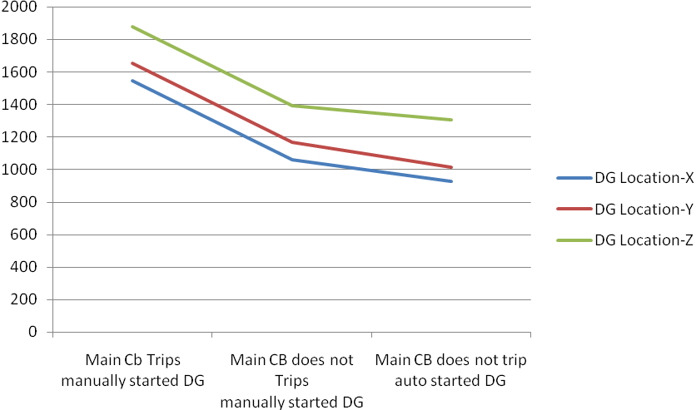
Fig. 4.25: Comparison of SAIDI for local distribution system
4.8.3. Comparison of CAIDI
The similar comparison has been made for CAIDI and presented in Table 4.61 and graphically in Fig. 4.26.
Table 4.61: Comparison of CAIDI for local distribution system
Location of DG at | Main CB trips  Manually started DG | Main CB does not trip
Location of DG at | Main CB trips  Manually started DG | Manually started DG | Auto started DG
X | 60 | 109 | 176
Y | 64 | 120 | 180
Z | 72 | 143 | 187

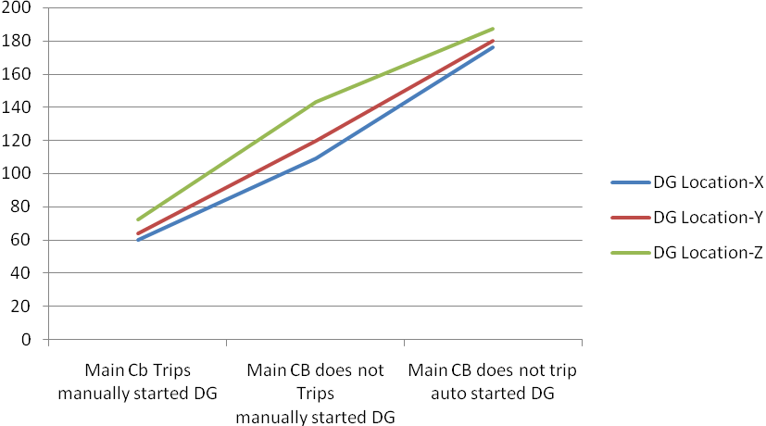
Fig. 4.26: Comparison of CAIDI for local distribution system
4.8.4. Comparison of ASAI
The values of ASAI are shown in Table 4.62. The impact of DG on ASAI is not very significant as evident from the results. It is also graphically shown in Fig. 4.27.
Table 4.62: Comparison of ASAI for local distribution system
Location of DG | Main CB trips  Manually started DG | Main CB does not trip
Location of DG | Main CB trips  Manually started DG | Manually started DG | Auto started DG
X | 0.997065 | 0.99790 | 0.998249
Y | 0.996861 | 0.99779 | 0.998044
Z | 0.99650 | 0.99744 | 0.997613
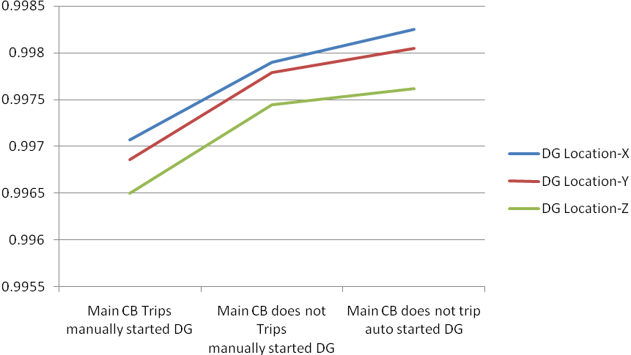
Fig. 4.27: Comparison of ASAI for local distribution system
4.8.5. Comparison of EENS
The value of EENS depends on ASAI and it is low when ASAI is high and vice-versa. EENS are shown in Table 4.63and graphical representation is given in Fig. 4.28.

Table 4.63: Comparison of EENS for local distribution system
Location of DG at | Main CB trips  Manually started DG | Main CB does not trip
Location of DG at | Main CB trips  Manually started DG | Manually started DG | Auto started DG
X | 121847.1 | 83875.24 | 73359.43
Y | 130220.5 | 92248.6 | 80214.44
Z | 147978.6 | 110006.73 | 103146.5
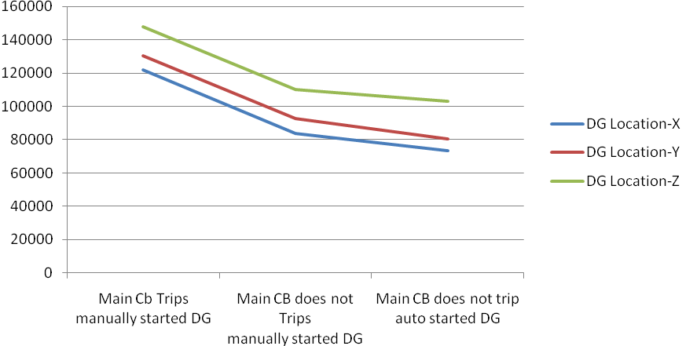
Fig. 4.28: Comparison of EENS for local distribution system
4.9. Availability Analysis of Load Point Connected DG
The Markovian reliability models for load point connected DG are proposed in sections 3.3 and 3.4 of Chapter 3. Three Markov models are proposed for three different modes of operation of DG while it is connected to any load point of a distribution system. For the model shown in Fig. 3.1, the steady state probability of being in a particular state are calculated using equations (3.17) to (3.20). The reliability data shown in Table 4.64 has been considered for the models to evaluate the steady state probabilities and from those calculations the availability of the DGs are estimated.
Table 4.64: Reliability data for Markov Models [53, 54]
SL No | Items/Components/Systems | Failure rate (f/hr) | Repair rate (r/hr)
1 | Normal power source | λ_{i}/λ_{NP} = 0.0001 | µ_{i}/µ_{NP} = 0.1766
2 | DG | λ_{DG} = 0.002 | µ_{DG} = 0.013
3 | PV unit | λ = 0.0045 | µ = 0.0763
The impact of failure and repair rates of DG units on the steady state probability is examined considering the data given in Table 4.64 as the base values. A multiplying factor k is considered to incorporate different failure and repair rates in the models and steady state probabilities are calculated and presented in Table 4.65 and 4.66.
Table 4.65: Effects of λ_{i} and μ_{i} on steady state probabilities
Steady state probabilities | λ_{i} = k * 0.0001 f/hr |  |  |  | μ_{i} = k* 0.1766 r/hr
Steady state probabilities | k= 0.5 | k= 1.0 | k= 1.5 | k= 2.0 | k= 0.5 | k= 1.0 | k= 1.5 | k= 2.0
P₁ | 0.8664 | 0.8662 | 0.8659 | 0.8657 | 0.8657 | 0.8662 | 0.8663 | 0.8664
P₂ | 0.0002 | 0.0005 | 0.0007 | 0.0010 | 0.0010 | 0.0005 | 0.0003 | 0.0002
P₃ | 0.1333 | 0.1333 | 0.1333 | 0.1332 | 0.1332 | 0.1333 | 0.1333 | 0.1333
P₄ | 0.0000 | 0.0000 | 0.0001 | 0.0002 | 0.0002 | 0.0000 | 0.0001 | 0.0000
Table 4.66: Effects of λ_{DG} and μ_{DG} on steady state probabilities
Steady state probabilities | λ_{DG} = k * 0.002 f/hr |  |  |  | μ_{DG} = k* 0.013 r/hr
Steady state probabilities | k= 0.5 | k= 1.0 | k= 1.5 | k= 2.0 | k= 0.5 | k= 1.0 | k= 1.5 | k= 2.0
P₁ | 0.9280 | 0.8662 | 0.8120 | 0.7643 | 0.7643 | 0.8662 | 0.9065 | 0.9280
P₂ | 0.0005 | 0.0005 | 0.0005 | 0.0004 | 0.0004 | 0.0005 | 0.0005 | 0.0005
P₃ | 0.0714 | 0.1333 | 0.1874 | 0.2352 | 0.2352 | 0.1333 | 0.0930 | 0.0714
P₄ | 0.0000 | 0.0000 | 0.0001 | 0.0001 | 0.0001 | 0.0000 | 0.0001 | 0.0000
It has been observed from Table 4.65 that the changed failure and repair rates of normal supply source do not affect much the steady state probability values P₁, P₂, P₃ and P₄. But the changed failure and repair rates of DG influence the steady state probabilities as it is evident from Table 4.66. If the failure rate is reduced by 50% then P₁ has been increased almost 7% whereas P₃ is decreased by 46%. As discussed in chapter 3, the value P₁ is the probability that both DG and normal power supply source are giving power to the load points and P₃ indicates the probability that the DG is only failed and the load point is not disconnected from the substation.
The DG may also be operated in standby mode as explained in chapter 3. In this case the load point connected DG will operate if normal power is not available. As discussed in chapter 3, referring to Fig. 3.2, when the main power source fails, the system state transition occurs from state 1 to either state 2 or 4. It will be in state 2 if the DG starts successfully or in state 4 if the DG fails to start when an attempt is made to do so. The four-state Markov model presented in Fig. 3.2 is applied to evaluate the steady state probabilities and to study the effect of the probability of standby DG to start when needed (c). The effect of c on the steady state probability values P₁, P₂, P₃ and P₄ has been evaluated by considering values 0.5, 0.6, 0.7, 0.8, 0.9 and 1 and presented in Table 4.67.
Table 4.67: Effect of c values on steady state probabilities
Steady state probabilities | c = 0.5 | c = 0.6 | c = 0.7 | c = 0.8 | c = 0.9 | c = 1.0
P₁ | 0.9659 | 0.9615 | 0.9572 | 0.9529 | 0.9487 | 0.9445
P₂ | 0.0263 | 0.0308 | 0.0352 | 0.0395 | 0.0439 | 0.0481
P₃ | 0.0072 | 0.0072 | 0.0071 | 0.0070 | 0.0070 | 0.0069
P₄ | 0.0005 | 0.0005 | 0.0005 | 0.0005 | 0.0005 | 0.0005
As the value of c increasing, the P₁ value is decreasing gradually, i.e., if the DG is more probable to start successfully the less is the probability being in state 1 whereas the probability being in state 2 increases. Since the DG is in failed state in state 3 and 4, there is no impact of c values on P₃ and P₄.
The Markov model presented in section 3.4 of chapter 3 has also been considered for study. For calculation purpose, it is assumed that there are only N = 4 units in the system. The failure and repair rate λ and μ are taken from Table 4.64. Using the method described in chapter 3, the steady state probabilities P₁, P₂, P₃, P₄, and P₅ are calculated. A constant k is introduced in the calculation to examine the effect of increased and decreased failure and repair rates of units on steady state probabilities. The results are presented in Table 4.68.
Table 4.68: Effects of λ and μ on steady state probabilities
Steady state probabilities | λ = k * 0.0045 f/hr |  |  |  | μ_{DG} = k* 0.0763 r/hr
Steady state probabilities | k= 0.5 | k= 1.0 | k= 1.5 | k= 2.0 | k= 0.5 | k= 1.0 | k= 1.5 | k= 2.0
P₁ | 0.8903 | 0.7952 | 0.7124 | 0.6402 | 0.6402 | 0.7952 | 0.8570 | 0.8903
P₂ | 0.1050 | 0.1876 | 0.2521 | 0.3021 | 0.3021 | 0.1876 | 0.1348 | 0.1050
P₃ | 0.0046 | 0.0166 | 0.0335 | 0.0534 | 0.0534 | 0.0166 | 0.0079 | 0.0046
P₄ | 0.0001 | 0.0007 | 0.0020 | 0.0042 | 0.0042 | 0.0007 | 0.0002 | 0.0001
P₅ | 0.0000 | 0.0000 | 0.0000 | 0.0001 | 0.0001 | 0.0000 | 0.0000 | 0.0000
The value P₁ is the probability that all 4 identical units are in operation. It is seen from the Table 4.68 that as the failure rate increases the P₁ value gradually decreases whereas it is increases when repair rate increases. When the failure rate is reduced by 50% or the repair rate increased by 100% from the base value the steady state probabilities are identical. From this result, it may be concluded that availability of the units can be increased by increasing the repair rate since the failure of units is random in nature.
In summary, this chapter presents results that obtained by employing the proposed models in two test systems. Effort has been made to evaluate more realistic load point and system reliability indices incorporating various influential parameters present in the system. The impact of DG on these indices is also estimated. When DG power is injected to the system, to evaluate reliability, it is also important to know the availability of the DG. Three Markov models are proposed in this research work and examine the effects of failure and repair rates on the availability of the DG.
The conclusions drawn from this analysis along with the future scope of the research work are presented in the next chapter.

Chapter 5
Conclusion and Future Scope
5.1. Conclusion
This chapter describes the important conclusions based on literature review and on the results of the various analysis performed in the present work. The conclusions are presented in two classes as shown below:
- General conclusion based on literature review
- Specific conclusions based on the reliability evaluation of distribution system incorporating different types of isolation processes of faulty sections and integration of distributed generation (DG).
5.1.1. General conclusion
The conclusions based on literature review are listed below:
- Application of reliability concepts to distribution systems differs from generation and transmission system, because it is more customer load point oriented instead of being system oriented, and the local distribution system is considered rather than the whole systems including generation and transmission.
- Almost more than 80% of all customer interruptions occur due to failure in the distribution system.
- The acceptable levels of service continuity of distribution system are determined by comparing interruption frequency and duration indices with some pre-determined targets.
- In practice, very fewer utilities perform distribution system expansion studies using probabilities models rather they rely on some deterministic criterion. But there are ample opportunities for distribution utilities to optimally invest in distribution system expansion activities to meet the future load growth by using the probabilistic methods.
- Distributed Generators (DG) are small scale power sources, either conventional or non-conventional, usually installed on the customer side and provide backup power during any interruption due to failures of distribution system. DG not only used as backup sources but also used to improve the performance of the system.
- The penetration of DG converts passive distribution network into an active network. It results in different power quality issues like flicker, transient voltage variations, harmonics etc in distribution system. Reliability analysis of distribution system is not an easy task considering power loss, reactive power support, voltage profile, DG location, cost benefit analysis etc.
- The islanding operation increases the reliability of the distribution system. The induction generator maintains active and reactive power under short time islanding but synchronous generator injects reactive power to the external grid. By using synchronous generator with power frequency control and automatic voltage regulator, the frequency deviation can be maintained within the limit. It can supply the island network in a safe mode.
- When DG is integrated to a distribution system, the capacity and location of DG influence the reliability of the distribution system.
- The type and location of switches play an important role on the reliability of the distribution system as well as of the individual loads. If the manual switches are replaced by automated switches then there is an improvement in reliability.
- The switch placement problem may be formulated to minimize the number of new switches to be used, to maximize the priority load in the island, to maximize the amount of total load in the island and to minimize the number of switch operations.
- Reliability improvement depends on the location of DG. But if it is located at distribution sub-station then there is no any improvement of reliability.
- Markov modeling technique is one of the efficient tools to model the DG for reliability evaluation of distribution system. These models are useful for finding availability of DG.
- The effectiveness of various methods developed for reliability evaluation of distribution system are usually tested and compared using some standard test systems. Two widely accepted test systems are IEEE – Reliability Test Systems and and Roy Billinton Test System (RBTS).
- RBTS is most widely used test system for academic purpose.
5.1.2. Specific conclusion
In this research work the basic load point reliability indices (λ, r, U) used for reliability evaluation of distribution system are modified to incorporate the effect of failure characteristics of most of the distribution components. When a failure occurs in distribution system, the isolation process of faulty sections is addressed properly to give more realistic values of reliability indices. As the present study focused on the impact of DG on distribution reliability, the availability of DG during operations must be ensured. In this aspect, Markov modeling technique is applied to develop reliability models of DG. The following parameters and operational strategies are addressed while DG is connecting to the system:
- Role of main CB: either trip or does not trip during any failure in distribution system
- Role of restoration time of transformers: either repairing time or replacement time
- Role of DG starting: either manual or automatic
The models are developed and considering various modes of operation load point reliability indices and system indices are evaluated for the distribution network connected to load Bus 2 of RBTS. The indices are calculated either connecting DG to the system or without DG. Two sets of load points are specifically selected from the system, one is at far ends and the other near the bulk supply point, on the basis of review of literature. The similar analysis has also been carried out for a local distribution system of Guwahati, Assam.
The following specific conclusions are drawn from the analysis of results:
- In the distribution system of Bus 2 of RBTS, the isolation process of faulty section and DG starting process play an important role in improvement of reliability of the system.
- Major advantage of injecting DG to the distribution system is to minimize transmission and distribution losses. This is due to proximity of load centre from the generating source.
- Distribution reliability is improved if DG is integrated to the system. It can be further improved by injecting more number of units at different locations with different capacities. Thus the size and location of DG influence the reliability.
- The load point failure rates are same irrespective of DG placement when main CB trips, DG started manually and both replacement and repairing time of transformer are considered. However, the failure rates are different when DG is automatically started.
- The values of SAIFI are not affected by the location of DG, except under the condition that main CB does not trip and auto started DG.
- The system reliability indices SAIFI, SAIDI and EENS increase with the increase of feeder failure rates under the same condition but CAIDI decreases.
- Connection of DG improves the reliability of the distribution system. The improvement of reliability is more when DG is connected at the far end of the feeder.
- The value of CAIDI depends on sum of customer interruption duration and total no of customer interruption. The value of CAIDI is the highest since total no of customer interruption is the lowest for main CB does not trip and auto started DG connected at the far end of the feeder.
- Reliability improvement depends on that location of DG from which it can meet the maximum load demands during outage.
- The system with condition ‘main CB does not trip and manually started DG’ is more reliable than the condition ‘main CB trips and manually started DG’. However, the system with condition ‘main CB does not trip and auto started DG’ is more reliable than ‘main CB does not trip and manually started DG’.
- Reliability is becoming less when repairing time of transformer is considered instead of replacement time.
- Three Markov models are developed for load point connected DG. Availability of a DG connecting to a particular load point has been evaluated using these models.
- The impact of failure and repair rate of each system component on these probabilities has been studied.
- When a DG is connecting to a load point the changed failure and repair rates of normal supply source do not affect much the steady state probability values. But the changed failure and repair rates of DG influence these probabilities.
- When a DG is operating in standby mode, the effect of the starting probability of DG on the steady state probabilities are also examined.
- It has been observed from the analysis of these three Markov models is that the 50% decrease in base failure rate or 100% increase in repair rate gives identical steady state probability values. The failure of components are random in nature and therefore to increase the availability of the system, the failure rate cannot be reduced but the repair rate can be increased by facilitating skilled repair crews and provisioning of sufficient spare parts.
5.2. Future Scope
The present study is performed considering the different types of isolation processes of faulty section. The connection of DG with the distribution system helps to improve the reliability of the system. But the improvement of the system reliability depends on the isolation process of the faulty section as well as the starting process of the DG. In this study, the reliability improvement is analyzed under three types of isolation process with manually started DG and auto started DG. The study is performed for the conditions – main CB trips & manually started DG, main CB does not trip & manually started DG and main CB does not trip & auto started DG. The existing load point failure rate and load point annual outage time have been modified and implemented. The study has been performed by connecting four separate DGs to four separate feeders. It also assumed that the DG connected to a particular feeder is having the capacity to meet the load demand of that feeder.
The study has been performed considering the outage due to the feeder failure and failure of other equipments. But outage due to loss of supply, lightning, tree contacts, birds, animals, adverse environment etc may be considered for reliability assessment. The study may also be conducted for optimal location of DG considering loss, centre of the load etc.
DG sources, either conventional or renewable can be modeled as voltage sources and uninterrupted power sources.
DG reliability models are formulated individually and employed to certain study systems. An effort may be given to develop a generalized algorithm to estimate the reliability of distribution systems including conventional and renewable DG.
The customers need reliable and continuous electrical energy at reasonable cost. Economic constraints have an important role in taking decision to optimize investment for disconnects. The cost-benefit analysis helps to know the worth of using the isolating devices. The reliability worth may be assessed from unreliability cost i.e. from interruption cost.

References

- Willis, H. Lee, Scott, Walter G.“Distributed Power Generation”, Marcel Dekker, Inc., New York, 2000.
- Billinton, R., Li, W., “Reliability Assessment of Electric Power Systems Using Monte Carlo Methods”, © 1994 Plenum Press, New York.
- Jenkins, N., Allan, R., Crossley, P., Kirschen, D., Strbac, G., “Embedded Generation”, Published by the Institution of Electrical Engineers, London
- Billinton, R., Allan, R. N., “Reliability Evaluation of Power System”, Longman, London (England), Plenum Publishers, New York, (1984).
- Billinton, R., Allan, R. N., “Reliability Assessment of Large Electric Power System”, Kluwer Academic Publishers, Boston/ Dordrecht/ Lancaster.
- Barker, P. P., Mello, R. W.,”Determining the impact of distributed generation on power system: Part I – Radial distribution system”, IEEE Summer Power Meeting, Vol. 3, Pp. 1645-1656, 2000.
- Ackermann, T., et al., “Distributed Generation – a definition”, Electric Power System Research, 57(2001) pp. 195-204.
- CIGRE STUDY COMMITTEE No. 37: “Impact of increasing contributions of dispersed generation on the power system”, Final Report of Working Group 37-23, September 1998
- CIRED preliminary report of CIRED Working Group 04: “Dispersed Generation”, Issued at the CIRED Conference, June 1999.
- Report of International Energy Agency on “Distributed Generation in Liberalized Electricity Markets”: OECD/IEA 2002
- Brown, Richard E., “Electric Power Distribution Reliability”, Marcel Dekker, Inc. New York, 2002
12. Billinton, R., Allan, R. N.: “Reliability Evaluation of Engineering Systems: Concepts and Techniques”, Plenum Press, New York, 1992

- Billinton, R., Allan, R. N.: “Reliability Evaluation of power Systems”, Plenum Press, New York, 1996
- Gertmar, L.,“Power Electronics and Wind Energy”, ABB, Corporate Research, Västerås, Sweden
- Brown, R. E., Freeman, L., A., L., “Analysing the reliability impact of distributed generation.” Power Engg. Soc. Summer meeting, Vol. 2, 2001, pp. 75-81, Jan/Feb 1998.
- Dahiya, S., Jain, D. K. and Kumar, A., “Power Quality Issue of Embedded Generation”, Power India Conference, 2006 IEEE
- Aslanzadeh, S., Jamali, S., “Study of Distributed Generation Type and Islanding Impact on the operation of Radial Distribution System”, UPEC 2007, pp. 1216 – 1221
- Falaghi, H., Haghifan, M. R., “Distributed Generation Impacts on Electric Distribution System Reliability: Sensitivity Analysis”, International Conference on Computer as a Tool, Vol. 2, 2005, pp. 1465-1468
- Barker, P. P., de Mello, R. W., “Determining the impact of distributed generation on power system: part-I, – Radial Distribution System”, IEEE Summer Power Meeting, Vol. – 3, Pp. 1645-1656, 2000
- Brown, R. E., Freeman, L., A., L., “Analyzing the reliability impact of distributed generation”, Power Engg. Soc. Summer meeting Vol. 2, 2001, pp. 75-81, Jan/Feb 1998.
- Banerjee, B., Islam, S. M., “Reliability Based Optimum Location of Distributed Generation”, Electrical Power and Energy System, 33(2011), 1470 - 1478
- Wang, C., Nehir, M. H.,“Analytical Approaches for Optimal Placement of Distributed Generation Sources in Power Systems”, IEEE Transaction on Power System, Vol. 19, No. 4, November 2004
- Keane, A., O’ Malley, M.,”Optimal Allocation of Embedded Generation on Distribution Networks”, IEEE Transaction on Power System, Vol. 20, No. 3, August 2005
- Borges, Carmen L. T., Falcao, Djalma M., “Optimal distributed generation allocation for reliability, losses, and voltage improvement”, Electrical Power and Energy Systems 28 (2006) 413–420
- Al – Muhaini, M., Heydt, Gerald T., “ Evaluating Future Power Distribution System Reliability Including Distributed generation ” IEEE Transaction On Power Delivery, Vol. 28, No. 4, October 2013
- Goldin, R. E., Fahey, T. S., Hanson, A., “Distribution reliability using reclosers, sectionalisers”, ABB, Tech. Rep. 2004
- Heinrich, C., “Calculation of network improvement of feeder upgrade by reclosers, sectionalisers and other distribution equipment”, 8th International Conference APSCOM, pp 1-5, Hong Kong, China, 8-11 Nov., 2009
28. Das, B & Deka, B. C., “Impact of Distributed Generation on Reliability of
Distribution System”, ISOR Journal of Electrical and Electronics Engineering, Vol. 8, Issue 1, pp. 42-50
- Das, B & Deka, B C., “Impact of Location of Distributed Generation on Reliability of Distribution System”, International Journal of Engineering Research And Development, Vol. 9, Issue 5, pp. 01-08.
- Das, B & Deka, B. C., “Impact of Isolation Process of Faulty Section on Reliability of Distribution System with Distributed Generation”, International Journal of Power and Energy Conversion, Vol. 9, No 1, pp.47-57.
- Heidari, A.,Agelidis, V.G., Naderi, M. S., “Effects of Switch Type and Location on the Reliability of Power Distribution Systems Considering Distributed Generation”, 978-1-4673-45699/2013 IEEE.
- Billiton, R., Jonnavithula,, “Optimal Switching Device Placement in Radial Distribution System”, IEEE Transactions on Power Delivery, Vol. 11, pp. 1646-1651, July 1996
- Barker, P. P., de Mello, R. W.,” Determining the impact of distributed generation on power system: part-I, – Radial Distribution System”, IEEE Summer Power Meeting, Vol. – 3, Pp. 1645-1656, 2000
- Powell, L. J., “An Industrial View of Utility Cogeneration Protection Requirements” IEEE Ind. Applicat. , Pt 1, Vol. 24, No. 1, pp. 75-81, Jan./Feb 1998
- Haughton, D., Heydt, G., “Smart distribution system design: Automatic reconfiguration for improved reliability.” IEEE Power and Energy Society General Meeting, 2010, pp. 1-8.
- Zayandehroodi, H., Mohamed, A., Shareef, H., and Farhoodnea, M., “A novel neural network and back tracking based protection coordination scheme for distribution system with distributed generation”, International Journal of Electrical Power & Energy Systems, Vol. 43, no. 1, pp. 868-879, 2012
- Mao, Y., Miu, Karen N., “Switch Placement to Improve System Reliability for Radial Distribution Systems with Distributed Generation”, IEEE Transactions on Power Systems, Vol. 18. No. 4, November 2003.
- Abiri-Jahromi, A., Fotuhi- Firuzabad, M., Parvania, M. and Mostec, M., “Optimised Sectionalizing Switch placement Strategy in distribution system”, IEEE Transaction on Power Delivery, Vol. 27, pp. 362-370, 2012.
- Moradi, A., Fotuhi-Firuzabad, M., ‘Optimal switch placement in distribution system using trinary particle swarm optimization algorithm”, IEEE Transaction on Power Delivery, Vol. 23, pp. 271-279, 2008.
- Miu, K. N., Chiang, H. D., Yuan, B. Bento and Daring, G., “Fast service restoration for large scale distribution system with priority customers and constraints”, IEEE Transaction of Power System, Vol. 13, pp. 789-795, August, 1998.
- Golestani, S., Talayon, M., “Optimal switch placement in Distribution Power System Using Linear Fragmented Particle Swarm Optmisation Algorithm Preprocessed by G. A.”, 8th International Conference on the European Energy Market, 25-27 May, 2011, Zagreb, Croatia.
- Waseem, I., Pipattanasomporn, M., Rahman, S., “Reliability Benefits of Distributed Generation as a Backup Source”, Power & Energy Society General Meeting 2009, PES, ’09, IEEE.
- Neto, A. C., da Silva, M. G., Rodrigues, A. B. “Impact of Distributed Generation on Reliability Evaluation of Radial Distribution Systems Under Network Constraints” , 9th International Conference on Probabilistic Method Applied to Power Systems KTH, Stockholm, Sweden, June 11 – 15, 2006.
- Zhu, D., Broadwater, Robert P., Tam, Kwa-Sur, Seguin R., Asgeirsson, H., “Impact of DG Placement on Reliability and Efficiency With Time – Varying Loads”, IEEE Transactions on Power Systems, VOL. 21, No. 1, February 2006.
- IEEE Committee Report, “IEEE Reliability Test System”, IEEE Transaction on Power Apparatus and Systems, Vol. PAS – 98, 1979, pp 2047 – 2054.
- Allan, R., et al,, “The Reliability Test System- extensions to and evaluating of the generating system”, IEEE Transactions on Power Systems, Vol. PWRS- 1, No. 4, Nov. 1986, pp. 1-7
- IEEE Committee Report, IEEE Reliability Test System - 1996, IEEE Transactions on Power Systems, Vol. 14, No. 3, August 1999, pp 1010 – 1020.
- Billiton, R., et al., “A Reliability Test System for educational purposes – basic data”, IEEE Transactions on Power Systems, Vol. 4, No. 3, 1989, pp. 1102-1109
- Billiton, R., et al., “A Reliability Test System for educational purposes – basic results”, IEEE Transactions on Power Systems, Vol. 5, No. 1, Feb. 1990, pp. 319-325
- Choudhury, N., Billiton, R., “A Reliability Test System for educational purposes – Spinning reserve studies in isolated and interconnected systems”, IEEE Transactions on Power Systems, Vol. 6, No. 4, Nov. 1991, pp. 1578 - 1583
- Allan, R. N., Billiton, R., Sjarief, I., Goel, L., So, K. S., “A Reliability Test System For Educational Purposes- Basic Distribution System Data And Results”, IEEE transaction on Power Systems, Vol. 6, No. 2, May 1991
- Das, B., “Effect of Faulty Section Isolation Process on reliability of DG connected Distribution System”, International Journal of Electrical and Electronics Engineering, Vol. 13, Issue 1, Ver. II, January 2018.
- Singh, C., Patton, A. D., “Reliability Evaluation of Emergency and Standby Power Systems”, IEEE Trans. on Industry Applications, Vol. IA 21, No. 2, March/April 1985.
- Alferidi A, Karki R., “Development of Probabilistic Reliability Models of Photovoltaic System Topologies for System Adequacy Evaluation”, Applied Science, 2017, 7,176.

Appendix

Table A1: Feeder Data (RBTS) [51]
Type | Length (Km) | Feeder Sections/Lateral Numbers
1 | 0.60 | 2, 6, 10, 14, 17, 21, 25, 28, 30, 34
2 | 0.75 | 1, 4, 7, 9, 12, 16, 19, 22, 24, 27, 29, 32, 35
3 | 0.80 | 3, 5, 8, 11, 13, 15, 18, 20, 23, 26, 31, 33, 36

Table A2: Loading Data (RBTS) [51]
Load Points | Customer Type | Average load per load point in KW | No of customer per load point
1, 2, 3, 10, 11 | Residential | 535 | 210
12, 17, 18, 19 | Residential | 450 | 200
8 | Industrial | 1000 | 1
9 | Industrial | 1150 | 1
4, 5, 13, 14, 20, 21 | Industrial | 566 | 1
6, 7, 15, 16, 22 | G & I | 454 | 10
Total: |  | 12291 | 1908

Table A3: Reliability Data (RBTS) [51]
Components | Failure rate per year | Repair Time (Hr) | Switching Time (Hr)
Transformer
33/11 KV | 0.015 | ---- | 1
LT | 0.015 | 200 | 1
CB
33 KV | 0.002 | 4 | 1
11 KV | 0.006 | 4 | 1
Busbars
33 KV | 0.001 | 2 | 1
11 KV | 0.001 | 2 | 1
Section/Lateral
11 KV | 0.065, 0.13, 0.195 | 5 | 1

Table A4: Feeder Data (Local Distribution System) [28, 29, 30, 52]
Section | Length | Section | Length | Section | Length
1 | 180m | 9 | 300m | 17 | 400m
2 | 150m | 10 | 50m | 18 | 30m
3 | 50m | 11 | 30m | 19 | 50m
4 | 40m | 12 | 50m | 20 | 30m
5 | 50m | 13 | 40m | 21 | 1000m
6 | 300m | 14 | 300m | 22 | 25m
7 | 40m | 15 | 150m | 23 | 500m
8 | 350m | 16 | 50m | ----------

Table A5: Reliability Data (Local Distribution System) [28, 29, 30, 52]
Laterals | Failure rate of lateral per year
a | 4
b | 2
c | 3
d | 4
e | 3
f | 2
g | 1
h | 4
i | 3
j | 4
k | 3
l | 2
m | 3
n | 4
o | 3
p | 2
q | 3
r | 4
s | 3
t | 1
u | 4
v | 3

Table A6: Loading Data (Local Distribution system) [28, 29, 30, 52]

Load Points | Load in KW | No. of Customers
A | 190 | 95
B | 238 | 110
C | 238 | 110
D | 238 | 110
E | 238 | 110
F | 60 | 30
G | 238 | 110
H | 24 | 01
I | 238 | 110
J | 238 | 110
K | 476 | 220
L | 300 | 135
M | 238 | 110
N | 238 | 110
O | 95 | 45
P | 238 | 110
Q | 60 | 30
R | 95 | 45
S | 238 | 110
T | 455 | 190
U | 95 | 45
V | 238 | 110

List of Publications

- Das, Basudev & Deka, Bimal C.: “Availability Analysis of Distributed Generations Connected to Distribution Systems”, Communicated to Int. J. of “Electric Power Systems Research”, (Elsevier Publications).
- Das, Basudev & Deka, Bimal C.: “Impact of Isolation Process of Faulty Sections on Reliability of Distribution System Connected with Distributed Generation”, International Journal of Power and Energy Conversion, Vol. 9, No 1, pp.47-57, 2018 (Inderscience Publishers).
- Das, Basudev & Deka, Bimal C.: “Impact of Distributed Generation on Reliability of Distribution System”, ISOR Journal of Electrical and Electronics Engineering, Vol. 8, Issue 1, pp. 42-50, Nov.-Dec. 2013
- Das, Basudev & Deka, Bimal C.: “Impact of Location of Distributed Generation on Reliability of Distribution System”, International Journal of Engineering Research And Development, Vol. 9, Issue 5, pp. 01-08, Dec. 2103.
- Das, Basudev & Deka, Bimal C.: “Embedded Generation and Its Effect on Distribution System Reliability” All India Seminar on Power System Management, 14-15 October 2011, Guwahati, Organized by The Institution of Engineers (India), Assam State Centre.
- Deka, Bimal C & Das, Basudev : Embedded Generation: A New Trend in Power Generation from Distributed Energy Resources”, National Conference on Energy Resources of North East India, 11-12 November, 2009, Guwahati, Organized by Oil India Limited.

