Project Report

on

**Automatic Solar Based Water Saving and Energy Conservation System in a Multi-Storey Building**

Submitted in partial fulfilment of the requirements for the award of

the degree of Bachelor of Technology in Electrical Engineering of

Assam Science and Technology University

Session : 2023



**By**

Priyanka Thakuria (190610003067)

Shreya Bhattacharjee (190610003080)

Vishal Nag (190610003090)

Hridishmita Medhi (200650003002)

Under the guidance of

**Dr. Bimal Chandra Deka**

Professor

Department of Electrical Engineering

Assam Engineering College, Jalukbari

**Department of Electrical Engineering**

**Assam Engineering College, Jalukbari, Guwahati - 781013**

**ABSTRACT**

In this project, we have built an automated water management system with the purpose of managing the water present in the overhead tanks of a multi storey building i.e. the system will make sure that water is always present in the water tanks so that there is no inconvenience caused to the consumers of water in the building. The system is built to ensure that there is no waste or spillage of water from the water tanks. Thus it saves both water and electricity at the same time.

Also in this project, we have incorporated a system for the protection of the water pump. This is achieved with the help of various sensors that are used in the system. The first is to protect the water pump from overheating that may be caused due to various known and unknown phenomena. Whenever the sensor detects any hike in the temperature of the motor and it exceeds a certain set value, the system will automatically cut off all the circuits connected to the water pump. The other protection scheme is the overload protection scheme. This scheme will come into play when the current flowing through the water pump increases than the normal rated value due to various factors. Also 3-phase auto phase sequence correction circuit has been designed to prevent malfunction of the motor in case of reversal of supply phase sequence.

The microcontroller used in the automated system is an Arduino Uno R3. This project has been incorporated with two arduinos to provide the water management scheme and the system protection scheme. The main sensors used in the project are the temperature sensor and the current sensor which detects if there is any unwanted rise of temperature or current in the water pump. The whole model has been successfully tested in a simulation and after the exceptional results of the simulation model, it has been approved to go further for the hardware part.

**CERTIFICATE FROM THE SUPERVISOR**

This is to clarify that the project entitled “Automatic Solar Based Water Saving and Energy Conservation System in a Multi-Storey Building” has been carried out and presented by:

Priyanka Thakuria (190610003067 )

Shreya Bhattacharjee (190610003080)

Vishal Nag (190610003090)

Hridishmita Medhi (200650003002)

students of 8th semester (Electrical Engineering), Assam Engineering College, under my supervision and guidance in a manner satisfactory to warrant its acceptance to a prerequisite for the award of the degree of Bachelor of Technology in Electrical Engineering of Assam Science and technology University.

Further, the report has not been submitted/reproduced in any form for the award of any other degree/diploma.

Date: Dr Bimal Chandra Deka

Professor

Place: Guwahati Department of Electrical Engineering

Assam Engineering College

Jalukbari, Guwahati-13

**CERTIFICATE FROM THE HEAD OF THE DEPARTMENT**

This is to clarify that the project entitled “Automatic Solar Based Water Saving and Energy Conservation System in a Multi-Storey Building” has been carried out and submitted by:

Priyanka Thakuria (190610003067 )

Shreya Bhattacharjee (190610003080)

Vishal Nag (190610003090)

Hridishmita Medhi (200650003002)

In partial fulfilment of the requirements for the award of the degree of Bachelor of Technology in Electrical Engineering of Assam Science and technology University.

Date: Dr Aroop Bordoloi

Head of the Department

Place: Guwahati Department of Electrical Engineering

Assam Engineering College

Jalukbari, Guwahati-13

**ACKNOWLEDGEMENT**

We take this opportunity to express our sincere gratitude and heartiest thanks to our guide Dr. Bimal Chandra Deka, Department of Electrical Engineering, Assam Engineering College, for his valuable guidance, cooperation and helpful suggestions throughout the course of our project. His keen interest in this topic has been a constant source of encouragement for all of us.

We would also like to express our heartiest thanks to our respected Head of the Department Dr. Aroop Bordoloi for valuable advice and help during the entire course of our project.

Priyanka Thakuria (190610003067)

Shreya Bhattacharjee (190610003080)

Vishal Nag (190610003090)

Hridishmita Medhi (200650003002)

**CONTENTS I**

TOPIC PAGE NO

Chapter 1: Introduction 1

1.1 Water supply in Multi-Storey

Buildings 1

1.2 Automated Water System 2

1.3 Purpose 3

Chapter 2: Literature Review 4

Chapter 3: Methodology and Materials 6

3.1 Basic Principle 6

3.2 Interconnected Overhead Tanks 9

3.3 Components Required 10

3.3.1 Arduino UNO 11

3.3.2 Water level sensor 16

3.3.3 Temperature sensor 17

3.3.4 Current sensor 18

3.3.5 LCD 20

3.3.6 Relay Module 22

3.3.7 Solar Panel 24

3.3.8 Charging Unit 24

3.3.9 Motor 25

Chapter 4: Simulation and system modeling 26

4.1 Simulation 26

4.1.1 Water level monitoring and management

Scheme 26

4.1.2 Overheat Protection Scheme 27

4.1.3 Overload Protection Scheme 28

4.1.4 Simulation of complete circuit 29

4.1.5 Simulation of 3-phase automatic sequence

Corrector 30

Chapter 5: Hardware Model 33

Chapter 6: System Analysis 35

6.1 Cost Analysis 35

Chapter 7: Results and Discussion 36

Chapter 8: Conclusion and Future works 38

8.1 Conclusion 38

8.2 Pros 39

8.3 Cons 39

8.4 Future Scope 40

BIBLIOGRAPHY 41

**CONTENTS II**

LIST OF FIGURES PAGE NO

Fig 3.1 Block diagram of the working mechanism 7

Fig 3.2 Interconnected overhead tanks 9

Fig 3.3 Arduino UNO R3 11

Fig 3.4 Pin diagram of Arduino UNO R3 12

Fig 3.5 Ss Contact type water level sensor 16

Fig 3.6 LM35 temperature sensor 17

Fig 3.7 ACS712 Sensor 18

Fig 3.8 LCD Module 20

Fig 3.9 LCD pin diagram 21

Fig 3.10 Relay Module 22

Fig 3.11 Relay pin diagram 23

Fig 3.12 Solar Panel 24

Fig 3.13 Submersible Pump 25

Fig 4.1 Simulation of the complete circuit 29

Fig 4.2 Simulation of Phase-Sequence Indicator 31

Fig 4.3 Auto-phase Sequence Corrector 32

LIST OF TABLES PAGE NO

Table 3.1 Pin description of Arduino UNO ` 13

Table 3.2 Technical specification of Arduino UNO 14

Table 6.1 Cost of equipment 35

Table 7.1 Threshold Data 36

**CHAPTER 1**

**Introduction**

* 1. **Water supply in Multi-Storey Buildings**

Water supply system consists of collection, conveyance, treatment and distribution of water. Water supply in a building depends on the size and height of the building. In tall buildings, water is pumped to elevated tanks and it is flown down to respective locations.

Availability of sufficient quantity of water from sources like municipal water, groundwater and surface water should be there. Normally, municipal water is first treated and then supplied. In a similar way, ground and surface water should also be properly treated as per the needs of the users. Water is first collected in a sump, which can be constructed below the ground floor level and pumped up to the elevated water tanks with the help of a motor. From these tanks, water can be distributed down with gravity pressure. Water storage tanks located on the terrace should be properly covered and protected from contamination. Plastic water tanks are preferred for storage purposes.

Water supply pressure from the mains is not sufficient to reach the upper floors on many occasions, so it is necessary to pump it to reach the upper floors. The water requirement in such buildings is very high for both drinking and general use. Thus there is a need to store water and supply it with gravity pressure. The storage of water is possible only on the terrace of the building.

**1.2 Automated water Management system**

The Automatic Water Management (AWM) system mainly concentrates on the water conservation process. This can be implemented in places where wastage of water exists. AWM helps the people at home to fill the overhead tank, water the plants and extinguish the fire during fire accidents automatically. This project involves the use of a microcontroller, water pump, display and an assembly language program.The water level indicator monitors the filling of overhead tanks and displays the water level in the display. The sensor has two main parts i) detection system ii) monitoring system.

The design of this project is to conserve the water resources in domestic usage. This system can reduce the wastage of water in different areas. Automatic water management system helps the people at home to fill the overhead tank. This problem is quietly related to poor water allocation, inefficient use, and lack of adequate and integrated water management. Therefore, efficient use and water monitoring are potential constraints for home or office water management systems. The water level indicator indicates three levels: low level, medium level and full tank. The system will automate the process by placing a single sensor unit in the tank that will periodically take measurements of the water level and will control the motor automatically. The problem like overflow of water in the tank of interest, empty tank condition, motor overheating due to continuous usage, motor overloading and malfunction of motor due to supply phase sequence change is avoided.

**1.3 Purpose**

The main purpose of our project is to automatically save water and at the same time save electrical energy in a Multi-Storey Building along with complete protection of the motor. This is done with the help of several sensors that are integrated in the system. The purpose is achieved by automatically turning on and off the water pump with respect to the amount of water that is present in the overhead water tank. The water level indicator sends a signal to the integrated system consisting of Arduino and accordingly the water pump acts. If the level of water in the overhead water pump is full, then the water pump will be turned off by the system. In the same way, if the water in the overhead tank is half or minimum, the water pump will be again turned off automatically. Also if the supply 3-phase sequence changes, it automatically corrects the sequence. The system always makes sure that the water is always available in the overhead water tank.

**CHAPTER 2**

**Literature Review**

Water scarcity is one of the major problems facing most cities in the world. Hence water supply and pumping systems in various fields must be economical. In order to achieve this, an automated system is designed taking many considerations in fulfilling the needs of the system. The system uses a microcontroller to automate the process of water pumping in an over-head tank storage system and has the ability to detect the level of water in a tank, switch on/off the pump accordingly and display the status on an LCD screen. This research has successfully provided an improvement on existing water level controllers by its use of calibrated circuit to indicate the water level and use of DC instead of AC power thereby eliminating risk of electrocution. Water scarcity is a serious issue in major cities. One has to keep on observing his tank water level to switch off the motor once it is switched on. And sometimes this also can happen that the motor coil burns because of the absence of water in the sump. It is completely automated with the help of a microcontroller. The system doesn’t need any attention from the user unless the sump is empty due to some unknown reason. The program was developed in an Arduino program developing environment and uploaded to the Microcontroller. Water level in the system is controlled automatically. The controller operates on battery power. Whenever the system encounters an empty level and the status of load shedding, it acts automatically with the use of low cost sensors and the simple circuitry this work aims at a low cost product. The aim is to use the readily available material to construct low cost sensors. Relays are controlled by the microcontroller through the high current driver IC and provided for controlling solenoid valves, which controls the flow of water to different parts of the field. Another relay is used to shut-off the main motor which is used to pump the water to the field. Performance of sensors in terms of energy consumption has also been analyzed.

**CHAPTER 3**

**Methodology and Materials**

**3.1. Basic principle:**

The working principle of this project is based on the automatic control of the running of the motor using the status of the water in the various interconnected tanks of a multi-storey building. The system also monitors the running condition of the motor. The motor gets turned off in case of occurrence of the common faults such as overheating or overload faults in order to prevent any kind of damage to the motor. The system parameters are determined using various sensors like the temperature sensor, over current sensor and contact type water level sensor which tells the microcontroller about the status of the motor whether overload or over current in case of fault and the tanks status respectively. Also a software simulation of the 3 phase automatic phase sequence corrector has been designed to avoid malfunction of the motor in case of supply phase reversal (i.e., ryb to rby or rby to ryb). This will prevent the motor from running in the opposite direction which is not permissible.

The block diagram for our model is as shown:

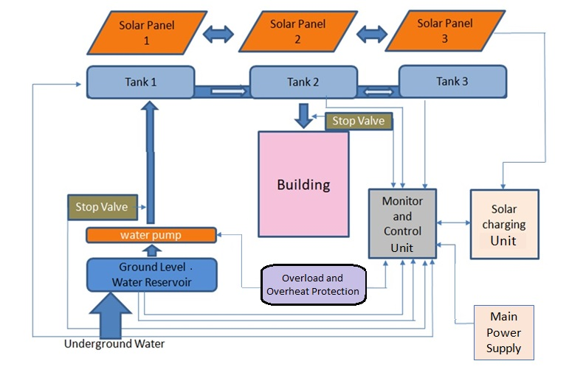

Fig 3.1: Block Diagram of the working mechanism

The water is initially pumped up and stored in the underground reservoir called the sump tank. The sump tank contains a water level sensor which indicates if the sump tank is empty. From the sump tank the water is then pumped up to the overhead tank using a submersible tank. A stop valve is connected near the motor to stop the motor under emergency conditions. The water in the overhead tank is distributed evenly among all the tanks. Thus the water level indicators are connected to only one tank. It contains three water level indicators - Low level, mid level and full level. When the water in the tank is below mid level or low level, then the motor automatically starts running. When the water reaches above full level then the motor automatically stops.

The submersible motor is the most important and expensive component of our project and hence its protection and maintenance is given utmost priority. The general faults that may affect the motor are overheat and overload conditions and hence we have used overheat and overload sensors which turns off the motor under undesirable conditions.

All the signals from the sensors and the motor are sent to the monitor and control unit which contains the microcontroller that analyses the signals and sends the required instruction to the various components. It also contains the display unit, i.e., the LCD which displays the real time status of the output from the various sensors.

Also a circuit is designed to automatically correct the phase sequence of the motor supply in case the supply phase sequence changes. A circuit is designed to automatically detect supply phase sequence change and give a 5V signal for the same. This 5V signal is used as input signal for another circuit that automatically corrects the phase supply and sends it to the motor.

The entire system is primarily powered from the main power supply. But in case of failure of the main power supply the solar powered batteries are used for auxiliary supply.

**3.2. Interconnected Overhead tanks system:**

The overhead tanks of our system are internally interconnected with each other such that they always maintain the same level of water. This is done so that monitoring is easier and the number of water level indicators can be reduced thus making our model more economical. The interconnection is done at the bottom of the tank in the following manner:

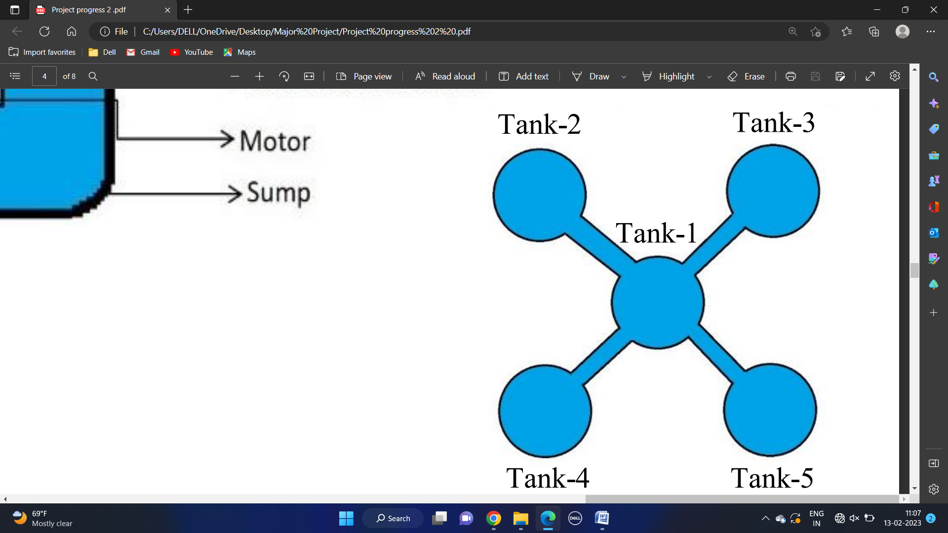

Fig 3.2: Interconnected overhead tanks

**3.3. Components required:**

The main components of the system are-

1. Arduino UNO
2. Water Level Sensor
3. Overheat Sensor
4. Overload Sensor
5. LCD unit
6. Relay Module
7. Solar Panel
8. Charging Unit
9. Motor

**3.3.1. Arduino UNO**

The Arduino UNO is an open-source microcontroller board based on the Microchip ATMega328P microcontroller and developed by Arduino.cc. 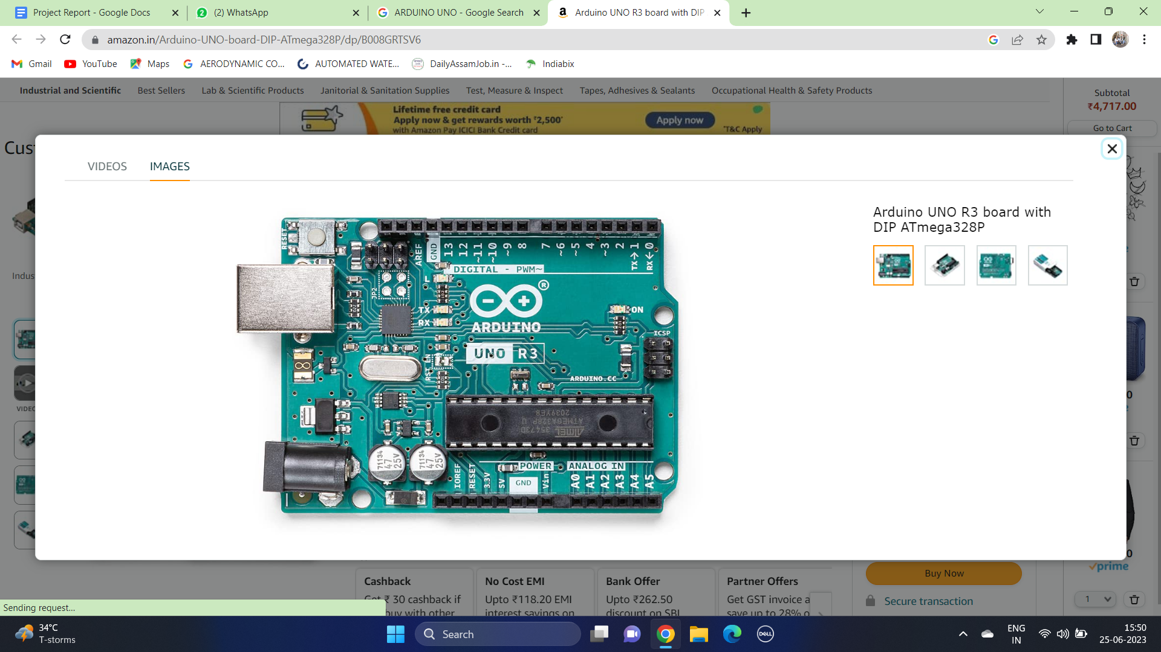

Fig 3.3: Arduino UNO R3

The board is equipped with sets of digital and analog input/output (I/O) pins that may be interfaced to various expansion boards (shields) and other circuits. The board has 14 digital I/0 pins (six capable of PWM output), 6 analog I/O pins, and is programmable with the Arduino IDE (Integrated Development Environment), via a type B USB cable.

It can be powered by the USB cable or by an external 9-volt battery, though it accepts voltage between 7 and 20 volts. The ATmega328 on the board comes pre-programmed with a boot loader that allows uploading new codes to it without the use of an external hardware programmer.

**Pin Description**

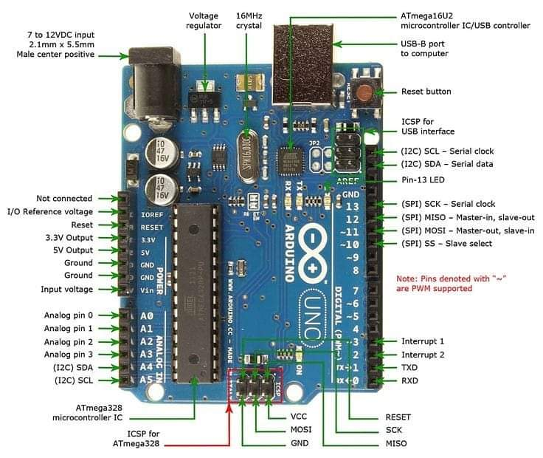

Fig 3.4: Pin Diagram of Arduino UNO R3

Table 3.1: Pin description of Arduino UNO

|  |  |  |
| --- | --- | --- |
| **Pin Category** | **Pin Name** | **Details** |
| Power | Vin, 3.3V, 5V, GND | Vin: Input voltage to Arduino when using an external power source.  5V: Regulated power supply and to power microcontroller and other components on the board.  3.3V: 3.3V supply generated by on-board voltage regulator. Maximum current drawn is 50mA.  GND: Ground Pin |
| Reset | Reset | Resets the microcontroller. |
| Analog Pins | A0 - A5 | Used to provide analog input in the range of 0-5V. |
| Input/Output Pins | Digital Pins 0-13 | Can be used as input or output pins. |
| Serial | 0(Rx), 1(Tx) | Used to receive and transmit TTL serial data. |
| External Interrupts | 2, 3 | To trigger an interrupt |
| PWM | 3, 5, 6, 9, 11 | Provides 8-bit PWM output |
| SPI | 10(SS), 11(MOSI), 12(MISO), 13(SCK) | Used for SPI communication. |
| Inbuilt LED | 13 | To turn on the inbuilt LED. |
| TWI | A4(SDA), A5(SCA) | Used for TWI communication |
| AREF | AREF | To provide reference voltage for input voltage. |

**Technical Specifications**

Table 3.2: Technical specification of Arduino UNO

|  |  |
| --- | --- |
| Microcontroller | ATmega328P - 8 bit AVR family microcontroller |
| Operating Voltage | 5 V |
| Recommended Input Voltage | 7-12 V |
| Input Voltage Limits | 6-20 V |
| Analog Input Pins | 6 (A0 - A5) |
| Digital I/O Pins | 14 (Out of which 6 provide PWM output) |
| DC Current on I/O Pins | 40 Ma |
| DC Current on 3.3V Pin | 50 Ma |
| Flash Memory | 32 KB (0.5 KB is used for Bootloader) |
| SRAM | 2 KB |
| EEPROM | 1 KB |
| Frequency (Clock Speed) | 16 MHz |

**Special Pin Functions**

Each of the 14 digital pins and 6 analog pins on the UNO can be used as an input and output, under software control (using pinMode(), digitalWrite() and digitalRead() functions). They operate at 5V. Each pin can provide or receive 20 mA as the recommended operating condition and has an internal pull-up resistor (disconnected by default) of 20-50K ohm. A maximum of 40mA must not be exceeded on any I/O pin to avoid permanent damage to the microcontroller.

The UNO has 6 analog inputs, labeled A0 through A5; each provides 10 bits of resolution (i.e., 1024 different values). By default, they measure from ground to 5 volts, though it is possible to change the upper end of the range using the AREF pin and the analogReference() function.

In addition, some pins have specialized functions:

* **Serial /** UART: pins 0 (RX) and 1 (TX). Used to receive (RX) and transmit (TX) TTL serial data. These pins are connected to the corresponding pins of the ATmega8U2 USB-to-TTL serial chip.
* **External Interrupts:** pin 2 and 3. These pins can be configured to trigger an interrupt on a low value, a rising or falling edge, or a change in value.
* **PWM** (pulse-width modulation)**:** pins 3, 5, 6, 9, 10 and 11. Can provide 8-bit PWM output with the analogWrite() function.
* **SPI** (Serial Peripheral Interface): pins 10 (SS), 11 (MOSI), 12 (MISO) and 13 (SCK). These pins **support** SPI communication using the SPI library.
* **TWI** (two-wire interface) / PC pin SDA (A4) and pin SCL (A5). Support TWI communication using the Wire library.
* **AREF** (analog reference): Reference voltage for the analog inputs.

**3.3.2. Water Level Sensor**

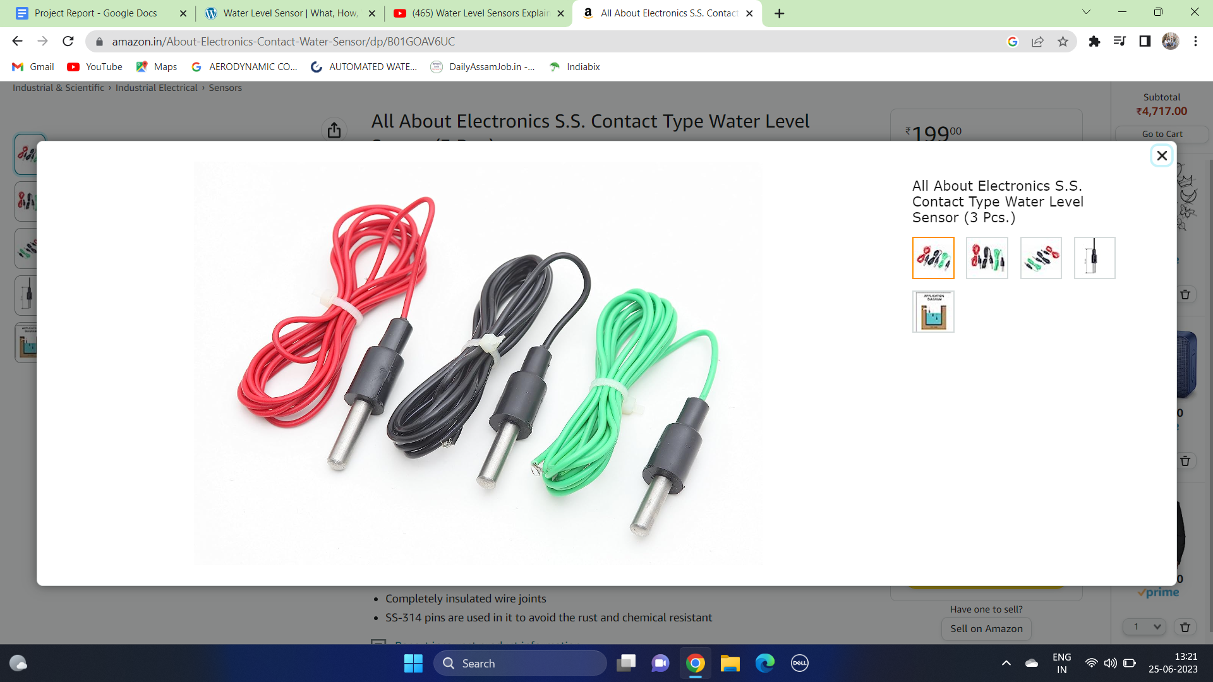

Fig 3.5: Ss Contact type water level sensor

In our project we have used the Ss Contact type water level sensor. It works on the principle of conductivity. When both the pins are dipped under water then the circuit gets completed through the water and the output pin gives out the required signal. Initially when one pin is kept under water and the pump is run. Another pin is kept at the height where the presence of water is to be measured. Thus when the water reaches the required height then the water touches the second pin completing the circuit.

**3.3.3. Temperature Sensor**

LM35 is an analog, linear temperature sensor whose output sensor varies linearly with change in temperature. LM35 is a three terminal linear temperature sensor. It can measure temperature from -55 degree Celsius to +150 degree Celsius. The voltage output of the LM35 increases 10mV per degree Celsius rise in temperature. LM35 can be operated from a 5V supply and the standby current is less than 60µA. It has an analog output voltage proportional to the temperature. The pin out of LM35 is shown in figure below.

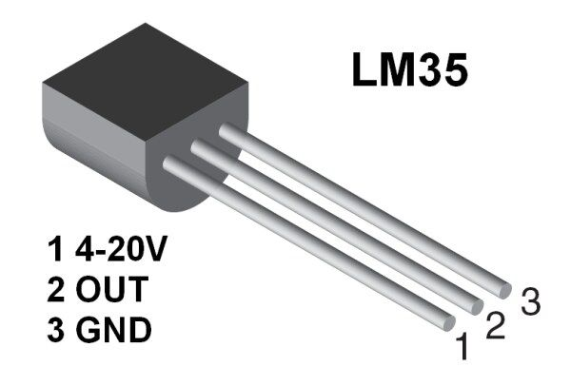

Fig 3.6: LM35 Temperature Sensor

**VCC:** Supply Voltage (4V – 30V)

**Out:** It gives analog output voltage which is proportional to the temperature (in degree Celsius).

**GND:** Ground

**3.3.4. Current Sensor**

In our project we have used the ACS712 current sensor to determine overload in the system. It is a fully integrated; Hall Effect based linear sensor with 2.1kV RMS voltage isolation and an integrated low-resistance current conductor. In simple terms it uses its conductor to calculate and measure the amount of current applied. It provides economical and precise solutions for AC and DC current sensing in industrial, commercial and communication systems.

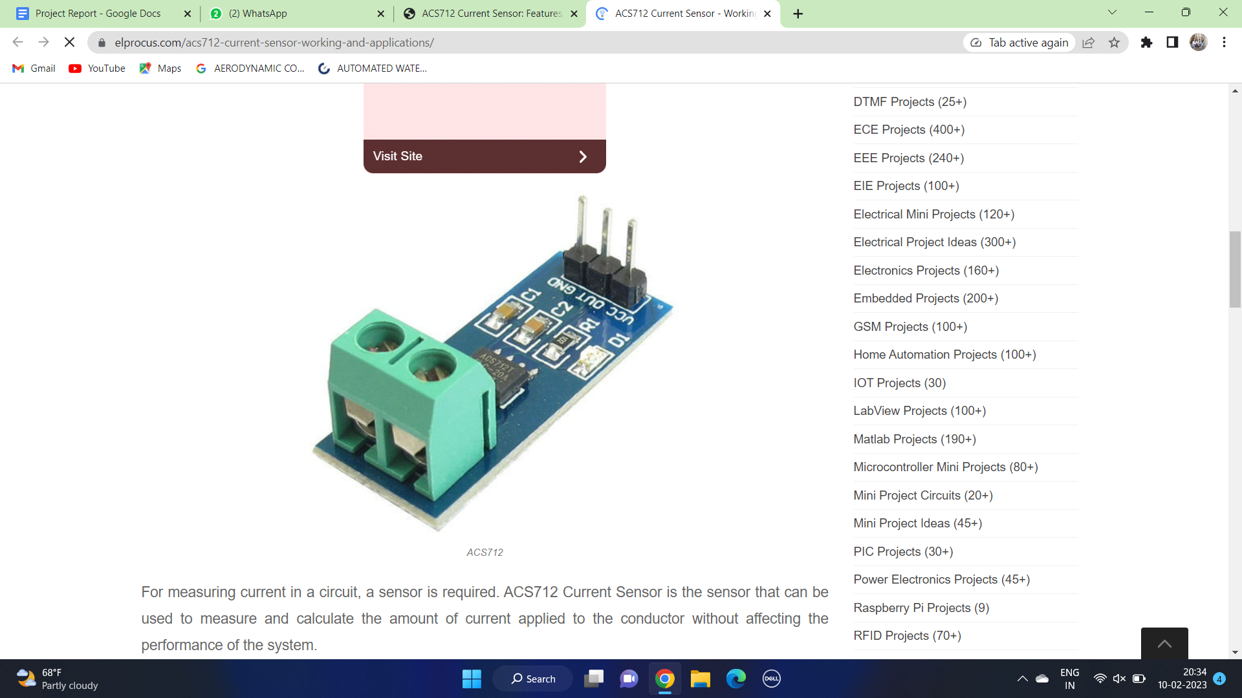

Fig 3.7: ACS712 Sensor

Current Sensor detects the current in a wire or conductor and generates a signal proportional to the detected current either in the form of analog voltage or digital output. ACS712 Current Sensor uses Indirect Sensing method to calculate the current. To sense current a linear, low-offset Hall sensor circuit is used in this IC. This sensor is located at the surface of the IC on a copper conduction path. When current flows through this copper conduction path it generates a magnetic field which is sensed by the Hall Effect sensor. A voltage proportional to the sensed magnetic field is generated by the Hall sensor, which is used to measure current.

The features of ACS712 include:

* 80kHz bandwidth
* 66 to 185 mV/A output sensitivity
* Low-noise analog signal path
* Device bandwidth is set via the new FILTER pin
* 1.2 mΩ internal conductor resistance
* Total output error of 1.5% at TA = 25°C
* Stable output offset voltage.
* Near zero magnetic hysteresis

Pin Description:

1. Vcc - Input voltage is +5V for typical applications
2. Output - Outputs Analog voltage proportional to current
3. Ground - Connected to ground of circuit
4. Wire In - The wire through current has to be measured is connected here
5. Wire Out

**3.3.5. LCD**

A liquid crystal display (LCD) is a flat panel display, electronic visual display, or video display that uses the light modulation properties of liquid crystals (LCs). LCs do not emit light directly.

LCDs are used in a wide range of applications, including computer monitors, television, instrument panels, aircraft cockpit displays, signage, etc. They are common in consumer devices such as video player, gaming devices, clocks, watches, calculators and telephones.

LCDs have replaced cathode ray tube (CRT) displays in most applications. They are available in a wider range of screen sizes than CRT and plasma displays, and since they do not use phosphors, they cannot suffer image burn-in. LCDs are, however, susceptible to image persistence.

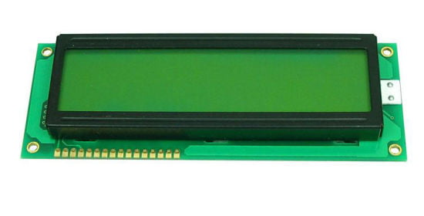

Fig 3.8: LCD Module

LCDs are more energy efficient and offer safer disposal than CRTs. its low electrical power consumption enables it to be used in battery-powered electronic equipment. It is an electronically modulated optical device made up of a number of segments filled with liquid crystal and arranged in front of a light source (backlight) or reflectors to produce images in a colour or monochrome. The most flexible one uses an array of small pixels. Each pixel of an LCD typically consists of a layer of molecules aligned between two transparent electrodes, and two polarizing filters, the axes of the transmission of which are (in most of the cases) perpendicular to each other. With no actual liquid crystal between the polarizing filters, light passing through the first filter would be blocked by the second (crossed) polarizer.

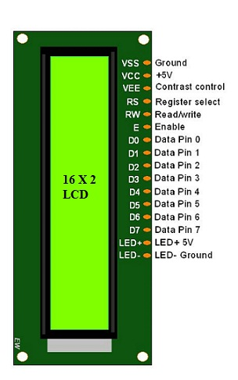

Fig 3.9: LCD pin diagram

The surfaces of the electrodes that are in contact with the liquid crystal materials are treated so as to align the liquid crystal molecules in a particular direction. This treatment typically consists of a thin polymer layer that is rubbed in one direction. The Liquid Crystal Display is intrinsically a “passive” device. It is a simple light valve. The managing and control of the data to be displayed is performed by one or more circuits commonly denoted as LCD drivers.

**3.3.6. Relay Module:**

A power relay module is an electrical switch that is operated by an electromagnet. When activated, the electromagnet pulls to either open or close an electrical circuit

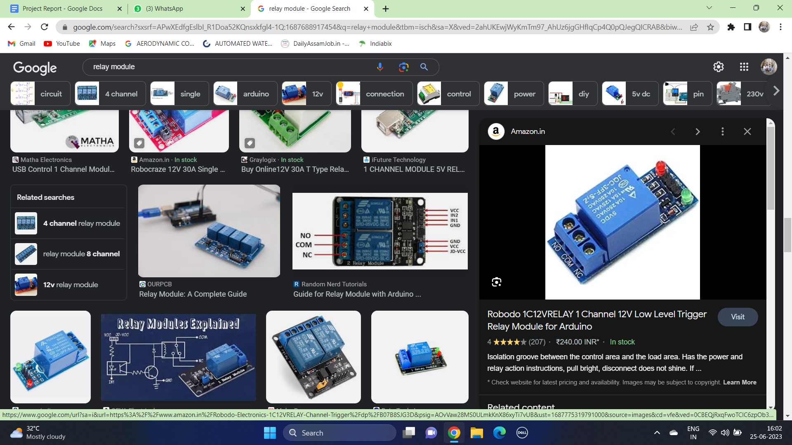

Fig 3.10: Relay Module

A simple relay consists of wire coil wrapped around a soft iron core, or solenoid, an iron yoke that delivers a low reluctance path for magnetic flux, a movable iron armature and one or more t of contacts. The movable armature is hinged to the yoke and finked to one or more sets of the moving contacts. Held in place by a spring, the armature leaves a gap in the magnetic circuit when the relay is de-energized. While in this position, one of the two sets of contacts is closed while the other set remains open

When electrical current is passed through a coil, it generates a magnetic field that in turn the armature. This movement of the movable contacts makes or breaks a connection with the fixed contact. When the relay is de-energized, it sets of contacts that were closed to open and breaks the connection and vice versa if the contacts are open. When switching off the current to the coil, the armature is returned, by force, to its relaxed position. This force is usually provided by a spring, but gravity can also be used in certain applications. Most power relays are manufactured to operate in a quick manner.

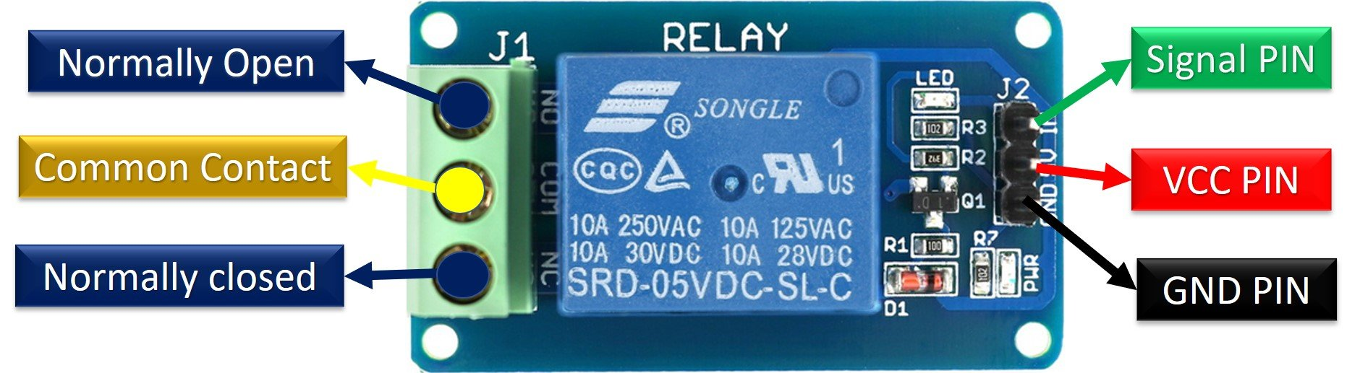

Fig 3.11: Relay Pin Diagram

**3.3.7. Solar panel:**

Solar panels are those which are used to absorb the sun's rays and convert them into electricity or heat.

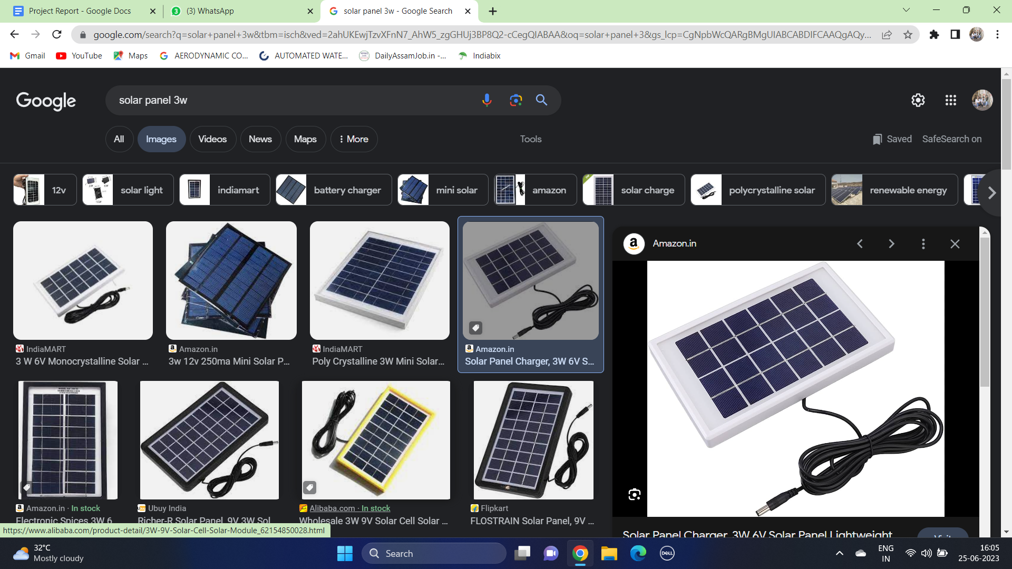

Fig 3.12: Solar Panel

A solar panel is actually a collection of solar (or photovoltaic) cells, which can be used to generate electricity through photovoltaic effect. These cells are arranged in a grid-like pattern on the surface of solar panels. Most solar panels are made up using crystalline silicon solar cells.

**3.3.8. Charging Unit:**

A valve regulated lead-acid (VRLA) battery, commonly known as a sealed lead-acid (SLA) battery, is a type of lead-acid battery characterized by a limited amount of electrolyte ("starved" electrolyte) absorbed in a plate separator or formed into a gel; proportioning of the negative and positive plates so that oxygen recombination is facilitated within the cell and the presence of a relief valve that retains the battery contents independent of the position of the cells.

**3.3.9. Motor (pump/valve):**

A pump is a mechanical machine used to raise or transfer fluids using suction or pressure. The most well-known examples of pumps are the windmill and watermill used to pump water. The motor is an electro-mechanical device that transforms electrical energy into mechanical energy.

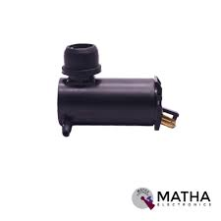

Fig 3.13: Submersible pump

A water pump is an essential tool to pump out water from the garden, pool, or under the ground. It controls the speed of the water and is incredibly useful in conserving water. The pumps come with various designs and capacities to cater to different needs of water pumping.

**CHAPTER 4**

**Simulation and System Modeling**

**4.1. Simulation:**

The simulation of the system is divided into four main parts and the integration of all these parts gives us the complete software model of the project. These parts are:

1. Water Level Monitoring and Management Scheme
2. Overheat Protection Scheme
3. Overload Protection Scheme
4. Automatic 3-phase correction scheme

**4.1.1. Water level monitoring and management scheme:**

The water level monitoring and management circuit is used to detect the water level in the overhead tanks and accordingly switch ON/OFF the motor. It includes a sump tank which stores the underground water. Then the water is pumped up to the overhead tank from the sump tank using a submersible water pump. The motor must not run under empty sump condition. Thus the water level of the sump is to be detected. Thus we use a water level indicator in the sump tank which indicates if the sump is empty. In case the sump is found empty then the motor ceases to work and status is accordingly displayed in the LCD.

The overhead tank also has 3 water level indicators – empty tank, tank half-filled and full tank. In the half-filled or empty tank condition the motor must

start pumping water into the overhead tank if the sump tank is not empty. But as soon as the overhead tank becomes full, the motor must stop working.

Thus the water level in the sump and overhead tank governs the running of the submersible water motor.

**4.1.2. Overheat Protection Scheme:**

The circuit shows the simulation of the temperature condition of the motor. An output voltage of about 80V corresponding to the normal operating temperature is considered to indicate normal temperature under normal operating condition of the motor.

Under normal operating conditions when the temperature is at a normal range, the motor will continue to operate and at the same time an output voltage of 80V corresponding to the normal operating temperature range will be displayed in the voltmeter connected across the circuit. Thus, the motor will continue to operate.

Incase of any fault condition like- short circuit, overload, etc where the operating temperature of the motor increases beyond its normal range the corresponding voltage output will also increase above 80V indicating increase in temperature of the motor. At this condition the relay will trip and the motor will cease to work.

**4.1.3. Overload Protection Scheme:**

The circuit shows the simulation of an overcurrent sensor. In case of any kind of faults such as short circuit or any other internal faults which leads to increase in current in the motor, the relay connected to the circuit will trip and the motor will cease to work.

Under normal operating conditions the current displayed in the ammeter is 0.03A. However, in case of faults the current will rise dangerously and this will affect the motor. Therefore, the motor will send a signal to the arduino and the arduino will send a signal to the relay. Thus the relay will trip and the motor will cease to work. As the motor stops the current will reduce. Once it reaches the normal value the relay will get connected to the circuit and the motor will start running again.

**4.1.4. Simulation of the complete circuit:**

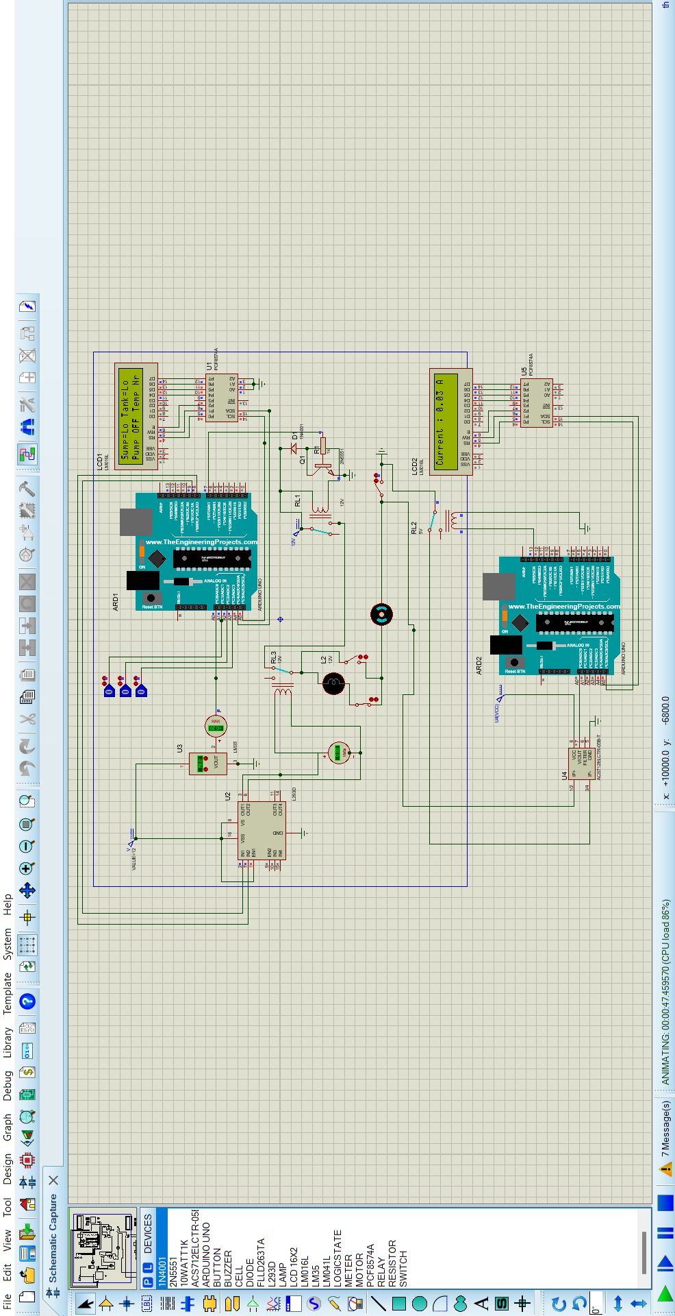

Fig 4.1: Simulation of the complete circuit

**4.1.4. Automatic 3-phase correction scheme:**

In our project we have incorporated one serious 3-phase supply problem, i.e., 3-phase automatic sequence correction. It is quite often observed that the supply sequence of the 3-phase supply changes, often due to negligence of the workers. This causes the water pump motor to malfunction or rotate in the opposite direction which is not permissible.

For this we have initially designed a circuit which gives a 5V output when the supply phase sequence changes.

This output is then used for auto-correction of the phase sequence using relay combination. When the phase sequence is correct then one set of relay becomes close which gives the required 3 phase supply to the motor. When the supply phase sequence is reversed, then this set of relay becomes OFF and another set of relay becomes on, giving the correct phase sequence supply to the motor.

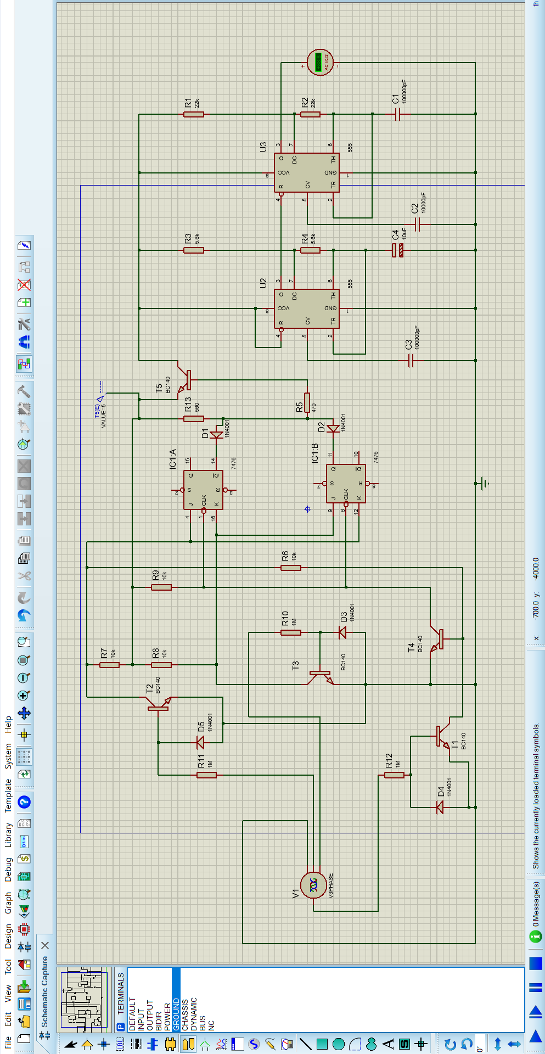

Fig 4.2: Simulation of Phase-Sequence indicator

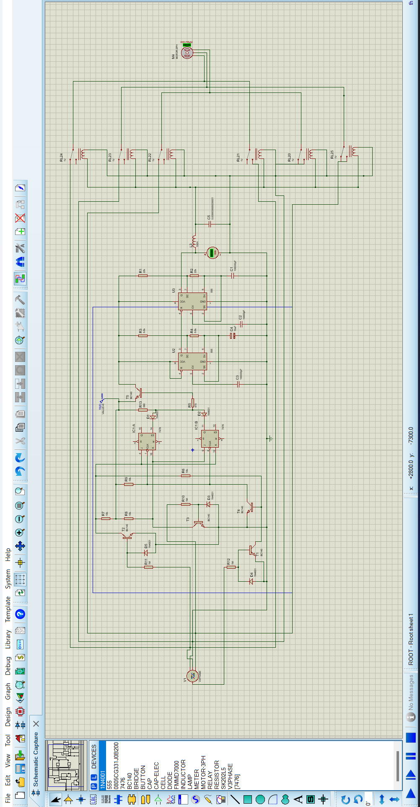

Fig 4.3: Auto-phase sequence corrector**CHAPTER 5**

**Hardware Model**

We have prepared a rough smaller scale prototype of the proposed model. In our hardware model we have 3 main parts- (i) Water management in the tank and pump operation (ii) Protection scheme of the motor (iii) Main and auxiliary power supply system.

(i) Water management in the tank and pump operation:

Initially through the Ss contact type sensor the status of the sump is checked. One pin with 12V supply is put at the ground level in the sump. And the other pin is put at a height of 5cm from the ground level. If the water is below 5cm of the tank, the circuit is not complete and thus the Arduino will not get any signal and thus the pump will not work. When the sump water reaches the height of 5cm and above, then the circuit will be complete through water and the pin at height of 5cm will start conducting. Hence now the motor might work depending on the status of the overhead tank. The sump status will be continuously displayed in the LCD.

The overhead tank also has two ss contact type sensors to indicate the full and empty status of the overhead tank. When the tank is empty, then the contact pin at the height of 5cm will not come in touch with water and hence the circuit will not be complete. When the water reaches the height of 5cm and above then the circuit will become complete and thus the Arduino will receive the signal to run the motor.

When the overhead tank becomes full, then the pin at the top of the tank will start conducting and send the signal to the Arduino to stop the motor.

The switching ON/OFF of the motor is controlled through a relay. The relay stays in normally open condition. When the motor is to be turned ON then the arduino sends a signal to normally close the relay thus completing the pump circuit.

(ii) Protection scheme of the motor:

We have incorporated two protection schemes - overload and overheat protection.

Using the ACS712 current sensor the current through the motor is measured. If the current exceeds the limit then it sends a signal to the Arduino to trip the circuit.

Using the LM35 temperature sensor the temperature of the motor is measured. If the motor exceeds 35 degree Celsius, then it sends a signal to the Arduino to trip the circuit.

If the Arduino receives any of the trip signals then it opens the normally close circuit and the pump circuit becomes open.

(iii) Main and auxiliary power supply system:

The main power supply is connected to the normally close side of a relay. It is connected to a voltage sensor. If the voltage goes below 11.5V then it sends a signal to the Arduino to normally open the relay. The auxiliary solar supply is connected in the normally open pin of the relay.

Thus in case of failure of the main supply, the supply is automatically shifted to the auxiliary solar supply giving the system an uninterrupted power supply.

**CHAPTER 6**

**System Analysis**

**Cost Analysis:**

**6.1 Cost of the components**

Table 6.1: Cost of equipment

|  |  |
| --- | --- |
| **Components** | **Price(Rs)** |
| Solar panel 3W | 520 |
| Arduino Uno R3 | 600 |
| Relay module (12Vx2) | 134 |
| Relay module (5Vx3) | 114 |
| LCD (2) | 206 |
| I2C module | 120 |
| SS contact type sensor | 239 |
| 12V DC water pump | 189 |
| Current sensor | 105 |
| Voltage sensor | 28 |
| Temperature Sensor | 45 |
| 12V Adapter | 269 |
| 5V Adapter | 136 |
| Total | 2,705 |

**CHAPTER 7**

**Results and Discussion**

The objective of the proposed system is to sense the water level in the overhead tank and to pump the water in the tank depending on the water level. The following table thus shows the system status in the different conditions.

Table 7.1: Threshold data

|  |  |  |
| --- | --- | --- |
| Sump Tank level | Overhead tank level | Pump Status |
| <20% | For any level | OFF |
| >20% | <20% | ON |
| >20% | <50% | ON |
| >20% | >95% | OFF |

The LCD shows the motor operating conditions also such as the temperature and the load condition. We have set the temperature limit to 40 degree Celsius above which the motor ceases to operate. Also the overload condition is set to 0.5A above also the microcontroller observes faulty condition and turns OFF the motor. Under the faulty conditions the microcontroller sends a signal to the relay driver which turns OFF the pump. When the faults clear then the motor again starts working.

The overheat protection circuit operates when the temperature exceeds over 50 degree Celsius.

The overload protection circuit operates when the current exceeds 3.5A.

These specifications can also be adjusted according to the system and surrounding requirements.

When the temperature and current returns within the limiting values then the system again starts operating under normal conditions.

Also the 3-phase sequence correction circuit automatically corrects the 3-phase supply sequence in case of reversal.

**CHAPTER 8**

**Conclusion and Future Scope**

The project work “Automatic Solar Based Water Saving and Energy Conservation System in a Multi-Storey Building” is the combination of solar energy, embedded system and control system. During this project we have learned many new things as well as being able to differentiate the theoretical knowledge and practical skills.

In our prototype Arduino, contact type water level sensor, overheat sensor and over current sensor are some of the fundamental elements used to build up the circuit up to the expectations. The proposed system is more efficient and accurate than the manual system. The contact type water level sensor is used to sense the level of the water in the tank which will send signal to the Arduino and further the signal will be sent to the motor to turn ON/OFF accordingly and automatically thereby saving both water as well as electrical energy. The model also consists of an overheat and over current sensor to detect the temperature rise and short circuit current in the motor in order to protect the motor from any fault and damage.

It is also cost effective, practical, eco-friendly and the safest way to save electrical energy.

A simulation for 3-phase has been prepared which consists of a phase sequence indicator and autocorrect the phase sequence in case of reversal of supply phase sequence to prevent motor malfunctioning.

**8.1 Pros**

* Reduce manual labour as the system is automated.
* Minimization of wastage of water as well as electrical energy.
* System works on Solar power when the main supply gets cut off and thus we get an uninterrupted power supply.
* Protection system for the motor is installed separately and hence it is easily replaceable.
* Automatic detection and auto correction of change in phase sequence of 3 phase motor.

**8.2 Cons**

* The contact type water level indicator operates based on conductivity of the water. But when the level of water increases, resistance of water increases. Thus there will be voltage drop due to which the signal becomes weak and the necessary signal is not obtained by the Arduino and relay to operate the motor. Also there may be electroplating phenomena on the sensor pins on application of DC voltage.
* While bypassing the circuit there might be switching surges.

**8.4 Future Scope**

The system can be enhanced by using ZigBee technology where information regarding the status of the tank can be sent to our cell phones which will automatically give updates regarding the status of the tank. Also the water level sensor can be upgraded to magnetic water level sensor.

Following are some of the additional features that can be added to the system-

* Protect the pump from dry run.
* Monitor the quality of the water and filter out the impurities.
* Automatic alarming system in case of fault in the system.
* Provision for 3 phase implementation.
* Entire system can be operated on Solar power.

**BIBLIOGRAPHY**

* G.Sangeetha, K.Sudhirtha, at all , “Water Conservation in Multistoried Buildings using Arduino with Zigbee”, Asian Journal of Applied Science and Technology(AJAST), 2018.
* Kulia A.M, “Automation of residential building water supply system pumping station”, Automation technological and business- processes, 2016.
* Santosh Anand1, Adithya.S.Nath2, at all, “Automatic water management system”, ICASISET, 2020.
* Rakib Ahemed, Mahfida Amjad, “Automated water management system(WMS), MECS, 2019.
* Kalaivani Muthuvelan, M.H.Saboo Siddik Polytechnic, “Auto Phase sequence Control System with RFID”, International journal of Engineering Research and Technology (IJERT), 2021.
* Daniel Sant’ana, “Domestic Water End-Uses and Water Conservation in Multi-Storey Buildings in the Federal District, Brazil”, PLEA, 2012
* <https://www.youtube.com/watch?v=A1gIaBI7A1Y>
* <https://www.buildtrack.in/blog/automated-water-management-in-buildings-with-3-phase-pumps/amp/>
* <https://www.buildtrack.in/blog/smart-app-based-control-and-monitoring-for-building-water-management/amp/>
* <https://www.electronicsforu.com/electronics-projects/automatic-water-pump-controller>
* https://www.quora.com/What-happens-when-the-phase-sequence-of-3-phase-equipment-are-changed