**B.TECH FINAL YEAR PROJECT REPORT**

**ON**

**ENERGY MANAGEMENT OF MICROGRID WITH HYBRID ENERGY STORAGE AND MULTI PORT INTERFACING**

*Submitted in partial fulfillment for the award of the Degree of Bachelor of Technology of Assam Science and Technology University*



Submitted to

**Department of Electrical Engineering**

By

Pritish Dey 200610003070

Soumit Saha 200610003086

Shubham Sharma 200610003085

Bhargab Subedy 200610003016

*Under the guidance of*

Dr. Bimal Ch Deka

Professor

**Department of Electrical Engineering**

**Assam Engineering College**

**Guwahati, 781013**

**ACKNOWLEDGEMENT**

We express our heartfelt gratitude to Dr. Bimal Ch Deka for his invaluable guidance and unwavering support throughout the advancement of our final year project, entitled “Energy Management of Microgrid with Hybrid Energy Storage and Multi Port Interfacing.” His extensive knowledge and expertise in the field provided a solid foundation for this project, and his expertise and mentorship played a pivotal role in enhancing our understanding of the subject matter, and navigating the challenges encountered during its execution. We are sincerely thankful for his commitment, encouragement, and insightful inputs that significantly contributed to the success of this endeavor. We also express our sincere gratitude to all the faculty members of the department for their continuous moral support for successful completion of the work.

Pritish Dey (200610003070)

Soumit Saha (200610003086)

Shubham Sharma (200610003085)

Bhargab Subedy (200610003016)

Date:

Place:

**ABSTRACT**

This study explores the energy management of a microgrid employing hybrid energy storage systems and multiport interfacing. In this project, a comprehensive energy management system for a microgrid has been implemented incorporating solar photovoltaic (PV) system, wind energy system, fuel cells and battery storage. The proposed work focuses on developing advanced control algorithms that consider the intermittent nature of solar and wind inputs, aiming to enhance the microgrid's stability and overall efficiency. Through the synergistic utilization of solar PV, wind power, and battery storage, the microgrid aspires to be a sustainable and reliable energy solution. In this work, simulation models have been developed to study the significance of various renewable resources in microgrid and demonstrated the results in the form of voltage, current and power outputs of the system.

**CONTENT**

|  |  |  |  |  |  |  |
| --- | --- | --- | --- | --- | --- | --- |
|  |  |  |  | | | **Page No.** |
|  |  | Certificates |  | | | i |
|  |  | Acknowledgement |  | | | iii |
|  |  | Abstract |  | | | iv |
|  |  | List of figures |  | | | vi |
|  |  |  |  | | |  |
| **CHAPTERS** |  |  |  | | |  |
| **1** |  | **INTRODUCTION** |  | | | **1-4** |
|  | 1.1 | Important terminology |  | | | 1 |
|  | 1.2  1.3 | Objective of the Project  Organization of the report |  | | | 4  4 |
| **2** |  | **LITERATURE REVIEW** |  | | | **5-9** |
| **3** |  | **SIMULATION MODEL AND RESULTS** | |  | | **10-14** |
|  | 3.1 | Distributed Energy Resources (DERs) |  | | | 11 |
|  | 3.2 | Layout |  | | | 12 |
|  | 3.3 | Individual Simulation Models and Results |  | | | 28 |
| **4** |  | **CONCLUSION** | | |  | **29-30** |
|  |  | **BIBLIOGRAPHY** |  | | | **31-33** |

|  |  |  |
| --- | --- | --- |
|  | **LIST OF FIGURES** |  |
| **Figure No.:** | **Name of the figures** | **Page No.:** |
| **3.1** | Proposed microgrid layout | **12** |
| **3.2** | Wind Turbine Model Simulation | **13** |
| **3.3** | Wind Turbine Model Simulation Result | **14** |
| **3.4** | PV Array Model Simulation | **15** |
| **3.5** | Solar PV model simulation result | **15** |
| **3.6** | MPPT Algorithm for Solar PV Array | **16** |
| **3.7** | Battery Energy Storage System Simulation | **17** |
| **3.8** | Battery Controller Simulation Result (Charging) | **18** |
| **3.9** | Battery Controller Simulation Result (Discharging) | **18** |
| **3.10** | Simple Fuel Cell Simulation | **19** |
| **3.11** | Fuel Cell Simulation Result | **20** |
| **3.12** | Simulation of Converter Circuit | **20** |
| **3.13** | Simulation of PV connected with Grid | **21** |
| **3.14** | Output Voltage at DC side of Simulation of PV connected with Grid | **22** |
| **3.15** | Output Voltage at AC side of Simulation of PV connected with Grid | **22** |
| **3.16** | Simulation of Battery Discharging | **23** |
| **3.17** | Battery Discharging Result | **23** |
| **3.18** | Fuel Cell Connected to grid | **24** |
| **3.19** | DC Output Voltage when Fuel Cell is connected to Grid | **24** |
| **3.20** | AC Output Voltage when Fuel Cell is connected to Grid | **25** |
| **3.21** | Series connected fuel cells simulation | **25** |
| **3.22** | DC Output Voltage of Series connected fuel cells | **26** |
| **3.23** | AC Output Voltage of Series connected fuel cells | **26** |
| **3.24** | Simulation of Wind and PV system connected to the grid | **27** |
| **3.25** | AC side output voltage when PV and Wind system are connected to the grid | **27** |
| **3.26** | DC side output voltage when PV and Wind system are connected to the grid | **28** |

**CHAPTER 1**

**INTRODUCTION**

**CHAPTER 1**

**INTRODUCTION**

In response to the diminishing availability of fossil fuels and the imperative for sustainable development, there is a growing focus on harnessing renewable energy resources. Persistent endeavors are directed toward increasing reliance on renewables, driven by the objectives of fostering a pollution-free environment, curbing the rapid depletion of natural reserves, and reducing transmission costs to energize remote areas. The principle of "local collection, local storage, and local utilization" aligns seamlessly with the utilization of renewable energy sources. Microgrids emerge as pragmatic substitutes for centralized power generation and bulk transmission, offering localized generation, regulation, and consumption. This paradigm effectively resolves the tension between large power grids and distributed generation, mitigating the adverse impact of distributed generation on the grid and optimizing the efficiency of renewable energy utilization. A microgrid, characterized by interconnected loads and distributed energy resources within defined electrical boundaries, functions as a manageable entity in relation to the grid. It can effortlessly connect and disconnect from the grid, enabling operation in both grid-connected and island-mode configurations.

**1.1 Important terminology**

**Energy Router:**

Given the rapid proliferation of various distributed energy sources, ensuring a dependable power supply has become crucial to meet the demands of power consumers—an aspect where traditional distributed networks face challenges. To tackle this issue, the Energy Router (ER) concept has been introduced. Leveraging advancements in power electronics and communication technology, ERs are rapidly evolving and demonstrating appealing attributes in power quality control, including AC-DC hybrid distribution, active bidirectional power flow management, and convenient access to Distributed Energy Resources (DERs).

Built upon the Energy Router concept, power consumers can access AC-DC hybrid power across multiple voltage levels. The Multiport Energy Router (MER) operates in two modes: 1) Grid-connected mode and 2) Islanded mode. Acting as a barrier, the MER effectively isolates faults and interferences between the grid side and the user side. In instances of distribution grid failure, the Energy Storage (ES) battery ensures the uninterrupted operation of the energy subnet, guaranteeing power supply reliability. This innovative approach addresses the challenges posed by the dynamic landscape of distributed energy sources and enhances overall power system resilience.

**Energy Management:**

Energy management has become a topic of significant importance and complexity in today's context. It involves the selection of energy sources to power a set of loads, aiming to minimize losses and costs. The strategy for energy management is designed to extend battery life, enhance economic benefits for power consumers, and mitigate fluctuations in renewable energy production or load consumption. In traditional power systems, energy flows unidirectionally from centralized power plants to customers through one-way energy transmission.

In contrast, a Multiport Energy Router (MER) integrated smart grid embraces a distributed and flexible energy management paradigm. This innovative system maximizes the utilization of renewable resources in a distributed manner, and a substantial portion of grid users function as both energy producers and consumers.

**Microgrid:**

A microgrid is a localized and self-contained energy system that integrates various distributed energy resources, such as renewable sources, energy storage, and traditional generators, within a specific geographic area. Operating either connected to the main grid or in an isolated mode, a microgrid offers increased resilience, reliability, and efficiency in energy distribution. It empowers communities, campuses, or industrial facilities to generate, store, and manage their energy, providing a more sustainable and adaptable alternative to conventional centralized power systems. The flexibility of microgrids allows for better integration of renewable energy sources, reduction of transmission losses, and the ability to operate independently during grid outages, making them a key element in the evolution of modern, smart energy networks.

Microgrids offer several advantages that contribute to their growing popularity in modern energy systems:

1. Resilience and Reliability
2. Integration of Renewable Energy
3. Energy Efficiency
4. Grid Support and Stability
5. Energy Independence
6. Scalability

**1.2 Objective of the Project**

The objective of the project work is to integrate wind, solar, fuel cell and battery storage devices to microgrid to create a resilient, sustainable energy system. This includes maximizing the integration of renewable sources, ensuring energy independence, enhancing grid resilience, optimizing energy storage, and reducing carbon emissions. The microgrid aims to balance intermittent renewable sources, provide reliable power through strategic storage use, offer ancillary services to the main grid, engage the community in sustainable practices, and remain scalable and adaptable to future energy needs. Overall, the goal is to achieve an efficient, cost-effective, and environmentally friendly energy solution.

**1.3 Organization of the report**

The chapter 1 gives a brief introduction on important terminology relevant to the proposed work and the objectives of the project. A brief overview of literature has been presented in chapter 2. The simulation models are developed for the system and presented in chapter 3 along with results and analysis. Finally, conclusion have been derived and presented in chapter 4 followed by the bibliography.

**CHAPTER 2**

**LITERATURE RIEVIEW**

**CHAPTER 2**

**LITERATURE RIEVIEW**

An extensive review of literature has been conducted to gain knowledge and to study the methodology of integrating renewable sources of energy and the energy storage devices to the microgrid. The summary of our review has been depicted in the following:

Yi Xu et.al [2011] analyze the application of multiport energy routers (MERs) in a hybrid AC/DC system for the energy internet. MERs enhance power supply reliability, expand power supply forms, and enable plug-and-play access for distributed generation. Control and protection systems ensure their reliable operation, while smart energy management optimizes power flow. Experimental results validate their effectiveness. The paper anticipates that MERs will have a significant role in the future energy internet, particularly in collaborative interconnection operations, shaping the evolving energy landscape [1].

Eklas Hossain et.al [2014] explores how the Grid connection capability of distributed generation attracts researchers due to the cumulative demand for electricity and environment pollution concern as a new emerging technology for providing reliable and clean power supply. A microgrid comprises distributed generation, energy storage, loads, and a control system that is capable of operating in grid-tied mode and/or islanded mode. As operation modes are shifted, the microgrid should successfully manage the voltage and frequency adjustment in order to protect the grid and any loads connected to the system. Facilitation of the generation-side and load-side management and the resynchronization process is required. This paper presents an overall description and typical distributed generation technology of a microgrid. It also adds a comprehensive study on energy storage devices, microgrid loads, interfaced distributed energy resources (DER), power electronic interface modules and the interconnection of multiple microgrids [2].

Adam Hirsch et.al [2018] explore that the costs of solar photovoltaic generation and battery storage are rapidly dropping, to the point that they are closing in on cost parity with traditional electricity sources. As a result, broad adoption of these technologies may soon accelerate to the point that energy prosumption, where end users import and export electricity, is the norm rather than the exception. Before millions of distributed energy resources are connected to the electrical grid, it behooves society to plan ahead and to understand what architecture will best integrate these and other distributed energy technologies. Microgrids are poised to manage this transition by balancing supply and demand locally while ensuring reliability and resilience against what appear to be escalating natural and man-made disturbances. Whether microgrids remain a niche application or become ubiquitous depends on two main factors: (1) to what degree regulatory and legal challenges can be successfully surmounted, and (2) whether the value they deliver to property owners and communities in terms of power quality and reliability (PQR) and other economic benefits outweigh any cost premiums incurred to capture those benefits. These questions are now being answered in courtrooms and commercial markets around the globe as electricity grids evolve to address social and economic concerns and incorporate 21st-century technology to update Thomas Edison's original vision of the grid [3].

Bin Liu et.al [2021] studies Energy Routers (ERs), intelligent power devices managing distributed energy resources. ERs, acting as bridges between consumers and grids, provide versatile DER access, enhance reliability, and facilitate fault isolation. It examines coordinated control strategies ensuring seamless grid-connected and islanded operations, including advanced compensation and mode-switching. Energy management strategies, particularly fuzzy logic controllers, are discussed for grid-connected mode to optimise battery life, improve consumer economics, and stabilize renewable energy fluctuations. Validation through simulations and experiments confirms the effectiveness of these strategies. The paper concludes ERs' potential for wide application in low-voltage distribution networks, which is an important part of making our energy systems better and more up-to-date [4].

Firmansyah Nur Budiman et.al [2022] explore the optimization of microgrid scheduling, emphasising the integration of hybrid energy storage systems (HESS) with batteries and supercapacitors. It studies stochastic optimization techniques to address uncertainties arising from intermittent renewable energy sources (RESs) and variable load demands. Comparative studies reveal that while supercapacitors have a marginal impact on deterministic scheduling, they tend to increase expected total costs significantly in stochastic scheduling. The review concludes by highlighting the need for further research to enhance microgrid resilience under uncertainties, potentially exploring alternative energy storage solutions [5].

Sreelekshmi R.S. et.al [2022] addresses the increasing demand for energy storage solutions in microgrids, particularly due to the integration of renewable energy sources and the need to manage their fluctuations. It focuses on the design and simulation of a microgrid with a battery management system, suitable for both on-grid and off-grid operations. The study highlights the development of battery management algorithms to enhance safety and efficiency, along with an On-Grid–Off-Grid controller for optimized power flow management. Additionally, the implementation of a shunt active filter algorithm demonstrates improvements in power quality, reducing total harmonic distortion (T.H.D). This work contributes to the broader field of energy storage, microgrid management, and power quality enhancement [6].

Mostafa Esmaeili Shayan et.al [2022] emphasizes Renewable energy regulations place a Premium on both the use of renewable energy sources and energy efficiency improvements. One of the growing milestones in building construction is the invention of Green cottages. Building Integrated Photovoltaic (BIPV) technologies have been proved to aid buildings that partially meet their energy demand as sustainable solar energy generating technologies throughout the previous decade. Curved facades provide a challenge for typical photovoltaics. This study designed, produced, and assessed elastic Solar panels supported by flexible photovoltaic systems (FPVS) on a 1 m2 layer. This project investigates a flexible solar panel for Energy on curved surfaces. They employed the actual capability of flexible solar energy conversion in this study, which was conducted utilizing environmental evaluation and environmental techniques centered on pilot projects [7].

Rona George Allwyn et.al [2023] explores the general topics related to energy management for hybrid systems of different configurations, the diverse techniques used, forecasting methods, control strategies, uncertainty consideration, tariffs set for financial benefits, etc. are reviewed in this paper. The novelty of reformer-based fuel cells, which generates hydrogen on demand, thereby eliminating the requirement of hydrogen storage and lowest carbon footprint is discussed for the first time in this paper. The topics requiring extended research and the existing gap in literature in the field of energy management studies are presented in the authors’ perspective, which will be helpful for researchers working in the same specialization [8].

Sayemul Islam et.al [2023] explores smart technologies for different system configurations, e.g power systems with solar energy, wind energy, hybrid renewable energy and ESS. This study emphasizes that smart technologies are essential to manage the uncertainty and disruptions of renewable energy sources. integration, enabling real-time data forecasting and analysis. It provides a comprehensive overview of different algorithms have been used for forecasting, uncertainty analysis, forecasting and optimal sizing of systems including ANN, CNN, LSTM, PSO, NARX-NN, MARS, DCNN, CGAE, WPD and NN-COA. This study highlights the significant improvements that these technologies have brought to electrical system accuracy, stability, optimization, control procedures, size, lifetime, operating costs, and storage capabilities with the integration of renewable energy In addition, smart technologies integrated renewable energy in combined systems facilitates cost analysis and optimal size of systems by integrating them into the ESS improve effective inspection procedure, optimal size, service life improvement, operating costs and storage capacity. In short, this research shows that smart technologies are crucial in terms of efficiency systematic research and provide a promising way to care feasibility of the electrical system in the future [9].

In addition to study of above journal papers, various text books have been reviewed for the purpose.

**CHAPTER 3**

**SIMULATION MODEL AND RESULTS**

**CHAPTER 3**

**SIMULATION MODEL AND RESULTS**

**3.1 Distributed Energy Resources (DERs)**

**Solar PV System:**

In the context of our research, we are investigating the integration of a Solar Photovoltaic (PV) system equipped with Maximum Power Point Tracking (MPPT) technology, considering it as a distributed energy resource and a potential generator for the Energy Router model. The MPPT algorithm, an essential feature of PV inverters, continually adjusts the load impedance to ensure optimal operation of the PV system near its peak power point. This adaptation accommodates changing environmental conditions, including variations in solar irradiance, temperature, and load. Our model implements the MPPT algorithm through a boost converter, and the mathematical model for this approach is accessible on MathWorks, a platform offering a range of technical computing tools and software solutions.

**Energy Storage Battery:**

The model incorporates an energy storage battery as one of the distributed energy resources, designed to store surplus energy generated by stochastic renewable sources. This stored energy becomes valuable during periods of low renewable generation or peak demand. To integrate the energy storage battery into the microgrid model, we developed a simulink model. The model simulates the dynamic processes of charging and discharging the battery while offering real-time monitoring of crucial parameters like state of charge (SOC), voltage, and current. These parameters play a vital role in efficiently managing the energy storage system within microgrid applications.

**Wind System:**

This study focuses on integrating wind energy as a distributed energy resource in a microgrid system by developing a model of a variable speed wind turbine with a permanent magnet synchronous generator (PMSG). The model is based on the reference provided by MathWorks, with slight modifications made to accommodate for output/load. This model can be manipulated by the user to simulate and analyze the system's response to varying parameters. The objective of this research is to analyze the performance of the microgrid system with the integration of a wind energy source and provide insights for the development of efficient and sustainable energy systems.

**Fuel Cell:**

Fuel cell simulations are computational models used to understand and predict the performance of fuel cells under various operating conditions. These simulations help in optimizing design parameters, enhancing efficiency, and reducing costs. They encompass a range of phenomena including electrochemical reactions, heat and mass transfer, fluid dynamics, and material properties. The rate of flow of the gases used in fuel cell can be controlled by manipulating the respective rate of flow functions.

**3.2 Layout**

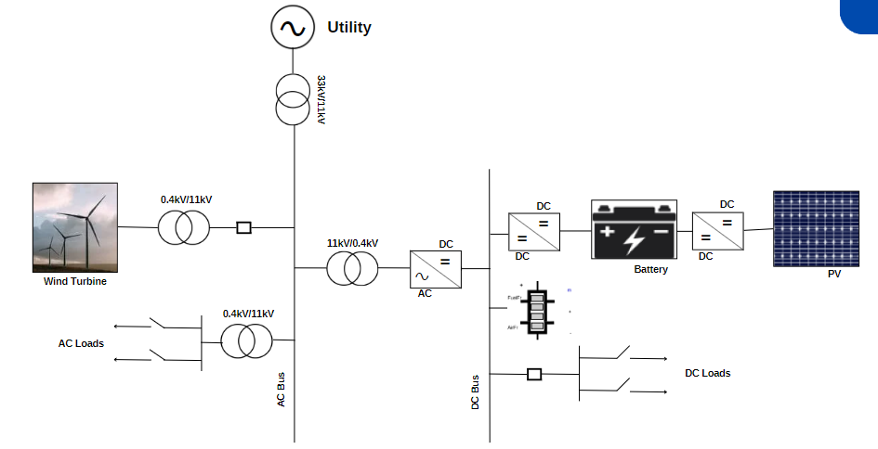

*Fig 3.1: Proposed microgrid layout*

The energy router will provide the integration of renewable resources into the system and provide both output for AC and DC load. The router will feature a DC bus that will be fed either directly by the PV array or by the wind turbine through the mechanism of AC-DC conversion by using a converter, which will have a DC port for further distribution. The router will also integrate an energy storage battery that can be charged and discharged through the same port, with the battery connected to the DC bus. The final DC voltage from the Battery Energy Storage System (BESS) will again pass through the DC-DC converter before supplying the bus. The energy router model will operate in two modes: grid mode and islanded mode. In grid mode, all power will be sourced from the main grid, whereas in islanded mode, the renewable sources will provide the power. The energy router will switch between these modes automatically. Our proposed energy router model has significant potential in realizing sustainable and reliable power systems, based on renewable energy sources, and reducing the dependency on non-renewable sources, thereby increasing energy security.

**3.3 Individual Simulation Models and Results**

**Wind Turbine:**

*Fig 3.2: Wind Turbine Model Simulation*

In this model wing turbine is taken in which a step signal and rate limiter is used to give a constant wind supply to the turbine. A trip signal is also connected to trip the turbine in undesirable conditions. A bus selector is used to visualize various wind turbine parameters through the scope. A programmable three phase source with neutral grounded, a transformer and two three phase V-I measurement units are connected to the three phases of the wind turbine. The three phase V-I measurement helps to measure different parameters in both turbine and grid side.

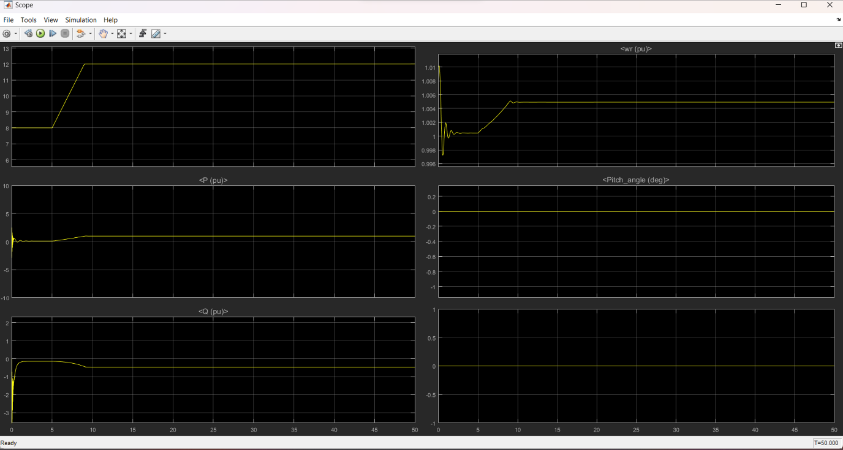

*Fig 3.3: Wind Turbine Model Simulation Result*

Graphical representation of wind speed, real power and reactive power developed by the rotor, rotor power, pitch angle and torque are shown on the above graph. In case of any change in wind speed pitch angle adjust automatically to maintain the output power to be constant. Rate limiter is used to limit the wind speed within the range 8m/s to 12m/s. The capacitive block in this model simulation helps to reduce reactive power losses from the main grid by injecting reactive power from it.

The first graph shows the wind speed which was initially 5m/s and then it increased to 12m/s. The second graph shows the real power which fluctuates initially when the wind speed is not stable and then it remains constant. The third graph shows the reactive power which initially fluctuates and then becomes constant. The fourth graph shows the rotor speed which is constant after the wind speed reaches the base wind speed i.e. 12m/s. The fifth graph shows the Rotor torque which decreases after reaching the base speed.

**Solar PV Array:**

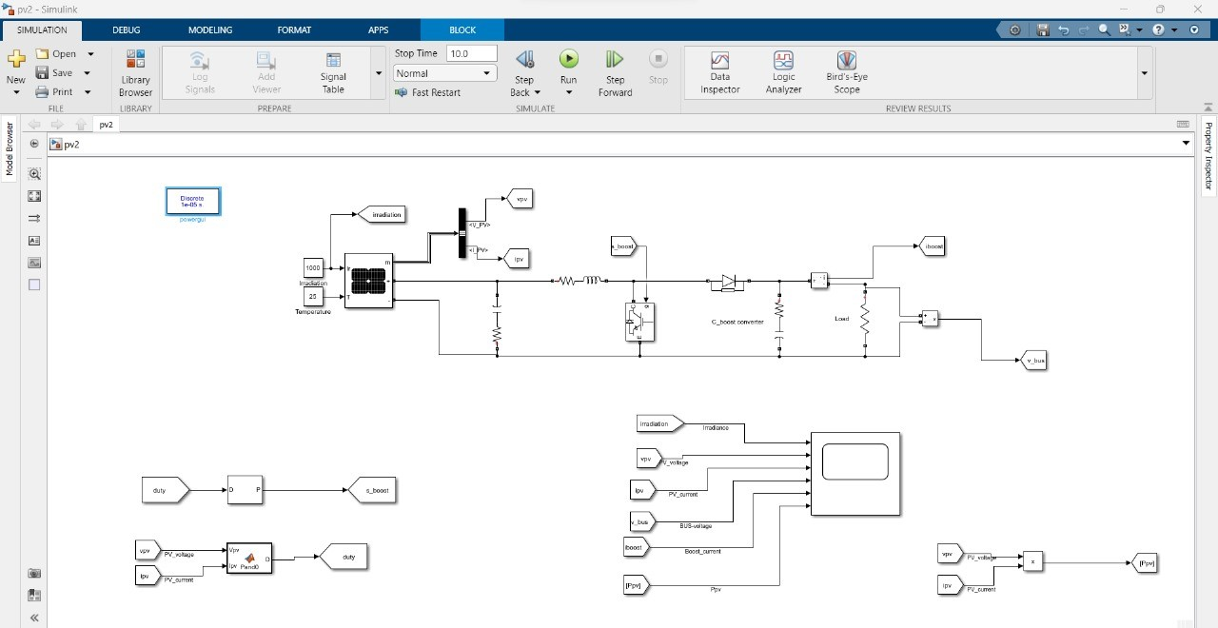

*Fig 3.4: PV Array Model Simulation*

In this circuit diagram first a PV array module is taken and with the help of two constant blocks the value of irradiation and temperature is given to an array. A bus selector is used to interpret various data like the voltage and current, irradiation, temperature etc. Series RC circuit MOSFETs and diodes are used in making of the boost converter circuit. Various GOTO blocks are used to make the circuit as simple as possible. A scope is used to visualize various waveforms.

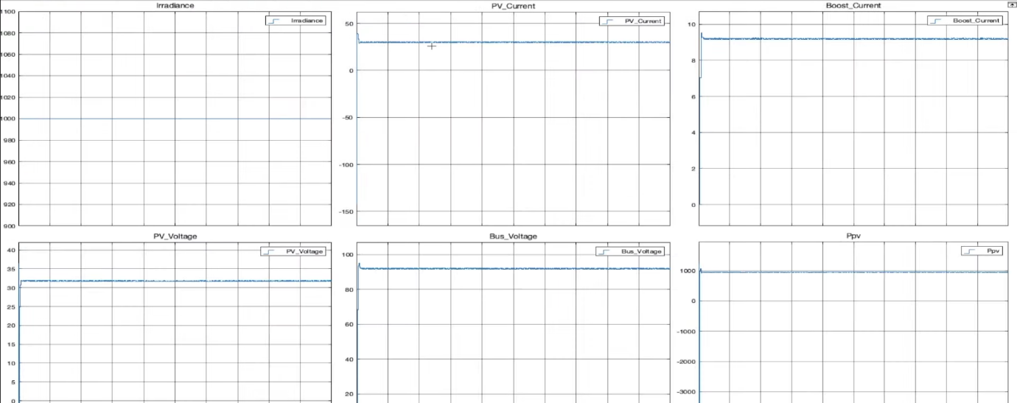

*Fig 3.5: Solar PV model simulation result*

The above figure shows the graphical output representation of irradiance (which is constant of 1000), voltage and current output from the PV module, Bus voltage, boost current, and the power output to the bus. Here, we have used maximum power point tracking (MPPT) algorithm to track the point from which optimum power can be generated. The MPPT algorithm is shown below:

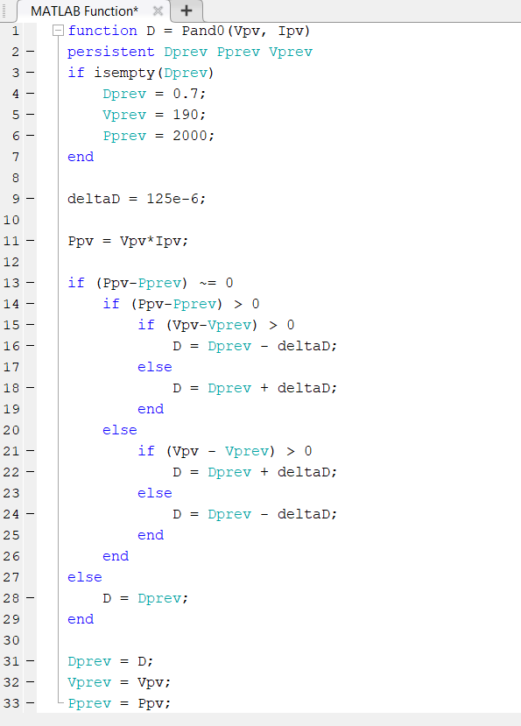

*Fig 3.6: MPPT Algorithm for Solar PV Array*

**Battery Energy Storage System (BESS):**

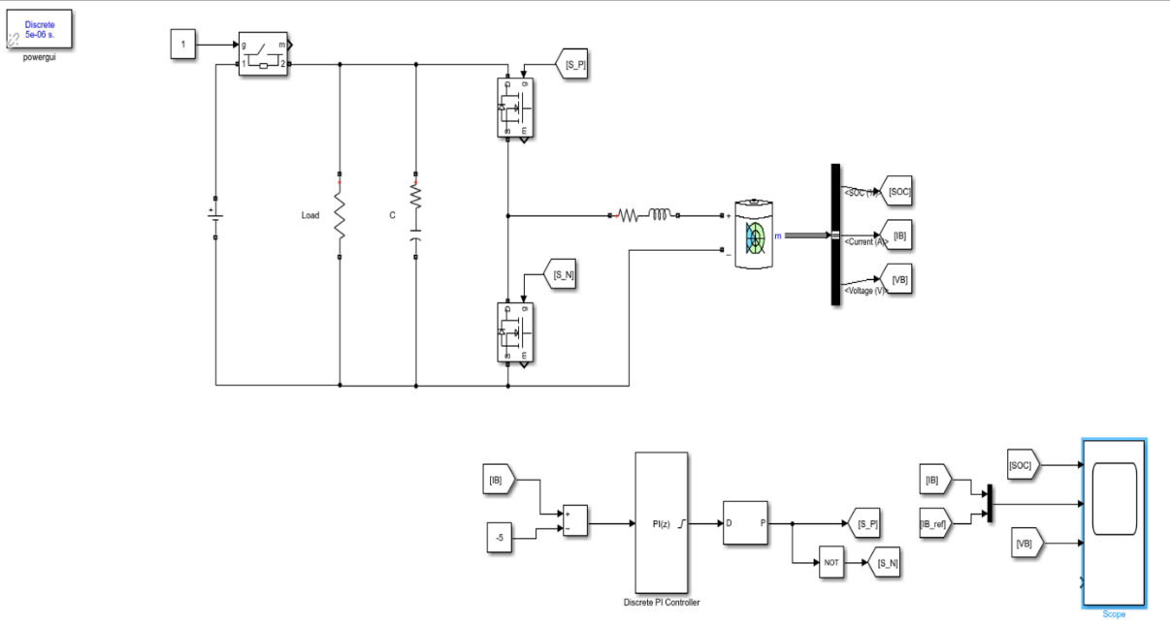

*Fig 3.7: Battery Energy Storage System Simulation*

In this circuit a battery module DC-DC converter and a common load is used. In charging mode, a PID controller is used to control currents and voltages which is fed through multiple GOTO blocks and logics to provide gate pulse at different intervals to the converter. A different PID controller fed by output voltage and reference voltage is used to discharge the battery against a constant resistive load. A switch which is fed by battery charging current, discharging current and source is used to switch between charging and discharging mode.

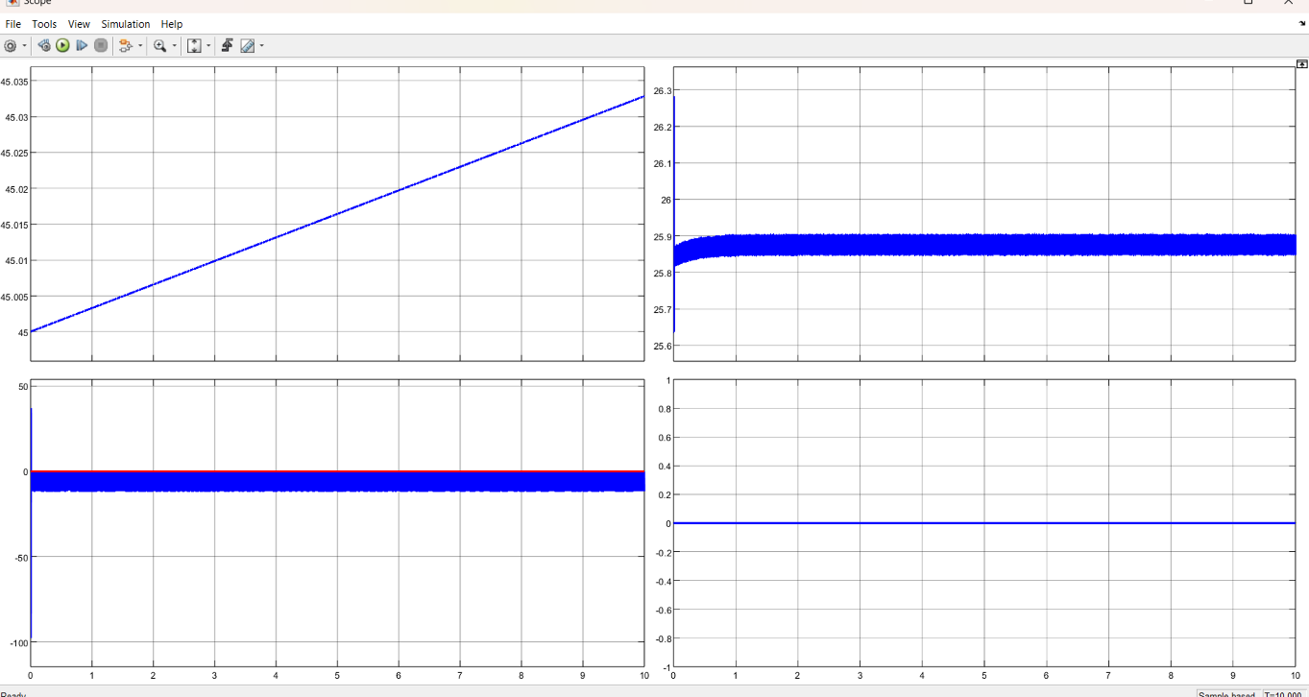

*Fig 3.8: Battery Controller Simulation Result (Charging)*

The simulation results presented above for the battery's charging mode include graphical representations depicting the State of Charge (SOC), current, and voltage profiles. These visualizations offer valuable insights into the charging behavior of the battery, enabling thorough analysis and real-time monitoring of the charging process.

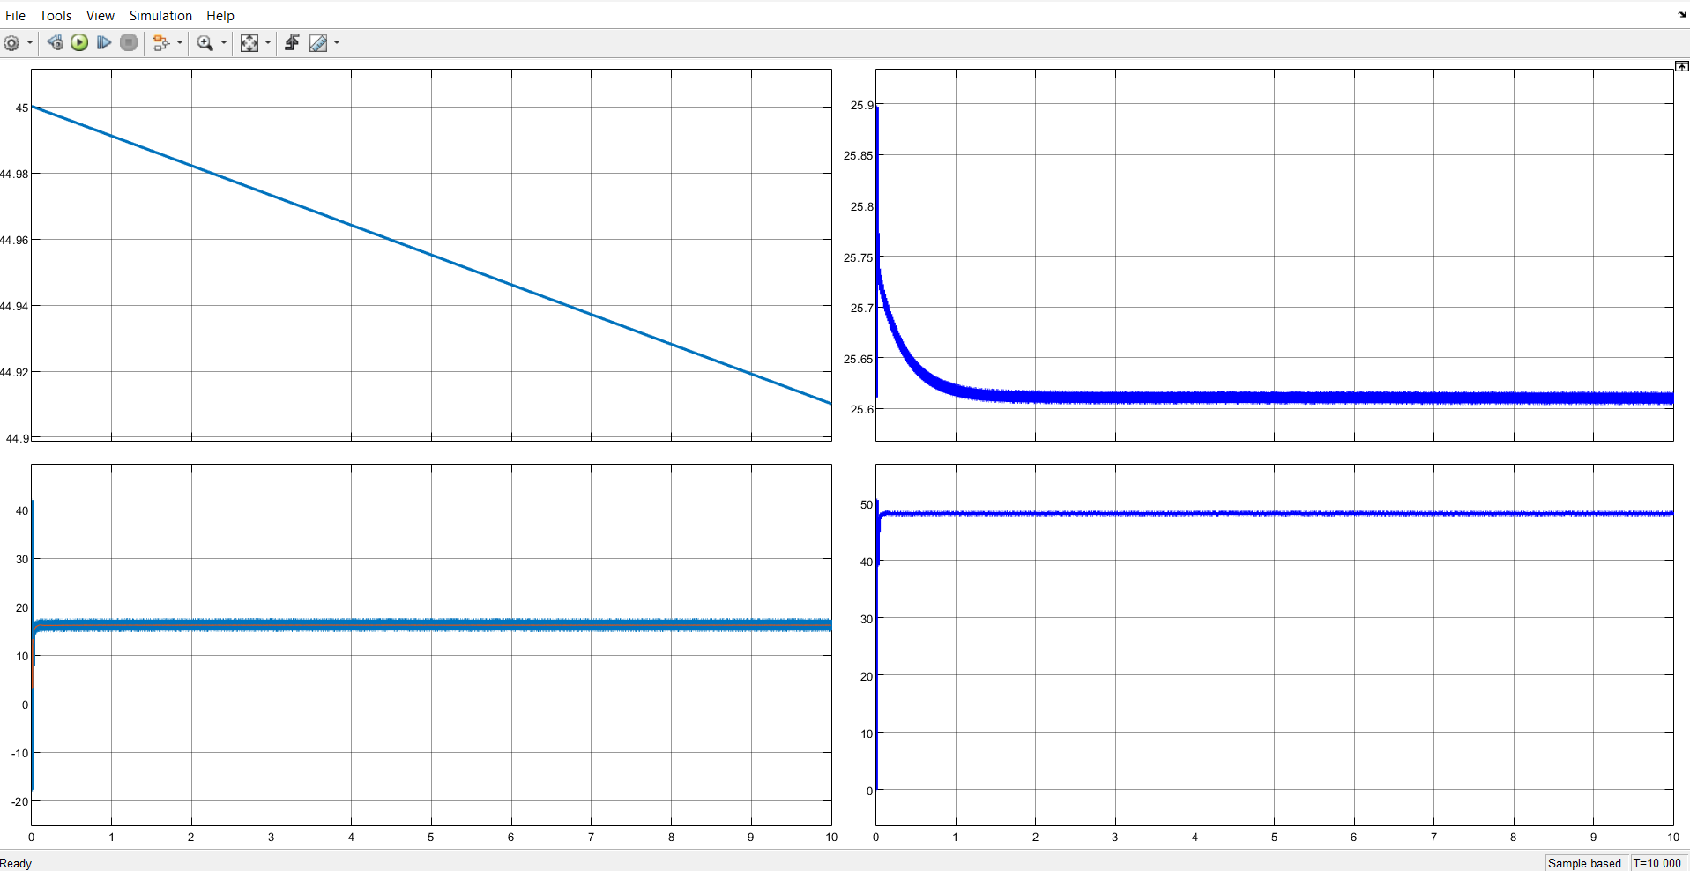

*Fig 3.9: Battery Controller Simulation Result (Discharging)*

In the initial graph, the battery's state of charge steadily decreases from its reference level of 45% as it discharges. Concurrently, the reference current rises and stabilizes at 17A, as depicted in the second graph. Meanwhile, in the third graph, the battery voltage declines as the discharge progresses. Notably, the fourth graph illustrates a consistent voltage of 48V across the load.

**Fuel Cell:**

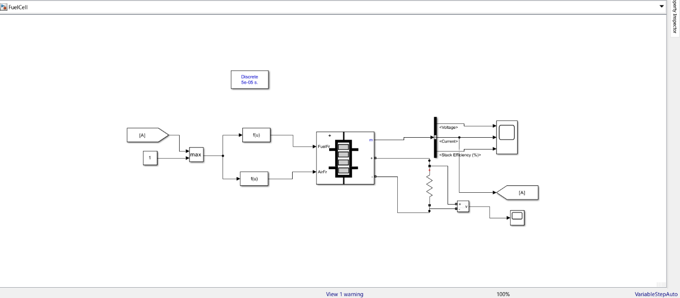

*Fig 3.10: Simple Fuel Cell Simulation*

The fuel cell circuit comprises a pivotal component known as the Fuel Cell Stack, which contains 65 cells. Operating at an operational temperature of 65 degrees Celsius, this stack boasts a nominal efficiency of 55%. The regulation of fuel and air flow rates within the stack is facilitated by two function blocks. These blocks, integral to standard fuel cell operations, are linked to a MinMax block, which receives current feedback.

To utilize the output of the fuel cell stack, a load resistance of 15 Ohms is connected at its terminal. This load resistor is then interfaced with a voltage measurement unit, enabling the recording and analysis of voltage waveforms via a connected oscilloscope.

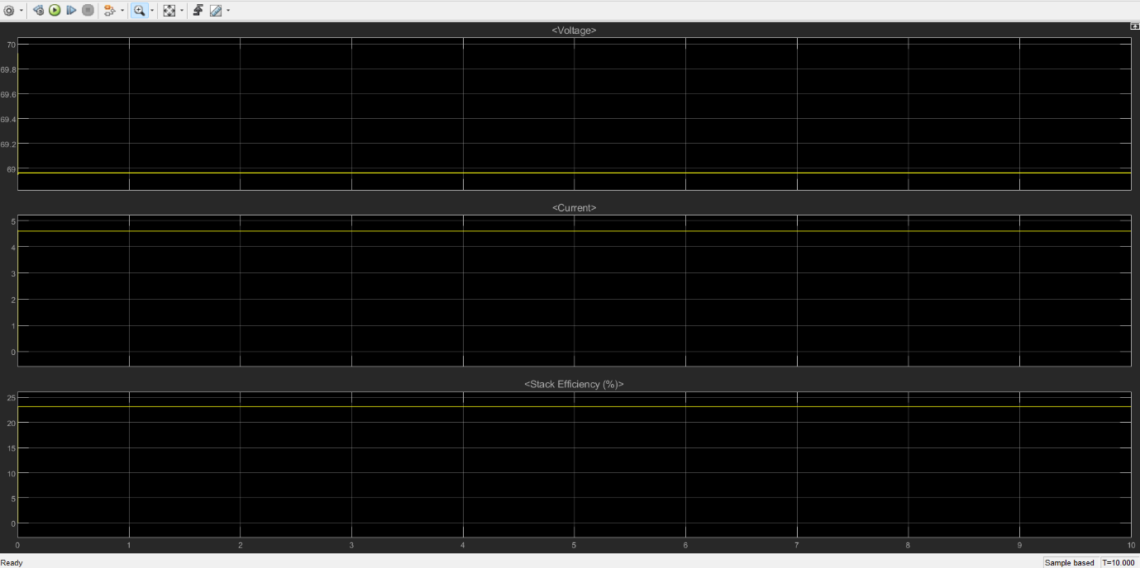

*Fig 3.11: Fuel Cell Simulation Result*

The above graph shows the output waveform of voltage current and stack efficiency. The output voltage is nearly equal to 68.9V, current is slightly greater than 4.5A and stack efficiency slightly greater than 23%.

**Converter Circuit:**

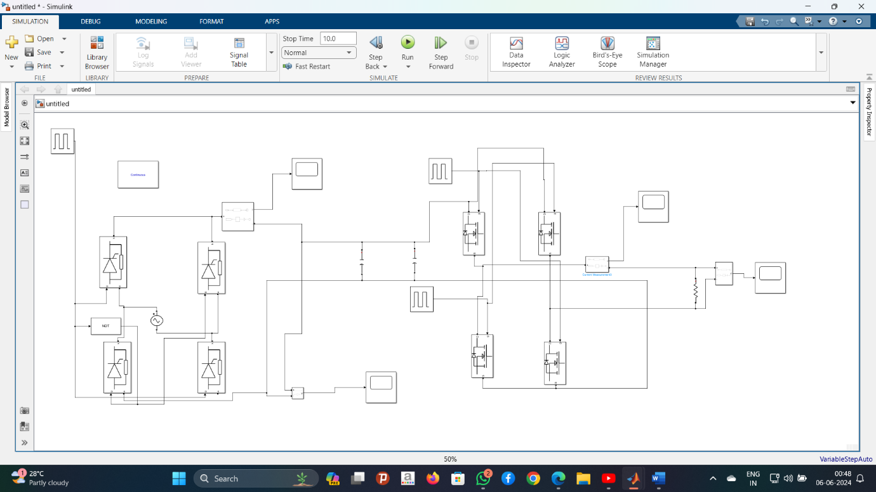

*Fig 3.12: Simulation of Converter Circuit*

The depicted diagram illustrates the converter circuit employed in this simulation, designed to transform input signals into both AC and DC forms. On the left side, the DC converter circuit is depicted, responsible for converting any input signal into DC. It comprises four thyristor modules arranged in parallel, with two of them triggered in opposite directions. On the right side, the AC section of the circuit is depicted, featuring four MOSFETs arranged similarly, with two oppositely triggered.

Various current and voltage measurement blocks are strategically placed throughout the circuit, connected to scopes for the measurement and analysis of voltage and current waveforms.

**3.4 Combined Simulation Models and Results**

**PV connected with Grid (Battery Charging):**

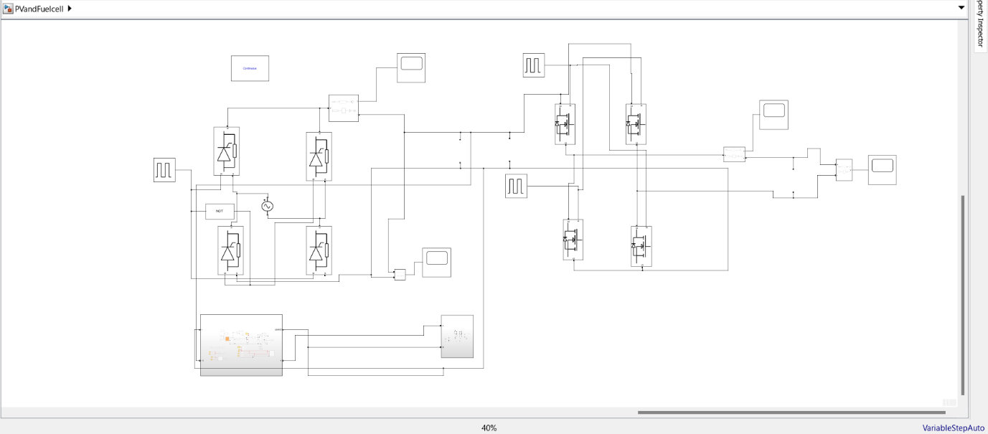

*Fig 3.13: Simulation of PV connected with Grid*

In this circuit, the PV and battery subsystems are interconnected before being linked to the grid. The ideal switch on the battery subsystem is set to 1, indicating that power is solely supplied to the grid by the PV system while the battery is charging. On the left side, the DC converter circuit, responsible for DC-DC conversion, is depicted. It comprises four thyristor modules connected in parallel, with two of them triggered oppositely. On the right side, the AC section of the circuit is depicted, where four MOSFETs are connected, with two oppositely triggered, facilitating the conversion of DC signals into AC signals. Various current and voltage measurement blocks are strategically positioned throughout the circuit, each connected to scopes for voltage and current waveform measurement and analysis.

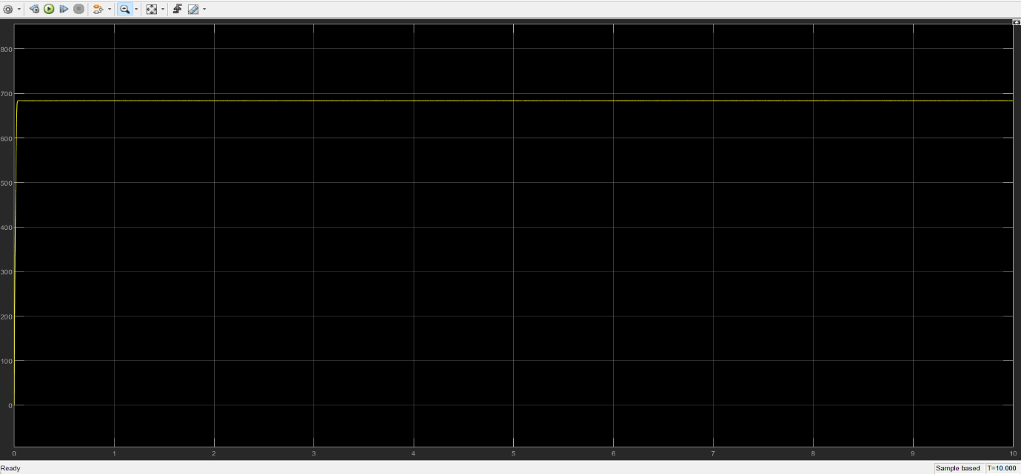

*Fig 3.14: Output Voltage at DC side of Simulation of PV connected with Grid*

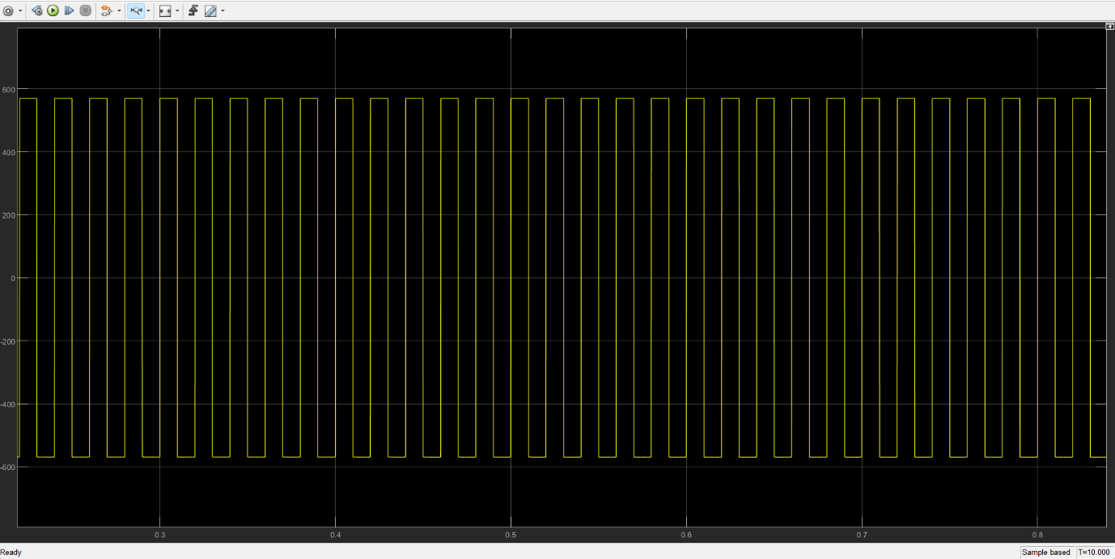

*Fig 3.15: Output Voltage at AC side of Simulation of PV connected with Grid*

In the above figures the DC side voltage is about 683V and the AC side voltage is in between +570V and -570V.

**Simulation of Battery Discharging at constant load:**

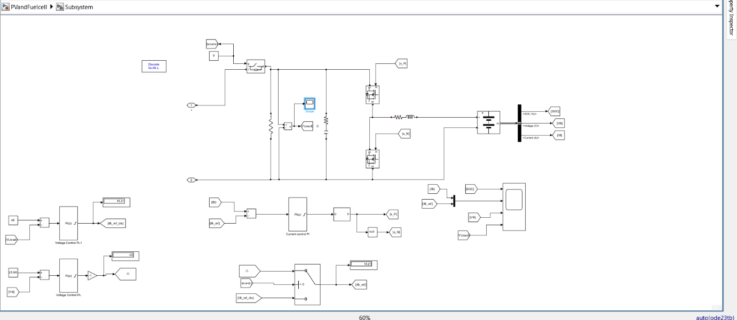

*Fig 3.16: Simulation of Battery Discharging*

This circuit utilizes a battery module, a DC-DC converter, and a shared load. During the charging mode, a PID controller regulates currents and voltages. The controller's output passes through various GOTO blocks and logical functions to generate gate pulses at different intervals for the converter. Another PID controller, receiving the output voltage and reference voltage, manages battery discharge against a fixed resistive load. Additionally, a switch, triggered by battery charging current, discharging current, and the power source, alternates between charging and discharging modes.



*Fig 3.17: Battery Discharging Result*

**Simulation of Fuel Cell Connected to Grid:**

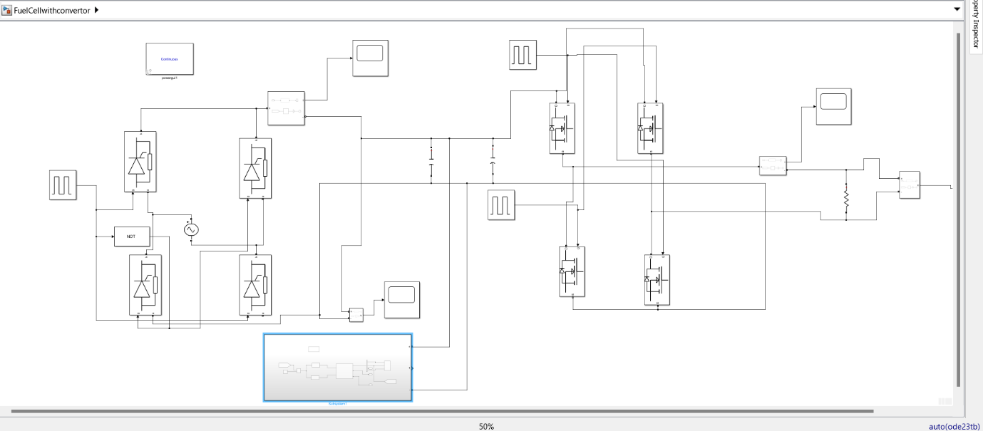

*Fig 3.18: Fuel Cell Connected to grid*

The illustrated circuit depicts the connection of the fuel cell to the grid. On the left side, there is the DC converter circuit responsible for DC-DC conversion. It comprises four thyristor modules connected in parallel, with two of them oppositely triggered. On the right side, the AC section of the circuit is depicted, where four MOSFETs are connected, with two oppositely triggered, facilitating the conversion of DC signals into AC signals. Various current and voltage measurement blocks are strategically positioned throughout the circuit, each connected to scopes for voltage and current waveform measurement and analysis.

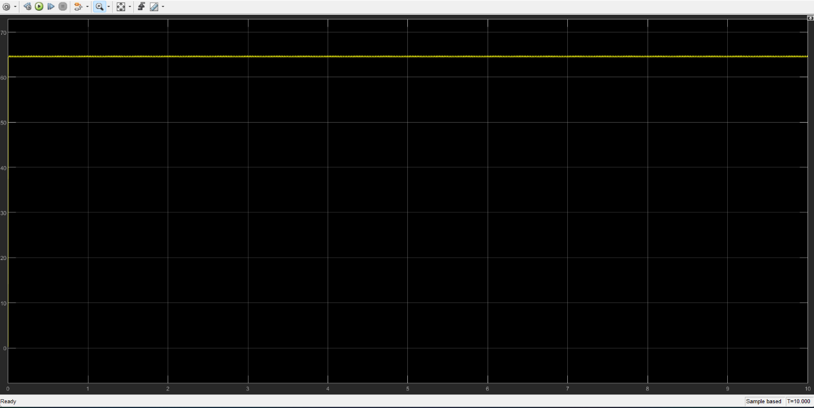

*Fig 3.19: DC Output Voltage when Fuel Cell is connected to Grid*

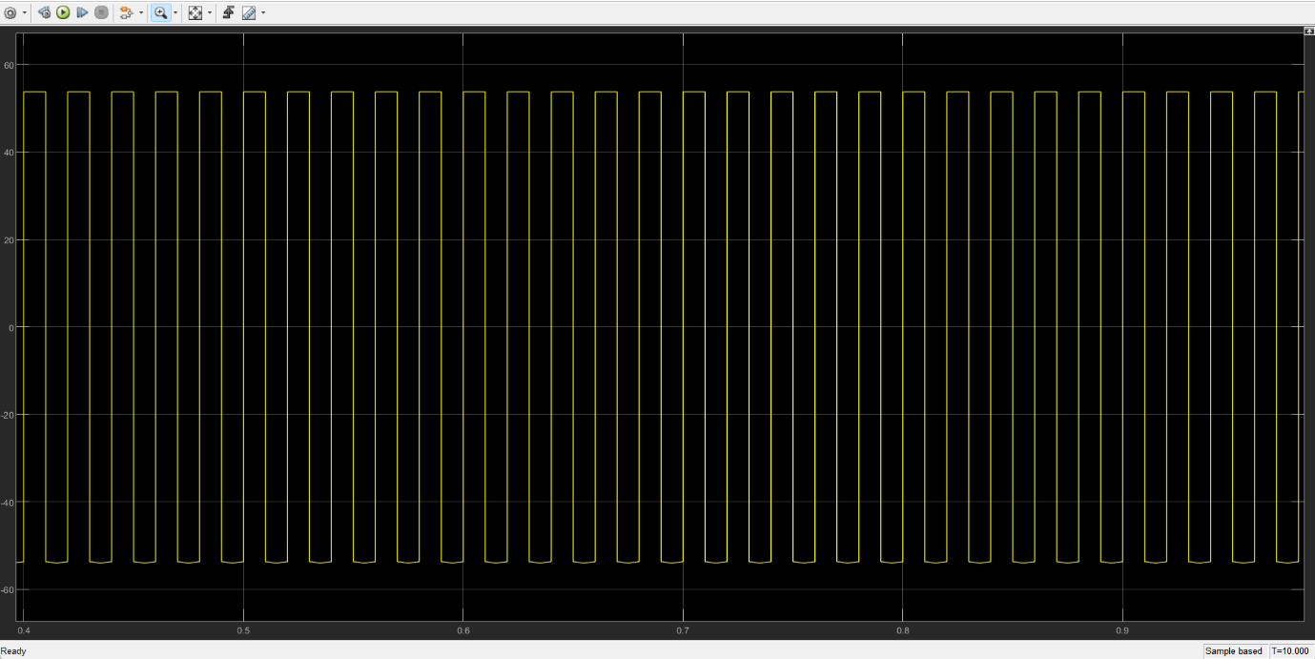

*Fig 3.20: AC Output Voltage when Fuel Cell is connected to Grid*

The DC side voltage is nearly equal to 62V whereas the AC side voltage fluctuates between +55V and -55V on connecting single fuel cell subsystems. The voltage range is too small to be connected to grid. But we can simulate the fuel cells in series to produce a desired voltage level which can supply the grid. An example of two fuel cells connected in series is shown below.

**Simulation of series connected fuel cells:**

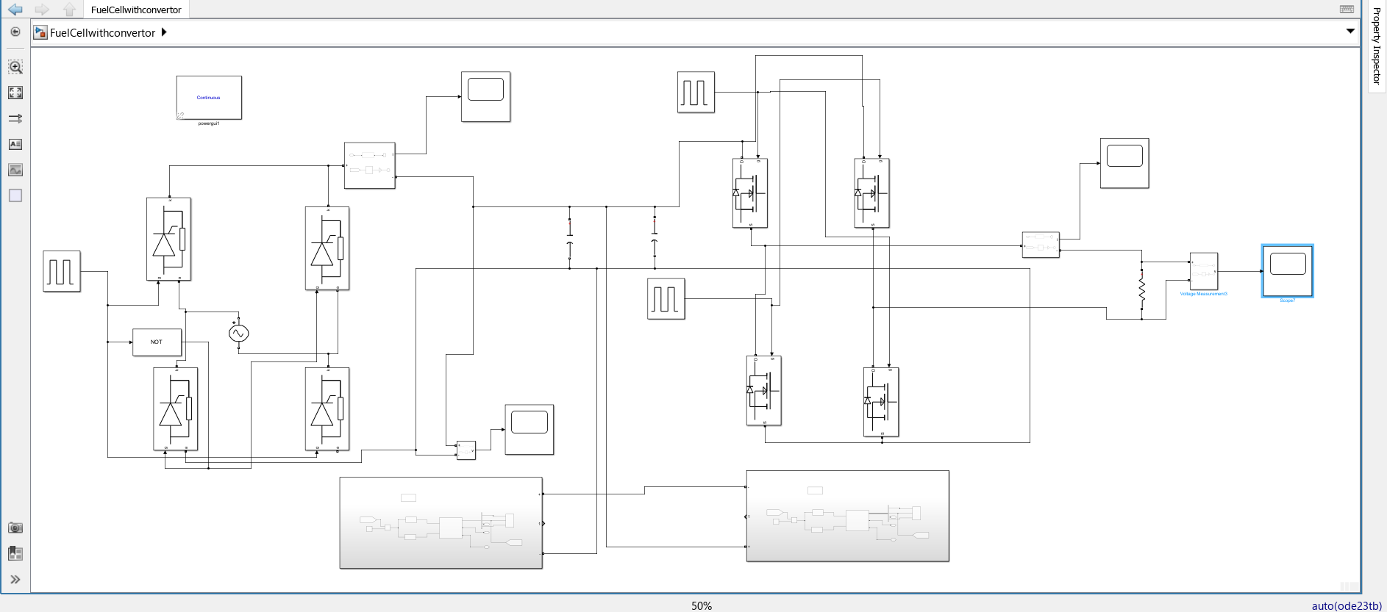

*Fig 3.21: Series connected fuel cells simulation*

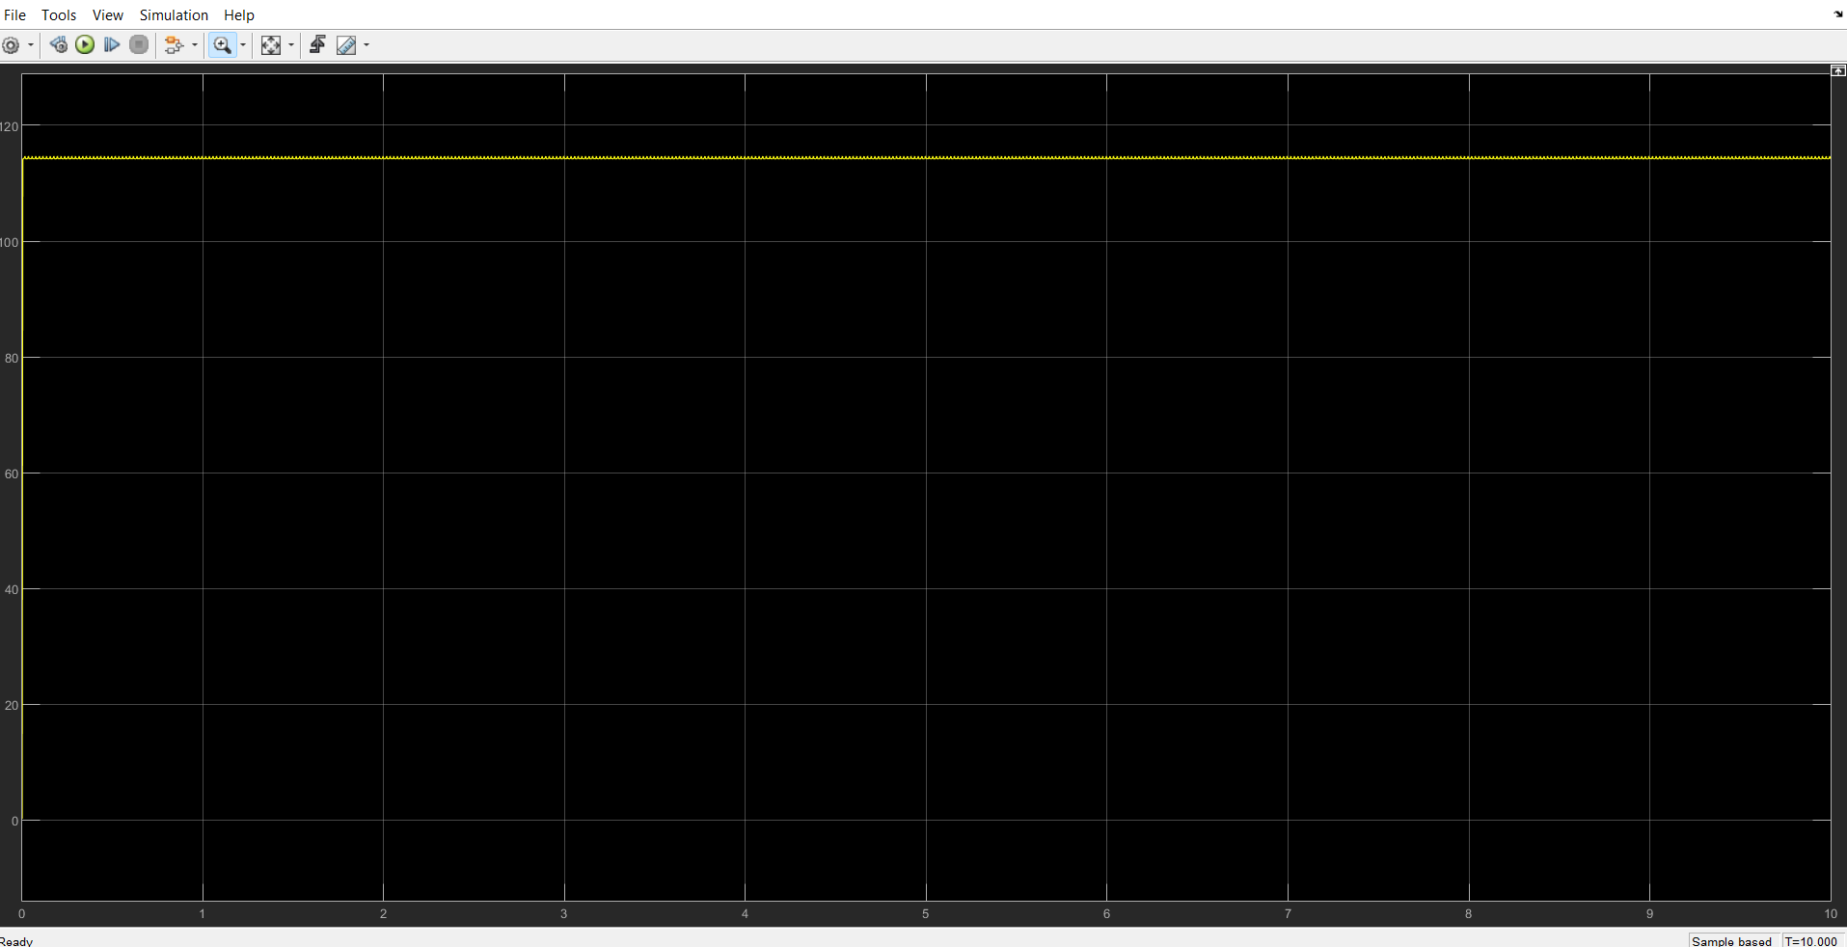

*Fig 3.22: DC Output Voltage of Series connected fuel cells*

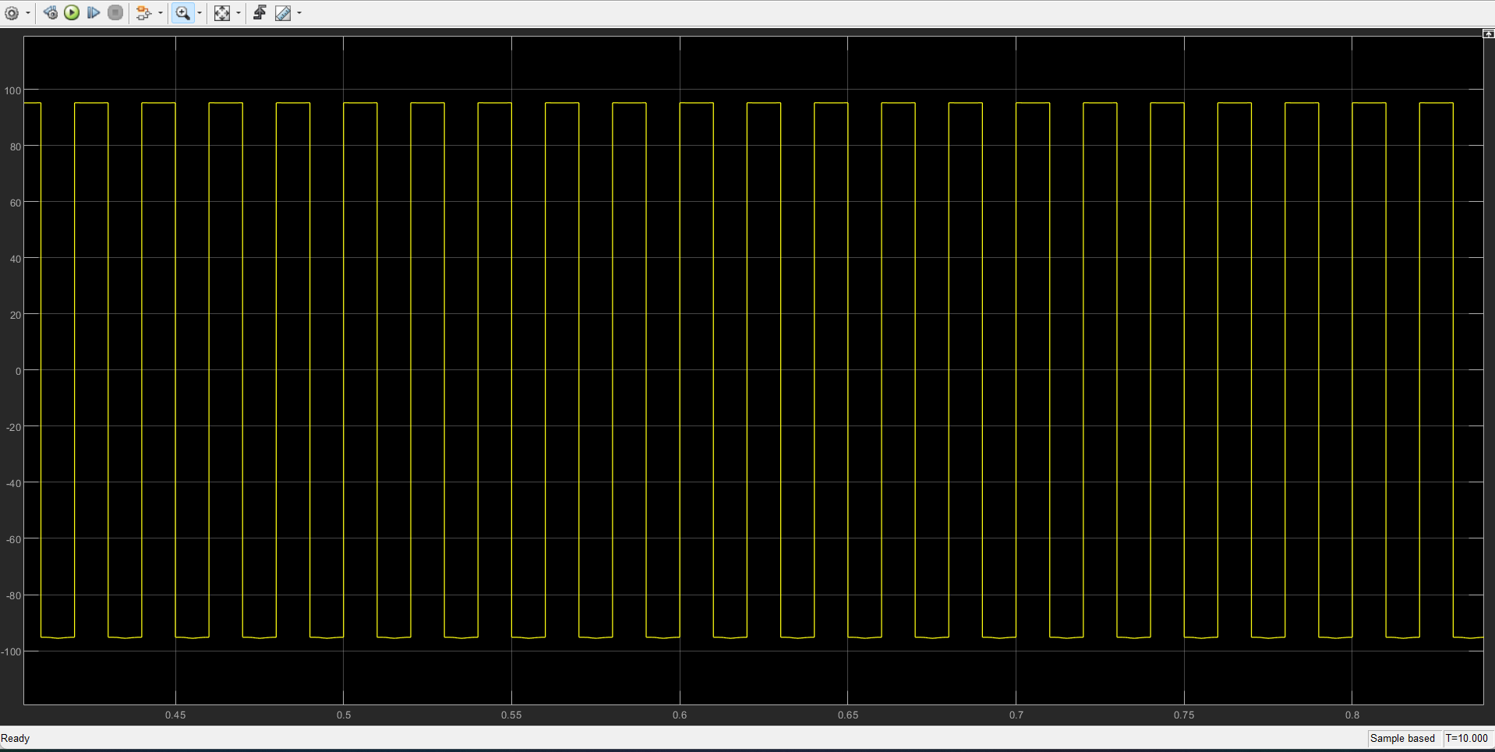

*Fig 3.23: AC Output Voltage of Series connected fuel cells*

The DC side output when two fuel cells are connected in series is 115V and AC side output is fluctuating between +98V and -98V. Here, we observe that the output in this case is almost double. So, we can add more fuel cells in series to match the grid voltage.

**Simulation of Wind and PV system connected to the grid:**

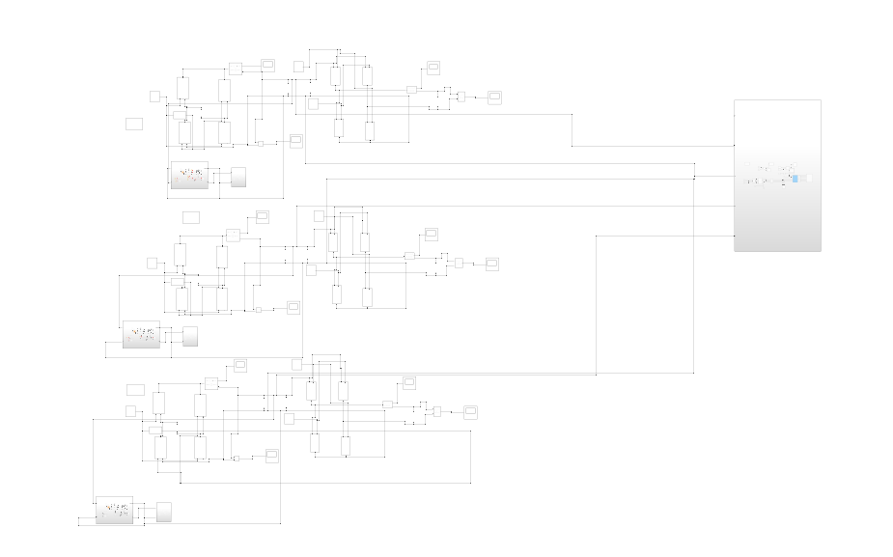

*Fig 3.24: Simulation of Wind and PV system connected to the grid*

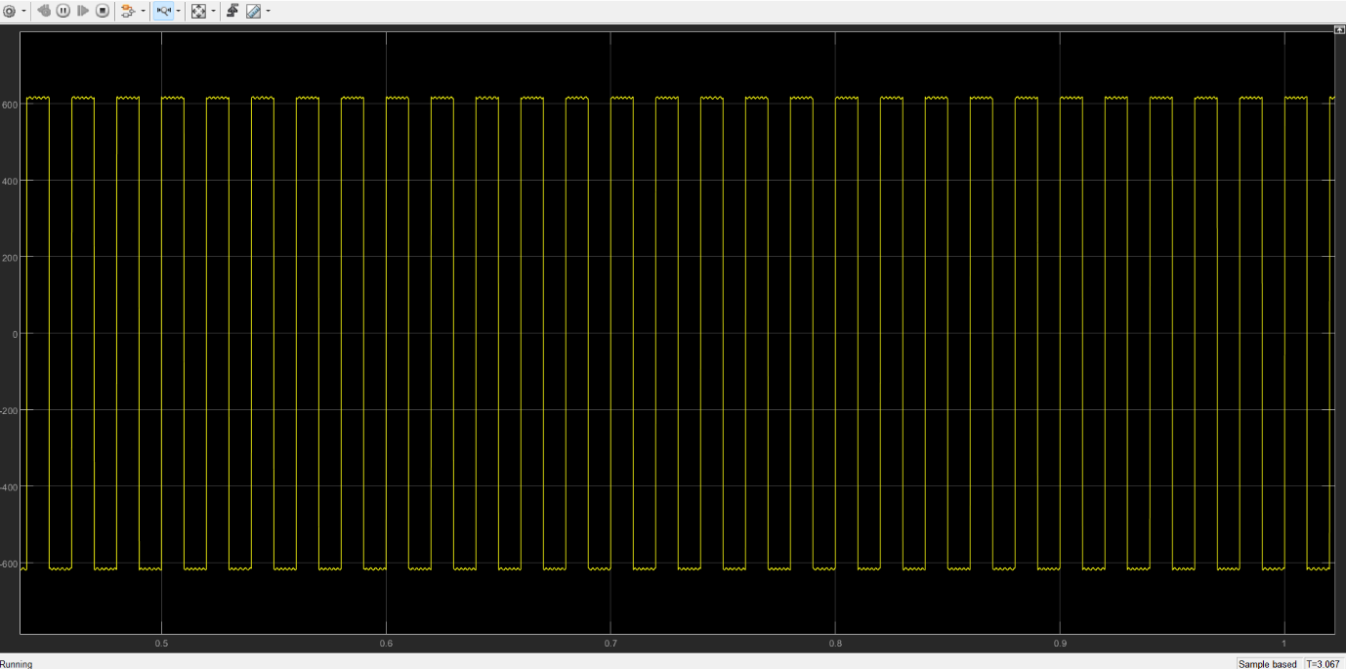

*Fig 3.25: AC side output voltage when PV and Wind system are connected to the grid*

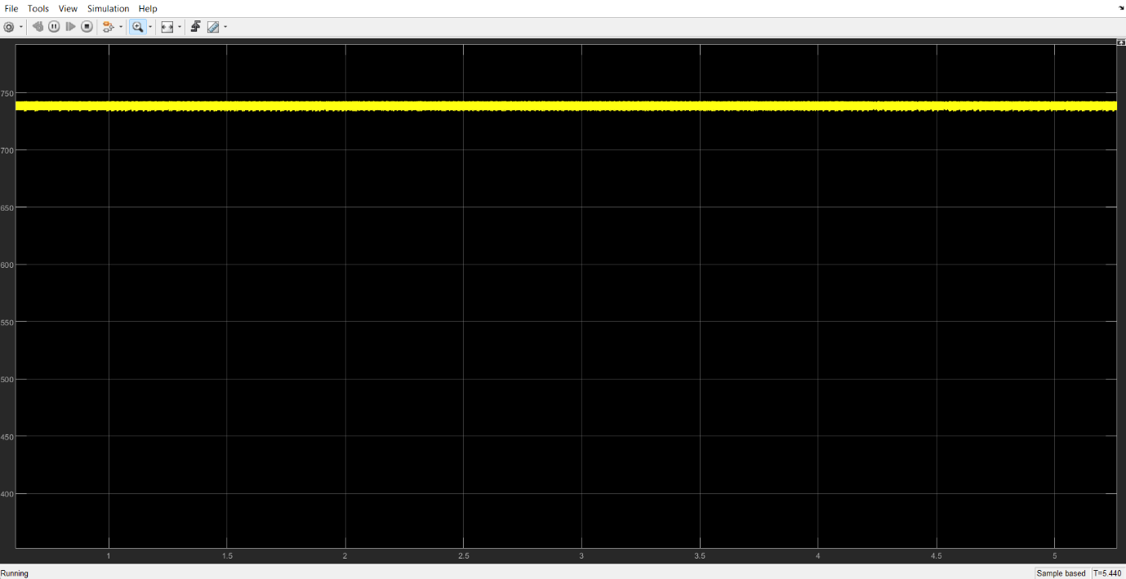

*Fig 3.26: DC side output voltage when PV and Wind system are connected to the grid*

The output voltage on the AC side is square sinusoidal wave and fluctuates between +600V and -600V whereas the DC is slightly less than 750V.

**CHAPTER 4**

**CONCLUSION**

**CHAPTER 4**

**CONCLUSION**

The proposed work focuses on to integrate PV system, wind energy system, fuel cells and battery storage in a microgrid system. Using MATLAB simulations, models have been developed for each system and implement in the microgrid. The behavior of individual systems and integrated systems have been studied by doing simulation of the model. This project aims at contributing to sustainable energy solutions by creating a holistic microgrid model that accurately represents the dynamic interactions between renewable sources and energy storage with microgrid.

**CHAPTER 5**

**BIBLIOGRAPHY**

**BIBLIOGRAPHY**

[1] Yi Xu, Jianhua Zhang, Wenye Wang, A. Juneja and S. Bhattacharya, **"Energy router: Architectures and functionalities toward Energy Internet,"** *IEEE International Conference on Smart Grid Communications (SmartGridComm),* Brussels, pp. 31-36, 2011.

[2] Eklas Hossain, Ersan Kabalci, Ramazan Bayindir, Ronald Perez (2014) **“A Comprehensive Study on Microgrid Technology,”** *International Journal of Renewable Energy Research,* Vol. 4, No. 4, 2014.

[3] Adam Hirscha, Yael Paraga, Josep Guerrero **“Microgrids: A review of technologies, key drivers, and outstanding issues”** *Energy reports,* Vol 90, pp 402-411, 2018.

[4] Bin Liu, Weihan Wu, Chunxiao Zhou, Chengxiong Mao, Dan Wang, Qing Duan, and Guanglin Sha, **"An AC–DC Hybrid Multi-Port Energy Router with Coordinated Control and Energy Management Strategies,"** *IEEE Access*, vol. 7, pp. 109069-109082, 2021.

[5] Firmansyah Nur Budiman, Makbul Anwari, Ahmad H. Milyani, Houssem R E H Bouchekara, Muhyaddin Rawa, Rifqi Firmansyah and Mustafa M.A. Seedahmed, **“Stochastic optimization for the scheduling of a grid-connected microgrid with a hybrid energy storage system considering multiple uncertainties,”** *Energy Reports*. vol. 8, pp. 7444-7456, 2022.

[6] R.S., S., Lakshmi, R. and Nair, M.G. **“AC microgrid with battery energy storage management under grid-connected and islanded modes of operation”** *Energy Reports,* vol 8, pp. 350–357, 2022.

[7] Mostafa Esmaeili Shayan, M., Najafi, G., Ghobadian, B., Mazlan, M. (2022) **“Sustainable design of a Near-Zero-Emissions Building Assisted by a Smart Hybrid Renewable Microgrid,”** *International Journal of Renewable Energy Development*, 11(2), 471-480, 2022.

[8] Rona George Allwyn, Amer Al-Hinai, Vijaya Margaret **“A comprehensive review on energy management strategy of microgrids,”** *Energy Reports*, vol 9, pp 5565-5591, 2023.

[9] Sayemul Islam, Naruttam Kumar Roy **“Renewables integration into power systems through intelligent techniques: Implementation procedures, key features, and performance evaluation,”** *Energy Reports*, vol 9, pp 6063-6087, 2023.