Project Report

On

**Electric Vehicle Battery Monitoring and Security System with Remote Access**



**Assam Engineering College**

**SUBMITTED BY-**

RAJDEEPA NEINA (19/037)

PAARAJ PRATIM BARDALOI (19/186)

SHEKHAR JYOTI BORAH (19/188)

SONU KUMAR SAH (19/200)

*Under the guidance of*

**Dr. Bimal Ch. Deka**

Professor

Department of Electrical Engineering

Assam Engineering College, Jalukbari, Guwahati-13

**Department of Electrical Engineering**

**Assam Engineering College, Jalukbari, Guwahati-13**

**ABSTRACT**

The electrical vehicle is going to be very common and primary mode of transportation in the near future. There are incidence of burning of electric vehicle due to inefficient battery management system. An efficient system which can monitor different parameters of an electric vehicle is very much necessary to protect from fault like overcurrent, overheating of motor, mechanical vibration etc. A system is highly needed to monitor all the high-tech information as well as unauthorized access to the electric vehicle.

In this project, an effort has been made to design an effective information system that can monitor and secure a vehicle while running on the road.

The proposed system which may be an android/iOS based “app” or application, offers endless monitoring of the vehicle for any suspicious movement where the vehicle are going to be fitted with a smart device having inbuilt G.P.S., a SIM card with internet facility, SMS/Notification sending interface. This system, using the concepts of “machine to machine communication” and “Internet of Things” will intimate the owner of the vehicle location just in case of the movement whenever detected.

Also in this project, we have proposed a framework that can differentiate between the “theft” and therefore the “tow” allowing users to require appropriate action.

**CERTIFICATE FROM THE SUPERVISOR**

This is to certify that the project entitled “**Electric Vehicle Battery Monitoring and Security System with Remote Access**” has been carried out and presented by:

Rajdeepa Neina (19/037)

Paaraj Pratim Bardaloi(19/186)

Shekhar Jyoti Borah(19/188)

Sonu Kumar Sah(19/200)

students of 7th semester (Electrical Engineering), Assam Engineering College, under my supervision and guidance in a manner satisfactory to warrant its acceptance as a prerequisite for the award of the degree of Bachelor of Technology in Electrical Engineering of Assam Science and Technology University.

Further, the report has not been submitted/reproduced in any form for the award of any other degree/diploma.

Date: Dr. Bimal Ch. Deka

Place: Guwahati Professor

Department of electrical engineering

Assam Engineering College

Jalukbari,Guwahati-13

**CERTIFICATE FROM THE HEAD OF THE DEPARTMENT**

This is to certify that the project entitled “**Electric Vehicle Battery Monitoring and Security System with Remote Access**” has been carried out and presented by:

Rajdeepa Neina (19/037)

Paaraj Pratim Bardaloi(19/186)

Shekhar Jyoti Borah(19/188)

Sonu Kumar Sah(19/200)

in partial fulfilment of the requirements for the award of the degree of Bachelor of Technology in Electrical Engineering of Assam Science and Technology University.

Date: Dr. Aroop Bardalai

Place: Guwahati Head of the Department

Department of Electrical Engineering

Assam Engineering College

Jalukbari, Guwahati-13

**ACKNOWLEDGEMENT**

We take this opportunity to express our sincere gratitude and heartiest thanks to our guide Dr. Bimal Ch. Deka, Department of Electrical, Assam Engineering College for his valuable guidance, cooperation and helpful suggestions throughout the course of our project. His keen interest in this topic has been a constant source of encouragement to all of us.

We would also like to express our heartiest thanks to our respected Head of the Department Dr.Aroop Bardalai for his valuable advice and help during this project.

Rajdeepa Neina (19/037)

Paaraj Pratim Bardaloi(19/186)

Shekhar Jyoti Borah(19/188)

Sonu Kumar Sah(19/200)

|  |
| --- |
| CONTENTS |

TOPIC PAGE NO.

CHAPTER 1: Introduction 1-3

* 1. Research Background 1
  2. Problem Statement 2
  3. Scope Of Study 2
  4. Objective of the Study 3
  5. Features 3

CHAPTER 2: Literature review 4-5

CHAPTER 3: Technology used 6-11

3.1 Embedded system 6

3.2 IoT Technology 7

3.3 Background of IoT Technology 8

3.4 How iot Works 9

3.5 Web Technology 10

3.6 Wi-Fi Communication 10

3.7 Advantages of Wi-Fi communication 11

3.8 Limitations of Wi-Fi communication 11

CHAPTER 4: Methodology 12-15

4.1 Block Diagram 12-13

4.2 Circuit Diagram 13

4.3 Working Principle 13-14

4.4 Flowchart 15

CHAPTER 5: Components Used 16-35

CHAPTER 6: Result and discussion 36

CHAPTER 7: Conclusion 37

BIBLOGRAPHY 38

**LIST OF ABBREVIATIONS**

EV: Electric Vehicle

BMS: Battery Monitoring System

CS: Current Sensor

VS: Voltage Sensor

TS: Temperature Sensor

ADC: Analog to Digital Converter

AREF: Analog Reference

LCD: Liquid Crystal Display

IOT: Internet of things

VR: Voltage Regulator

GND: Ground

**LIST OF TABLES AND FIGURES**

**LIST OF TABLE Page No.**

Table 5.1 ESP32 Features 20

Table 5.2 pin configuration of Current Sensor 26

Table 5.3 Current sensor features 27

Table 5.4 Voltage Sensor Features 31

Table 5.5 ATMEGA328P features 32

Table 6.1 Results 36

**LIST OF FIGURES**

Fig 3.1 Pin diagram of embedded system 6

Fig 3.2 IOT 7

Fig 4.1 Block Diagram 12

Fig 4.2 Circuit Diagram 13

Fig 4.4 Flowchart Of Our Model 15

Fig 5.1 ESP32 Diagram 16

Fig 5.2 Pin Diagram of Esp32 19

Fig 5.3 LCD 21

Fig 5.4 Pin diagram of LCD 22

Fig 5.5 Temperature Sensor 24

Fig 5.6 Current Sensor 26

Fig 5.7 Pin Diagram of Current Sensor 27

Fig 5.8 Voltage Sensor 28

Fig 5.9Pin Diagram of voltage sensor 29

Fig 5.10 Schematic of Voltage sensor module 30

Fig 5.11 Atmega328P 32

**CHAPTER 1**

**INTRODUCTION**

Today we live in the time where the security of one’s assets are of the top priority concerns for one, their vehicles being one of these. Every individual feels the necessity of monitoring their vehicle parked in unknown vicinity. The vehicle may or might not be fitted with an alarm and therefore the alarm may or might not trigger. The proposed system will monitor the vehicle continuously. The vehicle will be fit with a smart device with a Global Positioning System (G.P.S.), internetwork and different sensors like temperature sensor, current sensor, voltage sensor, etc.

Internet of Things (IoT) is nothing but the devices (things) communicating with each other by using the internet. IoT may be a trend-setting innovation during which all the information from sensors is stored in the cloud/database where it can be easily accessed from the cloud. We use cloud/database not only to store data but also for data analysis, gathering, visualization. Most thefts creates serious problem that is to be considered. So to overcome these issues we planned a device for observing and controlling framework. We have utilized distinctive sensors and gathered data from every sensor. And then data is analyzed and we have utilized a GPS module to track the data and here the microcontroller we have used is ESP32.

**1.1 Background**

Vehicle tracking system is getting popular and widely used in a lot of countries worldwide. It has tons of advantages to users even more to the vehicle users in which it will make it easier for them to track their vehicles. Nowadays, everyone cannot be separated from their smartphones. A number of five thousands individuals from USA, UK, South Korea, India, China, South Africa, Indonesia and Brazil took a survey regarding which was done by Time magazine. The result proved most of them is inseparable from their smartphones, eighty four per cent allegedly claimed that survive without their smartphones. Another study shows that seventy five per cent of the market share is smartphone and a total of one hundred and six million smartphone were shipped in the second half of 2012. Smartphone became the top telecommunication medium in the market in the present time worldwide and it became the most popular used telecommunication medium known to man. So, from the above mentioned survey now it’s clear that how smartphones became important and integral part of our modern day life, that’s the reason to make this vehicle tracking system text message oriented so that we can take care of our own vehicle in just one touch of our hand. Through smart phone we can track real time location of our vehicle with the help of internet connection. In such a manner, this tracking system designed so that users can have easy and user friendly interface to fetch their vehicle.

**1.2 Problem statement**

In the present day vehicle tracking is becoming essential for the purpose of improving our life condition. Convenience and ease of using vehicle is what home vehicle tracking is offering. Vehicle tracking offers a futuristic way of life in which an individual gets to control his vehicle using a smart phone, from tracking a vehicle /detecting accidental place of a vehicle; it also offers an efficient use of technology. But to get or acquire such system installed will cost a lot of money and that is the major reason of why vehicle tracking has not received much demand and attention, adding to that also the complexity of installing it and configuring it. Thus it is essential to make it cost effective and easy to configure. If this is granted to people then they will be willing to acquire it in their personal vehicles, school buses and taxes/cabs etc. In other words, a system modification for the vehicle tracking is required in order to lower the price of applying it to vehicles. Also this tracking project can be used to purpose of women safety as well as parents can be used to take care of their child/kid for the safety or missing purpose or to track their activities for their future. Even more realistically this project can be used to track airline baggage because as we know every year almost 13% airline baggage used to get missing by a worldwide survey.

**1.3 Scope of study**

In order to fulfil the stated objectives several steps must be taken. These steps involve both software programming and hardware implementation. These steps are as follows:

* Establishing a wireless network communication between the GSM module and the smart phone, using a microcontroller (Arduino-Uno).
* Create a simple yet reliable vehicle tracking system using Arduino-Uno as a microcontroller that will be the medium between the GPS and the GSM module so that embedded system works efficiently
* To find a suitable place locator app (in this project we are using Google Maps) that will work efficiently with the internet connection (online as well as offline) in order to track the vehicles.
* Program the Arduino-Uno board in a way that will let it interact with the GPS and GSM module directly and easily.

**Significance of the study**

This study will be undertaken to create a vehicle tracking system at low cost and easy to create. This will benefit both the manufacturer and the client. It will help the manufacturer by making it easy and cheaper to apply it, and it will also benefit the clients by making it cost effective. And the most important advantage is that it will make the vehicle a much mor safer than its actually for the clients.

**1.5 Objective of the study**

The primary objective of the proposed system is to design a sensor based network that implement WSN (Wireless Sensor Network) to monitor the following parameters-

* Voltage of the battery
* Flow of current throughout the system
* Temperature of the battery to prevent from burn out.
* Temperature of the electric motor to prevent from prospective damage.
* Remote access of the vehicle to prevent from unauthorized use and vehicle theft.

**1.6 Features**

* User authentication based on user ID and password
* Remote locking system
* Motor deactivation multiuser system
* Storage of data for further analysis

**CHAPTER 2**

**LITERATURE REVIEW**

Battery monitoring in vehicle plays a vital role in battery critical applications where backup is quite crucial for operation of the load. The text reviews that most research result on common types of battery monitoring systems methods, systems and their impact .The relation of IoT system and monitoring system is described in more details. The goal is to inform users regarding the present state of the battery, failure conditions of batteries and alert the users with remote access. If health of the battery is monitored, preventive action can be taken to avoid any damage and eventually safeguarding the battery from damage.

A lot of efforts have been made by many researchers for automation of the battery monitoring system in vehicles. A Vehicle detection and tracking system IoT based system is discussed by Mohammad F, Alrifae 1,2,Norharyati Harum1,Mohd Fairuz Iskandar Othman1,Irda Roslan1.The author has designed this system using GPS and GSM modem. The main processing units they have considered is ARM7 based processor LPC2148. ARM7 is wastage of resource and cost as vehicle tracking system doesn’t need Hugh processing power. ATMFG 16based microprocessor which is comparatively efficient but cost effective than ARM 7 is designed by Patole Gitanjali, Shide Jyoti, Salve Satish, Vipul Ranjan Kaushik,Puri S.B in“IOT based Vehicle Tracking & VVehicular Emergency System”. The author is using an ADXL based accelerometer to identify the position of the vehicle to detect any abnormal position which may lead to or identify accident of the vehicle.

In “Battery Management System in Electric vehicles” by. I. Priyanka, R. Sandeep, V. Ravi, O. Shekar, the battery management clearly which helps us to understand the BMS system is been explained. They have clearly specified state of charge, state of health and thermal management system which is important design and efficient system. IOT based vehicle health monitoring system that is embedded for the detection the condition of a vehicle by monitoring the internal parameters such as heating rate etc is explained by S kumar Reddy, V.V. venella in “IOT bases smart Vehicle monitoring System”. They also include a real time vehicle health monitoring system is designed and developed to detect and identify fault on vehicle .The hardware part like LCD, microcontroller ,ADC,MQ7 etc is used . An anti-stealing system which is used to track a automobile and which works using GPS and GSM Modules is explained byShaik Maznu ,G.Deekshitha ,G. Bhavana ,P.Yeshwanth ,K. Rajesh in ”Vehicle tracking system using IOT technology” .It is an embedded system which is used for tracking .The main aim of the project is to monitor a moving automobile and send the status of the automobile on user demand .Here, the author uses a GSM modem to send the position of the automobile.

Boddapati Venkata Sai Padma, Venkata Ratnam Kolluru , Syam Sai Kota has used an ultrasonic sensor to identify the distance between two vehicle or any object which can prevent from perspective accident by activating an alarm system. They have also used MQ3 based alcohol detection system to monitor if driver is drunken or not. A DHT11 sensor using to measure temperature and humidity. The DHT11 is used to measure humidity of air but instead of that they could have used a temperature sensor which can detech the temperature of the engine Or the motor of an electric vehicle.Yogesh Kr. Mallick, Anamika Talukdar, Debleena Bhattacharjee, Sandipan RYogesh Kr. Mallick have designed a simple vehicle health monitoring system.It is designed to analyse the health condition of a vehicle on the basis of physical parameters of its engine. The hardware part consists of microprocessor which is responsible for collecting and processing data based on various parameters from the vehicle using sensors and send to the server over a unique IP address whereas the software part which consists of a web application and is responsible for receiving the data and store it which can be retrieved later to create health report of the vehicle. The web application makes use of PHP, HTML and MySQL for receiving and storing the data. WAMP server is used to create dummy server for hosting the application.

Electric Vehicle Battery Monitoring and security system with remote access, Advance in electric and electronic engineering.

Advantages:

* Ensures that the battery is in good working order.
* Battery health is continuously monitored to avoid an explosion.
* It is cost saving and also provides employee tracking,improved safety and instant alerts.

**CHAPTER 3**

**TECHNOLOGY USED**

**3.1 Embedded system**

An **embedded system** is a special-purpose system in which the computer is completely encapsulated by or dedicated to the device or system it controls. Unlike a general-purpose computer, such as a personal computer, an embedded system performs one or a few predefined tasks, usually with very specific requirements. Since the system is dedicated to specific tasks, design engineers can optimize it, reducing the size and cost of the product. Embedded systems are often mass-produced, benefiting from economies of scale.

Personal digital assistants (PDAs) or handheld computers are generally considered embedded devices because of the nature of their hardware design, even though they are more expandable in software terms. This line of definition continues to blur as devices expand. With the introduction of the OQO Model 2 with the Windows XP operating system and ports such as a USB port — both features usually belong to "general purpose computers", — the line of nomenclature blurs even more.

Physically, embedded systems ranges from portable devices such as digital watches and MP3 players, to large stationary installations like traffic lights, factory controllers, or the systems controlling nuclear power plants.

In terms of complexity embedded systems can range from very simple with a single microcontroller chip, to very complex with multiple units, peripherals and networks mounted inside a large chassis or enclosure.

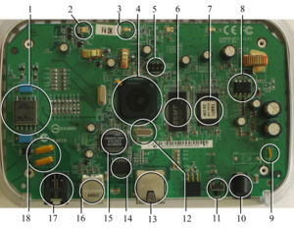

**Fig 3.1**: Pin diagram of embedded system

**Examples of Embedded Systems:**

* Avionics, such as inertial guidance systems, flight control hardware/software and other integrated systems in aircraft and missiles
* Cellular telephones and telephone switches Engine controllers and antilock brake controllers for automobiles
* Home automation products, such as thermostats, air conditioners, sprinklers, and security monitoring systems
* Handheld calculators
* Handheld computers
* Household appliances, including microwave ovens, washing machines, television sets, DVD players and recorders
* Medical equipment
* Personal digital assistant
* Videogame consoles
* Computer peripherals such as routers and printers.
* Industrial controllers for remote machine operation.

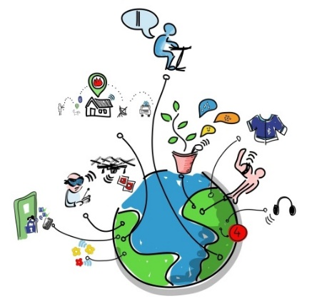**3.2 IoT Technology**

**3.2.1:Introduction**

Fig 3.2 IOT

The **Internet of Things** (**IoT**) is a system of interrelated computing devices, mechanical and digital machines, objects, animals or people that are provided with unique identifiers and the ability to transfer data over a network without requiring human-to-human or human-to-computer interaction. The IoT allows objects to be sensed or controlled remotely across existing network infrastructure, creating opportunities for more direct integration of the physical world into computer-based systems, and resulting in improved efficiency, accuracy and economic benefit in addition to reduced human intervention. When IoT is augmented with sensors and actuators, the technology becomes an instance of the more general class of [cyber-physical systems](https://en.wikipedia.org/wiki/Cyber-physical_system), which also encompasses technologies such as [smart grids](https://en.wikipedia.org/wiki/Smart_grid), [virtual power plants](https://en.wikipedia.org/wiki/Virtual_power_plant), [smart homes](https://en.wikipedia.org/wiki/Smart_home), [intelligent transportation](https://en.wikipedia.org/wiki/Intelligent_transportation) and [smart cities](https://en.wikipedia.org/wiki/Smart_city).

**3.2.2: The background of IoT**

As of 2016, the vision of the Internet of things has evolved due to a convergence of multiple technologies, including ubiquitous wireless communication, real-time [analytics](https://en.wikipedia.org/wiki/Analytics), [machine learning](https://en.wikipedia.org/wiki/Machine_learning), commodity sensors, and [embedded systems](https://en.wikipedia.org/wiki/Embedded_system). This means that the traditional fields of embedded systems, [wireless sensor networks](https://en.wikipedia.org/wiki/Wireless_sensor_network), [control systems](https://en.wikipedia.org/wiki/Control_system), [automation](https://en.wikipedia.org/wiki/Automation)(including [home](https://en.wikipedia.org/wiki/Home_automation) and [building automation](https://en.wikipedia.org/wiki/Building_automation)), and others all contribute to enabling the Internet of things.

The concept of a network of smart devices was discussed as early as 1982, with a modified Coke machine at [Carnegie Mellon University](https://en.wikipedia.org/wiki/Carnegie_Mellon_University) becoming the first Internet-connected appliance, able to report its inventory and whether newly loaded drinks were cold. [Mark Weiser](https://en.wikipedia.org/wiki/Mark_Weiser)'s seminal 1991 paper on [ubiquitous computing](https://en.wikipedia.org/wiki/Ubiquitous_computing), "The Computer of the 21st Century", as well as academic venues such as UbiComp and PerCom produced the contemporary vision of IoT. In 1994 Reza Raji described the concept in [*IEEE Spectrum*](https://en.wikipedia.org/wiki/IEEE_Spectrum) as "[moving] small packets of data to a large set of nodes, so as to integrate and automate everything from home appliances to entire factories". Between 1993 and 1996 several companies proposed solutions like [Microsoft](https://en.wikipedia.org/wiki/Microsoft)'s [at Work](https://en.wikipedia.org/wiki/At_Work) or [Novell](https://en.wikipedia.org/wiki/Novell)'s [NEST](https://en.wikipedia.org/wiki/Novell_Embedded_Systems_Technology). However, only in 1999 did the field start gathering momentum. [Bill Joy](https://en.wikipedia.org/wiki/Bill_Joy) envisioned [Device to Device (D2D)](https://en.wikipedia.org/wiki/Device-to-device) communication as part of his "Six Webs" framework, presented at the World Economic Forum at Davos in 1999.

The concept of the Internet of things became popular in 1999, through the [Auto-ID Center](https://en.wikipedia.org/wiki/Auto-ID_Labs) at [MIT](https://en.wikipedia.org/wiki/Massachusetts_Institute_of_Technology) and related market-analysis publications. Radio-frequency identification ([RFID](https://en.wikipedia.org/wiki/RFID)) was seen by [Kevin Ashton](https://en.wikipedia.org/wiki/Kevin_Ashton) (one of the founders of the original [Auto-ID Center](https://en.wikipedia.org/wiki/Auto-ID_Labs)) as a prerequisite for the Internet of things at that point. [Ashton](https://en.wikipedia.org/wiki/Kevin_Ashton) prefers the phrase "Internet *for*things." If all objects and people in daily life were equipped with identifiers, computers could manage and store them. Besides using RFID, the [tagging](https://en.wikipedia.org/wiki/Tag_(metadata)) of things may be achieved through such technologies as [near field communication](https://en.wikipedia.org/wiki/Near_field_communication), [barcodes](https://en.wikipedia.org/wiki/Barcodes), [QR codes](https://en.wikipedia.org/wiki/QR_codes) and [digital watermarking](https://en.wikipedia.org/wiki/Digital_watermarking).

In its original interpretation,one of the first consequences of implementing the Internet of things by equipping all objects in the world with minuscule identifying devices or machine-readable identifiers would be to transform daily life. For instance, instant and ceaseless [inventory control](https://en.wikipedia.org/wiki/Inventory_control) would become ubiquitous .A person's ability to interact with objects could be altered remotely based on immediate or present needs, in accordance with existing [end-user](https://en.wikipedia.org/wiki/End-user) agreements. For example, such technology could grant motion-picture publishers much more control over end-user private devices by remotely enforcing [copyright](https://en.wikipedia.org/wiki/Copyright) restrictions and [digital rights management](https://en.wikipedia.org/wiki/Digital_rights_management), so the ability of a customer who bought a [Blu-ray disc](https://en.wikipedia.org/wiki/Blu-ray_disc) to watch the movie could become dependent on the copyright holder's decision, similar to Circuit City's failed [DIVX](https://en.wikipedia.org/wiki/DIVX).

A significant transformation is to extend "things" from the data generated from devices to objects in the physical space. The thought-model for future interconnection environment was proposed in 2004. The model includes the notion of the ternary universe consists of the physical world, [virtual world](https://en.wikipedia.org/wiki/Virtual_world) and mental world and a multi-level reference architecture with the nature and devices at the bottom level followed by the level of the Internet, sensor network, and mobile network, and intelligent human-machine communities at the top level, which supports geographically dispersed users to cooperatively accomplish tasks and solve problems by using the network to actively promote the flow of material, energy, techniques, information, knowledge, and services in this environment. This thought model envisioned the development trend of the Internet of things.

**3.2.3: How IoT Works**

The Internet of Things (IoT), also sometimes referred to as the Internet of Everything (IoE), consists of all the web-enabled devices that collect, send and act on data they acquire from their surrounding environments using embedded sensors, processors and communication hardware. These devices, often called "connected" or "smart" devices, can sometimes talk to other related devices, a process called machine-to-machine(M2M) communication, and act on the information they get from one another. Humans can interact with the gadgets to set them up, give them instructions or access the data, but the devices do most of the work on their own without human intervention. Their existence has been made possible by all the tiny mobile components that are available these days, as well as the always-online nature of our home and business networks.

Connected devices also generate massive amounts of Internet traffic, including loads of data that can be used to make the devices useful, but can also be mined for other purposes. All this new data, and the Internet-accessible nature of the devices, raises both privacy and security concerns.

But this technology allows for a level of real-time information that we've never had before. We can monitor our homes and families remotely to keep them safe. Businesses can improve processes to increase productivity and reduce material waste and unforeseen downtime. Sensors in city infrastructure can help reduce road congestion and warn us when infrastructure is in danger of crumbling. Gadgets out in the open can monitor for changing environmental conditions and warn us of impending disasters.These devices are popping up everywhere, and these abilities can be used to enhance nearly any physical object.

**3.3: WEB TECHNOLOGY**

WEB technology refers to the means by which computers communicate with each other using markup languages and multimedia packages. It gives us a way to interact with hosted information, like websites. Web technology involves the use of hypertext markup language (HTML) and cascading style sheets(CSS).

In past few decades, web technology has undergone a dramatic transition , from a few marked up web pages to the ability to do very specific work on a network without interruption.

**3.4: WIFI COMMUNICATION**

**3.4.1 Introduction**

**WiFi** or **Wi-Fi** is a technology for [wireless local area networking](https://en.wikipedia.org/wiki/Wireless_LAN) with devices based on the [IEEE 802.11](https://en.wikipedia.org/wiki/IEEE_802.11) standards. Wi-Fi is a trademark of the [Wi-Fi Alliance](https://en.wikipedia.org/wiki/Wi-Fi_Alliance), which restricts the use of the term Wi-Fi certified to products that successfully complete [interoperability](https://en.wikipedia.org/wiki/Interoperability) certification testing .Wi-Fi most commonly uses the 2.4 gigahertz [UHF](https://en.wikipedia.org/wiki/UHF) and 5.8 gigahertz [SHF](https://en.wikipedia.org/wiki/Super_high_frequency) [ISM](https://en.wikipedia.org/wiki/ISM_band) radio bands. Anything within range with a [wireless modem](https://en.wikipedia.org/wiki/Wireless_modem) can attempt to access the network; because of this, Wi-Fi is more vulnerable to attack (called eavesdropping) than wired networks. Wi-Fi Protected Access is a family of technologies created to protect information moving across Wi-Fi networks and includes solutions for personal and enterprise networks. Security features of Wi-Fi Protected Access constantly evolve to include stronger protections and new security practices as the security landscape changes. Increasingly in the last few years (particularly as of 2007), embedded Wi-Fi modules have become available that incorporate a real-time operating system and provide a simple means of wirelessly enabling any device which has and communicates via a serial port. This allows the design of simple monitoring devices. An example is a portable ECG device monitoring a patient at home. This Wi-Fi-enabled device can communicate via the Internet.

**3.4.2: Advantage of Wi-Fi Communication**

* Convenient
  + Useful for smartphones, tablet devices and other portable devices to connect at any convenient location within premises.
* Simplicity
  + To connect a new device with a network, simply turn on the Wi-Fi and do the simple configuration settings.
* Mobility
  + Internet can be accessed from anywhere, i.e. Bus, train, coffee-shop, super market, etc.
* Expandability
  + It is convenient to add more wireless devices with current hardware settings without any cost and time.
* Efficiency
  + Wi-Fi enabled devices are used at offices for convenient to access their files at any location and it gives more productivity for the company.
* Cost Control
  + In Wi-Fi network devices can be added without any cost unlike cables needs to be get man power to do the job.
* Standardization of Technology
  + Wi-Fi technology has standardized for all countries, it helps for the mobile devices to connect the Wi-Fi regardless of the location.

**3.4.3: Limitation of Wi-Fi Communication**

* Performance/Speed
  + Although Gigabit Wi-Fi is available in the market, we cannot get the gigabit speed at all locations. Now cable network has 10 Gbps speed.
* Connectivity/Reliability
  + Wi-Fi signal is depends on the interference. i.e. Concrete wall will reduce the signal strength. Also, there is a limit for distance to connect Wi-Fi signals.
* Security
  + Wi-Fi router has various encryption methods to secure our network password.
* Unlicensed spectrum invites congestion from a range of other devices using the ISM band, from cordless phones to baby monitors, and now LTE-U cellular service can encroach on the same frequencies
* Since 802.11n (2009), no new Wi-Fi standard has improved on the maximum range of 230 feet indoors, and 802.11ac’s throughput advantages are unremarkable at 100 feet or more
* Wi-Fi throughput is difficult to estimate due to modulation, coding, and carrier sensing, increasing the information costs of researching hardware purchases, which leads consumers to buy range extenders that contribute to spectrum pollution
* Another new standard is always just on the horizon, encouraging planned obsolescence among manufacturers.

**CHAPTER 4**

**METHODOLOGY**

**4.1 Block Diagram**

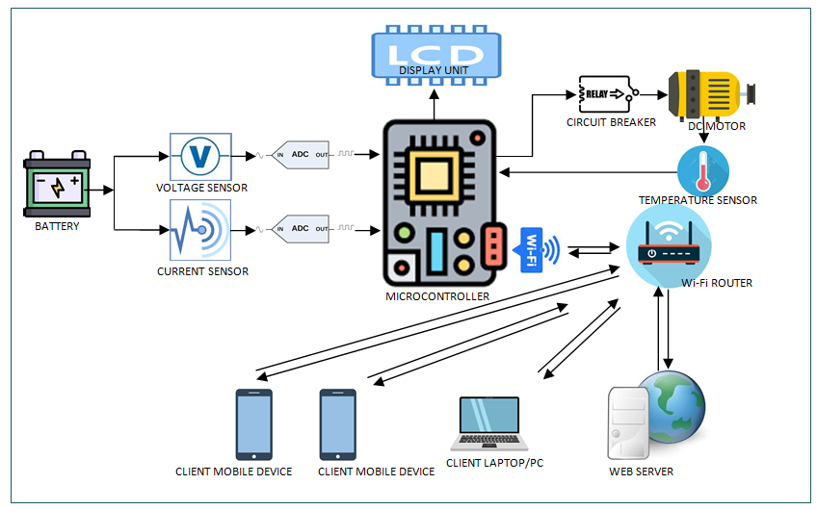

**Fig 4.1 BLOCK DIAGRAM**

The Primary objective is to measure the battery health of a Electric Vehicle. To do so,we are using a voltage sensor and a current sensor which is responsible for collecting the voltage and current from battery. The both sensor are analog type and we need the value in digital form we are using ADC from analog to digital converter. It connects to microcontroller as we are going to use ESP32 the ADC we inbuilt in microcontroller itself.

Now the voltage and Current from the sensor will be calculated and displayed on LCD. At the same time we can calculate the power (VI) . Hence Voltage, Current and Power will be displayed in LCD.

In second phase we are having IOT section .The IOT section of ESP32 will communicated with a sensor through Router . The Programme executing in ESP32 will communicate with a sensor through Router . The Programme executing in ESP32 is responsible for establishing communication between the sensor and transmit all information to the circuit.

In server we have a database storage system which store the data coming from wifi module. In Web Server a well defined sheet of PHP and HTML has to be designed so that it can create user interface through which user can interact with system . For example : Retrieving data , controlling the motor remotely , switching on /off etc.

Similiarly a temperature sensor is connected with motor so that we can measure temperature of motor and if motor gets heated beyond a specific level it will automatically shut down the motor from further damage.

**4.2 Circuit Diagram**

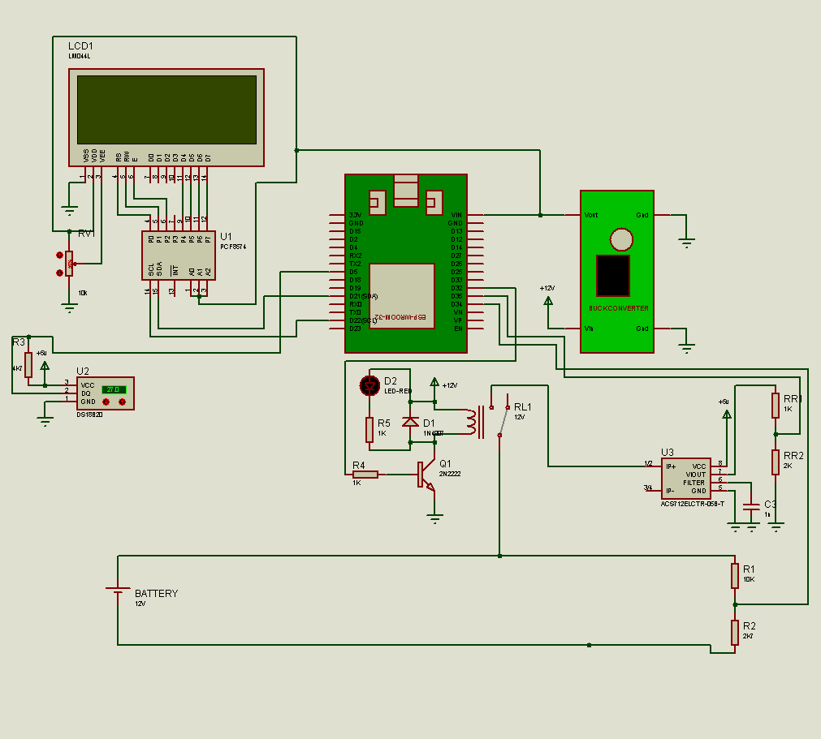

Fig 4.2 CIRCUIT DIAGRAM

**4.3 Working Principle**

The working principle of the project title is based on the combination of embedded system and Web technology to fulfil the requirement of IOT and concept . So in this system, the brain of the hardware section is ESP32 microcontroller development board which is having in built ADC, wi-fi and Bluetooth communication. The primary objective of the system is to monitor voltage level of the EV battery . Flow of current throughout the electrical circuit, monitor the temperature of the motor and protect from overheat and unauthorized of the vehicle.

To measure the battery level ,the system is using the concept of voltage divider circuit so the it can measure a higher voltage level then the maximum input level of ADC channel. ESP32 can handle maximum 3.3V as input but we are measuring the voltage level of a 12 volt battery . Hence the voltage divider circuit is implemented. The programme executing in the microcontroller is responsible for mapping the input and output of the voltage divider circuit to calculate the battery voltage level.

To measure the flow of current through the circuit we are using ACS 712 current sensor. That is ACS712 is based on hall effect sensor depending on the flow of current through ACS712 .It return different voltage level according to datasheet of ACS712, it returns 0 to 5V. from 0 to 2.5 volt. It represent negative current and from 2.5 and above represent positive current. For 5 ampere varient of ACS712, 185mV represent 1 ampere. the output of the current sensor is fetched to ADC channel of ESP32 and the program executing in the devices responsible for converting the output voltage of the current sensor into corresponding current value.

To measure the temperature of the motor the system implementing digital temperature sensor DSB1820 this is the sensor can measure a temperature level from -55 degrees Celsius to 125° Celsius it is a smart sensor which is having 64-bit a APROM address for each and every DSB1820 and circuit works with one wire communication protocol under analog temperature sensor like LM35 or LM335, DSB12820 directly provide the temperature through serial communication it has a specific set of command so that it can interact with the microcontroller for data conversion, data transfer Etc.

To display the voltage current and temperature is 16*2 LCD is used in Hardware section .To reduce the consumption simplify the current we are using I2C communication interfacing LCD and ESP32

The circuit is also having a circuit breaker design with electromagnetic relay so that the motor can be automatically shut down the device if the temperature goes beyond the threshold value.To protect the motor from prospective damage at the same time the circuit breaker can be remotely control to prevent the vehicle from theft or unauthorized access..

All the parameters like voltage, current and temperature is transmitting from ESP32 to web server using inbuilt Wi-Fi communication.

The system is designed in such a way that after a specific time interval the hardware section transmits the vital data to a specific web server using Wi-Fi communication. For experimental setup, we are using a local web server or a Cloud Server for testing the system but it can be easily displayed on any commercial web server.

In web section a well-defined set of web program is designed using PHP , HTML and CSS .Out of all the program server site scripting . A spatially designed PHP file is responsible for collecting the data from the hardware. This program is preferred by Hardware section it connects the data, open database and is stores those data in a database management system permanently so that the web application can generate different report and real-time monitoring after vehicle whenever needed for background processing or server processing. PHP is used for database storage. It is using MySQL and for Fountain designing HTML and CSS is used.

**4.4 Flowchart**

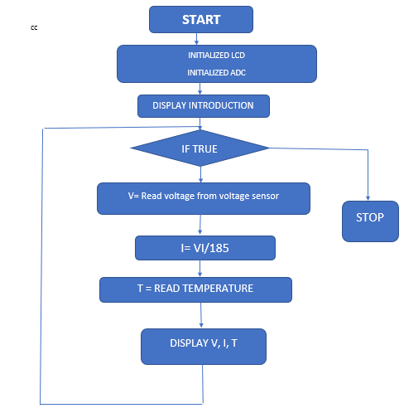

**Fig 4.3 FLOWCHART**

**CHAPTER-5**

**COMPONENTS USED**

**5.1Hardware components**

The main components are the ESP32, sensors (current sensor, voltage sensor temperature sensor), LCD, relay.

ESP32

ESP32 is a single 2.4 GHz Wi-Fi-and-Bluetooth combo chip designed with the TSMC ultra- low-power 40 nm technology. It is designed to achieve the best power and RF performance, showing robustness, versatility and reliability in a wide variety of applications and power scenarios. The ESP32 series of chips includes ESP32-D0WDQ6, ESP32-D0WD, ESP32- D2WD, and ESP32-S0WD.

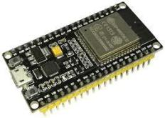

*Fig5.1 : ESP-32*

**Features of the ESP32**

* + - * **Processors**:
        + CPU: Xtensa dual-core (or single-core) 32-bit LX6 microprocessor, operating at 160 or 240 MHz and performing at up to 600 DMIPS
        + Ultra low power (ULP) co-processor
      * **Memory**: 320 KiB RAM, 448 KiB ROM
* **Wireless connectivity**

Wi-Fi: 802.11 b/g/n

* + - * + Bluetooth: v4.2 BR/EDR and BLE (shares the radio with Wi-Fi)
      * **Peripheral interfaces**:
        + 34 × programmable GPIOs
        + 12-bit SAR ADC up to 18 channels
        + 2 × 8-bit DACs
        + 10 × touch sensors (capacitive sensing GPIOs)
        + 4 × SPI
        + 2 × I²S interfaces
        + 2 × I²C interfaces
        + 3 × UART
        + SD/SDIO/CE-ATA/MMC/eMMC host controller
        + SDIO/SPI slave controller
        + Ethernet MAC interface with dedicated DMA and planned IEEE 1588 Precision Time Protocol support
        + CAN bus 2.0
        + Infrared remote controller (TX/RX, up to 8 channels)
        + Motor PWM
        + LED PWM (up to 16 channels)
        + Hall effect sensor
        + Ultra low power analog pre-amplifier
      * **Security:**
        + IEEE 802.11 standard security features all supported, including WPA, WPA2,

WPA3 (depending on version) and WAPI

* + - * + Secureboot

Flash encryption

* + - * + 1024-bit OTP, up to 768-bit for customers
        + Cryptographic hardware acceleration: AES, SHA-2, RSA, elliptic curve cryptography (ECC), random number generator (RNG)
      * **Power management:**
        + Internal low-dropout regulator
        + Individual power domain for RTC
        + 5 μA deep sleep current

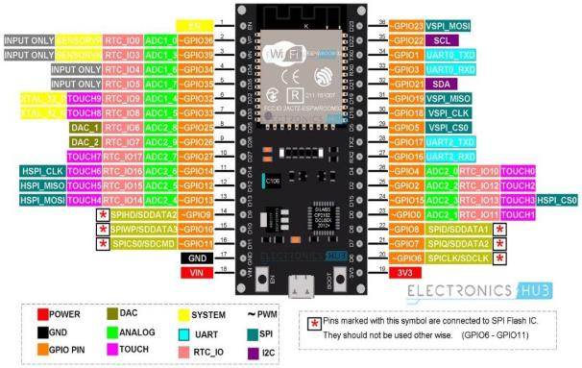

Fig 5.2: Pin Diagram of ESP32

|  |  |
| --- | --- |
| **CHARACTERISTIC** | **ESP32** |
| Processor Frequency | 2*240 MHZ |
| Memory Ram | 512KB |
| Connectivity | Bluetooth and Wifi |
| Architecture | 32 bits |
| Clock Memory Flash ROM | 160 mHZ |

**Table 5.1- ESP32 FEATURES**

**LCD**

A liquid crystal display (LCD) is a [flat panel display,](http://en.wikipedia.org/wiki/Flat_panel_display) [electronic visual display,](http://en.wikipedia.org/wiki/Electronic_visual_display) or [video](http://en.wikipedia.org/wiki/Video_display) [display](http://en.wikipedia.org/wiki/Video_display) that uses the light modulating properties of [liquid crystals](http://en.wikipedia.org/wiki/Liquid_Crystals) (LCs). LCs do not emit light directly.

LCDs are used in a wide range of applications, including [computer monitors](http://en.wikipedia.org/wiki/Computer_monitor), [television](http://en.wikipedia.org/wiki/Television), instrument panels, [aircraft cockpit displays,](http://en.wikipedia.org/wiki/Flight_instruments) [signage,](http://en.wikipedia.org/wiki/Signage) etc. They are common in consumer devices such as video players, gaming devices, clocks, watches, [calculators](http://en.wikipedia.org/wiki/Calculator), and [telephones](http://en.wikipedia.org/wiki/Telephone). LCDs have replaced [cathode ray tube](http://en.wikipedia.org/wiki/Cathode_ray_tube) (CRT) displays in most applications. They are available in a wider range of screen sizes than CRT and [plasma displays](http://en.wikipedia.org/wiki/Plasma_display), and since they do not use phosphors, they cannot suffer image burn-in. LCDs are, however, susceptible to [image](http://en.wikipedia.org/wiki/Image_persistence) [persistence.](http://en.wikipedia.org/wiki/Image_persistence)

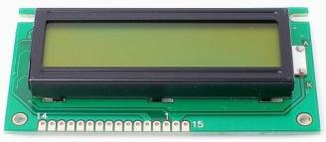

*Fig5.3: LCD*

LCDs are more energy efficient and offer safer disposal than CRTs. Its low electrical power consumption enables it to be used in battery-powered electronic equipment. It is an electronically modulated optical device made up of any number of segments filled with liquid crystals and arrayed in front of a light source (backlight) or reflector to produce images in colour or monochrome. The most flexible ones use an array of small pixels. Each pixel of an LCD typically consists of a layer of molecules aligned between two transparent electrodes, and two polarizing filters, the axes of transmission of which are (in most of the cases) perpendicular to each other. With no actual liquid crystal between the polarizing filters, light passing through the first filter would be blocked by the second (crossed) polarizer.

The surface of the electrodes that are in contact with the liquid crystal material are treated so as to align the liquid crystal molecules in a particular direction. This treatment typically consists of a thin polymer layer that is unidirectionally rubbed using, The Liquid Crystal Display is intrinsically a “passive” device, it is a simple light valve. The managing and control of the data to be displayed is performed by one or more circuits commonly denoted as LCD drivers.

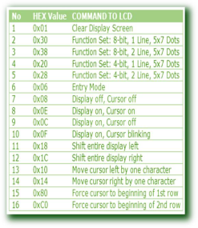

*Table : Command for LCD*

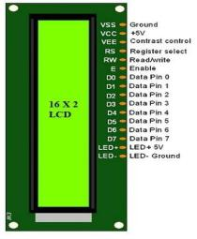

*Fig 5.4 : Pin diagram of LCD*

**TEMPERATURE SENSOR (DS18B20)**

The waterproof DS18B20 temperature sensor is useful when you need to measure temperature from some distance or in wet conditions. The DS18B20 provides 9 to 12-bit (configurable) temperature readings over a 1-Wire interface, so that only one wire (and ground) needs to be connected from a central microprocessor with 3 to 5.5V voltage supply.

**Cable specs:**

* + - * Stainless steel tube 6mm diameter by 30mm long
      * Cable is 36" long / 91cm, 4mm diameter
      * Contains DS18B20-compatible temperature sensor
      * If your sensor has four wires - Red connects to 3-5V, Black connects to ground and White is data. The copper wire is soldered to the wire shielding
      * If your sensor has three wires - Red connects to 3-5V, Blue/Black connects to ground and Yellow/White is data

**Technical specs:**

* + - * Usable temperature range: -55 to 125°C (-67°F to +257°F)
      * 9 to 12 bit selectable resolution
      * Uses 1-Wire interface- requires only one digital pin for communication
      * Unique 64 bit ID burned into chip
      * Multiple sensors can share one pin
      * ±0.5°C Accuracy from -10°C to +85°C
      * Temperature-limit alarm system
      * Query time is less than 750ms
      * Usable with 3.0V to 5.5V power/data

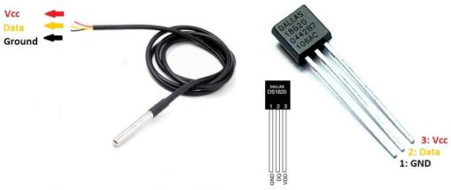

*Fig 5.5 Temperature Sensor*

**CURRENT SENSOR(ACS712)**

ACS712 provides economical and precise solutions for AC or DC current sensing in industrial, commercial, and communications systems. The device package allows for easy implementation by the customer. Typical applications include motor control, load detection and management, switchmode power supplies, and overcurrent fault protection. The device is not intended for automotive applications. The device consists of a precise, low-offset, linear Hall circuit with a copper conduction path located near the surface of the die. Applied current flowing through this copper conduction path generates a magnetic field which the Hall IC converts into a proportional voltage. Device accuracy is optimized through the close proximity of the magnetic signal to the Hall transducer. A precise, proportional voltage is provided by the low-offset, chopper-stabilized BiCMOS Hall IC, which is programmed for accuracy after packaging. The output of the device has a positive slope (>VIOUT(Q)) when an increasing current flows through the primary copper conduction path (from pins 1 and 2, to pins 3 and 4), which is the path used for current sampling. The internal resistance of this conductive path is 1.2 mΩ typical, providing low power loss. The thickness of the copper conductor allows survival of the device at up to 5× overcurrent conditions. The terminals of the conductive path are electrically isolated from the signal leads (pins 5 through 8). This allows the ACS712 to be used in applications requiring electrical isolation without the use of opto-isolators or other costly isolation techniques. The ACS712 is provided in a small, surface mount SOIC8 package. The leadframe is plated with 100% matte tin, which is compatible with standard lead (Pb) free printed circuit board assembly processes. Internally, the device is Pb-free, except for flip-chip high-temperature Pb-based solder balls, currently exempt from RoHS. The device is fully calibrated prior to shipment from the factory.

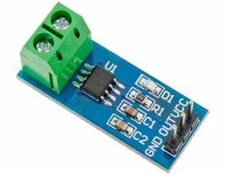

*Fig5.6: current sensor ACS712*

**Features and Benefits**

* Low-noise analog signal path
* Device bandwidth is set via the new FILTER pin
* 5 μs output rise time in response to step input current
* 80 kHz bandwidth ▪ Total output error 1.5% at TA = 25°C
* Small footprint, low-profile SOIC8 package
* 1.2 mΩ internal conductor resistance
* 2.1 kVRMS minimum isolation voltage from pins 1-4 to pins 5-8
* 5.0 V, single supply operation
* 66 to 185 mV/A output sensitivity
* Output voltage proportional to AC or DC currents
* Factory-trimmed for accuracy
* Extremely stable output offset voltage
* Nearly zero magnetic hysteresis
* Ratiometric output from supply voltage

|  |  |  |
| --- | --- | --- |
| **Pin Number** | **Pin Name** | **Description** |
| 1 | Vcc | Input voltage is +5V for typical applications |
| 2 | Output | Outputs Analog voltage proportional to current |
| 3 | Ground | Connected to ground of circuit |
| T1 | Wire In | The wire through current has to be measured is connected here |
| T2 | Wire Out |  |

**Table 5.2- Pin Configuration of ACS712**

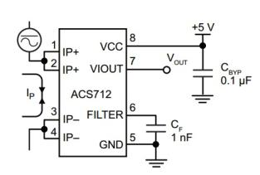

*Fig5.7 : Pin diagram of ACS712*

|  |  |
| --- | --- |
| **CHARACTERISTIC** | **ACS712** |
| Bandwidth | 80kHz |
| Output Sensitivity | 66 to 185 mv/A |
| Internal Conductot Resistance | 1.2 milli ohm, |
| Total Output Error | 1.5% |
| Magnetic Hysteris | Near Zero |

**TABLE 5.3- CURRENT SENSOR FEATURES**

**VOLTAGE SENSOR**

For measuring external voltages using Arduino, we have to make use of the Analog Input pins of the Arduino Board. If we recall a little bit about the Arduino Analog Pins, their input voltage is limited to 5V i.e. we can measure up to 5V directly using the Analog Input Pins of the Arduino.

But what if we want to measure voltages that are greater than 5V? We cannot directly use the Analog Input Pins of the Arduino as we might fry the ATmega328P IC on the Arduino UNO board (or the relevant Microcontroller IC depending on the Arduino Board we are using).

Here comes the Voltage Sensor Module to the rescue. Using this Voltage Sensor Module, we can measure voltages up to 25V.

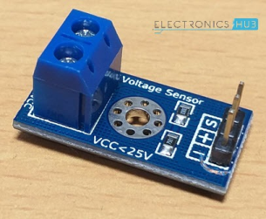

*Fig5.8: Voltage sensor*

**Pins of the Voltage Sensor**

Before going into the details of the Voltage Sensor like its functionality and schematic, let me give you an overview of the available Pins of the Voltage Sensor Module. Basically, a 25V Voltage Sensor, like the one used here, has 5 pins in total. Two of them are on the two-pin screw terminal and three are male header pins. The Screw Terminal pins are marked as VCC and GND and they must be connected to the external source of voltage i.e. the voltage that needs to be measured.

Coming to the three male headers, they are marked as S, + and –. The S pin is the “Sense” pin and it must be connected to the Analog Input of the Arduino. The “–” pin must be connected to the GND of the Arduino. The pin marked as “+” is not connected to anything (it is an N/C Pin).

The following image shows the pins of a Voltage Sensor Module.

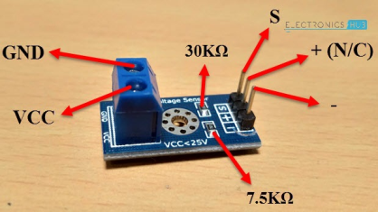

*Fig 5.9: Pin diagram of Voltage Sensor*

* VCC: Positive terminal of the voltage to be measured (0-25V)
* GND: Negative terminal of the voltage to be measured
* Analog Input of Arduino
* +: Not connected (N/C)
* –: GND of Arduino

**Schematic of Voltage Sensor**

Now, let us talk about the important thing about the voltage sensor: its schematic. The Voltage Sensor is basically a Voltage Divider consisting of two resistors with resistances of 30KΩ and 7.5KΩ i.e. a 5 to 1 voltage divider.

The following image shows the schematic of the Voltage Sensor Module with an input voltage limit of 25V.

Interfacing Voltage Sensor with Arduino Voltage Sensor Schematic

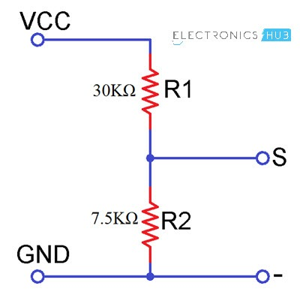

*Fig 5.10:* schematic of the Voltage Sensor Module

|  |  |
| --- | --- |
| **CHARACTERISTIC** | **VOLTAGE SENSOR** |
| R1 | 10 Kilo Ohm |
| R2 | 3.3 Kilo Ohm |
| Vin | 13 V |
| Vout | 5V |

**TABLE 5.4- VOLTAGE SENSOR FEATURES**

ATMEGA328P

ATmega328 is an Advanced Virtual RISC (AVR) microcontroller. It supports 8-bit data processing. ATmega-328 has 32KB internal flash memory.

ATmega328 has 1KB Electrically Erasable Programmable Read-Only Memory (EEPROM). This property shows if the electric supply supplied to the micro-controller is removed, even then it can store the data and can provide results after providing it with the electric supply. Moreover, ATmega-328 has 2KB Static Random Access Memory (SRAM). Other characteristics will be explained later. ATmega 328 has several different features which make it the most popular device in today's market. These features consist of advanced RISC architecture, good performance, low power consumption, real timer counter having separate oscillator, 6 PWM pins, programmable Serial USART, programming lock for software security, throughput up to 20 MIPS etc. Further details about ATmega 328 will be given later in this section.

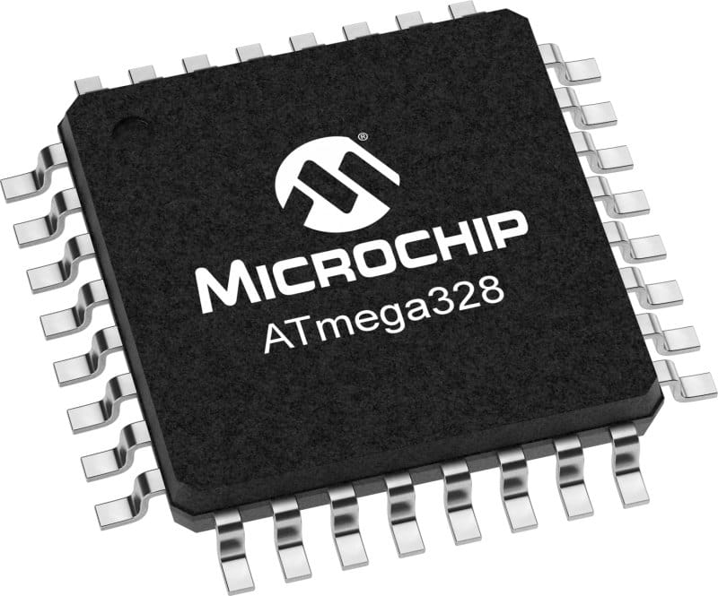

*Fig 5.11: Atmega328P*

|  |  |
| --- | --- |
| **CHARACTERISTIC** | **ATMEGA328P** |
| Operating voltage | 5V |
| input voltage | 7-12V |
| Analog input pins | 6 |
| Flash memory | 32KB |
| Digital input pins | 14 |
| Frequency | 16MHZ |

**TABLE 5.5- ATMEGA328P FEATURES**

**SOFTWARE COMPONENTS**

The main components are the Arduino IDE,Proteus ,Wamp Server,My SQL,HTML,PHP,DBMS.

ARDUINO IDE

The ARDUINO IDE is a part ARDUINO Project started by MASIMO BANZI, ARDUINO is not only a hardware, or software, ARDUINO is an integrated system that include Hardware, IDE, Project as well as a community. The ARDUINO make it easier for the new comer and the hobbyist who is having limited knowledge of technical background. Because of ARDUINO people from different field of Engineering are successfully designing and implementing the power of electronics and embedded system. With the improvement of ARDUINO IDE and different hardware platform it become popular among the IT and CS students. Before ARDUINO Embedded system was a complicated system for both CS and Electronics students. Where Electronics student do not have proper programming knowledge, the CS/IT student was not having proper knowledge of Electronics circuit and sensors. The ARDUINO minimize the gap between this two distinct faculties.

The Arduino Integrated Development Environment is a [cross-platform](https://en.wikipedia.org/wiki/Cross-platform) [IDE](https://en.wikipedia.org/wiki/Integrated_development_environment) designed for [Arduino microcontrollers](https://en.wikipedia.org/wiki/Arduino" \o "Arduino). The IDE uses a combination of the [C standard library](https://en.wikipedia.org/wiki/C_standard_library) and [C++](https://en.wikipedia.org/wiki/C%2B%2B_Standard_Library). It is used to write and upload programs to [Arduino](https://en.wikipedia.org/wiki/Arduino" \o "Arduino) compatible boards, but also, with the help of third-party cores, other vendor development boards.

The source code for the IDE is released under the [GNU General Public License](https://en.wikipedia.org/wiki/GNU_General_Public_License), version 2. The Arduino IDE supports the languages [C](https://en.wikipedia.org/wiki/C_(programming_language)) and [C++](https://en.wikipedia.org/wiki/C%2B%2B) using special rules of code structuring. The Arduino IDE supplies a [software library](https://en.wikipedia.org/wiki/Software_library) from the [Wiring](https://en.wikipedia.org/wiki/Wiring_(development_platform)) project, which provides many common input and output procedures. User-written code only requires two basic functions, for starting the sketch and the main program loop, that are compiled and linked with a program stub main() into an executable [cyclic executive](https://en.wikipedia.org/wiki/Cyclic_executive) program with the [GNU toolchain](https://en.wikipedia.org/wiki/GNU_toolchain), also included with the IDE distribution. The Arduino IDE employs the program avrdude to convert the executable code into a text file in hexadecimal encoding that is loaded into the Arduino board by a loader program in the board's firmware. By default, avrdude is used as the uploading tool to flash the user code onto official Arduino boards.

Arduino IDE is a derivative of the [Processing IDE](https://en.wikipedia.org/wiki/Processing_(programming_language)), however as of version 2.0, the Processing IDE will be replaced with the [Visual Studio Code](https://en.wikipedia.org/wiki/Visual_Studio_Code)-based [Eclipse Theia](https://en.wikipedia.org/wiki/Eclipse_Theia) IDE framework.

With the rising popularity of Arduino as a software platform, other vendors started to implement custom open source compilers and tools (cores) that can build and upload sketches to other [microcontrollers](https://en.wikipedia.org/wiki/Microcontroller) that are not supported by Arduino's official line of microcontrollers.

In October 2019, the [Arduino](https://en.wikipedia.org/wiki/Arduino" \o "Arduino) organization began providing early access to a new Arduino Pro IDE with debugging and other advanced features.

PROTEUS

The Proteus Design Suite is a proprietary software tool suite used primarily for electronic design automation. The software is used mainly by electronic design engineers and technicians to create schematics and electronic prints for manufacturing printed circuit boards. Using this software we can design different circuit. Proteus has a rich library of component which includes microcontroller, Different types of voltage source etc. By using this software we can make stimulated circuit to check before start it in lab.

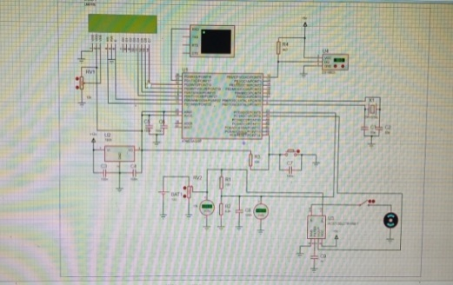

*Fig: Proteus Software*

WAMP SERVER

WAMP is an acronym that stands for Windows, Apache, MySQL, and PHP. It’s a software stack which means installing WAMP installs Apache, MySQL, and PHP on your operating system (Windows in the case of WAMP). Even though you can install them separately, they are usually bundled up, and for a good reason too. WAMP acts like a virtual server on your computer. It allows you to test all WordPress features without any consequences since it’s localized on your machine and is not connected to the web.

First of all, this means that we don’t need to wait until files are uploaded to your site, and secondly – this makes creating backups much easier.

WAMP speeds up the work process for both developers and theme designers alike. However, to actually make the website go live, you need to get some form of hosting service and a Domain.In essence, WAMP is used as a safe space to work on your website.

MYSQL

MySQL enables us to set up and run reports to display live information from a MySQL server, such as status and performance information. MySQL reporting facility supports both built-in reports and user-defined reports. The reporting facility is available from MySQL. Reports can be created directly at the MySQL Shell interactive prompt, or defined in scripts that are automatically loaded when MySQL starts.

Reports written in any of the supported languages (JavaScript, Python, or SQL) can be run regardless of the active MySQL language. Reports can be run once using the MySQL Shell \show command, or run and then refreshed continuously in a MySQL Shell session using the \watch command.

**CHAPTER 6**

|  |  |
| --- | --- |
| **ITEM USED** | **OUTPUTS** |
| BATTERY VOLTAGE | 13 VOLT |
| VOLTAGE | 12.899(AT LOAD) |
| CURRENT | 1.16(AT LOAD) |
| CURRENT SENSORS  R1 | 10KOHM |
| R2 | 3.3KOHM |
| ESP32 INPUT VOLTAGE | 3.3VOLT |
| ATMEGA328P INPUT VOLTAGE | 3VOLT |
| AREF | 5VOLT |

**Table6.1: Results**

**6.2 DISCUSSION**

This chapter discusses the results of the project. It managed to successfully apply the BATTERY MONITORING AND VEHICLE TRACKING SYSTEM USING IoT and it was user friendly and cost effective. User friendly as in anyone can use just a click of a URL on a smart phone screen and everything works.

**CHAPTER 7**

**CONCLUSION**

The concept of electric vehicle was conceived to address the different problem associated with Current Situation monitoring and protection of motor.

The modern Ecosystem is influenced by IOT in Various industries including health education, autombile etc. During the Development of system initially we faced the problem of micro controller selection , identification sensors which could be effectively used in our system and more of the Development programmes after Study of various Block of Magazine and online Resources we have interfaced the sensors but again the problem was designing the programme from scratch. There are number of Blogs and Websites available where interfacing of single sensors are available but when we have to combine multiple sensors in a single programme. We have faced different and unexpected issues but finally we have solved the problem and achieved the Required Output.

**BIBLOGRAPHY**

* Mohammed F. Alrifaie, Norharyati Harum, Mohd Fairuz Iskandar Othman, Irda Roslan,“VEHICLE DETECTION AND TRACKING SYSTEM IOT BASED”, International Research of Journal of Engineering and Technology (IRJET),2018.
* S kumar Reddy , V.V. venella,“IOT bases smart Vehicle monitoring System”,International Journal of advance research in computer science,march-april 2018.
* A.Mounika, Anitha Chepuru,“IOT Based Vehicle Tracking and Monitoring System Using GPS and GSM”,International Journal of Recent Technology and Engineering (IJRTE),2019.
* Boddapati Venkata sai Padma , Venkata Ratnam Kolluru , Syam,“ IOT based Implementation of Vehicle Monitoring And Tracking system using Node MCU”, International Journal of Innovative Technology and Exploring Engineering (IJITEE),April 2019.
* Websites Visited

1. <https://www.ti.com/applications/automotive/hev-ev-powertrain/hev-ev-battery-management-system-bms/overview.html>
2. <https://www.brickhousesecurity.com/gps-trackers>
3. <https://www.irjet.net/>
4. <https://www.ripublication.com/>